FMOD Studio

Basic Functionality Guide

Introduction
This guide is designed to the software program, FMOD Studio. It will provide explanations of all the current elements of the software as well as some basic work flow and functionality information in the form of a series of tutorials to introduce the user to working with FMOD Studio.

FMOD Designer Users
To those users who have used FMOD Designer in the past, FMOD Studio will include some familiar functionality, but overall it is an entirely new product and it has many new and different work flow processes.
Important
FMOD Studio differs from traditional audio creation applications in that it does not use destructive editing. This means that a sound file added to FMOD Studio is never altered in any way within the software. Sounds are referenced and all processes that change or manipulate the output sound are performed in real time.
FMOD Studio will create a copy of the referenced sound and place it into the Audio bin folder in the relevant project folder. If you need to alter the reference sound file you will need to edit the version in the audio bin folder.

Table of Contents
Basic Functionality Guide 1
Introduction 1
FMOD Designer Users 1
Core Concepts 20
The Concepts of Game Audio Design 20
The Sound File is not the Sound 20
Implementation and Creation: The blurry line 21
A New Approach 21
FMOD Studio Main Interface Window 22
Key Controls 22
The Menu Bar 23
File Menu 23
New 24
Open... 24
Open Recent 24
Close 24
Save 24
Save As... 24
Revert to Saved... 24
Import Audio File... 24
Build 24
Export GUIDs… 25
Connect to Game... 25
Source Control 25
Identify Local Changes 25
Exit 25
The Edit Menu 25
Undo 26
Redo 27
Cut 27
Copy 27
Paste 27
Delete 27
Paste at Original Position 27
Select All 27
Deselect All 27
Duplicate 27
Move To… 27
Move to Cursor 28
Bring to Front 28
Send to Back 28
Set Color 28
Open in External Sample Editor 29
Preferences… 29
The View Menu 29
Browser 30
Deck 30
Properties 30
Loop Playback 30
Follow Cursor 30
Snap to Ruler 30
Zoom In 31
Zoom Out 31
Zoom to Fit 31
The Window Menu 31
Minimize 32
Zoom 32
Cycle Through Windows 32
Bring All to Front 32
Audio Bin 32
Event Browser 32
Event Editor 32
Mixer 32
Contextual List of Windows 33
Close Window 33
The Help Menu 33
Manual 33
Visit our Forum 33
Contact support@fmod.org... 33
About FMOD Studio 33
The Preferences Window 34
Assets 34
Metering 34
Plugins 35
Control Surfaces 35
Source Control 36
The Browser 36
The Editor 36
Breadcrumbs 37
Missing References 37
The Transport 37
Loop Playback 37
Ghost Cursor 38
Track and Strip Views 38
The Event Birdseye View 39
Viewing an Extended Timeline / Game Parameter 39
Defining and Resizing the Editor Region 40
The Deck 40
A Note on the Deck Areas 41
Event Decks 41
Mixer Decks 42
3D Preview 42
Properties 42
The Banks Tab 43
Platform Support 43
The Mixer 44
Getting Started: Creating a new project 45
Introduction 45
Project Files 45
Saving a New Project 45
Define the Project Location and Name 46
Basic Control Concepts 47
Introduction 47
Right click Magic 47
Fine Tuning Control 47
Pop-up Windows 47
Editor Zoom 48
Resizing and Repositioning Modules 48
Event Drag and Drop 49
Tooltips 49
Controls and Properties 50
Introduction 50
Direct Value Input 50
Control Types 50
Dial Controls 50
Slider Controls 51
Buttons 51
Toggle Buttons 52
Radio Buttons 52
Range Sliders 52
Alphanumeric Inputs 52
Graphical Display Inputs 53
Volume 53
Components with Volume Controls 54
Pitch 55
Components with Pitch Controls 55
Object Data 56
Command Line Interface 57
Modulators 57
Creating a Modulator 57
Accessing the Pitch or Volume Controls 58
Creating a New Modulator 58
Random Modulation 58
Random Modulation Example 59
AHDSR Modulation 59
Autopitch 60
Creating an Autopitch Modulator 61
Accessing or creating a Game Parameter 61
Accessing or Creating a Sound Module 62
Side Chain Modulator 64
Creating a Sidechain Modulator 64
Sidechain Properties 65
Automation 68
Creating Automation 68
Accessing an Event 68
Creating Automation 69
Automation Track Names 70
The Audio Bin 71
Adding Sound Files to the Audio Bin 72
Introduction 72
Adding Sound Files to the Audio Bin 72
Audition Mode 73
Audio Bin Context Menu 74
New Folder 74
Move into New Folder 74
Move to Top Level 74
Move to 74
Replace… 74
Delete 74
Open in External Sample Editor 75
Unused Sound Files 75
Creating your First Event 76
Introduction 76
Creating a new Event 76
Naming the New Event 76
Adding Sounds to an Event 78
Option 1 78
Option 2 79
Modules 81
Sound Modules 81
Modules that Produce Sound 81
Creating a Sound Module 82
Multi Sound Module 83
Playlist Properties 83
Playlist Context Menu 83
Bulk Editing 86
Editing Properties 86
Range Extremes 87
Controlling Property 88
Bulk Editing Parameters 88
Bulk Editing the 3D Previewer 88
Module Playback Behavior 89
Module Looping Behavior 90
Looping a Module’s individual Playlist Entries 90
Module set to single playback, all entries set to loop 90
Sound Module set to single playback, some entries set to loop 90
Sound Module set to looping playback, all entries set to not loop 91
Sound Module set to loop, some entries set to loop 91
Sound Module set to loop with all playlist entries set to loop 91
Single vs. Multi Sound Modules 91
Event Module 91
Sub Events 92
Event Reference Modules 92
Creating Event Reference Modules 93
Sound Scatterer Modules 94
Trigger Behavior 94
A word on Generative Audio 96
Audio Weather Module 96
Single Module 96
Events within Events 97
Event Instances 98
Trigger Regions 99
Introduction 99
Trigger Region Names 99
Auto Naming 99
Renaming Trigger Regions 100
Trigger Region Colors 100
Trigger Region Instances 101
Precise positioning for Trigger Regions 101
Move To… 101
Move to Cursor 102
Bring to Front 102
Send to Back 102
The Logic Track 103
Introduction 103
Logic Track Display 103
Loop Regions 103
Creating a Loop Region on the Logic Track 104
Creating a Loop Region on a Trigger Region 104
Sustain Points 105
Creating a Sustain Point 105
Working with Sustain Points 106
Timelocked and Non-Timelocked Sounds 108
Timelocked Sound Modules 108
Non-time Locked Sound Modules 108
Loop Region Logic Functionality 109
Tempo Markers 109
Markers 111
Creating a Marker 111
Transition Timelines 111
Programmer Sound Modules 112
Multiple Projects 112
FMOD Studio Music System 112
Introduction 112
The Logic Track 112
Markers 113
Creating Markers 113
Working with Markers 113
Tempo Markers 114
Creating Tempo Markers 115
Defining Tempo 115
Working with Tempo Markers 115
Transitions 116
Creating Transitions 116
Working with Transitions 116
Transition Functionality 117
Transition Regions 117
Creating Transition Regions 118
Working with Transition Regions 118
Transition Region Quantization 118
Transition Timelines 119
Loop Regions and Sustain Points 121
Trigger Behavior 122
Defining Trigger Behavior 122
Time 122
Tempo 123
Parameters 125
Step 1 Creating a Parameter 125
Parameter Properties 126
Parameter Modulation 128
Distance Parameter 128
Direction Parameter 129
Elevation Parameter 129
Event Cone Angle Parameter 129
Event Orientation Parameter 130
The Timeline Parameter 131
Introduction 131
Aspects of Time-based Events 131
Timelocked sounds 131
Loop Regions and Time 132
The Distance Parameter 133
Introduction 133
Step 1 Creating a Distance Parameter 133
The Event Cone Angle Parameter 134
Introduction 134
Step 1 Creating an Event Cone Angle Parameter 134
Controlling Events External to an Event 136
Introduction 136
Creating a Higher Level Parameter Controller 137
Introduction 137
Tutorial 137
Step 1 Create a New Event 137
Step 2 Create an Event Module 138
Step 3 Create a Parameter 138
Step 4 Create a Parameter Automation Controller 139
Linked Parameter Control for Nested and Reference Events 139
Tags 141
Searching for Tags 141
The Tag Browser 141
Creating and Assigning Tags 142
Creating a new Tag 142
Method 1: Adding Tag information to an Event 142
Method 2: Assigning an Event to a Tag 143
Creating a Tag in the Tag Browser 143
The Browser Search Bar 144
GUID Searches 145
Tag Searches 145
Routing and Assigning 146
The Mixer 147
In Depth: The Mixer Functionality 148
The Mixer Tool Set 148
Multiple Mixer view 148
Group Solo 148
Basic Signal Paths 148
A Word on Effects 151
Group Buses 152
Why Group Buses? 153
Keep Things Simple 153
Creating a Group Bus 154
Step 1 Display the Mixer View 154
Step 2 Create a Group Bus 154
Routing Inputs to Buses 155
Step 1 Open a Project with existing Events and Group Buses 155
Step 2 Route an Input to an existing Group Bus 156
Step 3 Rerouting an Input to a New Group Bus 156
Step 3 Route an Input to the Master Bus 157
Signal Routing 158
Working with Group Buses 159
A new Channel Strip 159
The Deck 159
Buses within Buses 160
Basic Routing Setup 160
Creating Sub Group Buses 162
Step 1 Open a Project with existing Events and Group Buses 162
Step 2 Create a Group Bus within an existing bus 162
Sends 164
Basic Send routing in Events 164
Basic Send routing in Mixer 165
Adding Sends to Events 166
Step 1 Creating a Send 166
Send/Return Functionality 167
Routing Audio Tracks to Return Tracks 168
Step 1 Creating a Send 168
Adding Sends in the Mixer 169
Adding a Send 169
Step 1 Creating a Send 169
Routing buses to existing Return Buses 170
Step 1 Creating a Send 170
Routing at the Event Level 171
Routing to tracks 171
Routing to Audio Tracks 172
Step 1 Create an new Event 172
Step 2 Assigning Audio Tracks to Audio Tracks 172
Signal Routing within an Event 173
VCAs 174
Implementation 174
VCA Controls 174
Creating VCAs 176
Step 1 Create a new VCA 176
Assigning to VCAs 177
Step 1 Assigning to VCAs 177
Multiple Mixer Views 178
Concept 178
Administering Mixer Views 179
Bus Naming 179
Assigning to Mixer Views 180
Step 1 Assigning to Mixer views 180
Snapshots 181
Mixer Snapshots 181
Creating a Snapshot 182
Working with Snapshots 183
Modulation 184
Automation 184
Copying Snapshots 184
Blank Snapshots 185
Snapshots and Stacking 185
The Snapshot Priority List 186
Multiple Instances of the same Snapshot 186
Multiple Snapshots with no shared Properties 186
Multiple Snapshots with Shared Properties 186
Priorities 186
Snapshot Automation 187
Snapshot Timeline and Parameters 187
Mixer Routing Window 187
Assigning Mixer Buses to VCAs 188
Add Sends: To Mixing Desk 188
Channels and Panning 189
Setting Channel modes 190
Step 1 Switching channel output modes 190
Using the Panner Controls 191
Concept 191
Stereo Panner 191
Surround Panner 192
Pan Automation 192
Switching Speakers On and Off 193
Surround Panner with Speaker Channels switched off Mixer Strip Source Control Lock 194
FMOD Music System 196
The Logic Track 196
Markers 196
Creating Markers 197
Working with Markers 197
Tempo Markers 197
Creating Tempo Markers 198
Defining Tempo 198
Working with Tempo Markers 199
Transitions 199
Creating Transitions 200
Working with Transitions 200
Transition Functionality 200
Transition Regions 201
Creating Transition Regions 201
Working with Transition Regions 201
Transition Functionality 202
Transition Region Quantization 202
Loop Regions and Sustain Points 203
Trigger Behavior 204
Logic 204
Defining Delay and Quantization 205
Time 206
Tempo 206
Seek 207
Polyphony 208
The 3D Panner 208
Min and Max Distance 209
3D Sound Properties 209
Sound Size 210
Min Extent 211
Pan Override 211
3D Preview 211
Distance Attenuation 212
Event Macros 214
Master 214
Sends 215
3D Panner 215
Polyphony 215
Priority 215
Flip Control 215
Effects 217
Inserting Effects 217
Inserting and Effect unit 217
3rd Party and User Created Plugins 218
Effects Automation 219
Inserting Effects Automation 219
Inserting and Effect Unit 219
3-EQ 220
3 EQ Properties and Default Values 220
Properties 220
Low, Mid and High 220
X-Low 221
X-High 221
X-Slope 221
Compressor 222
Compressor Properties and Default Values 222
Properties 222
Threshold 222
Ratio 222
Attack 223
Release 223
Gain 223
Sidechain 223
Sidechaining 224
Channel Ducking 224
Creating a Sidechain 224
Creating a new Compressor 224
Creating the Sidechain 225
Chorus 227
Flanger Properties and Default Values 227
Chorus Settings 227
Rate 227
Depth 227
Mix 227
Delay 228
Delay Properties and Default Values 228
Properties 228
Delay 228
Wet Level 228
Dry Level 228
Feedback 229
Flanger 229
Flanger Properties and Default Values 229
Properties 229
Rate 229
Depth 230
Mix 230
High Pass 230
High Pass Properties and Default Values 230
Properties 230
Cuttoff 230
Resonance 231
Limiter 231
Limiter Properties and Default Values 232
Properties 232
Input 232
Ceiling 232
Release 232
Channels 232
Low Pass 233
Low Pass Properties and Default Values 233
Properties 233
Cuttoff 233
Resonance 234
Parametric EQ 234
Parametric EQ Properties and Default Values 235
Properties 235
Frequency 235
Gain 235
Bandwidth 235
Reverb 236
Reverb Properties and Default Values 236
Properties 237
Reverb Time 237
Early Delay 237
Late Delay 237
HF Decay 237
HF Reference 237
Diffusion 238
Density 238
Low Gain 238
Hi Cut 238
Low Freq 238
Wet Level 238
Dry Level 238
Early/Late 238
Legacy Effect Modules 239
Distortion 239
Highpass Simple 239
Lowpass Simple 240
Pitch Shifter 240
Tremolo 241
Settings for creating basic LFO shapes: 241
Plugin Modules 243
Gain Effect Module 243
Distance Filter Effect Module 243
Building and Implementing Projects 245
Introduction 245
Banks 245
Introduction 245
Assigning Events to a Bank 245
Accessing the Events within a Project 246
Assigning to a Bank 246
Assigning Events within the Banks Browser 247
Assigning Events within the Banks Browser 247
Removing Events from Banks 247
Method 1 247
Method 2 248
Creating New Banks 248
Creating a New Bank 248
Bank Properties 248
Bank Browser Specific Event Properties 250
The Build Process 251
Setting up Control Surfaces 253
Configuring the Device 253
MCU Pro 253
Adding the Device 253
SSL Nucleus 254
Software Set-up 254
ipMIDI 255
Adding the FMOD Studio Profile to the Nucleus 255
Nucleus Control with Studio 257
Nucleus Profiles 257
Common Controls 257
Transport Controls 258
Selection buttons 258
Instrument 259
Plug In 259
EQ 259
Pan 259
Send 260
Track 260
Send E 260
Pan 260
Track 9 Selection Button 260
Track 10 Selection Button 260
Tracks 11-16 Selection Buttons 260
The Shuttle Wheel 261
Global Controls 261
DAW 2 and DAW 3 261
Enter 262
Save 262
ESC 262
Undo 262
F2 262
Miscellaneous Controls 262
Flip 262
User 1 & User 2 262
Channel Strips 263
Default Channel Strip Behavior 263
Profiler 264
The Session Browser 264
Adding a Bus to a Session 265
Using the Profiler 265
Master Bus 265
Loudness Meter 266
Loudness Meter Module 266
Integrated Loudness 267
Loudness Range 268
Max Peak 268
Target 268
Pause 268
Reset 268
Bar Meters 268
Meter Signal Peak and Range Indicator 269
Loudness Histogram 269
Project Progression 270
Introduction 270
A Generative Audio Explosion 270
Concepts 270
Analysis of an explosion 270
Sound Components 271
Tutorial 1: Creating the project 272
Introduction 272
Step 1 272
Step 2 273
Summary 273
Tutorial 2: Creating an Event Folder 274
Introduction 274
Step 1 274
Step 2 274
Summary 275
Tutorial 3: Creating the first Event 276
Introduction 276
Step 1 276
Step 2 276
Summary 277
Tutorial 4: Adding Sounds to the First Event 278
Introduction 278
Step 1 278
Step 1 279
Summary 279
Analysis of FMOD Studio Projects 280
Single vs. Multi Sound Module 280
Introduction 280
The Basics 280
The Example 280
Taking Things Further 281
A Variable Duration Cycle 283
Introduction 283
The Event 283
The Mechanics 283
Going Further 284
Pitch Shifting Magic 285
Introduction 285
The Event 285
Going Further 286
Appendix A 287
Keyboard Shortcuts 287
Support 288
Website 288
Technical support 288
Sales / licensing enquiries 288
Training and tutorials 288
Manual written and produced by 288

Before You Start
It is important to note that FMOD Studio is a program that is constantly under development. The software is updated and new features are added multiple times a year. This process requires this User Manual to be updated to correctly reflect the state of FMOD Studio at any time. There will always be a small delay between a new version of FMOD being released and the User Manual being updated. This delay will usually only be a month or two.
In the unlikely event that you cannot find exactly what you are looking for in the User Manual we recommend you visit the FMOD Knowledge Base
FMOD Knowledge Base

Core Concepts

The Concepts of Game Audio Design
FMOD Studio operates around some core concepts that need to be understood before diving into the realm of game audio design. For those new to game sound audio design these are critical to the process of understanding how game audio differs from more traditional linear audio. Even those familiar with game audio will benefit from the clarification of concepts, especially when considering the expanded functionality of FMOD Studio.

The Sound File is not the Sound
Game audio has developed significantly in the relatively short life of the industry. Modern game projects can be complex productions that require large teams to complete. Regardless of the size and scope of your game project there is one key truth about game audio; the sound file is not the sound.
The act of implementing a sound into a game project will often greatly alter how the sound is heard and perceived. A 3D game world has numerous factors that will influence the playback behavior of a sound file. The position relative to the player, the speed of movement, environmental factors that may influence or manipulate the sound, all affect the sound that is actually played by the game. The end product can differ greatly from the actual file that contains a recorded sound.
This simple fact is critical in producing good quality game audio and is a central component in getting the best use out of a tool such as FMOD Studio. Studio has a complex series of tools and functions to allow a sound designer to create evocative audio environments, but it can still import and playback a single sound-file on demand with little or no alteration to the original sound.
FMOD Studio is an exponential jump in functionality from FMOD Designer 2010. It will pay well for someone who takes the time to appreciate the new capabilities and understand the concepts involved.

Implementation and Creation: The blurry line
A significant number of AAA production companies still use linear media methods of audio production. That is; create a sound effect in an external editor program, add that sound to a game project through a tool such as FMOD, then trigger that sound as required in game.

Linear Audio Production

While this process is a perfectly acceptable method of getting sounds to trigger in a game it misses the opportunity to produce audio that will sound better, use less resources and can even require less programmer time to implement.
High-level game production requires outstanding quality audio, but quality audio is more than just a spectacular sound, it’s a sound that is spectacular each time it is triggered, even unique where appropriate. It is a sound that is as efficient as possible in resource usage, and it is a sound that does not require hours of programmer time to set up complex playback behavior.
FMOD Studio combines the process of creating and implementing. A complex sound can be constructed from smaller sound components. When done correctly, this will result in the sound being unique when it is triggered because it is assembled in real-time. Each of the sound components used in the creation of the sound can be reused as components for other sounds thus maximizing the use of memory. This method is referred to as generative audio.

Generative Audio Production
Generative audio is not an all or nothing solution. There will always be times when a sound needs to be consistent and under those circumstances a single well-crafted sound-file triggered directly can be the most appropriate solution. A wise designer will always consider if a specific sound-file may also be useful as a component to create a different sound effect elsewhere in the project.

A New Approach
This method of audio production does require a new way of approaching sound design. Most designers are aware that the very nature of the games industry is constantly evolving as new methods of production are developed. We have only just scraped the surface of the potential for generative sound design. The possibilities for creative designers to produce outstanding audio with FMOD Studio are enormous.
We would invite sound designers both beginner and experienced to approach the use of FMOD Studio with an open mind and the curiosity of a child. We are confident you will discover methods of production you have not previously thought of and we sincerely hope you uncover possibilities of production that even the creators of Studio did not expect. Please enjoy the experience.

FMOD Studio Main Interface Window
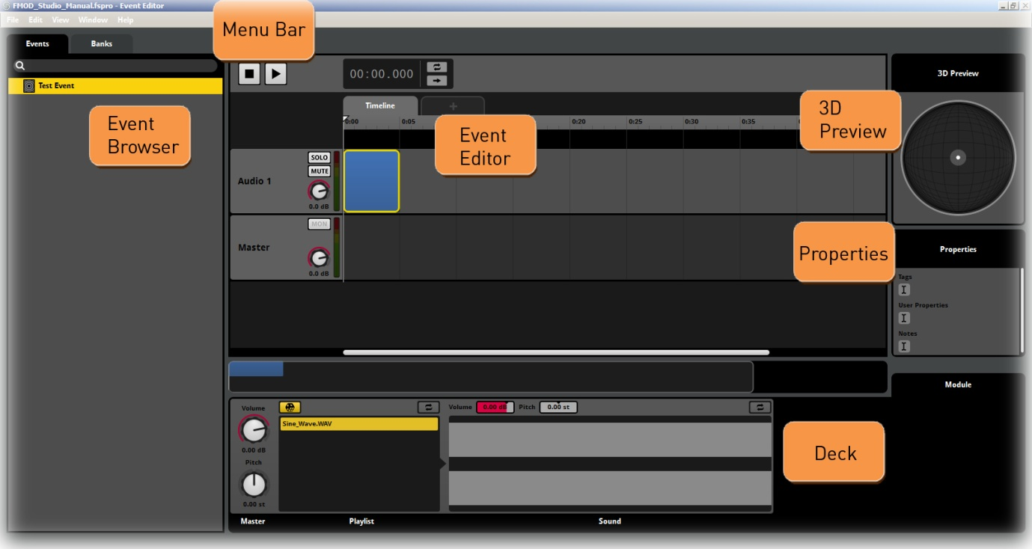
FMOD Studio Main Interface Window
FMOD Studio combines most of the workspace elements into a single screen. All the essential information is centered in this screen, with a number of pop-up menus, additional interface screens and tab menus. The regions tagged in the General interface graphic are the areas in which most users will spend most of their time during development.

Key Controls
FMOD Studio utilizes a right click system for much of its menu access and functionality on PC and a CTRL-click system for Macs. This means that under most circumstances access to the many functions within Studio is done by right clicking or CTRL-clicking in various locations within the interface. In general right clicking on an object or element within Studio will display a drop-down or pop-up menu with options relevant to the object in question. Exploring FMOD Studio by right clicking or CTRL-clicking in various locations of the interface is a good way of discovering the full range of functions within the application.

 | CTRL
PC | Mac
FMOD Controls
The Menu Bar

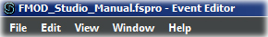
The Menu Bar
The Menu Bar in FMOD Studio provides direct access to the global settings. The selection is typical of most program applications.

File Menu
The File drop-down menu contains functionality relevant to creating and saving projects:
- New
- Open...
- Open Recent
- Close
- Save
- Save As...
- Revert to Saved...
- Import Audio File...
- Build...
- Connect to Game...
- Source Control
- Exit

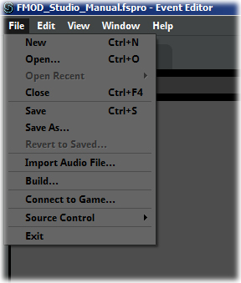
The File Menu

New
Click on new to create a new empty project workspace in FMOD Studio.

Open...
Selecting Open will trigger a pop-up window to be displayed. Browse through your computer’s folders and files to find an FMOD Studio project that you wish to open. Once you have selected a project file you can open it in FMOD Studio by selecting the Open button from the pop-up window. Alternatively you can press Cancel to close the window and return to the Studio main display.

Open Recent
FMOD Studio will automatically keep track of recently opened project files. The Open Recent command will list a short selection of recently opened files for users to select from to assist convenient workflow.

Close
This command instructs FMOD Studio to close the currently active project. If there is more than one project open in FMOD Studio only the active one will be closed.

Save
Click Save to save the existing active project within FMOD Studio. It will save the project with the name and path that has already been defined. If the project has not already had a name and path defined, selecting the Save settings will open a pop-up window in the same manner as the Save As... setting.

Save As...
Save As… allows the user to define the name and path of the current active project. This is most commonly used the very first time a project is saved to provide a name for the project and decide where you want the project and its relevant information to be saved on your computer. A pop-up window will be displayed that will allow a user to navigate through their computer’s folder system and select a location to save the project data for the FMOD Studio project.

Revert to Saved...
This command will reload the most recent save file of the currently active project. This is a quick way to undo all work prior to the last saved version. Only use this command if you are sure you want to abandon work done since the last save.

Import Audio File...
This allows users to access audio files on their computer and add them to the Audio Bin folder of a project. Once an audio file has been added to the projects Audio Bin it can be accessed via the Audio Bin window and added to project elements.

Build
The Build Command will run the build process for the active Project and build the necessary files to implement the project into a game. The Build process will only build the Banks that have been selected, this allows for a partial Build process to be completed.

Export GUIDs…
The Export GUIDs command allows users to provide unique IDs for many of the objects in FMOD Studio. This will usually be at the request of a programmer on your project team. GUIDS are Globally Unique Identifiers that are used in code and scripting to refer to Events created in FMOD Studio.
The Export GUIDS command will generate a pair of files and save them into the project folder structure. The Files are saved into the Build folder inside the project folder, the files created are,
- GUIDLookup.c
- GUIDs.txt
These files will generally only be required when specifically requested by a programmer on a project, so the export process allows the sound designer to provide these files to the programming team as needed.

Connect to Game...
This command instructs FMOD Studio to connect to a game project running the FMOD API. This allows for live mixing of the games audio elements through the FMDO Studio interface.

Source Control
The Source Control command will display the pop up window controlling the range of options for linking FMOD Studio to source control programs.

Identify Local Changes
This option is located in the Events Browser connect sensitive menu, but only appears when using version control. Its purpose is to track changes to the local version of a project while not connected to the revision control server or equivalent. This allows users to keep track of local changes should there be any network issues on site or if they are working remotely without connection to the source control network.
This function will compare the current version of all aspects of a project with the last logged version from the source control server. Studio will display alterations to the log to enable users to be aware of which local project elements have updated from the source controlled version.

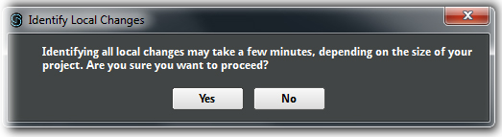

Exit
Selecting Exit will close FMOD Studio. If the current projects have not been saved a prompt message will ask the user if they wish to save the project prior to exiting the program.

The Edit Menu
The Edit menu contains global settings that alter the project:
- Undo
- Redo
- Cut
- Copy
- Paste
- Delete
- Paste at Original Position
- Select All
- Deselect All
- Duplicate
- Move To…
- Move to Cursor
- Bring to Front
- Send to Back
- Set Color
- Open in External Sample Editor
- Preferences...
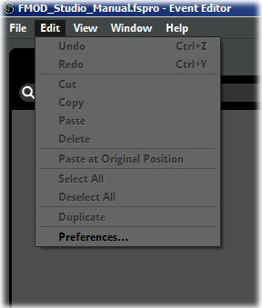
The Edit Menu

Undo
The Undo command will reverse the very last action that you have taken in FMOD Studio. Essentially any setting that has been applied, change or alteration of values, repositioning of graphical objects or controllers can be reversed using the undo function. FMOD Studio has an unlimited number of undo steps. This means you can backwards to unravel a series of steps should they become undesirable.

Redo
The redo function is essentially the exact opposite of the undo function. Redo will only work once an undo has been triggered. A user can use undo and redo to toggle back and forth between the last committed change to Studio. This can be a useful function to audition if an alteration provides the desired result. The redo function will operate as many times as there have been undo functions activated.

Cut
The Cut command will delete the selected object in the interface but will place it in the Copy buffer so it can be pasted to another location.

Copy
The Copy command will copy the selected object in the interface into the Copy buffer so it can be pasted in another location.

Paste
The Paste command will create a version of whatever is in the Copy buffer into the desired location of the interface.

Delete
The Delete command will delete the selected object in the interface.

Paste at Original Position
This command will paste a copy of whatever is in the copy buffer directly over the original object. This is handy if you wish to move the new instance manually to where it is required.

Select All
This command will select all selectable objects within the designated region of the interface.

Deselect All
This command will unselect any and all objects that are currently selected within a region.

Duplicate
The Duplicate command will create an exact copy of a selected object directly on top of the original. This is a quick way of creating an exact duplicate without having to use the Copy/Paste commands.

Move To…
The Move To… command is the same as the context menu accessed by right clicking on Trigger Regions. They allow the position of a Trigger Region to be exactly defined. By default the length Property is locked to maintain the current size of the Trigger Region. It is not possible to define Start and End values that exceed the locked length of a Trigger Region. Studio will accept the last inputted value and redefine the other value to match the locked length. If the Length value is unlocked then its value will be redefine to appropriately reflect the Start and End values.
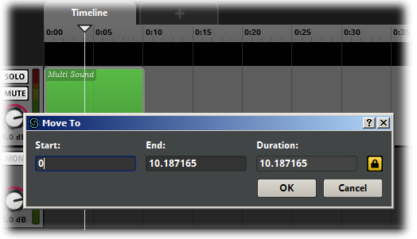
The Move to Function
This function allows you to define the exact size and start and end points of a Trigger Region This is the recommended process for when Trigger Region position is a critical aspect of Event creation and needs to be precise.

Move to Cursor
The Move to Cursor command is a quick way to reposition a Trigger Region to the location of the cursor. This can be particularly useful for working with Multi Track Events as this command will reposition a Region horizontally along the Timeline or Parameter while maintaining its position on the relevant Audio Track. Selecting the Trigger Region will cause the start point to align to the position of the cursor on the Timeline or Parameter.

Bring to Front
It is possible to position Trigger Regions on an Audio Track so that more than one Trigger Region occupies the same area. By default FMOD Studio will create cross fade regions when Trigger Regions overlap and will display the last selected Trigger Region in the front position. The Bring to Front command will reposition a Trigger Region that shares an overlap with another Trigger Region and place it in front.

Send to Back
The Send to Back command is the opposite of the Bring to Front command. It will reposition a Trigger Region that shares an overlap with another Trigger Region and place it behind any overlapping Trigger Regions.
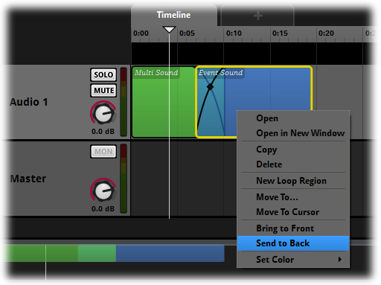
Send to Back

Set Color
Trigger Regions default to a light blue color. You can change this color if required. Using a range of colors for complex sound Events can make editing and implementing much easier.
The Set Color option will access an additional menu that provides a list of available colors that can be applied to your Trigger Region.
The copy / paste function will copy a Trigger Region exactly so the pasted version will have the same name, the same color and any Properties of the original.
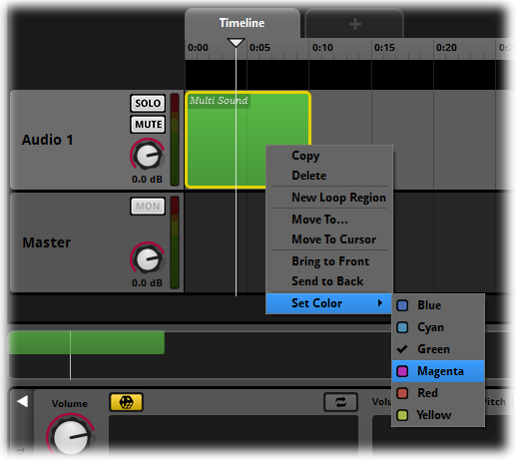
Set Color

Open in External Sample Editor
This command allows a user to edit a sound file that is part of an FMOD Studio project. A Sound file that is part of a single sound or multi Sound Module or in the Audio Bin can be selected and this command will open the application that is associated with sound file editing on the user’s computer.
Note
The Open in External Sample Editor command automatically refers to the application associated with sound file editing on your computer. For this command to function correctly you have to have an external editing program installed and associated with the target sound file type.

Preferences…
Use this command to make changes to FMOD Studio’s Preference settings.

The View Menu
The View Menu controls behavior in the Event Editor of the cursor and selection process. It includes the following commands:
- Browser
- Deck
- Properties
- Loop Playback
- Follow Cursor
- Snap to Grid
- Zoom In
- Zoom Out
- Zoom to Fit

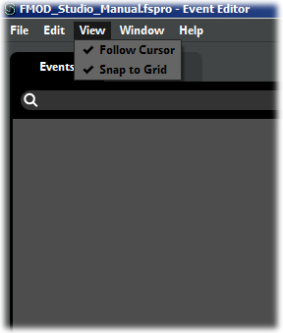
The View Menu

Browser
The Browser command duplicates the function of the Browser display shortcut keys “B”. This command hides or reveals the relevant Browser area in either both the Event Editor and Mixer displays.

Deck
The Deck command duplicates the function of the Deck display shortcut keys “D”. This command hides or reveals the relevant Deck area in either both the Event Editor and Mixer displays.

Properties
The Properties command duplicates the function of the Properties display shortcut keys “P”. This command hides or reveals the relevant Properties area in either both the Event Editor and Mixer displays.

Loop Playback
The Loop Playback menu item will activate the Loop Playback function in the transport controls. This command duplicates clicking on the Loop Playback button.
The Loop Playback button on the Transport controls is a useful audition tool. When activated it will instruct FMOD Studio to continuously retrigger a sound Event when it finishes, allowing the user to listen continuously to the sound during development. This is obviously not required for Events that loop within their structure, but for single shot sound Events it can be useful.
This function is not part of the project and will not make any difference to the Event’s functions; it is simply an audition tool within the Studio interface.

Follow Cursor
This command will instruct FMOD Studio to track the cursor as it moves along the timeline and keep it in view at all times. If this command is unselected then the displayed view will remain static and the cursor can move “off-screen”.

Snap to Ruler
This setting causes placement and movement of objects to be snapped to Ruler lines. This is a quick way to ensure exact placement of objects for rapid workflow. When unchecked, all objects can be dragged to any possible position.
This function operate on Parameters exactly as described above, however on the Timeline the Snap to Ruler function only works if there is a Tempo Marker present on the Timeline, and that Tempo Marker is to the left of the object being dragged. Timeline space to the left of a single Tempo Marker is NOT considered to have a Tempo and as such, Snap to Ruler does not operate in that space.
Note
Sometimes you might want to override the Snap function just briefly. Rather than having to access the Menu Bar to deactivate the Snap Feature you can simply hold down CTRL while moving objects. This modifier key allows objects to be moved freely. Releasing CTRL reactivates the Snap to Grid feature.

Zoom In
The Zoom In command will zoom in horizontally on the Timeline and Parameters in the Event Editor. Each selection of this menu option will zoom by a defined increment. Repeated use of this command will result in zooming in to the maximum value.

Zoom Out
The Zoom Out command will zoom out horizontally on the Timeline and Parameters in the Event Editor. Each selection of this menu option will zoom by a defined increment. Repeated use of this command will result in zooming out to the maximum value.

Zoom to Fit
This command will automatically resize the Event Editor to display all Trigger regions included within the active Event. The extent of the zoom effect is entirely dependent on the contents of the Event Tracks.

The Window Menu
The Window menu provides the following selections to control the display options for Studio
- Minimize
- Zoom
- Cycle Through Windows
- Bring all to Front
- Audio Bin
- Event Browser
- Event Editor
- Mixer
- Contextual List of Windows
- Close Window

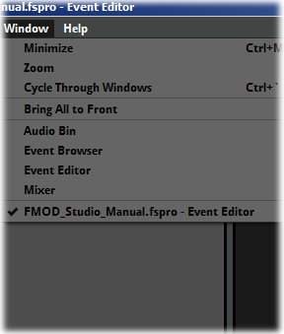
The Window Menu

Minimize
The minimize option will reduce the displayed window size of the application down to the task bar.

Zoom
This command will toggle between a windowed view and a Maximized view of the program.

Cycle Through Windows
This command will display all available windows within a project one at a time in a cyclic fashion. Each selection of this command will display the next window in the series.

Bring All to Front
This command will display all available windows in a project together. This is a good way to ensure all windows can be accounted for.

Audio Bin
Selecting the Audio Bin option will display the Audio Bin window. Once a sound file is added to an FMOD Studio project it will automatically be added to the Audio Bin list. This allows users to drag existing sound entries into other Modules and Events directly from the Audio Bin window.

Event Browser
This command will switch views to the Event Browser region.

Event Editor
This command will switch views to the Event Editor region.

Mixer
Selecting the Mixer option will display the Mixer window. This window will overlay the default Event window. The Event window will still be visible behind the Mixer window.

Contextual List of Windows
The exact content of this command will depend on what projects are open within FMOD Studio at any time. This command allows users to switch between multiple projects open at the same time and select which project they need to be active to work on. It lists all open FMOD Studio projects by name, no matter what projects those windows are associated with.

Close Window
This command will close the currently active window in FMOD Studio.

The Help Menu
The Help Menu includes the following commands:
- Manual
- Visit our Forum...
- Contact support@fmod.org...
- About FMOD Studio
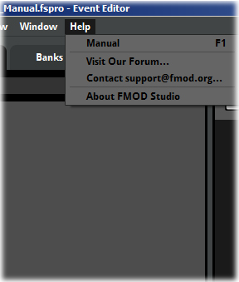
The Help Menu

Manual
This command will display this manual document.

Visit our Forum
This command will launch an internet browser and load the FMOD forum

Contact support@fmod.org...
This command allows users to directly contact the FMOD support team via email to report bug issues or make support requests.

About FMOD Studio
The About menu option provides detailed information on the specific version of FMOD Studio being used. This is useful to ensure you are up to date with the most current version.

The Preferences Window
Selecting this option will display a pop-up window that contains a series of global options for FMOD Studio. These options allow a user to define a variety of global settings for the project.

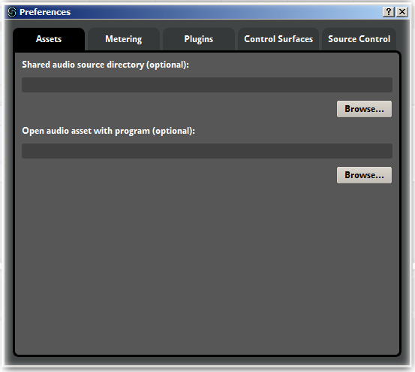
The Preferences Menu

Assets
By default FMOD Studio will create an audio bin folder automatically inside the project folder. All sound files used in Studio projects will be automatically copied to the audio bin folder. The Assets preference option allows users to redefine a location for all audio source files. Select the secondary option and then define the desired file path on your computer. This location can be used as a shared audio directory for multiple projects and users.
You can define an external editing program to be linked to FMOD Studio. When you select Menu Bar/Edit/Open in External Sample Editor, Studio will open the selected audio file in the editing program you have defined in this part of the preferences window. This allows you to edit the sound file and save it to its correct location in the project folder structure.

Metering
FMOD Studio provides three different options for how surround metering is displayed within the interface. This allows users the flexibility to set their project to their preferred method for workflow. The three options are as follows.
Standard (L, R, C, LFE, LS, RS, LSR, RSR)
Separate LFE (L, R, C, LS, RS, LSR, RSR, LFE)
Positional (LSR, LS, L, C, R, RS, RSR, LFE)
The default mode is Positional.
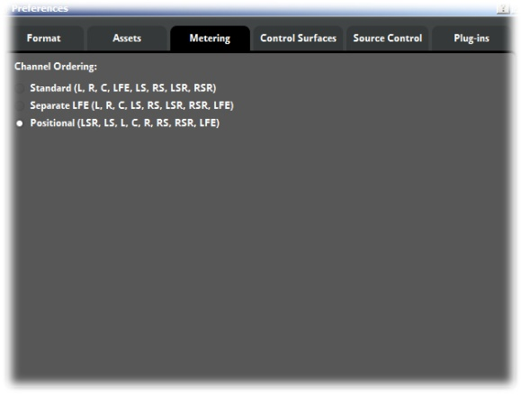
Metering

Plugins
FMOD Studio allows users to create their own Plugins to use within the app. The Plugins Preference page is where users define the location of their Plugins so that Studio can make use of them.
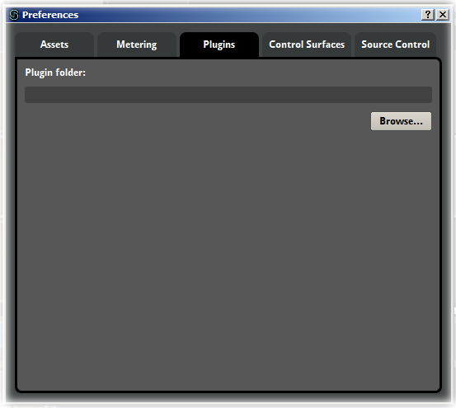
Plugins Preference Page

Control Surfaces
The control surfaces tab provides a drop-down list of the available supported control surfaces that will directly integrate with FMOD studio. The arrow will open the drop-down list and the desired controller can be selected.
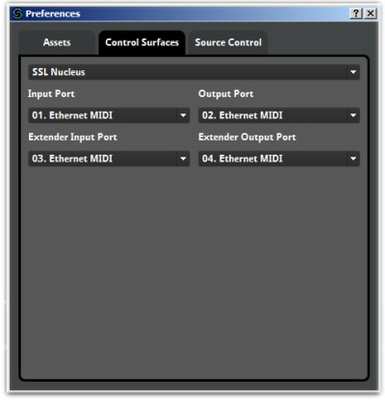
The Control Surfaces Menu

Source Control
The Source Control Tab provides a drop-down list of the available supported source control applications that will directly integrate with FMOD studio. The arrow will open the drop-down list and the desired application can be selected.

The Browser
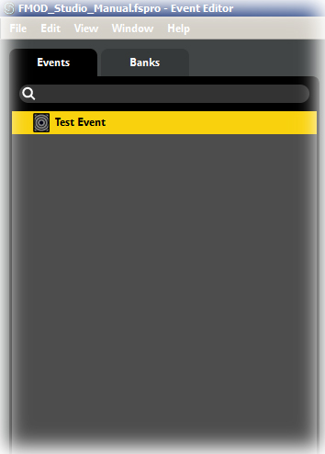
The Browser
The Browser includes both the Event Browser and the Banks Browser. The Events Tab is where you can create New Events, Event Folders and organize the layout of Events. The above image shows a single Event in the Event Tab, highlighted in yellow.
The Banks Tab displays the Banks Browser. Within the Banks Brower you can create Banks, define their Properties, and set Bank-specific Event Properties. Events can be assigned to Banks in both the Event Browser and the Banks Browser.

The Editor
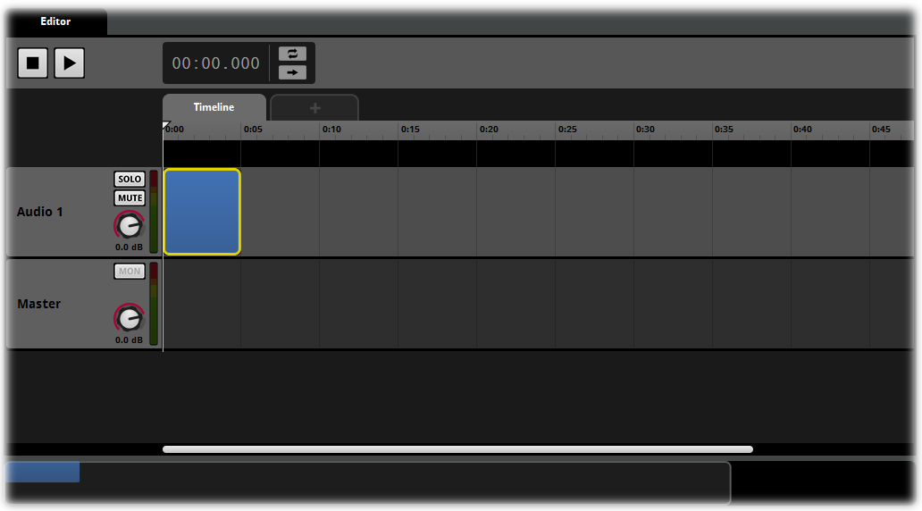
The Editor

The Editor is where contents of an Event are defined and most of the work within Studio is performed. By default a new Event will display the Timeline Parameter and a single Track titled “Audio 1”. There is also a Master Track for every Event created. Additional Tracks can be added to each Event as required.

Breadcrumbs
Breadcrumbs are an interface element that appears when working with Event Modules or Reference Events. The Breadcrumbs display indicates that the Event you are working on is positioned within another Event. The breadcrumbs display will keep track of how deep within a nested or referenced hierarchy you are working. Clicking on a breadcrumb Tab will close the current level of the nest and display the next level upwards. To explore further down into a hierarchy you can double click on any nested Event to open it up.
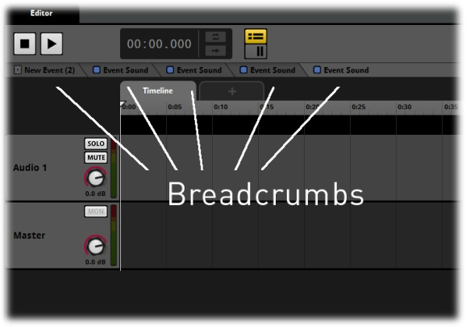
Breadcrumbs

Missing References
Under certain circumstance a project subject to revision control may end up in a situation where an Event Track’s Signal Chain contains a Send to a Return that no longer exists or a single sound whose audio file has been removed from the project. Such incongruities and referred to as ‘missing references’, and are now indicated by small exclamation marks.
Missing reference indicators highlight that previously existing aspects of the project will no longer work. These should be fixed, deleted or changed depending on the needs of the project. Note, if these are left alone they will produce the same result as if they’d been deleted.

The Transport

Loop Playback
The Loop Playback button on the Transport controls is a useful audition tool. When activated it will instruct FMOD Studio to continuously retrigger a sound Event when it finishes, allowing the user to listen continuously to the sound during development. This is obviously not required for Events that loop within their structure, but for single shot sound Events it can be useful.
This function is not part of the project and will not make any difference to the Event’s functions; it is simply an audition tool within the Studio interface.
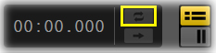
Loop Playback

Ghost Cursor
Playback in the Event Editor includes a Ghost cursor to provide additional playback functionality. During Playback there are several controls to provide more flexible playback. The exact function of the controls depends on the current playback state of the Event.
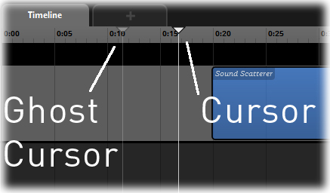
Ghost Cursor

When stopped
The Play button will commence the movement of the cursor along the Timeline.
The Stop button has no effect.

When Playing
The Play Button will return the cursor back to the Ghost Cursor Position.
The Space Bar will pause the advancement of the cursor and pause playback.
The Stop Button will pause the advancement of the cursor and pause playback.

When Paused
The Play button will return the cursor to the Ghost Cursor and start playback from that point.
The Space Bar will resume playback from the exact position of the Cursor.
The Stop Button will return the Cursor to the Ghost Cursor. A second click on the Stop button will return the Cursor to the zero point on the Timeline and clear the ghost cursor.

Track and Strip Views
There are two view alternatives for both the Event Editor and the Mixer. The Track and Strip views can be switched via the Track and Strip toggle buttons in the Transport controls. By default the Event Editor is set to Track view and the Mixer is set to Strip view but either can easily be toggled to the alternative view.
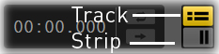
Track and Strip View Options

Track View for the Mixer is useful for adding Automation to Snapshots and Strip view can be useful for working with the Event integral Mixer functionality, but the views can be used simply as an alternative workflow method to suit individual users.

The Event Birdseye View
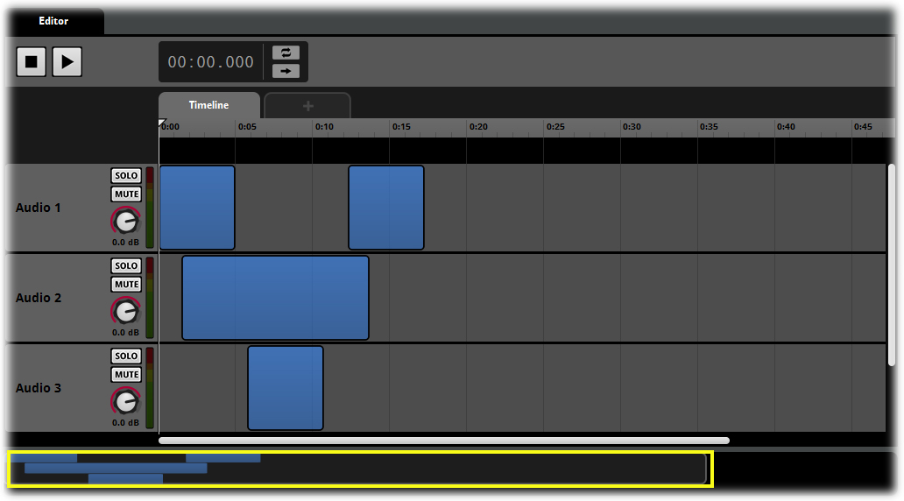
The Event Birdseye View
The Event Birdseye view provides a compressed representation of all the tracks and modules within the Event Editor. Modules are represented by appropriately colored boxes that are all scaled relative to their Module counterparts in the editor. The Birdseye View allows a user to immediately reference how many modules are in an Event and which part of the Event is being displayed in the Editor region.
The Birdseye View has two control options:
- Viewing an extended timeline/Game Parameter.
- Defining and resizing the editor region.

Viewing an Extended Timeline / Game Parameter
The Birdseye view represents an entire Event and includes information outside of the regular default Event Editor view. Drag the translucent white view box to scroll horizontally along the Timeline and Game Parameter in the main editor region.

Defining and Resizing the Editor Region
The Birdseye View is used to define exactly what is displayed in the Event Editor region. The default view will display a section of timeline when the Event is initially created. This visible area is represented by the translucent white view box in the Birdseye View. This view can be altered using the Birdseye View Functionality.
To alter the displayed viewing area, drag the edge of the view area box in the Birdseye View to resize it. The displayed area can be either increased or decreased by this method. FMOD Studio will rescale the Timeline or Game Parameter relative to the adjustment of the view box object and all Modules on the Timeline / Game Parameter will be scaled in size and position relative to their previous position. This allows a user to visualize a larger horizontal area of an Event.
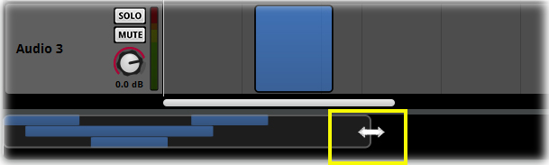
Event Editor Resize Function

The Deck

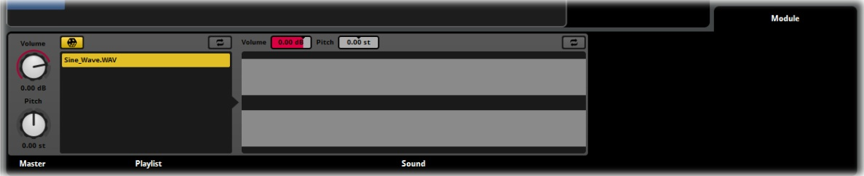
The Deck
The Deck is an area of the interface that allows the inspection of various project elements. The Deck displays the properties for the various Sound Modules as well as Effects Modules and plug-ins. This area will contextually display the relevant controllers for the selected Track or Module.

Note
There is a Deck area within the Mixer interface as well. There are many similarities between the Event Editor Decks and the Mixer Decks, but they are not identical in how they function. Refer to the chapters on each interface area separately for more details.

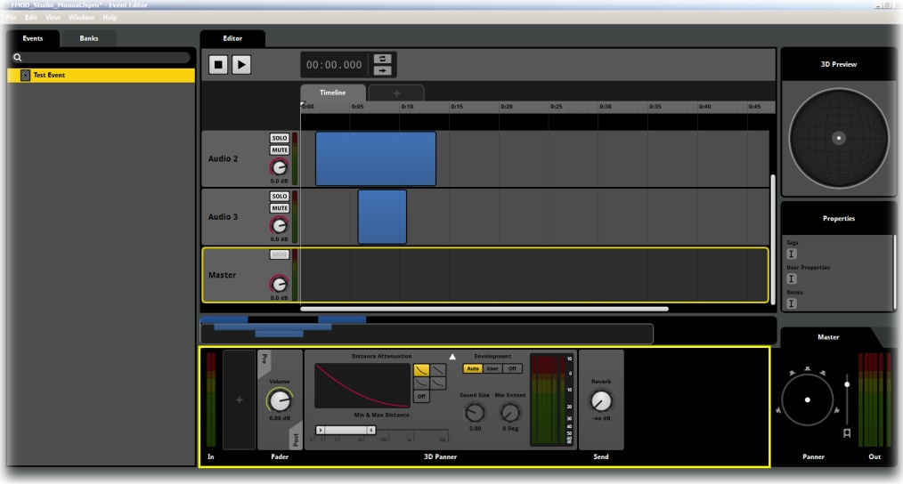
The Master Track Deck

Highlighted in red in the above graphic, the Deck displays the default control set for the selected Master track, which is outlined in yellow. The Master Track Deck defaults to displaying the Fader and 3D Panner controls. Right click in the Deck to display a drop-down menu with a range of effects, plug-ins and other controllers. The Deck can also define the signal path order by including controllers for either Pre Fade or Post Fade states of the signal path. These values can be defined individually for every Event within a project allowing for complex signal path routing.

A Note on the Deck Areas
Both the Event Editor and the Mixer include Deck areas that do share some similarities and functions, however they are not identical in how they operate. There are a couple of key differences in what functionality the two types of Deck have and these differences are important to understand when designing your project layout.

Event Decks
At the Event level the Deck areas are part of the Events themselves. This means they include functions specific to the Event Editor. All Modules added to the Deck of an Event Track allow for Automation of all Dials. This is a powerful method of controlling the values of the various settings either through time in the Timeline or by Game Parameter values. Dials on Modules can also have Modulation applied to them, either random or AHDSR.
The Event Deck also displays information on Sound Modules. Clicking on a Modules Trigger Region will cause the Deck to display the Sound Module and its settings. This allows access to the settings for Sound Modules and for Automation and Randomization of those settings as desired. For Modules that contain sound files this also provides information on the Sound files included in a module and a display of their wave form.

Mixer Decks
The Mixer a Deck is a representation of the controls on a Channel strip. Sliders for the Channel strips are displayed vertically alongside the Master Bus in the Mixer, but all the other possible controls are added to the Deck for each specific channel. The Fader dial is the representation of the slider in the Deck and Modules can be inserted either Pre or Post the Fader depending on the needs of the user.
So an Event Deck is an extension of the signal path within the Event itself. The Deck exists in the signal path between the sound file itself and the output of the Master Track and will display information relevant to the sound files within Modules. Modules can be inserted into the signal path either Pre or Post fader.
Some Effects Modules are limited to either Events or the Mixer, the context sensitive menu will display which modules are available.

3D Preview
The 3D Preview allows you to alter the orientation of a sound source. The node, positioned in the center position by default, represents the point of origin of the Event. This node includes an indicator arrow that defaults to pointing directly upwards or the zero degrees position. The Listener is always in the center position, facing upward to the zero degree position.
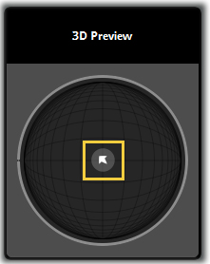
3D Preview
While working with the 3D Preview it is possible to alter the direction of this arrow to audition the orientation of the Sound Event by spinning the mouse wheel. Event orientation is related to the Event Cone Angle and Event Orientation Parameters in FMOD Studio. Changes to the value of these Parameters can be auditioned using the orientation controller.
As with many other FMOD Studio controllers, the 3D Preview can be reset to its default values by double clicking anywhere on it.

Properties
The properties box allows users to define the tags for a project as well as enter notes and information relevant to the selected Event. This is very useful for shared projects with more than one person working on the project file as well as for educational purposes and especially for contract sound designers that may need to pass on created work to a separate team for implementation.
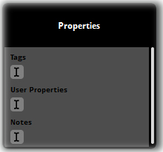
Properties

The Banks Tab
The Banks Tab allows you access to the Banks Browser and Banks Properties view.
The Banks Browser allows you to view, select and administer all the Banks within a project. Selecting a Bank will make it the active Bank and its associated Properties will be displayed in the Properties region.

The Banks Tab

Platform Support
FMOD Studio now supports the following platforms:
- PC
- Max OSX
- iOS
- Android
- Xbox360
- Xbox One
- PlayStation 3
- PlayStation 4
- PlayStation Vita

The Mixer
The Mixer view is the final stage of signal routing in FMOD Studio and allows for complex grouping arrangements of the signal chain. FMOD Studio supports live mixing of game projects and the Mixer is the principle interface for this process.
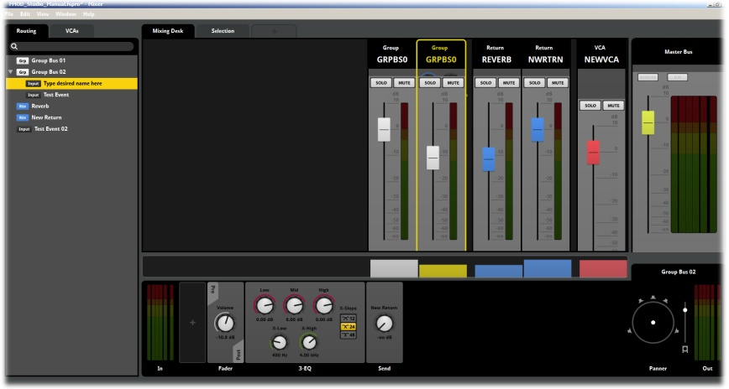
The Mixer
The Mixer allows for the creation of Group Buses, Returns and VCAs and for Inputs to be assigned and routed through these elements as required. The Mixer includes functionality equivalent to most hardware DAW control surfaces but allows for far more complex signal chains as it is not limited by physical hardware in the number of paths it can establish.

Getting Started: Creating a new project

Introduction
All work within FMOD Studio exists inside of the Project file. Understanding the basic format and function of Studio Projects is a core aspect of efficient workflow. The following section will take you through the steps required to create a new project, including Project files and the general layout of a project and its file structure.

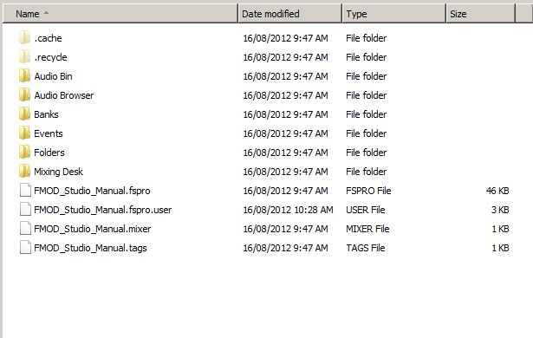
FMOD Studio Project folder on PC

Project Files
The project file is the starting point for any work created in FMOD Studio. Creating a new project defines the name and location on your computer for all the files required for the project to operate correctly.

Saving a New Project

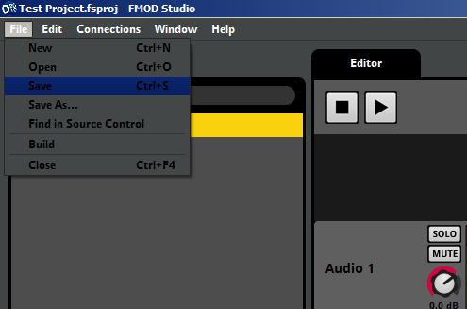
Saving a Project

- From the File Menu, select Save and either Left-Click or hit Enter.

Define the Project Location and Name

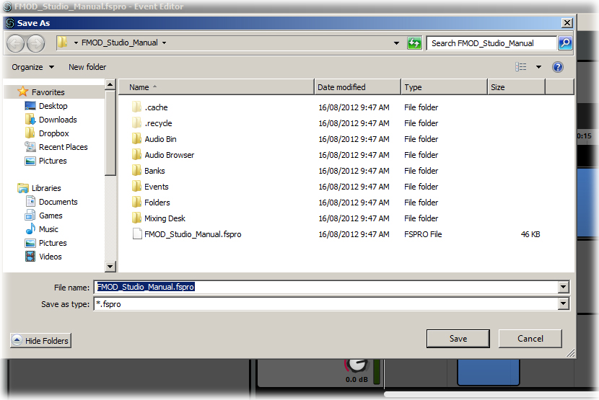
Name the Project
- Select the desired folder location for the new project and type in the project name.
- Click Save or hit Enter to save.
Note
Selecting Save from the main menu defines where you want your project to be located. When FMOD Studio saves a new project to a location it creates a parent folder of exactly the same name used for the project. Within that folder it creates a series of sub folders and files, everything that Studio needs to create the project will be contained within this project folder so by saving your project for the first time you automatically set up the entire workspace.

Basic Control Concepts

Introduction
There are some basic and common control methods utilized in FMOD studio. Understanding how some of these work make exploring the interface and discovering functionality far easier and more enjoyable.

Right click Magic
Many of the menus and context-specific commands in FMOD Studio are hidden from the main interface. This is because there are so many commands and options within Studio that to present all of them all the time would make the interface cluttered, unwieldy and intimidating.
Studio solves this problem by providing a great many “context” menus that display when the context they are related to is right clicked.

 | CTRL
PC | Mac
Opening Context Menus
‘Open in Explorer’ (or ‘Open in Finder’ if using a Mac) menu items can be found in a number of context menus, most notably for Single Sound Module Trigger Regions and Audio Bin entries. These menu items open the directory containing the contextual item in the OS’s native file-and-folder browser.
In many circumstances, even if multiple items are selected, only the specific one right clicked on is used as the context for the menu that is opened.

Fine Tuning Control
Most of the controllers in FMOD Studio receive input from mouse movement to define values for the associated settings. Many values allow small percentage or decimal increments that can be difficult to define exactly with general mouse control. Studio provides a “Fine Tuning” control system by holding down the CTRL key while operating the mouse. CTRL will reduce the scaling of the mouse movement to allow more precise adjustment of values.
This method is very useful for defining exact values or adjusting values in very small increments.

Pop-up Windows
FMOD Studio’s interface contains a series windowed areas that control different areas of its functionality. The default interface view is of the Event Browser and Event Editor. The other areas can be accessed via the Menu Bar and the Window option.
Even though Studio defaults to the Event Editor area, all window areas that include the Menu Bar share an equal hierarchy. What this means is that as long as there is a single window with a Menu Bar still open then the project is still considered open. So the Audio Bin could be the only window still active after all other windows have been closed and the project is still active.

Multiple versions of the Event Editor and Mixer window can be created to allow for flexible workflow solutions. Windows can be resized and repositioned as required and this makes working across multiple displays very easy.
Working with nested Events is another area where the interface will create new windows. Double-clicking on an Event nested within another Event will open a window that contains the entire interface for that new Event. Again these windows can be resized and repositioned as desired.
Nested Event windows do not include the Menu Bar and as such will not maintain the project if all other windows are closed.

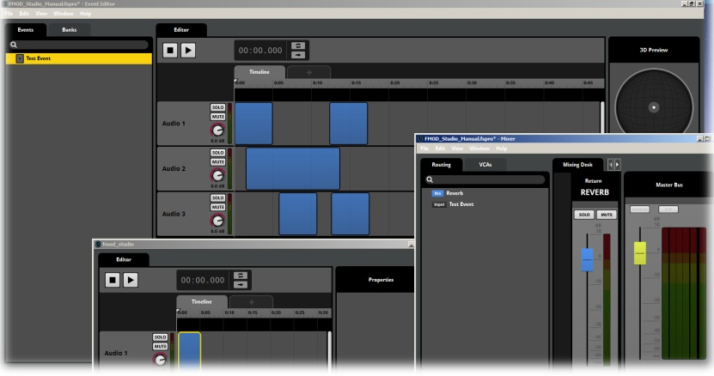
Pop-up Windows in the Editor

Editor Zoom
The Editor can display either the Timeline or Game Parameter tabs and in both cases a user may need to include a considerable amount of data on this screen. Multiple Events of varying sizes can be difficult to work within a single region. For this reason Studio allows the user to zoom within the Timeline and Game Parameter views. Use Alt + mouse wheel to zoom in and out on the Timeline and Game Parameter views.

Resizing and Repositioning Modules
Modules are a core element of FMOD Studio and much of a user’s time will be spent positioning and aligning Modules within Timeline or Game Parameter views. Modules can be moved horizontally along an Audio Track simple by dragging the object to the desired position. If there is more than one Audio Track an object can also be dragged up and down between available tracks.
Hovering the mouse over the side edges of a Module will alter the cursor to a double ended arrow that allows the object to be resized to alter the how much of the Timeline or Game Parameter it will occupy.

Event Drag and Drop
The Drag and Drop functionality is a method of assigning Events within FMOD Studio. Working with Events requires access to multiple Event Browser windows. From the Menu Bar/Windows users can create a new Event Browser which will pop up and sit above the existing default FMOD Studio view. The pop up Event Browser also accesses different functionality in that it includes the Event Browser Tab as well as the Tags Tab (see the entry on Tags for more information).

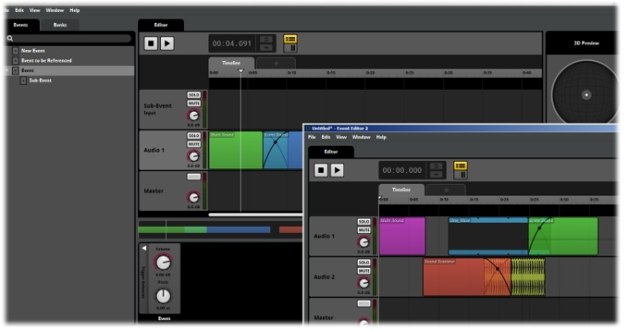
Two Event Browsers
Accessing two Event Browser Windows lets users drag Events into both Banks and Tags to assign them. Selecting the Event Tab in one window and either the Banks Tab or the Tags Tab in the other allows users to drop them easily in the desired assignment. In both instances the user must first create the desired Bank or Tag. Refer to the individual manual sections on Banks and Tabs for more information on creating these objects.
Dragging objects over Browser Tabs will result in the Tab area being displayed. This allows for faster Drag/Drop functionality between Browser views. For instance dragging an Event from the Event Browser and hovering over the Banks Browser will switch the display to the Banks Browser allowing the Event to be dropped onto the desired Bank.

Tooltips
The Tooltips display in FMOD Studio displays defined names of various elements. Its primary function is to allow a user to clearly identify an element that may be represented within the interface as an abbreviation.

Controls and Properties

Introduction
FMOD Studio provides a range of Properties and related controllers across all of its components. In many cases the Properties and their related controllers will be identical for each component that utilizes a specific Setting. Common control methods provide a consistency for users and work space efficiency.

Direct Value Input
All graphical controls within FMOD Studio allow for direct input of numerical values. Double-Clicking on the Value display for any control setting will open that display and allow for direct input of values by typing in numbers. This method is the most suitable for defining exact numerical values for FMOD Studio Setting.
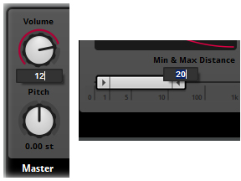
Direct Value Input

Control Types

Dial Controls
Various Properties within FMOD Studio utilize Dial controllers. The Dial is a graphical representation of a tradition voltage control pot on a hardware device. Control Dials will display a range of values depending on the position of the dial. All control dials have a text readout of both the value defines as well as the unit of measurement (dB for Volume, semitones for pitch etc.).
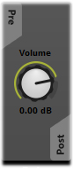
Dial Controller
Most dial controls are found in the objects found in the Deck region. Effects objects will often have multiple dial controls. Dial controls support the standard FMOD Studio CTRL + Drag functionality. Holding CTRL while altering values with the mouse will activate the fine tuning function that will decrease the sensitivity of the mouse drag and allow for defining more exact values for Properties.

Slider Controls
Slider Controls are unique to the Mixer view and provide a familiar input method for working with Channels strips for signal paths. Sliders work using the mouse drag input method and also support the CTRL drag function for more exact value definition. Sliders allow for multiple Properties to be manipulated simultaneously. By selecting multiple channel strips the sliders for all the selected channels can be controlled together. The sliders will all maintain their values relative to each other, but increase and decrease their ranges together as the selected group. This is the primary advantage of the channel strip display with sliders over individual dial controllers.
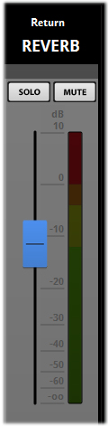
Slider Controller
Note
All Channel Strip sliders have an associated Dial controller. Channel Strip sliders most commonly control a channel’s volume levels. A Slider and its associated dial control are linked and will always display the same value. Altering the value of one will result in a corresponding alteration in the other (you can usually see this as the controller is moved).

Buttons
FMOD Studio includes a variety of controls that use a single button press. These are common controls such as Enter or Cancel on menu choices. These controls have a simple single button press to complete the command. More complex button controls are explained below.

Toggle Buttons
FMOD Studio contains a series of controls that have a basic on/off setting. These controls are represented with basic Toggle buttons. The buttons will light up when activated and dim when switched off. They are activated with a simple button click with the mouse.
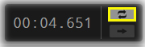
Toggle Buttons
Solo, Mute, Loop and Randomize all utilize toggle buttons.

Radio Buttons
Radio Buttons exist where there are more than two states to select from but only one state can be active at any time. The series of buttons will indicate which state is active by displaying the relevant button as being lit. Changing states is a simple matter of clicking on a different button.
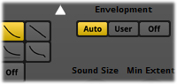
Radio Buttons

Range Sliders
Some functions require more than a single value. In this case FMOD Studio provides a Range Slider control that allows both a minimum and maximum value to be defined. Within these two values an overall Range is the value that Studio is given to work with. The two end values can be defined either by moving the relevant arrows or my double clicking and directly inputting the desired values.
Once minimum and maximum values have been defined the entire range can be altered by dragging the central range area back and forth. The relation between the minimum and maximum values will remain consistent and the entire range will alter accordingly.

Alphanumeric Inputs
FMOD Studio includes several control Properties that allow direct input of alphanumeric values or information. In all cases clicking in the text field will allow for direct input of either property values or for information, such as implementation notes or directions for projects personnel.
When a text field requires a specific setting value to be inputted it will prevent non relevant information from being accepted and return to its default field value if incorrect information is applied.
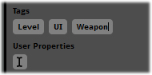
Text Inputs

Graphical Display Inputs
Various Properties within FMOD Studio require a specific method of input for the Properties being controlled. The exact nature of each controller will depend on the Properties it controls. In general, graphic display Properties are controlled via mouse drag input and allow a range of movements to define values.
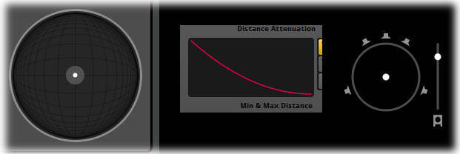
Graphical Display Inputs
Graphic Display inputs do not include text fields, but will have icons to represent the information and values being controlled. Refer to the individual entries for each setting within the manual for the exact set of functionality and controls.

Volume
The Volume Setting is defined by a Dial controller. Volume is measured in decibels (dB). Volume for all components will default to a value of 0dB (Zero Decibels). 0dB does not equate to an inaudible sound, it represents a nominal value with no alterations. What this means in practical terms is that FMOD Studio will play back a signal from the original source sound file with no alteration to the value of the volume at its point of input.
Note
If all Volume Functions for an input object (sound file) and its associated signal path are set to 0dB then Studio will output the Event sound at exactly the same volume as the original sound file would play.

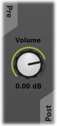
The Volume Dial controller
The Volume Dial controllers can be controlled by clicking on the dial and dragging the mouse to alter the Properties value. The volume setting has a range from -∞dB to +10dB. In practical terms this is a range from silence to 10dB above the native input level of the signal. The value display will alter as the dial is turned and displays values in whole dB numbers with two decimal places to allow for values down to 100th of a decibel accuracy. Hold the CTRL key while moving the mouse to fine tune control of values.
Many components within FMOD Studio include Volume Dial controls. They all share the same control functionality.

Components with Volume Controls
There are a range of Objects within FMOD Studio that include Volume Controls. These are usually in the Deck region of the relevant view and can be accessed by selecting the target component to make it active. Once a component is active its Deck region will be displayed and the Volume Controls can be accessed.
- Audio Tracks Located in the Audio Track Header controls &Deck Region
- Master Tracks Located in the Master Track Header controls & Deck Region
combined with Pitch control
- Module Objects Located in the Deck Region combined with Pitch control
- Mixer Master Bus Located in the Deck Region combined with Pitch control
- Mixer Returns Located in the Deck Region
- Mixer Inputs Located in the Deck Region
- Mixer Group Buses Located in the Deck Region

Note
Every Volume Controller within a signal path will contribute to the overall signal output and the values stack. This means that if in an Event Audio Track the volume is set to -6dB and then in the Mixer in a Return the Volume is set to +6dB the overall output will add the two values together with a result of 0dB. For this reason it is important to keep track of all alterations of a signal as it passes along the signal chain.

Pitch
The Pitch Setting is defined by a Dial controller. Pitch is measured in semitones using s/t as an abbreviated label. Pitch for all components will default to a value of 0.00 s/t (zero semitones). This represents a nominal value with no alterations. This means FMOD Studio will play back a signal from the original source sound file with no alteration to the value of the Pitch at its point of input.
Note
If all Pitch Functions for an input object (sound file) and its associated signal path are set to 0.00 s/t then Studio will output the Event sound at exactly the same pitch as the original sound file would play.
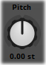
The Pitch Dial controller
The Pitch Dial controllers can be controlled by clicking on the dial and dragging the mouse to alter the Properties value. The Volume Setting has a range from -24 s/ t to +24 s/t. In practical terms this is a range from minus two octaves to two octaves above the native input pitch of the signal. The value display will alter as the dial is turned and displays values in whole semitone numbers with two decimal places to allow for values down to 100th of a semitone accuracy. Hold the CTRL key while moving the mouse to fine tune your control.
Many components within FMOD Studio include Pitch Dial controls. They all share the same control functionality.

Components with Pitch Controls
There are a range of Objects within FMOD Studio that include Pitch Controls. These are usually in the Deck region of the relevant view and can be accessed by selecting the target component to make it active. Once a component is active its Deck region will be displayed and the Volume Controls can be accessed.
- Master Tracks Located in the Master Track Header controls & Deck Region
combined with Volume control
- Module Objects Located in the Deck Region combined with Volume control
- Mixer Master Bus Located in the Deck Region combined with Volume control
Note
Just like Volume, Pitch Controllers within a signal path will contribute to the overall signal output and the values stack. This means that if in an Event Module the Pitch is set to -6 s/t and then in the Mixer Master Bus the Pitch is set to +6 s/t the overall output will add the two values together with a result of 0 s/t difference. For this reason it is important to keep track of all alterations of a signal as it passes along the signal chain.

Object Data
Dragging and dropping certain elements of a project into a text editor causes useful data about the dragged elements to be displayed in the text editor. The most important data that can be obtained in this manner are the GUIDs (Globally Unique Identifiers) of those elements. A range of objects can display their data in this way:
- Events
- Busses
- Snapshots
- Audio Assets
- Profiler Sessions
The data that is displayed may vary depending on the type of object that is dropped into the text editor; it may also vary if the project has been saved or not since being created. The data available for an element includes all of the following that are appropriate:
- Element Name
- Element Path
- GUID
The element name is often displayed as part of the path information. Please be aware that not all text editors support this kind of input.
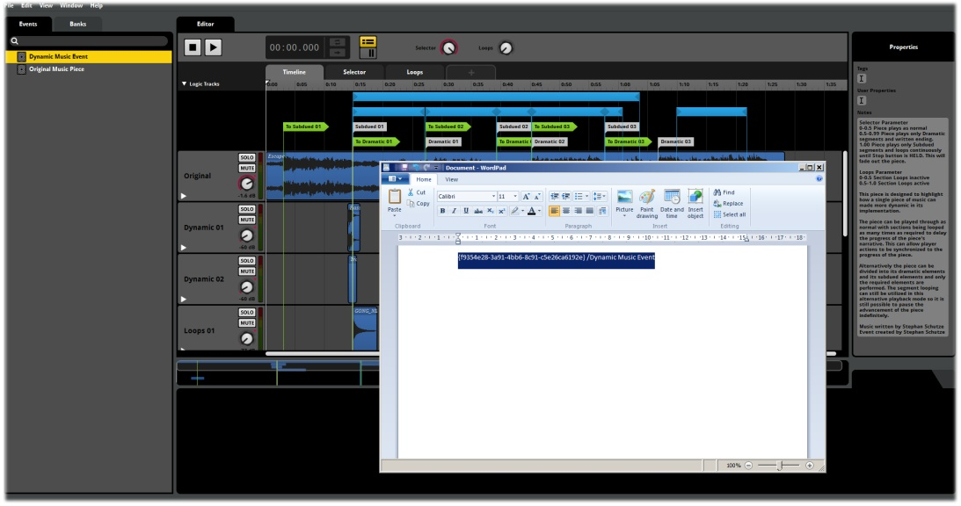
Element dragged into text editor

Command Line Interface
FMOD Studio includes a command line interface that can be useful for setting up build processes to run remotely or for batch processing. The command line interface is accessed through the fmodstudio.com file, located in the FMOD Studio installation directory. The complete list of arguments and usage examples that are available can be accessed by running fmodstudio.com -help.
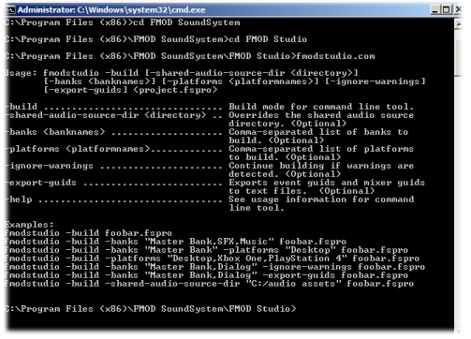
Command Line Interface
The list of arguments can also be viewed by running fmodstudio.com with no arguments. The command line interface is intended to allow scripting options for programmers working to automate the Build process in FMOD Studio.

Modulators
Modulators are Sub Properties that provide extended functionality for various FMOD Studio Properties. Modulators allow for the set value of a Setting to be extended beyond a single specific value to either a randomized value or an envelope setting
Not all Properties within FMOD Studio can have Modulators applied to them. Those that can will have a Modulator option in the Right Click menu for the relevant Setting Controller. Volume and Pitch are the two primary Properties that include Modulator options.

Creating a Modulator
This section will describe how to create a Modulator for either Pitch or Volume Properties

Accessing the Pitch or Volume Controls
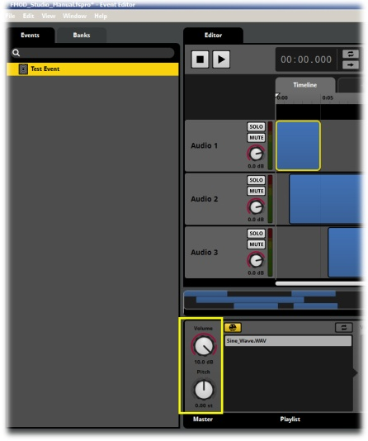
Selecting a Track
- Select an Event by clicking on it to make it the active Event
- Select either an Audio Track or the Master Track to make it active

Creating a New Modulator

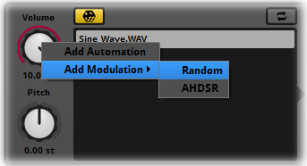
Adding a Modulator
- Within the Deck Region select either the Pitch or Volume control
- Right Click on the Control Dial to access the drop-down menu
- Select Add Modulator and via the arrow select Random or AHDSR

Random Modulation
The Random Modulator provides a Value Dial that defines a percentage value. Dragging the mouse will increase or decrease this value by percentage amounts. Holding CTRL while dragging allows for finer control of the value changes.
The Random Modulator extends its associated Property setting beyond its single defined value by the percentage amount set in the Modulator. For Volume it would extend the single defined value set in the Volume dial and instead provide a range of volumes over which Studio will randomly select values.
As the Modulator value is altered a colored outline on the associated Controller will reflect visually how the Modulator is going to affect the signal. For Volume controls the outline will move between the set value and the lowest value of -∞dB, for Pitch controls the outline will expand in both directions away from the defined value towards the maximum values of -24 s/t and +24 s/t.
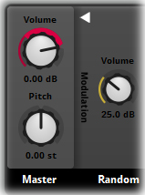
Random Modulation on Volume

Random Modulation Example
An Audio Track has its Volume set to -6dB. This means the sound output for that Audio Track will be lowered by exactly 6dB before it continues through the signal chain. If a Modulator with the Random functionality is added to this volume controller is allows for this single value of 6dB to be extended. A Modulator set to 25% will instruct Studio to randomize the value of the associated Volume Controller between 6dB and 25% of the values between 6dB and -∞ dB.
Value Range “Windows”
Modulators essentially create value range “windows” for functions. Instead of a function having a set, fixed value a Modulator allows for a range of values within which Studio randomly selects a value. We define a “window” with a minimum value and a maximum value and within that window of values Studio is free to randomly select the value it applies each time the relevant Event is triggered. This is one of the principle ways in which FMOD Studio helps sound designers to avoid repetition of Event playback.

AHDSR Modulation
Attack, Hold, Sustain, Decay, Release; these are common terms used to describe a volume envelope in many audio editing setups. The ADHSR Modulation setting in FMOD Studio provides a graphical interface to create and control an AHDSR envelope for a setting in FMOD. The graphical display allows for the node that relate to each of the AHDSR elements to be moved to define envelope shapes that will be applied to the output of a signal.
The Text display provides range values for each of the AHDSR elements as they are manipulated. In this way a user can create a specific envelop shape with exact values as required. As with other Properties holding CTRL while using the mouse will allow for finer control of values.
AHDSR modulation can be used to define Volume and Pitch envelopes as well as other Properties within FMOD Studio. This can be very useful for getting the most out of sound file assets as combinations of Modulation controls can greatly alter the playback of a single sound file.

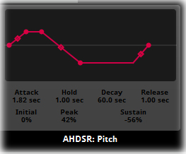
AHDSR Modulation on Pitch

Autopitch
The Autopitch modulator has been designed specifically to support the creation of engine sounds in game projects. Because of this it functions in a specific manner, but it can be adapted to other purposes with a little creativity.

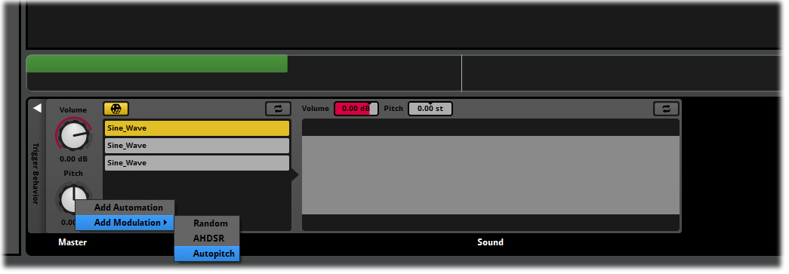
Accessing Autopitch via the Pitch Property Context Menu
When applied to a Sound Module that’s triggered by a Parameter other than the Timeline, an Autopitch Modulator alters the pitch of the Module in relation to the value of that Module’s controlling Game Parameter.
The Module for Autopitch includes a Root Pitch property that represents the point on the Parameter line where the Sound Module plays at its original pitch.
Autopitch works by defining a value of negative infinity pitch at the zero value of the Parameter. This value is used to achieve a pitch of zero hertz at the zero value of the Parameter. The Autopitch modulator references the Root Pitch and its position on the Parameter line and essentially creates a straight automation line for Pitch from –infinity at 0 on the Parameter, through no pitch adjustment at the Root Pitch value, and increasing pitch further up to the maximum value of the Parameter.
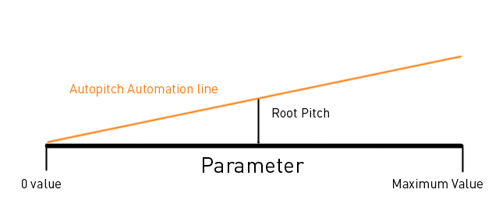
The Autopitch angle is defined by the position of the Root Pitch
As the lowest value of the Autopitch is always anchored to the zero value of the Parameter the angle of the automation line is entirely defined by the value of the Root pitch. It is also possible to create Parameters with negative values, but the Autopitch –Infinity point will always be locked to the Parameter’s zero value, and will adjust the pitch by –Infinity at all negative Parameter values. This is why the Root Pitch cannot display negative values.
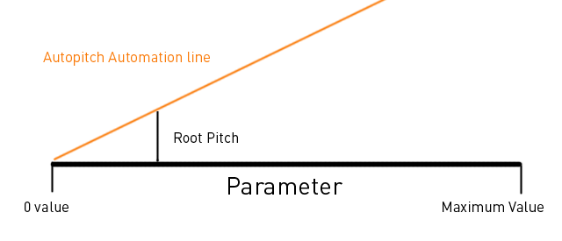
A Root Pitch close to Parameter 0 will generate a steep Pitch angle
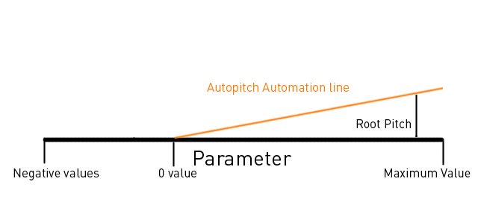
Autopitch is Anchored to Parameter value 0

Creating an Autopitch Modulator
The Autopitch Modulator can only be created under specific circumstances. The Modulator must be associated with a Sound Module that exists on a Game Parameter Track.

Accessing or creating a Game Parameter

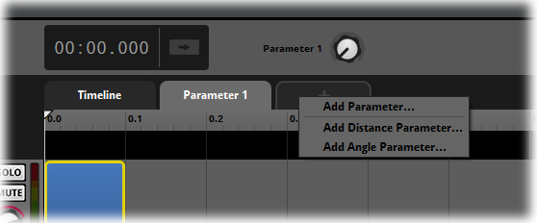
Selecting and creating Parameters
- Select an Event by clicking on it to make it the active Event
- Either select or create a Game Parameter

Accessing or Creating a Sound Module
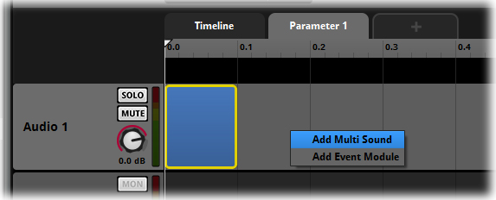
Selecting and creating Modules

- Within the Audio Track select and existing or create a new Sound Module
- Click on the Trigger Region of the target Sound Module
Studio will display the Deck region for the selected Sound Module that will include the Pitch and Volume controls for the Sound Module.

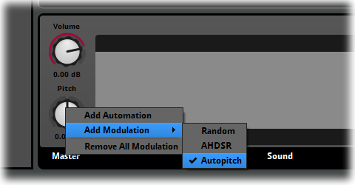
Creating an Autopitch Modulator

- Right Click on the Pitch Dial to access the context menu.
- Select the Autopitch Modulator.
Studio will create the Autopitch Modulator Module in the Deck area next to the Master controls. The Autopitch can now be tuned relative to the Parameter range.

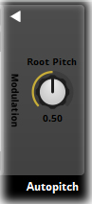
The Autopitch range matches the Game Parameter range

The above image displays the dial for the Autopitch Module. The Dial controls the Root Pitch of the Autopitch function. Root Pitch is the value at which there is no pitch alteration applied, i.e. the sound you hear is the unaltered sound of the Sound Module. You can alter the Root pitch value to “tune” your sounds, this is important if you are blending between several sounds across an Audio Track. It allows you to ensure the pitch at which one sound finishes is the same as the pitch at which the next sound begins so they blend seamlessly.
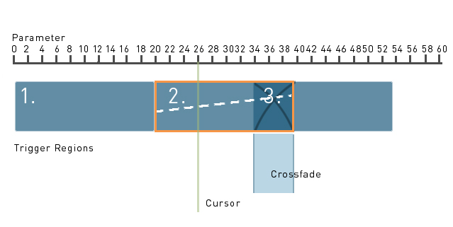
Autopitch Representation
The above diagram represents an Audio Track in FMOD Studio under a Game Parameter with a range from 0-60. The Audio Track contains three trigger regions 1, 2 and 3. The white dotted line is a visualization of the Autopitch values. Autopitch has no graphical representation within the Event Editor.
In this Diagram Trigger number 2 is highlight, indicating it has been selected and the Root Pitch for this trigger could be defined. The Cursor is set to a value of 26 on the Parameter. The Root Pitch is also set to 26. The white dashed line reflects this because the pitch at that value is neither positive nor negative; it is at a neutral value.
The Root Pitch for both Triggers 1 and 3 are not indicated in this diagram, but they would need to be set so the perceived pitch at the beginning of Trigger two matches the perceived pitch at the end of Trigger 1. These coincide with a value of 20 on the Parameter. Trigger 2 and Trigger 3 meet with a cross fade so this makes tuning the root pitches more tricky, the pitches would need to match throughout the range of the crossfade to create a smooth blend. Matching them at 27 on the Parameter should allow for a clean blend of the two triggers.

Note
The range of values displayed on the Root pitch Dial exactly match the range of the Game Parameter in which the Sound Module has been placed. If for any reason you change the range of the Parameter, the Root pitch range will change to reflect this. An easy way to visualize this is to think “What position on the Game Parameter line does the cursor occupy when my sound has no pitch alteration?”

Side Chain Modulator
FMOD Studio includes a Sidechain Modulator that can be added to Events. This modulator allows Sidechain type control within an Event by using the signal from one Track within an Event to modulate the value of a Property in another Track of the Event. It is not possible to use a Sidechain in one event to control a Sidechain modulator in another event.
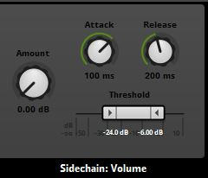
The Sidechain Modulator

Creating a Sidechain Modulator
A Sidechain Modulator can be created in the same manner as other Modulators. Simply access the context menu for any appropriate Property by right clicking on it and from the Add Modulation sub menu select Sidechain.
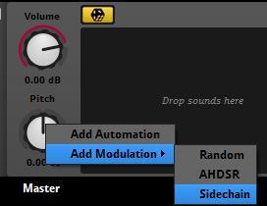
Creating a Sidechain Modulator
Sidechaining is most often associated with channel ducking by controlling a Compressor Effect Module, but the process of Sidechaining is essentially controlling one signal using a signal from somewhere else. The Sidechain Modulator can apply this function to any Event Property that can be modulated. The extent to which a Sidechain Modulator alters the Property is dependent on the signal it receives for the Sidechain input.

Sidechain Properties
The Sidechain Modulator has several Properties that define how it influences the Property it has been assigned to.

Attack and Release
The ‘Attack’ and ‘Release’ properties limit how rapidly a Sidechain can rise and fall, and are defined in terms of the time the Sidechained value takes for to reach its full value from its minimum, and how long it takes for it to return to its minimum from full value. These Properties function in a similar manner to the Attack and Release Properties on a Compressor Effect.

Threshold
The ‘Threshold’ ribbon fader sets the minimum and maximum values beyond which the Sidechain Modulator’s controlling signal has full or zero effect.

Amount
The ‘Amount’ knob sets the amount of effect the Sidechain has on the modulated Property when the Sidechain signal exceeds the Modulator’s maximum threshold. The precise units vary depending on the Property being modulated.

Note
Many of the Properties of the Sidechain Modulator are like those of a Compressor Effect Module because the manner in which they function is very similar.
A Sidechain Modulator requires a signal from elsewhere in an Event to function. A Sidechain Module can be added to the Deck region of another Audio Track within the Event to act as an input signal for the Sidechain Modulator.
To create a Sidechain Module simply right click in the Deck region of the target Audio Track and select Add Sidechain from the context menu.
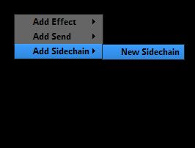
Adding a Sidechain to an Audio Track
Once a Sidechain has been created somewhere within the Event the you can specify it as a Sidechain Modulator’s input signal. Right click on the Sidechain Modulator and from the context menu select Sidechain Input.
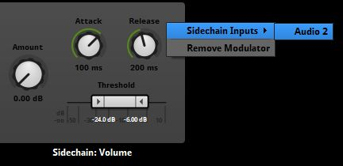
Assigning a Sidechain input to a Sidechain Modulator
The exact effect achieved by using a Sidechain Modulator varies considerably depending on what Property it modulates. The exact values of the Properties within the Sidechain Modulator and the Track that provides the input signal determine the end effect.

Hot Tip
Within Game project production, efficient resource management is critical to effective audio design. Modulators are an incredibly powerful tool for allowing a user to maximize the potential of every single sound file that is used in a game project. Before you add a sound file to a project, consider if anything you already have in memory could be altered, combined with other sounds, blended or edited internally to Studio to achieve the sound you need. This is not only good practise in being more efficient with resources it will often result in far more innovative and engaging sound design as you discover results you may have not realized were possible.

Automation
Many Properties within FMOD Studio Events can be controlled via Automation. All Event Audio Tracks and Master Tracks can have Volume, Pitch and Effects controls added as Automation Tracks.
Automation provides users with a way to define Properties that can alter throughout the course of Event playback. Once Automation has been applied to a specific setting a relevant Automation Track will be added to the associated Audio or Master Track and can be edited as required.

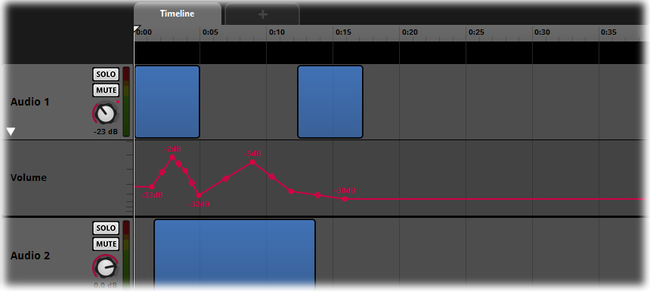
Automation Track for Volume
Automation Tracks provide a graphic interface for users to plot out the values of the various Effects Properties over either time in the Timeline tab or relative to Game Parameter values in Parameter tabs. The Automation lines can have control nodes added to them and through manipulation of these nodes, envelope shapes can be created to achieve a wide range of dynamic effects.

Creating Automation
Automation can be added to many of the Properties within Audio Tracks and Master tracks within Events. This section will describe how to create Automation for an Event Setting.

Accessing an Event
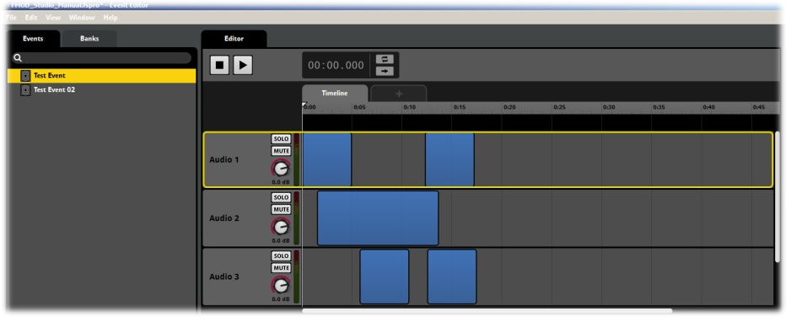
The Event Editor
- Select an Event by clicking on it to make it the active Event
- Select either an Audio Track or the Master Track to make it active

Creating Automation
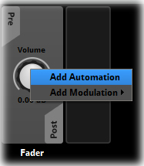
Adding Automation
- Within the Deck region Right Click on the Setting Dial of an Effect unit or Pitch or Volume Control
- From the Drop down menu select Add Automation
Studio will add an Automation Track to the Relevant Audio or Master Track in the Event editor. The Automation Track will display open upon creation, but can be hidden by clicking on the small white arrow on the Track Header of the associated Audio or Master Track.
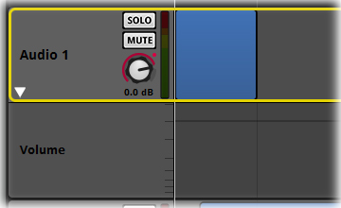
Track Header and Automation Header
By default the Automation Line in the track will be greyed out as it will default to the overall value of the relevant controller. If you use the control dial to change the Properties values, the line in the automation track will alter to reflect any value changes.
Clicking within the Automation Track will make it live, it will change color and create nodes along the automation line that correspond to user input clicks. In this way automation envelope shapes can be created. Drag an existing node to reposition it. A text display will indicate the value position of each node as it is set or manipulated.

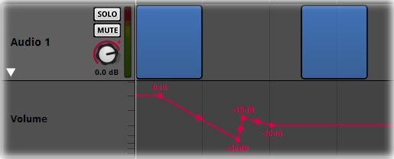
Automation Nodes and Text Values
Between nodes there are curve markers that allow for the type of curve shape to be defined. Drag the curve marker to change the shape of the curve.

Automation Curve Types

Automation Track Names
Automation Tracks adopt the name of the Sound Module or effect they are associated with, and automatically update if that name changes. This provides useful information at a glance and is particularly helpful when dealing with multiple Sound Modules and Automation Tracks.

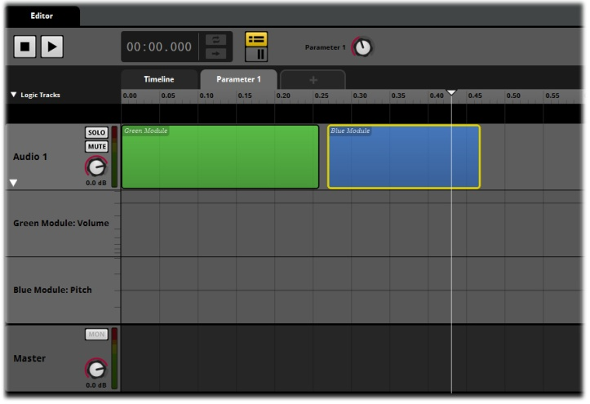
Automation Track names match Module names
Sound Module names can be edited easily in the Deck region or event editor by double-clicking on the name and inputting a new name for the Module.

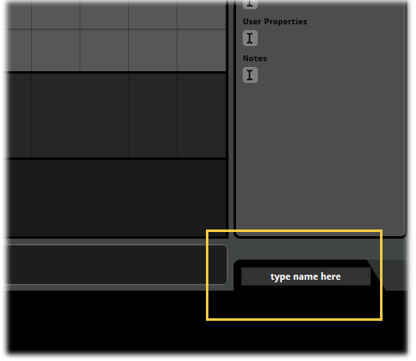
Define the Module name in the Deck area

The Audio Bin
The Audio Bin is a key part of the FMOD Studio interface. It contains a reference to every sound file added to an FMOD Studio project and is an efficient way to organize and add sounds to your project.
The Audio Bin is designed to function as a Browser window in Studio in much the same way as the Event Editor. You can create folders or a folder structure and assign sound files to different folders in the same way the Event Browser allows you to assign Events to various folders. This is particularly useful for keeping track of potentially thousands of sound files used in larger projects.
The Audio Bin also allows for sound files to be added directly to Events and Modules by being dragged from the Audio Bin to the desired location within Studio. Once a Sound File has been added to an FMOD Studio Project it will display in the Audio Bin and from there can be utilized over and over directly from the Audio Bin.

Note
Remember that FMOD Studio does not alter sound files, it only references them. Once a sound has been added to the Audio Bin it can be used a limitless number of times in a project without utilizing more memory than a single instance of that sound file would require. Reusing sounds within the Audio Bin is the most efficient method of creating the audio for your project.

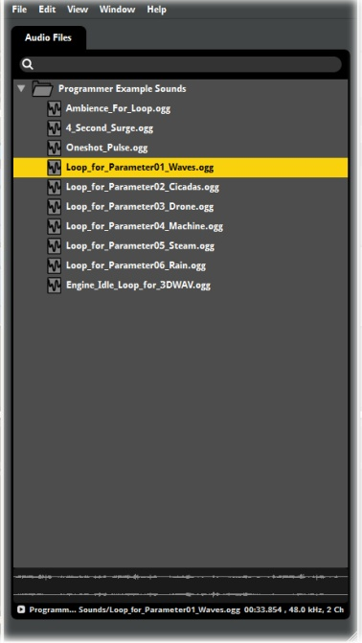
The Audio Bin

Adding Sound Files to the Audio Bin

Introduction
The Audio Bin is the main administrative area for Sound Files within an FMOD Studio Project. Once added to the Audio Bin sound files can be used an unlimited number of times within a Project.

Adding Sound Files to the Audio Bin
There are two methods of adding sound files to the Audio Bin.

Method 1

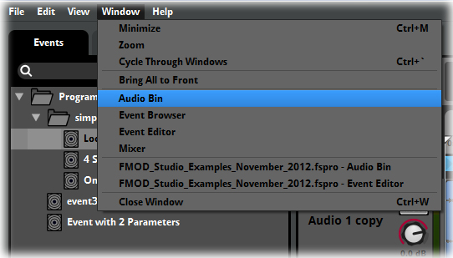
Accessing the Audio Bin
- Open the Audio Bin in FMOD Studio via the Menu Bar/Windows
- Open the folder on your computer that contains the sound files you wish to use in Studio
- Drag the sound files directly into the Audio Bin and drop them in the desired location
FMOD Studio will add references to the dragged sound files in the Audio Bin. It is possible to drag and drop single sound files as well as groups of sound files. If you position he mouse cursor above a folder within the Audio Bin the sound files will be assigned to that folder, if you position the mouse cursor over the general area within the Audio Bin then the sound files will be added to the general area.

Method 2
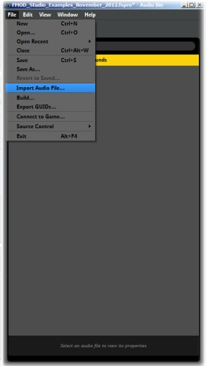
Importing within the Audio Bin
- Open the Audio Bin in FMOD Studio via the Menu Bar/Windows
- Select File/Import Audio File…
- Navigate to the location on your computer that contains the target sound files
- Select or group select the sound files you wish to import and press Enter
FMOD Studio will create a reference for each selected file within the Audio Bin. The Import Audio File method will always add the new sound files to the general root area of the Audio Bin. From there they can be reassigned to folders as required.

Audition Mode
The Audio Bin includes an audition function that allows sound files to be played directly from the Audio Bin window and displays the wave form of the selected sound file.
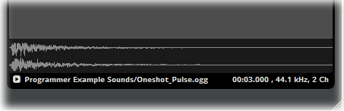
Audio Bin Audition area
Sound files can be played by either pressing the Play button or the Space bar. Pressing Play before a sound file has finished stop playback and will reset the play cursor to the beginning of the sound file. The cursor can be manually positioned within the wave form image to allow the sound file to be triggered from within the file. Positioning the cursor within the sound file wave form will automatically play the sound file from that point to the end of the sound.
The Audition area also includes information about the selected sound file. The full name and path within the audio bin as well as the sound files sample rate and bit rate are displayed. During playback a timer will also display playback time for the selected sound file.

Audio Bin Context Menu
There are a range of options within the Audio Bin context menu that provide administrative and control functions for the sound files within the Audio Bin. Right clicking on a sound file will access the context menu.
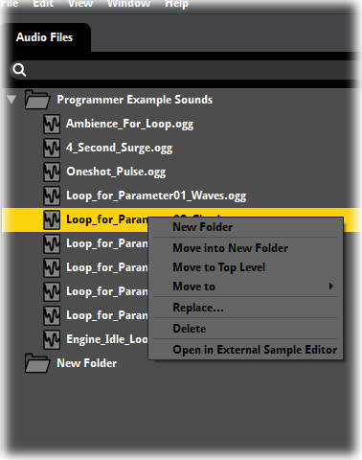
The Audio Bin Context Menu

New Folder
This will create a new folder within the Audio Bin and allow for the folder to be named as required.

Move into New Folder
This will create a new folder within the Audio Bin define the name for the folder and assign the selected sound file or sound files to the newly created folder in a single action.

Move to Top Level
This will reassign the selected sound file or sound files to the root position of the Audio Bin.

Move to
This will expand to a second context menu that will include all the existing folders within the Audio Bin and allow the selected sound file or sound files to be reassigned to the desired folder.

Replace…
Replace will allow the user to navigate through their computer to find a sound file to replace the currently selected sound file in the Audio Bin. The replacement file can be of a different format as long as it is a format supported by FMOD Studio and can have a different filename. This will replace the entry in the Audio Bin with the new sound file and remove the currently selected sound file.

Delete
This function will delete the currently selected sound file or sound files.

Open in External Sample Editor
This will open the Sample Editor defined in the Preferences window as the selected Sample editor to use with FMOD Studio and will load the selected sound file or sound files into the sample editor for editing.

Note
Right Clicking within the Audio Bin general area but not on a sound file will display a context menu with only the option to create a New Folder and the option to Sort by Name (sort alphabetically).

Unused Sound Files
It is possible to find any unused sound files within the audio bin by typing in ##unused into the Search bar. This displays a list of all sound files within the project that are not currently used within any Events. This is a useful method of finding and removing unused sound files from a Project.

Creating your First Event

Introduction
Events are the core objects used to create and control sound output in FMOD Studio. There are a series of Module types that are added to Events to utilize various Properties depending on the need of the user. All Events start with an empty Event object in the Event Browser.
This section will introduce Events by creating an empty Event object.

Creating a new Event
Creating Events in the Browser provides a new empty object to which sound files can be directly added. This is the first step towards creating sounds.

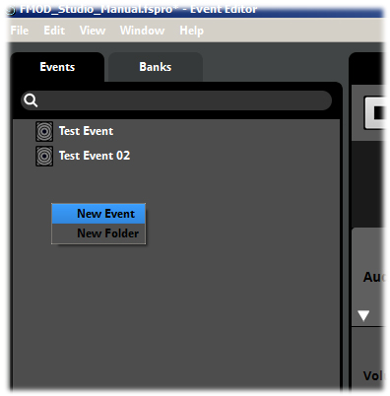
Creating a New Event
- Right click anywhere in the Event Browser.
- Select New Event from the drop-down menu.

Naming the New Event

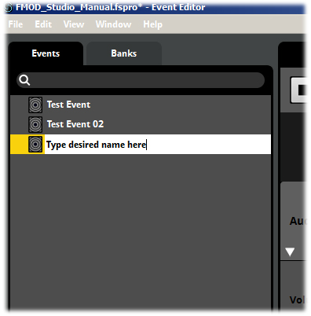
Naming a New Event
- The New Event will be created with the default name New Event.
- Type in the desired name for the Event you have created.
- Press Enter or left-click away from the Event title to confirm the Event name.

Note
The drop-down menu will contain more options if you right click on an existing Event, but you are still able to create a New Event from this menu.
Once you have created an Event in the Browser Region you can start to work with it in the Editor.

Adding Sounds to an Event
An Event does not produce any sound on its own; it needs to include at least one Module Object. There are a range of Modules that can be added to Events. The simplest consists of a single sound file set to play once when triggered.
This tutorial will add a single sound file to an empty Event. Any WAV file would be suitable for this tutorial.
Now that there is an Event it is possible to add sound files directly into the Editor region. There are a variety of ways in which to add sounds to Studio but the simplest is to drag and drop.

Option 1 Adding the target sound file; drag and drop
- Open the folder on your computer with the desired sound file.
- Drag the sound file from the folder into the Editor Region of FMOD Studio.
- Drop the Sound File onto the Track Audio 1
FMOD Studio will create a Module object in the Event timeline. The object will occupy an area of the timeline relative to the sound files length and can be adjusted to take more or less time by click-dragging the edges of the object. The Module will display a silhouette of the wave in both the Timeline box and in the Deck below the Event. The Deck is also where the properties for any selected Module are displayed. In this case the Volume and Pitch properties are displayed to allow for those properties to be altered for this Module.

Option 2 Adding the target sound file; drag from Audio Bin
The Audio Bin
- Open the Audio Bin via the Menu Bar
- Drag the sound file from the Audio Bin into the Editor Region of FMOD Studio.
- Drop the Sound File onto the Track Audio 1
FMOD Studio will create a Module object in the Event timeline. The object will occupy an area of the timeline relative to the sound files length and can be adjusted to take more or less time by click-dragging the edges of the object. The Module will display a silhouette of the wave in both the Timeline box and in the Deck below the Event. The Deck is also where the properties for any selected Module are displayed. In this case the Volume and Pitch properties are displayed to allow for those properties to be altered for this Module.

Note
A Sound File can be dragged and dropped onto the Audio Bin or added via the file navigation system. It is possible to select multiple sound files and drag them into the Audio Bin as a group.

Hot Tip
It is possible to create a new Event containing a Single Sound Module by directly dragging a sound file from either the Audio Bin or your computer into the Event Browser. The newly created Event will be named exactly the same as the sound file and will contain a Single Sound Module that contains the dropped sound file.
If you drag the sound file into an Event Folder the Event will be created inside the folder, otherwise it will be created in the general browser area.

Modules
There are a variety of objects that can be added to Events within FMOD Studio. These objects are called Modules and each type of Module object has a range of Properties that allow the user to achieve different results. Most Modules also include the Volume and Pitch Properties. The ability to nest Events within other Events and to link Events allows a user to combine the Properties of a series of Modules to create complex playback behavior.

Sound Modules
FMOD Studio uses the term Module to describe the variety of objects that can be included in Sound Events. Just like with hardware audio setups, modules can be inserted into the signal path in Studio to define, influence and control the ultimate audio playback that is produced by FMOD Studio.
Modules are displayed in the deck region of both the Event Editor and Mixer. There are also modules that are unique to the Event area. These are the sound producing modules.

Modules that Produce Sound
The various sound producing modules that can be added to a Sound Event function differently to the Effects modules. Most importantly, they are created initially within an Audio Track within the Event editor. When created they consist of two components that are equally important to how the module functions.
The first component is called a trigger region and is represented by a colored box that is displayed on either the Timeline or on a Game Parameter depending on where it was initially created. A trigger region defines exactly when a sound producing module will produce a sound in FMOD Designer. The region that it occupies on either the Timeline or a Game Parameter will respond to the position of the cursor during playback. When the cursor intersects with the colored box it will trigger playback of that sound producing Module.
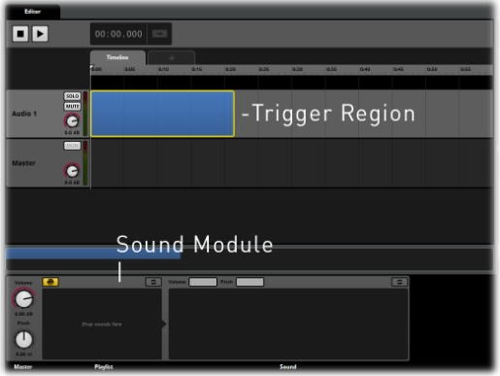
Sound Module and associated trigger region
Trigger regions can be resized and repositioned in the Event Editor to define their exact playback behavior in relation to the timeline or Game Parameter values. Trigger regions can be assigned different colors and named appropriately to assist with workflow efficiency.
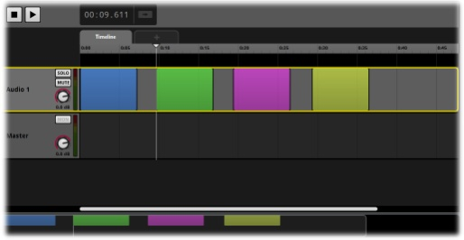
Colored Trigger Regions
The second component is the Module itself that is displayed in the Deck area of the relevant Audio Track. The Module interface in the Deck will include information relevant to the type of Sound Module that has been created. FMOD Studio has a number of Sound Modules, each with a unique set of properties to define its playback behavior.
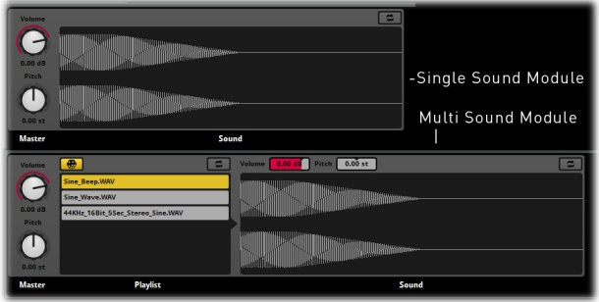
Single Sound and Multi Sound Modules
Sound Modules have properties that can be modulated and automated in the same manner as Effect Modules. Their function as a sound producing object in FMOD Studio differentiates them from all other modules and means that they will have both the Deck interface as well as the Trigger Region in the Editor.

Creating a Sound Module
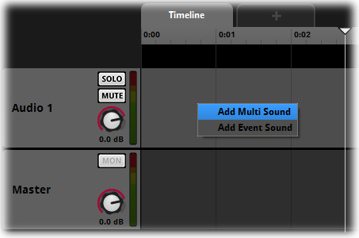
Module Menu
- Right click anywhere within an Event Audio Track in the Editor.
- From the drop-down menu select the desired Module.
- Click to create the new Module in the Audio Track.

Multi Sound Module
A Multi Sound Module can contain more than one sound file. The properties of this object allow you to define a variety of playback behaviors.
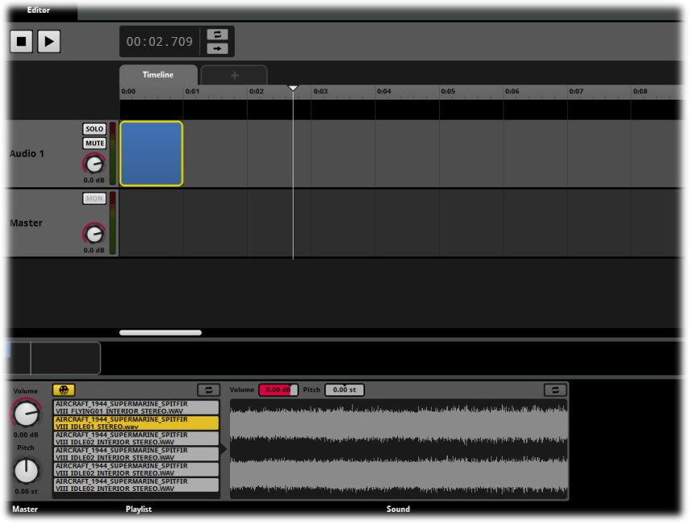
Multi Sound Module in the Event Editor

Playlist Properties
The playlist for a Sound Module is more than just a list of sound files. Clicking on a playlist entry causes information and properties specific to that entry to be displayed, grants access to that entry’s volume and pitch, and looping properties, and allows you to set its start offset behavior.
Note
A Sound File included in a Module Playlist is both a reference and an instance. Alterations made to any of its Properties in a Multi Sound Module only apply to the instance of the Sound File within that Module. Thus, altering the pitch or volume of a sound file in a Module will not affect other instances of that sound file used elsewhere within a project.

In addition to the playlist entry-specific properties, Pitch, Volume and looping controls are included in the Properties of a Multi Sound Module’s Playlist.

Playlist Context Menu
Each entry in a playlist can be modified via a context menu. Right clicking on a Playlist entry displays a menu of additional options.
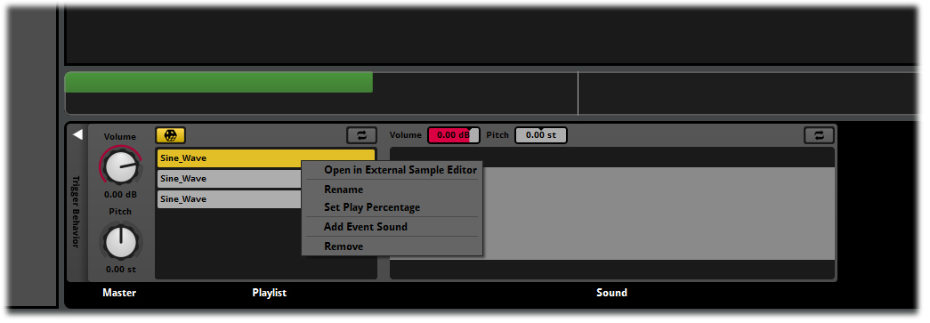
Playlist Entry Context Menu

Open in External Sample Editor
This opens the Sound File in an external program so it can be edited as required. If you haven’t specified a sample editor in the ‘Assets’ tab of the ‘Preferences’ window, FMOD Studio will use your operating system’s file type association to open the file.
Double-clicking on the Playlist Entry automatically executes this menu command for convenience.
Note
Editing a playlist entry in an external editor will alter the associated sound file in the project’s Audio Bin, or in its original location if the file is in your project’s shared audio source directory. This will permanently alter this asset and all instances of it so use this feature carefully.

Rename
This allows the Playlist entry to be renamed as required via direct text input. You can also use the standard Windows (F2) and Macintosh (Enter) OS shortcut keys for renaming.
This function is very useful for renaming Event Sounds so that they are not all labelled “Event Sound” but it can be used on any playlist entry.
Note
Renaming an item in the Playlist does not rename its associated sound asset, so this must be done with care. Extensive renaming across a project could result in the project being hard to understand.

Set Play Percentage
You can specify the percentage chance of a playlist entry being played when the play mode is set to random. The total play percentage for all play list entries cannot exceed 100%, and any entries that do not have a play percentage value defined will be automatically assigned an equal share of whatever percentage remains.
For example, in a Module with three Playlist entries, each would automatically be balanced to 33.33% each. If one was manually set to 50% the remaining 50% would be divided equally among the two remaining entries making them 25% each. If two more sounds were added to the Playlist without altering the set percentage the four non defined entries would automatically be set to 12.5% each.

Remove Play Percentage
This context menu item is only displayed once a play percentage value has been added to a playlist entry.
It removes the displayed Play Percentage and rebalances the play percentages of all playlist entries without displayed play percentages.

Add Event Sound
This adds an Event Sound Module to the Playlist of this Module.

Remove
This removes the selected entry from the playlist.

Bulk Editing
FMOD Studio supports Bulk Editing within the Event Editor. This allows Properties common to the selected Events to be adjusted simultaneously for all selected Events. This can be extremely useful when working with large projects than contain lots of Events.
Bulk Editing is automatically made available whenever multiple Events are selected at the same time. The Event Editor display changes to indicate which properties can be modified as part of the Bulk Editing function.
Hold CTRL while clicking on the desired Events to select multiple Events within the Event Browser. When multiple events are selected, their bulk editable properties are displayed in yellow.

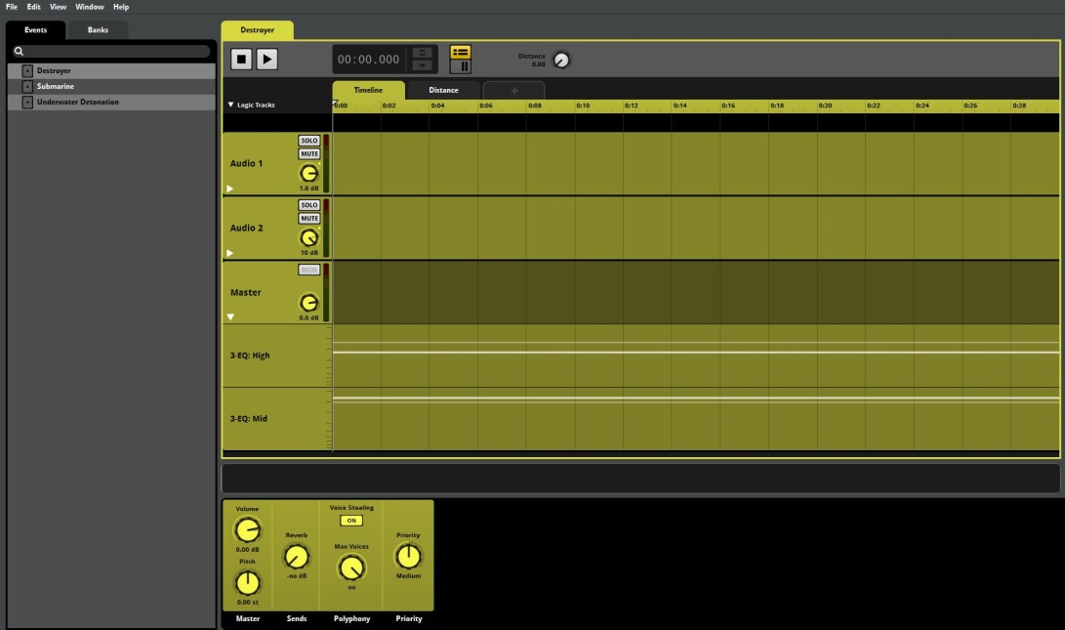
Bulk Editing in the Event Editor
Only objects that are eligible to be bulk edited are highlighted in yellow, anything that is not highlighted will only change the active event if edited. Automation lines that can be edited in Bulk Edit mode are indicated in white to make them easier to see.
Note
Only Properties that exist and have identical values in all selected Events are highlighted for Bulk Editing. For example, if you select three Events and one of the Events does not have a 3D Panner, the 3D Panner will not be highlighted for Editing. This is because it is not possible for FMOD Studio to identify the intended result for all selected events when non-identical properties are edited. Also, if a property you expected to be able to bulk edit is instead not highlighted, it may be that you have accidentally added an event to the selection that you did not intend to edit.

Editing Properties
By default, Bulk Editing allows you to change almost any common Property values in the selected Events. Altering a Property value while bulk editing results in that Property being altered relatively in all selected Events; If an altered property’s value would exceed the range of allowed values for that property, it is instead set to the closest allowed value. Where possible, FMOD Studio will also display Property values that do not exactly match when multiple Events are selected for bulk editing.

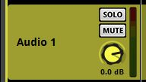
Volume Property Dial Bulk Edit display

The above image illustrates the Volume Property dial for Audio Track 1 of an Event. The darker line on the dial is the volume value for the displayed audio track, the lighter line is the volume value for a second Event that has been selected as part of this Bulk Edit process. If the Property value is changed this display will indicate the change to both of the selected Events via the dark line and light line. Alterations to values is relative, so the Property dial will indicate the value change of the displayed Property and the lighter lines will indicate the relative changes to any other selected Event properties.

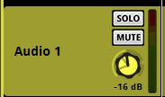
Bulk Editing Three Events

This diagram illustrates a change of -16dB to the displayed Audio Track and two lighter lines on the Property dial indicate the relative property values of two other Events selected for Bulk Editing. In the example of Volume Properties, keep in mind that the Property Dial for Volume is not a linear change when the dial is rotated, so the relationship between the displayed lighter and darker lines on the dial will shift as you move through the negative dB value ranges.
Alternatively, holding down the ‘Shift’ key while bulk editing the values of dials causes those values to be set to the same absolute value as the dial in the active event, rather than receiving the same amount of relative change.

Range Extremes
FMOD Studio attempts to keep a relative relationship between all selected Property values. So you would see the following results if you altered the Volume of three bulk selected Events.

Alterations of Volume Property Values by -3dB
Original Value New Value
0dB -3dB
+3dB 0dB
-12dB -15dB

All Properties have a maximum and minimum value that cannot be exceeded. Once a Property Value reaches an extreme value it will stay at that extreme value, but FMOD will still maintain the relative relationship until that specific edit attempt is completed. So if increasing the value of Event number 2 forces Event number 1 to an extreme, Event 1 will stay at that extreme value. If you then reduce the values of the combined Event Properties down without having released the mouse button, then Event 1 will maintain its value relative to all other selected Event Properties.

Alterations of Volume Property values by +4dB
Original Value New Value
0dB +4dB
+7dB +10dB (+10dB is the maximum value and cannot be exceeded)
-12dB -8dB

Controlling Property
When Bulk Editing, the Event that is selected last is usually the active event, and therefore the Event whose Properties you use to control all selected Events. So by adjusting a Property value of the controlling Property you adjust all selected Event Properties. This choice can influence your range of control. Remember that a Property cannot be adjusted outside of its range extremes, so you can only turn a Property dial so far before it will stop. If the controlling dial stops then obviously all other selected Property values stop as well, so make sure you select the most appropriate Event out of a group to be bulk edited to allow you to achieve the desired results. To alter the active event in an existing selection, press the ‘Tab’ key to cycle through all selected events.
There is an additional function for the Bulk Editing system. The Shift key works as a shortcut to assign all selected Properties to the same value. The assigned value is defined by the active Event’s Property, so whatever value is defined by the Active Event’s Property when the shift key is held is the value all selected Event Properties will snap to.

Bulk Editing Parameters
Parameters can only be Bulk Edited when the selected Events have Parameters of the same name, the same type and the same value ranges. Parameters that can be successfully Bulk Edited are highlighted when multiple Events are selected.
This requirement is to prevent undesirable editing. If two Parameters have the same name but not the same value ranges bulk editing could result in undesirable results and significantly affect the playback behavior of your project.

Bulk Editing the 3D Previewer
The 3D Preview tool can also be used in Bulk Edit mode. As with other Bulk Edit functions simply select all the Events you wish to edit simultaneously. As with all Bulk Edit examples Properties can only be varied within their maximum extremes and so any change that would take them beyond those extremes will stop at the extreme value range.

Module Playback Behavior
There are two toggle buttons within a Multi Sound Module that define the playback behavior of the Module.
The first has a die icon, and defines whether the entries within the Module’s playlist are selected at random or played sequentially.
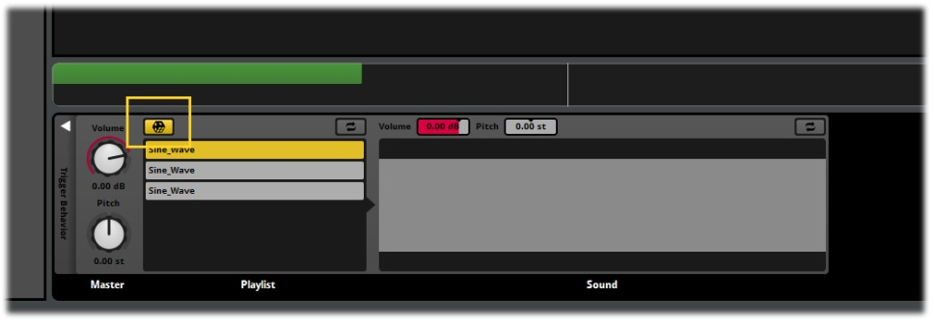
Multi Sound Module Random/Sequential Toggle Button
By default a playlist is set to random, and randomly selects from its list of entries while avoiding repeating the same entry too often. When this button is not highlighted, Studio selects the entries in the order in which they appear in the playlist.
To avoid over-repetition, if there is no playlist weighting, FMOD Studio handles the selection as if on ‘shuffle’ mode: The playlist is shuffled into a random order and played through once, then reshuffled and played through again, and again, and so on. So the maximum number of times an entry will play in a row is twice, and the frequency with which any given entry plays is always exactly 1/n, where n is the total length of all entries in the playlist.
If there is playlist weighting, then it's effectively truly random; the chance of an entry directly following itself is equal to the probability of that entry being selected.

Note
Both Random and Sequential playback behaviours make global calculations. This means that FMOD Studio tracks which playlist entries have been played across all instances of the Module in the project. So if a Module has the entries 1, 2 and 3 and is set to sequential playback order, it selects them in the order 1, 2, 3. If that Module is stopped and then started again it plays whatever sound file was next in the sequential order, and does not reset back to 1 every time it is triggered. Similarly, if multiple instances of the Module are triggered, the next item to be selected will be based on the most recently triggered entries across all instances, not just the one that’s currently playing.

Module Looping Behavior
The Looping toggle button specifies whether Studio applies looping playback to the Module. In a Module with a playlist, this setting loops the Module, not the individual entries within its playlist. The exact playback behavior of the Looping Flag is dependent on the Module type.
A Single Sound Module set to loop loops the playback of its sound file.
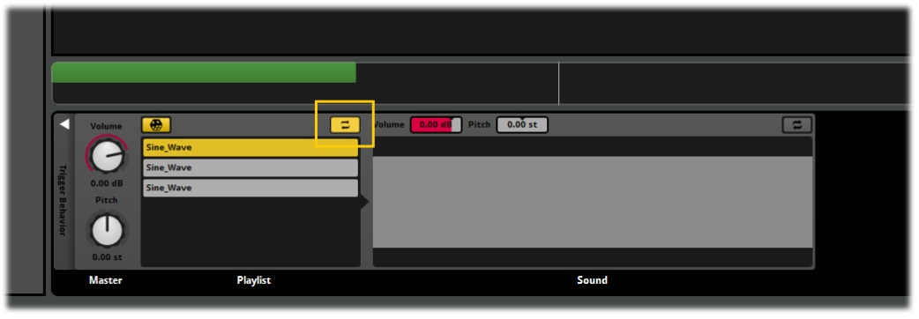
Module Loop Mode Button
The Scatterer Sound Module is a more complex Module and its behavior when set to loop is more varied. The best way to think about the Scatterer Sound Module is to think of it as having two components. The right side of the Module is essentially the same as a Multi Sound Module and it will behave in the same way. It triggers sound files from its playlist, and if set to loop, will string those sound files together to loop the Module.
The left side of the Module provides the Scatterer functions, which are applied to the integrated Multi Sound Module, not to the individual triggered playlist entries. When the Scatterer Sound Module is triggered, each sound scattered is a separate instance of the integrated Multi Sound Module. This means that when the integrated Multi Sound Module is set to loop, the Scatterer applies all its functions to the looping Multi Sound Module. So if Polyphony is set to 3 the Scatterer will allow up to 3 continuously looping sounds to be triggered depending on all the Properties and how they have been defined.
Timelocked Sound Modules cannot loop, so any Module set to loop will automatically not be Timelocked. More information on Timelocked sounds can be found in the relevant section.

Looping a Module’s individual Playlist Entries
Multi Sound Modules and Scatterer Sound Modules allow access to the Properties of the individual entries contained within their Playlists. Each playlist entry can be individually set to loop. Within a multi entry playlist this function can produce various types of playback behavior.

Module set to single playback, all entries set to loop
The Sound Module triggers a sound file either sequentially or randomly depending on its playback behavior settings. The selected entry loops indefinitely until the Module is stopped.

Sound Module set to single playback, some entries set to loop
In this setup the Sound Module triggers a sound file depending on its playback behavior mode. If it selects a non-looping entry that sound plays and then ends, if it selects a looping entry that sound plays and loops until the Module is stopped.

Sound Module set to looping playback, all entries set to not loop
The Sound Module loops by stringing the entries together end to end to achieve endless playback until the Module is stopped.

Sound Module set to loop, some entries set to loop
The Sound Module triggers and loops by stringing the entries together until it triggers a playlist entry that is set to loop. The Module then ‘jams’ on that entry and loops it until the Module is stopped.

Sound Module set to loop with all playlist entries set to loop
The Sound Module triggers and selects a playlist entry which then loops until the Module is stopped.

Single vs. Multi Sound Modules
The choice between using a Single or Multi Sound Module is one of the most basic examples of extended sound design. Traditional methods of sound design would select an appropriate sound effect for an Event and trigger that sound when required. In linear media this method is completely appropriate. In a game project, the target sound may be triggered over and over during the course of a game, so for instance using only a single sound file to represent an Event can result in undesirably repetitive playback.
By creating a Multi Sound Module and populating it with multiple variations of the same sound type, Studio can be made to randomize which sound file is selected for playback each time the Event is triggered. This instantly provides a wider selection of sounds and reduces repetition.

Event Module
An Event Module object is an object designed to contain other Events instead of directly referencing sound files. The Module created in the Editor Region includes Volume and Pitch controls but does not display any sound file data or playlist information. Double-clicking on an Event Module object will open a new window containing a blank Event. This Event can then be populated like any other Event.

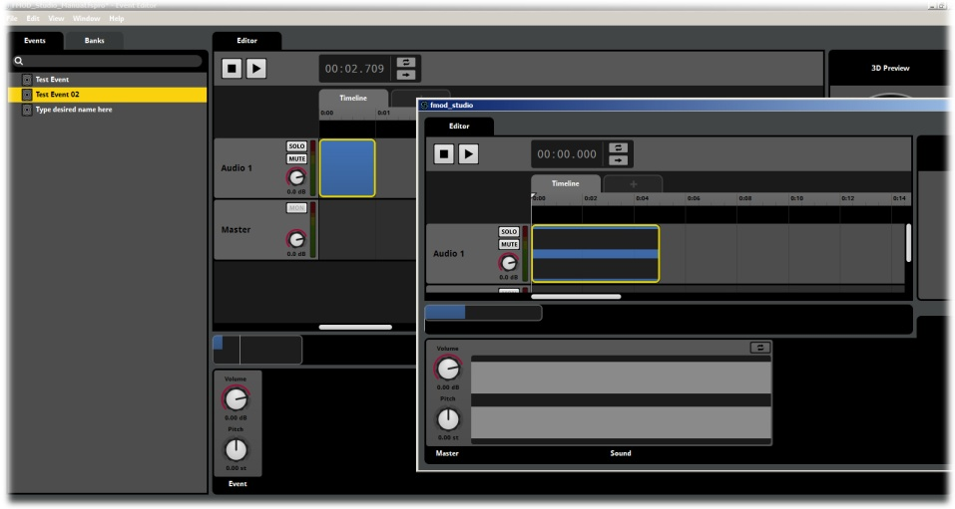
Event Module in the Event Editor

Sub Events
A Sub Event is created hierarchically below an existing Event in the Event browser. As the name suggests it is positioned at a lower level in relation to its related Event. A Sub Event actually routs through its parent Event in the same way as Event Modules do, except that Sub Events do not have a Trigger Region within the parent Event. Sub Events are separate entities in all regards except for how the signal path is created and are triggered separately.
The concept behind Sub Events is the ability to associate a series of individual Events together so that they can be grouped for routing and 3D positioning within a project. An example of this would be the various sounds that might go together to create the sound of a car. Each of these sounds may need to be individually triggered and controlled and yet are all still a part of the same overall object and as such would be routed and positioned as a single object Event.
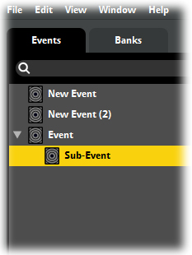
Sub Event

Event Reference Modules
FMOD Studio allows Existing Events to be referenced from within other Events and triggered in the same way Sound Modules are triggered. Event Reference Modules include a Trigger Region, positioned on either the Timeline or Parameter, and a limited set of Module Properties in the Deck area.
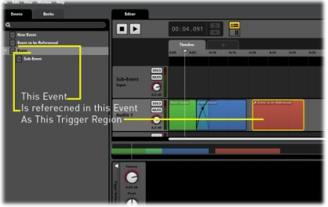
Event Reference Module
An Event Reference will be triggered by cursor position just as any other Sound Module would and can have Automation and Modulation added to its Properties. Event Reference Modules are not an instance in the same way that other Modules are. An Event Reference Module will always exactly reflect the original Event it was created from and any changes to the original Event will be applied to all Event Reference Modules associated with the original Event.

Creating Event Reference Modules
An Event Reference Module is created by a different process than other Sound Modules. The first, most important, step is to create the Event you want to reference. This Event does not need to be completely finalized as all changes will update automatically across all its associated references.
Because this process involves working with more than one Event at a time a second Event Editor Window should be opened from the Menu Bar. Go to Window/Event Editor (or alternatively use the shortcut keys CTRL + 1). Once you have two Event Editors open, select the Event you want to reference in one Editor and the Event you want to add the reference to in the other.
To create an Event Reference Module simply drag the Event from the Event browser in one Editor window into the Audio Track of the target Event in another window. Studio will create a new Trigger Region in the target location and from that point you can move and resize the Trigger Region as usual.
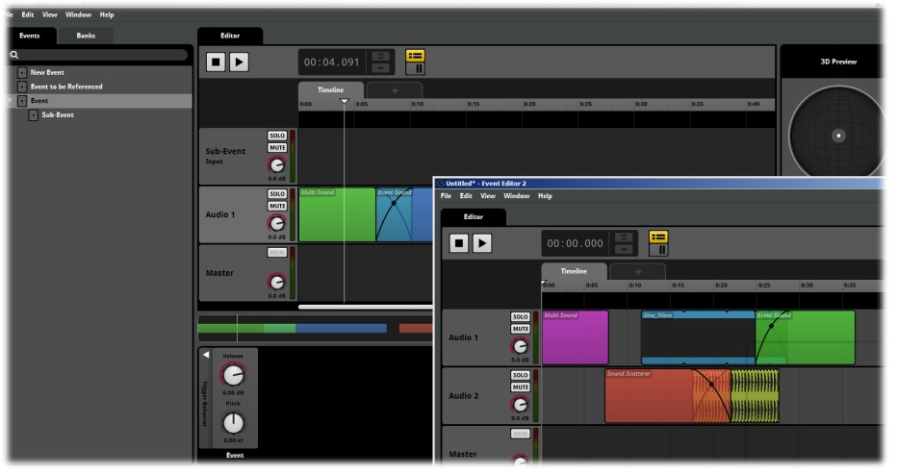
Creating an Event Reference Module

Double Clicking on the Trigger Region of an Event Reference Module will open that Event in the Editor in the same manner as accessing an Event Sound Module. It will indicate the location within the Event the same as Nested Events as well. The breadcrumb display will keep track of the location within the nested Event structure.

Note
Event Reference Modules are routed through the Event in which they are created. This means they will enter the Mixer via that Event’s Input. This means that any routing or processing of the original referenced Event in the Mixer will not be reflected within the associated Reference Events.

Sound Scatterer Modules
A Sound Scatterer Module includes some complex functionality that allows a single Module to produce a wide range of different sounds. It is also a basis for a lot of Generative Audio type Events. There is of course no requirement to utilize all of the functions all of the time. A Scatterer allows for continuous spawning of sound files as well as positional information for the sound Event in 3D space.
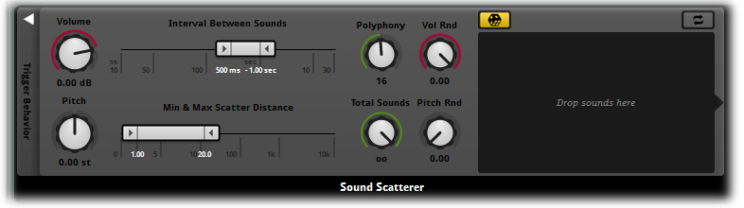
Sound Scatterer Module
A Sound Scatterer Module has four main function sections
- Trigger behavior
- 3D Positioning behavior
- Volume behavior
- Pitch behavior
The Volume and Pitch behaviors are similar to many other functions within FMOD Studio except that where most other Pitch and Volume properties can have Randomization Modulators added to them in a Sound Scatterer Module the Randomization controls are always displayed.

Trigger Behavior
A Sound Scatterer Module allows an Event to repeatedly trigger the sound files added to the Module. The upper ribbon slider is titled “Interval Between Sounds”. The value applied to this property will instruct the Module to count a defined period of time before triggering another Sound File from the modules Playlist.

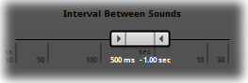
Interval Between Sounds
Two values are defined in the Trigger Interval property. These represent the minimum length of time FMOD must wait before triggering a sound and the maximum period of time. If both of these values are set to 1000ms then FMOD will trigger a sound exactly every 1000 ms or 1 second apart. Using these values FMOD will sound like a clock keeping perfect time. By setting the two values the same FMOD will trigger on exact time values.
If the two values are set differently the result is that FMOD is given a window in time in which to randomly select a value. For example the default values of 500ms-1 sec instructs FMOD to count at least 500ms and no more than 1 second, but within those two values FMOD is free to randomly select a time to trigger the sound. Defining a range window such as this will result in FMOD randomly selecting a different value each time it triggers a sound. This is useful for producing non-time specific behavior as often appears in nature.
Related to this property is the Polyphony dial. When FMOD is instructed to trigger sounds over and over it has no concept of the length of the audio tracks it is triggering. Even though the default values may trigger a new sound between 500ms and 1 second it is highly likely that many sounds are longer in length than 500 milliseconds.
This means Studio must be allowed to play more than one sound at a time. If Polyphony is set to 1 and a new sound is triggered while the current sound is still playing, FMOD is limited to only playing one sound at a time. This means the new sound will wait in queue until the current sound finishes and then it will play. Increasing the Polyphony to 2 would allow both sounds to play. The default value of 16 is designed to allow multiple sounds to play concurrently without utilizing too many channels. Polyphony values should be defined to suit both the creative requirements of the sound as well as the technical limitations of the target platform.
The Total Sounds dial allows the user to define a finite number of triggered sounds before FMOD will stop playing the Event. By default this property is set to infinite so once triggered an Event will play continuously until it is stopped. If the Total Sounds was set to a value of 5, Studio would trigger the sound with the appropriate interval defined by the Interval Between Sounds property, but would do so only 5 times before it automatically stopped playing.
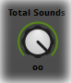
The bottom ribbon is used to define minimum and maximum Scatter Distance. As with the Interval property this property can be set to define an exact number or a range window in which FMOD will randomly generate a value. This property adds control of the 3D positioning of a Sound Event. By defining a minimum and maximum value the user to create can define an area in which Studio will randomly position each triggered sound within 3D space.
So a value of 0 to 10 would create a circular area with a diameter of 10 in which FMOD would randomly place each sound triggered. Think about a group of birds singing in a tree and how each sound is triggered within the canopy of the tree area. As with Interval Time, defining an exact value means that the sounds will still be positioned randomly around the emitter point in the 3D world, but at a constant distance defined by the Property. Setting this Property to 0-0 will remove any random 3D position behavior.
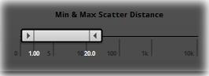
Min and Max Scatter Distance

Note
If an Event is set to 2D by deleting the 3D Panner from the Event Master Track and a Sound Scatterer Module is using the 3D min and Max values FMOD will randomize the position of the sound within a 2D stereo panning spread. This can be useful for creating dynamic stereo panning.

A word on Generative Audio
The Sound Scatterer Module is a key tool in creating Generative Audio, but what is Generative Audio? Generative audio is a method of sound design that allows users to create dynamic sound effects; that is sounds that are generated in real time. The concept is centered on using sound files as building blocks rather than as finished sound effects. A good example of this is creating an ambient effect of birds by using short individual bird calls. Using the Sound Scatterer Module a sound designer can instruct FMOD Studio to trigger a stream of bird sounds that overlap and spread across a defined area in 3D space. This can create the illusion of a group of birds within the area of a tree singing away. This is just one example, but there are many different methods of producing dynamic sound Events that can significantly improve the overall sound environment of a game project.

Audio Weather Module
The Audio Weather Module object is a plug-in object for FMOD Studio that provides a series of properties that combine to produce procedurally generated weather sound effects. Wind and water effects can be generated and controlled via a set of simple controls.

Single Module
A Single Module object is what is created when a sound file is drag-dropped directly into an Event Audio Track. The functionality is essentially the same as a Multi Sound Module except the object only references a single sound file. This is slightly more efficient from a code perspective than adding only one sound file to a Multi Sound Module and so is recommended when only one sound file is required.
The Single Module is not included in the drop-down menu.

Events within Events
One of the most powerful functions of FMOD Studio is the ability to nest an Event within an Event virtually endlessly. This allows for a Module with one type of function to be nested within a Module with a separate function. In this manner it is possible to combine the entire range of Module functions to achieve a vast range of output results.
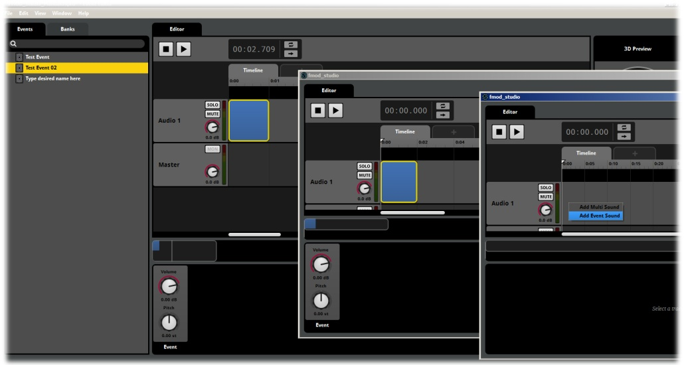
Nested Events
The above graphic illustrates Events nested to three levels. Each new level can be opened in a separate window for ease of workflow and editing. Combining different types of Modules in this way is the most efficient way of creating new types of functionality.
The base level of the chain could be a Multi Sound Module that selects randomly from a series of sound files. This object is then nested into a 3D Positional Module that allows for randomization of the sound source within a defined area on playback. Next, it could be nested within a Scatterer Module that will constantly retrigger the sound with a defined window of delay between each instance being played. This process can be added to continually to add more functionality and control to the final output sound.
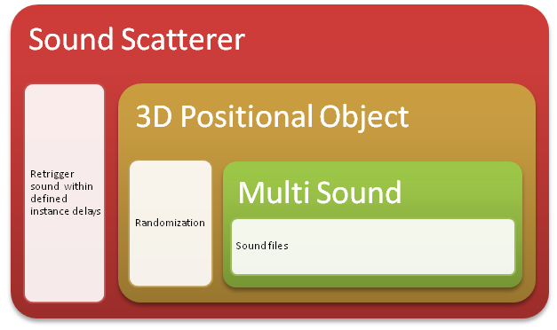
Nested Module objects combined to produce a complex result

Event Instances
The layout of FMOD Studio does not immediately show how it works. The ability to cross-reference Events or nest them within other Events is very powerful. Events can be influenced and controlled in different ways simultaneously. This is why controlled Events are all actually individual Instances.
When you link an Event to another Event either through Game Parameter control of through nesting, that Event is exposed to manipulation from sources outside the Event itself. This means you could potentially have two sets of controls working contradictory to each other. This is why Instancing is applied.
Double-clicking on an Event shows the Properties and behavior of that event as a unique Instance in the Event window.
You can change its behavior in this window while still controlling it from the Parent Event without breaking the process. Effectively the Parent Event is controlling an exact copy of the nested Event within the Parent Event, while the window you have open is a duplicate instance. Upon playback, both versions play together and apply their individual Properties and controllers.
This process is the safest way for FMOD Studio to process complex combinations of simultaneous controls through multiple linked Event Properties.

Trigger Regions

Introduction
Trigger Regions represent Sound Modules in either the Timeline or Parameters and are a primary aspect of creating and controlling Sound Events within FMOD Studio. There are a series of functions that apply to working with Trigger Regions that need to be understood to get the most out of working in FMOD Studio.
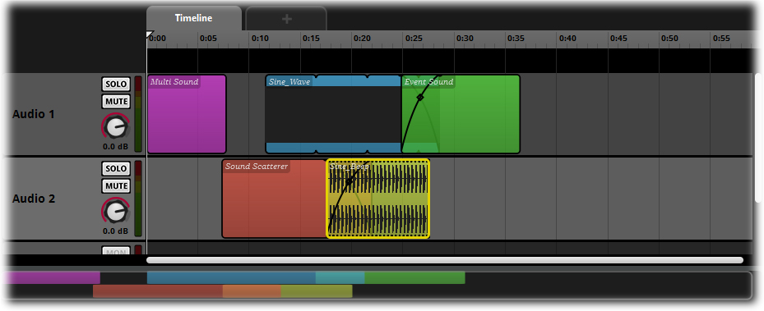
Trigger Regions

Trigger Region Names
All Trigger Regions can be named as required. For smaller projects with simple Sound Events the default naming system will most likely be enough, but for complex projects users can define the names of Trigger Regions to suit their project structure.

Auto Naming
FMOD Studio will automatically assign a name to a Trigger Region on creation. The exact name will depend on the Trigger Region type.
Trigger Region Type | Auto Name
Single Sound Module | Name of the sound file used to create the module
Multi Sound Module | Multi Sound
Event Sound Module | Event Sound
Sound Scatterer Module | Sound Scatterer
Copy/Paste of a module | Same name as original
Event References | Name of the referenced Event
Event Sounds Pasted | Name of originating Event

In all instances the Trigger Region’s name will be displayed on both the Trigger Region colored box in the Event Editor and the Deck Region for the Sound Module when it is selected in the Editor.
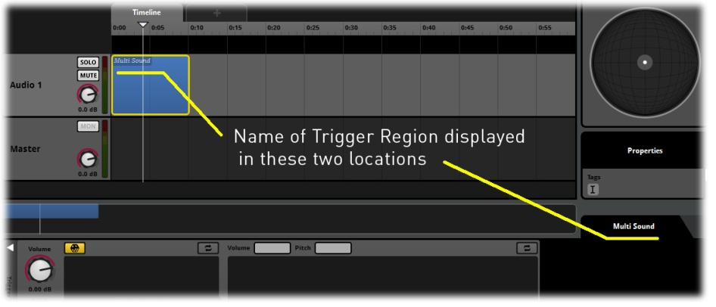
Trigger Region Naming

Renaming Trigger Regions
You can easily rename any type of Trigger Region by double clicking on the name in either the Trigger Region box or in the Deck area for the Sound Module. There is no limit on the number of characters that can be used to name a Trigger Region; however there is a limit on the number of characters that can be displayed, so it is best to keep names fairly short.
Note
How a name displays on a Trigger Region depends on the size of the Region Box on the Timeline or Parameter. In the Deck Area there is enough space for a name of approximately 25 characters including spaces, however the amount of space on the Region box depends on how big the Trigger Region is on the Timeline or Parameter. Smaller Trigger Region Boxes will only be able to display a few characters. If it is important for your project to be able to clearly distinguish between the Trigger Regions on a Timeline or Parameter then factor this in when you decide how to name your Sound Modules.

Trigger Region Colors
Trigger Regions default to a light blue color, this color can be changed as required. Using a range of colors for complex Sound Events can make editing and implementing much easier.
To redefine the color of a Trigger Region simply Right Click on the Trigger Region to access the Context Sensitive menu for that Region and select Set Color. An additional menu will provide a list of available colors that can be applied to your Trigger Region.
Note that the copy / paste function will copy a Trigger Region exactly so the pasted version will have the same name, color and any Properties of the original.
Trigger Region Color Options

Trigger Region Instances
A Trigger Region and its associated Sound Module can be copied and pasted as required within an Event or across any number of Events within a project. Right Click at the desired location and select Paste to place an exact duplicate of the copied Trigger Region and its Sound Module. This duplicate is an independent instance of the original copied object. This means that it can then be altered or redefined in any way without affecting its parent object or any subsequent child copies of itself. This is a quick way to use a Sound Module to rapidly populate a project with copies that can then all be edited as required.

Precise positioning for Trigger Regions
For basic positioning of Trigger Regions you can simply drag it to its desired position. More advanced methods for positioning Trigger Regions can offer more exact positioning solutions. These methods are accessed via the Trigger Region context menu that is displayed when a user Right Clicks on a Trigger Region

Move To…
The Move To… command will access a pop-up window that allows the position of a Trigger Region to be precisely defined. By default the length of the Trigger Region is locked to maintain the current size of the Trigger Region. This means defining Start and End values that exceed the locked length of a Trigger Region is not possible. Studio will accept the last inputted value and redefine the other value to match the locked length. If the Length value is unlocked then its value will be redefine to appropriately reflect the Start and End values.
Move to Function
This function allows you to define the exact size and start and end points of a Trigger Region. This is best used when the Trigger Region position is a critical aspect of Event creation and needs to be precise.

Move to Cursor
The Move to Cursor command is a quick way to reposition a Trigger Region to the location of the cursor. This can be particularly useful for working with Multi Track Events as this command will reposition a Region horizontally along the Timeline or Parameter while maintaining its position on the relevant Audio Track. Selecting this option will move the Trigger Region so as its start point aligns with the same value on the Timeline or Parameter as the cursor.

Bring to Front
You can position Trigger Regions on an Audio Track so that more than one Trigger Region occupies the same area. By default, FMOD Studio will create cross fade regions when Trigger Regions overlap, Studio will also display the last selected Trigger Region in front. The Bring to Front command will reposition a Trigger Region that shares an overlap with another Trigger Region and place it in the front position.

Send to Back
The Send to Back command is the opposite of the Bring to Front command. It will reposition a Trigger Region that shares an overlap with another Trigger Region and place it in the back.
Send to Back Function

The Logic Track

Introduction
Located just below the Timeline in the Event Editor, the Logic Track’s black strip provides specific and detailed control of how the timeline cursor moves during playback of Events.

Logic Track Display
Display or hide the Logic Track using the Logic Track disclosure triangle. Clicking on the triangle toggles the Logic track between being displayed and hidden. This is a useful way to maximize screen space when working with multiple audio tracks and large amounts of Logic content.

Loop Regions
A Loop Region defines two points on the Timeline. If the Cursor reaches the right end of the Loop Region it immediately snaps back to the left end of the region and continues along the Timeline from there. This effectively ‘traps’ the Cursor into a looping cycle within the boundaries of the Loop Region.

Note
When a Loop Region forces the Cursor to loop, the way it changes playback behaviour within FMOD Studio is entirely up to how Module Trigger Regions are set up in relation to the Loop Region. There are a variety of different effects that can be achieved with Loop Regions, but playback in FMOD Studio is always determined by the Cursor’s position in relation to a Module’s Trigger Region.

Creating a Loop Region on the Logic Track
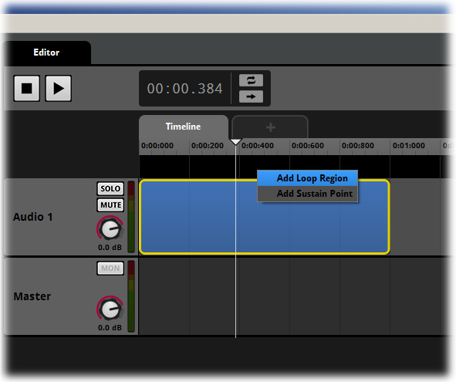
Creating a Loop Region
Take the following steps to create a Loop Region:
- Select an Event to make it active
- Right click on the Logic Track to display the context menu (this menu is only available on the Timeline Parameter).
- Select Add Loop Region from the menu.
The two edge markers of the Loop Region define the beginning and end of the loop. When this Event is auditioned, the Timeline Cursor advances along the Timeline and moves past the start of the Loop Region as normal. Once the Cursor reaches the Loop Region end it snaps back to the Loop Region start and continues to move through the Loop Region. The playback continues indefinitely until the Event is stopped.
A Module does not need to be set to looping for a Loop Region to function; Studio will simply loop cursor movement within the defined region. How effective a Loop Region will sound is dependent on the type and content of the Module and the placement of the Loop Region’s start and end points.

Creating a Loop Region on a Trigger Region
Take the following steps to create a Loop Region on a Trigger region:
- Select an Event to make it active
- Right click on a Sound Module’s Trigger Region to display the context menu.
- Select Add Loop Region from the menu.
Creating a Loop Region from the context menu of a Trigger Region will instruct FMOD to create a Loop Region that exactly fits the target Trigger Region. Technically the two loop edges are just outside the boundaries of the Trigger Region. They need to be in this position to correctly trigger the Trigger Region.

Sustain Points
Sustain Points are a type of Marker that can be placed on the Logic Track of the Timeline. The function of a Sustain Point is very simple:
When the Timeline cursor makes contact with a Sustain Point it will stop advancing forwards.(This will not necessarily pause all audio content of the event; See below.) There is no minimum or maximum time period that a Timeline can be paused for.
To deactivate the Sustain Point and allow the Timeline cursor to continue moving forward FMOD must receive a Keyoff command. This command must be sent in code. This means the behavior needs to be defined in game code by a programmer on your team. The Keyoff command can be simulated for audition purposes in FMOD Studio using the Cues button, marked A; Pressing this button causes the timeline cursor to ignore the next sustain point it comes across, or to cease being affected by the sustain point it is currently stopped at.

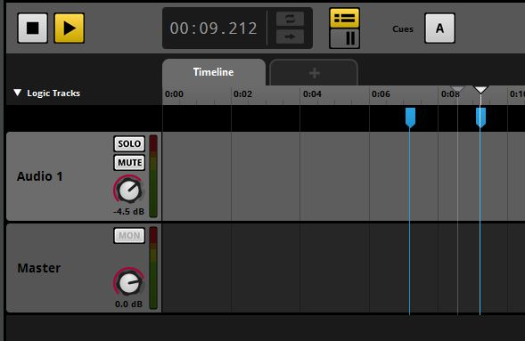
Sustain Points and the Cues button

There is no limit to the number of Sustain Points that can be added to an Event, but regardless of how many Sustain Points are created there is only ever a single Cues button that controls all Sustain Points in an Event.

Creating a Sustain Point
Take the following steps to create a sustain point:
- Select an Event to make it active
- Right click on the Logic Track to display the drop-down menu.
- Select Add Sustain Point from the menu.

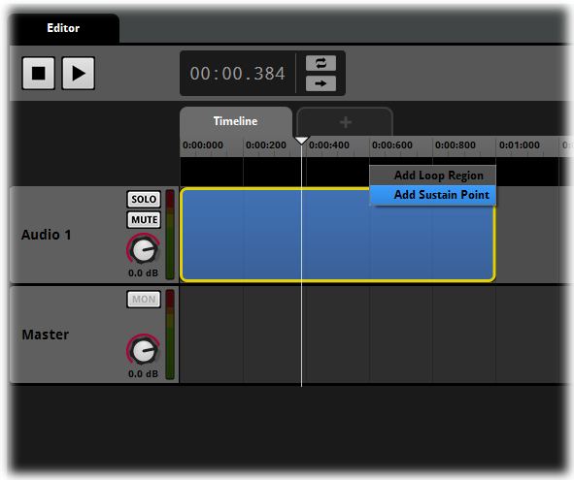
Creating a Sustain Point
Use the mouse to drag Sustain Points along the Logic Track. Delete a Sustain Point by right clicking on the handle at the top of the Sustain Point to open the context menu and selecting Delete.

Working with Sustain Points
The way a Sustain Point affects the playback behavior of an Event depends on how it is placed. If a Sustain Point is placed where it does not intersect with any Sound Module Trigger Regions, then it will pause the advancement of the cursor in the same position. This will effectively pause the Timeline playback on a silent region of the Timeline. This can be used to silence an Event without completely stopping its playback if you need to, provided there are no Sound Modules on the event’s other Parameters.
If a Sustain Point is positioned so that it intersects with a Sound Module Trigger Region it will also pause the advancement of the Timeline cursor, but the exact effect this will have on playback depends on the type of Sound Module.

Timelocked Sound Modules
A Timelocked Sound Module will behave in the same manner as a linear editor in relation to cursor movement. The cursor ‘reads’ the sound-file and tracks its progress visibly across the displayed waveform, so if the cursor movement is halted by a sustain point, playback is also halted at the exact position of the cursor.

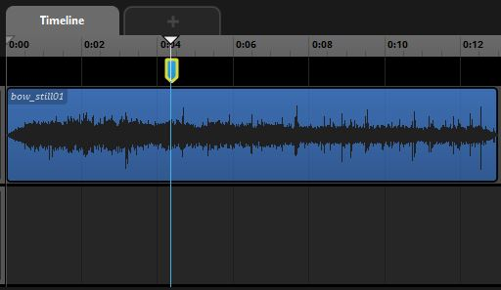
A Sustain Point on a Timelocked Sound
Once the Keyoff command is given the Timeline Cursor continues tracking time and the Timelocked sound continues play from the exact position of the Sustain Point. It is of course possible to add multiple Sustain Points across just a single sound so that playback can be paused and resumed in multiple positions.

Non-Timelocked Sound Modules
Non-Timelocked Sound Modules behave differently in relation to the cursor position on the timeline. A non-looping non-time locked Sound Module, once triggered on the Timeline, will play through to the end and stop playing, so a single shot non-looping non-time locked Sound Module will not be affected by the pausing Timeline cursor by a Sustain point. A looping non-time locked Sound Module will continue to play so long as it is triggered, and so will not cease playback if the timeline cursor pauses on it due to a sustain point. This is another method of creating a loop effect within FMOD Studio.

Note
Users can combine Loop Regions and Sustain Points. The Sustain Points need to be placed inside a Loop Region and Studio will pause at each Sustain Point until Keyoff is triggered. Once the Cursor reaches the end of the Loop Region it returns to the beginning and all Sustain Points will function again as expected.

Timelocked and Non-Timelocked Sounds
FMOD Studio has two types of Sound Module for the purposes of playback behavior:
- Timelocked Sound Modules.
- Non-Timelocked Sound Modules.
The way in which these two types of Sound Modules behave can be considerably different depending on the layout of an Event and the behavior of the Cursor. In all situations the basic playback behavior in FMOD Studio comes down to the following.
- Sound Modules are represented by their associated Trigger Regions on either the Timeline or on a Game Parameter.
- A Sound Module is triggered when the Cursor intersects with its Trigger Region and untriggered when the Cursor ceases to intersect it.
- The nature of the playback behavior when triggered or untriggered depends on the kind of module and its settings.
Timelocked or Non-Timelocked status, position on the Timeline or Parameter, trigger logic and playback logic can all affect playback behavior.

Timelocked Sound Modules
A Timelocked Sound Module is any Single Sound Module that is not set to loop and whose Trigger Region is on the Timeline. Unless subject to pitch adjustment, when a Timelocked sound plays, the position of the cursor on the waveform indicates the part of the sound that is playing.

So, just like in a sound editing tool you can position the cursor at a specific place on the wave form and FMOD will play from that point. This means that a Loop Region that forces the Cursor to loop on the Timeline will loop any areas of a Time locked sound that are intersected by the Cursor’s movement. It also means that if the Timeline cursor stops moving due to a sustain point, that trigger region will produce no audio, as the cursor will not be progressing through the waveform.

Non-time Locked Sound Modules
Any Sound Module that does not meet the criteria of a Timelocked Sound Module is treated as a non-time locked Sound Module. Non-Timelocked Sound Modules do not display a wave form in the trigger region because it would make no sense for them to do so. This could be because the Sound Module contains multiple sound files and it would be impossible to display just one, such as in a Multi Sound or Scatterer Sound Module; It could also be because the Sound Module is set to loop and so the relationship between the Cursor and the part of the waveform displayed on the Trigger Region is unpredictable.

A Non-time Locked Sound Module, like any Sound Module, is triggered by the Cursor intersecting with its associated Trigger Region. If not set to loop, a Non-Timelocked Sound Module triggers when the Cursor makes contact with its Trigger Region. Once triggered, the sound plays out in its entirety and then stops. If the a Non-Timelocked Sound Module is set to Loop, the sound triggers when intersected by the Cursor and loops so long as the Cursor continues to intersect the Trigger Region, and stops playing immediately that the Cursor ceases to be in contact with the Trigger Region. This behavior is the same no matter how long the actual sound files and playlist entries are.

Note
You can combine both Loop Regions and Sustain Points. If Sustain Points are placed inside a Loop Region, Studio pauses at each Sustain Point until Keyoff is triggered. Once the Cursor reaches the end of the Loop Region it returns to the beginning point and all Sustain Points will function again.

Loop Region Logic Functionality
Selecting a Loop Region causes its Module to be displayed in the Deck area.
A Loop Region can be made to function only while a certain condition is met by assigning it a Parameter condition through the Logic Module. Select which Parameter you wish to use to control the Transition Region by right clicking on the section of the Module marked with a ‘+’ and selecting the desired Parameter from the context sensitive menu. This causes FMOD Studio to add the logic condition to the Logic Module. Use the Ribbon Slider of this Module to define a range of values by setting a minimum and maximum value or a single value by setting both ends of the ribbon slider to the same value.
During playback, the Loop Region functions normally whenever the value of the Game Parameter is within the range defined in the Logic Module, but when the Parameter Cursor is outside of the defined range the Cursor will continue to move along the Timeline as if the Loop Region were not there.

Note
There are four ways to create looping playback within FMOD Studio:
- A Module’s looping playback setting sets one or more sounds or playlist entries within that Module to loop continuously, so long as that Module is intersected by the cursor.
- A Loop region within the Event Timeline causes the Timeline cursor to loop over that section of the timeline.
- A destination marker and transition marker can produce a similar effect.
- Dragging a Timelocked single Sound Module’s right edge to the right causes its waveform to be repeated a fixed number of times.

Tempo Markers
Tempo Markers are used to define the Tempo and Time Signature measurements when working with the Timeline. Defining values with Tempo Markers alters what information is displayed on the Timeline ruler, but it does not alter the speed at which the Timeline cursor advances. The Timeline cursor will always measure milliseconds, seconds, minutes and hours. The Timeline Display will simply adjust to display bars and beats accurate to real time depending on the defined values.

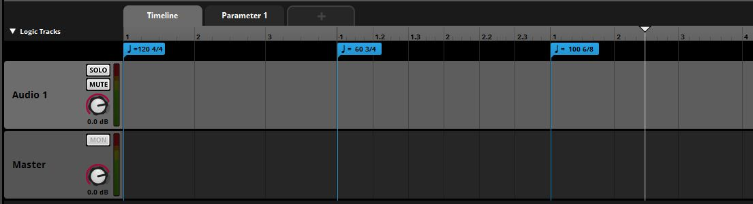
Three Tempo Markers on the Logic Track

FMOD Studio measures bar and beat values and adjusts the rate of measurement as it reaches each Tempo Marker. Quantization information appears relative to the tempo in the Logic system. Beat and Bar measures on the Track Ruler adjust to correctly display Beats and Bars in relation to the Timeline according to the tempo.
FMOD Studio applies a defined tempo to the right of each Tempo Marker. The Timeline to the left side of the leftmost of an Event’s Tempo Markers is essentially Tempo 0, and as such does not support quantization.
Time Signature values can be defined as follows:
Numerators: 1-999
Denominator: 1,2,4,8 or 16
There is no limit on the defined tempo for Tempo Markers.
Tempo Markers also function as quantization points, making them useful for working with music that includes variations in its tempo, such as almost any recording of live musicians. Each Tempo Marker redefines the bar and beat measures to its right as if a new bar started from that point, so the marker itself can be used to define specific quantization points.

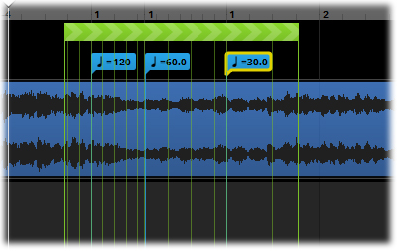
Tempo Markers function as Quantization points

Markers
Markers in FMOD Studio serve two purposes. Firstly they can be very useful for simply indicating certain points along the Timeline and providing a label with useful information. In this capacity a Marker has no functionality beyond being a label. It can be created, named and repositioned as required but it will not affect the playback behavior of the Event in any way.
When used as destination points, Markers provide a landing point for the Cursor when it is redirected by Transition Markers and Transition Regions.

Creating a Marker

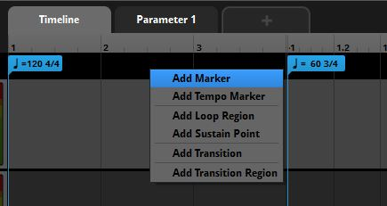
Creating a Marker
- Select an Event to make it the active Event
- Right click on the Logic Track to open the context menu.
- Select Add Marker from the menu.
- Type a name for your new Marker.
Markers can be moved along the Logic Track by dragging them with the mouse. A Marker can be deleted by right clicking on the head at the top of the Marker and selecting Delete from the context menu.

Transition Timelines
Transition Timelines are a feature of the FMOD Studio Logic System. A Transition Timeline is a self-contained miniature Timeline associated with a Transition Marker. When the Timeline cursor reaches the transition marker, it moves along the associated Transition Timeline before arriving at the destination Marker.
If the values of an existing Automation create a significant difference between the Transition point and the Destination Marker of a Transition Timeline, the Transition Timeline automatically blends between the automation values. This produces a smooth transition without the need to rework the existing Timeline or Parameter automation data.

Programmer Sound Modules
Programmer Sound Modules can be added to Event Audio Tracks. These are a special type of sound Module that allows the source audio to be specified in game code at run time. More details about Programmer Sound Modules can be found in the FMOD Studio Programmer’s API Documentation.

Multiple Projects
You can open more than one FMOD Studio project at the same time. Each such project displays in its own set of windows, just as if it is the only project open.
To open an additional project when there is already a project open, select ‘Open...’ from the ‘File’ menu then select the project. To have only one project open at a time you will need to manually close any projects that you do not want open, or exit and restart Studio and open only the project that you want.
Note
If the current project that is open is an empty project with no changes FMOD Studio will close this project when a new project is opened.
You can copy and paste project elements between projects. To do this, both projects need to be open when an object is pasted from one project to another. You cannot copy from Project A, close project A and try to paste into project B. This is because some objects may take up more memory than can be comfortably contained on the operating system’s clipboard.

FMOD Studio Music System

Introduction
FMOD Studio includes a series of tools designed to assist in the creation and implementation of musical works for games. The distinction between music and sound design in games is often blurred. For this reason, all features of FMOD Studio are designed to be flexible enough that the ‘Music’ tools are suitable for sound design purposes and vice versa. That said, the following tools are classified as musical tools because they deal with many aspects of production more often related to music than to other sound.

The Logic Track
The Logic Track allows you to control the playback behavior of the Timeline of an Event. The Logic Track can have markers placed along it horizontally to define specific behaviors as occurring at points along the Timeline. It can also be expanded vertically to allow multiple levels of placement on a vertical axis. Placement vertically applies a priority to the various markers within the Logic Track. A marker placed higher on the Logic Track will be prioritized more highly than markers positioned lower on the Logic Track.

Markers
The simplest way to use a Marker is to indicate a section or significant area by placing and naming a Marker. In this case, Markers are being used much like a street sign. They mark an area with a word or message that can provide useful information to the users or team of users while developing a project. This function can also be very useful for educational purposes as you can clearly indicate various aspects of a project with Markers.

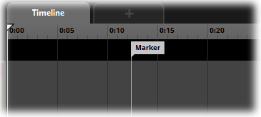
Markers
Markers also have a purpose within the Logic system: Markers can be set as Transition destinations. In this case they quite literally work as street signs as Studio can be instructed to jump to a Marker location when the Transition Marker’s conditions are met.

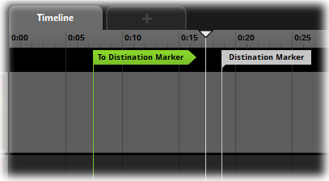
Markers and Logic

Creating Markers
Right click on the Logic Track and select Add Marker from the context sensitive menu to add a Marker. A new Marker will be created at the point where you clicked on the Logic Track. Note that logic markers of any kind can only be created on the Timeline.
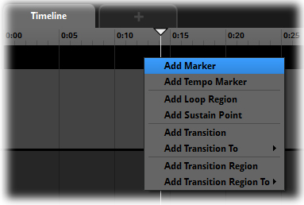
Add a Marker

Working with Markers
Move Markers by dragging them back and forth or up and down on the Logic Track. Rename a Marker by double clicking on the head of the Marker. To delete a Marker, either click on it to make it active and press the Delete key, or right click on the head of the Marker and select Delete from the context sensitive menu that appears.
Any number of Transitions and Transition Regions can point to the same Marker.
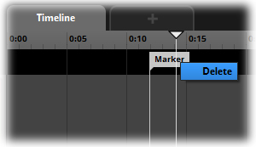
Deleting a Marker

Tempo Markers
Tempo Markers look similar to Markers and share most of the basic workflow. The difference is that Tempo marker defines the musical tempo applied to the Event Timeline from the position of the Tempo Marker onward. Multiple Tempo Markers result in the Tempo being different on different parts of the timeline. Tempo Markers also define the time signature of the Timeline making regular changes of time signature possible using multiple Tempo Markers
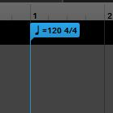
Tempo Marker
The Tempo of an Event does not affect the rate at which the Cursor progresses along the Timeline. However, A Tempo Marker applies tempo measurement to the Timeline for the purposes of quantization for Trigger Region activation. So a Tempo Marker is used in conjunction with the Trigger Behavior Drawer that is part of all Sound Modules.
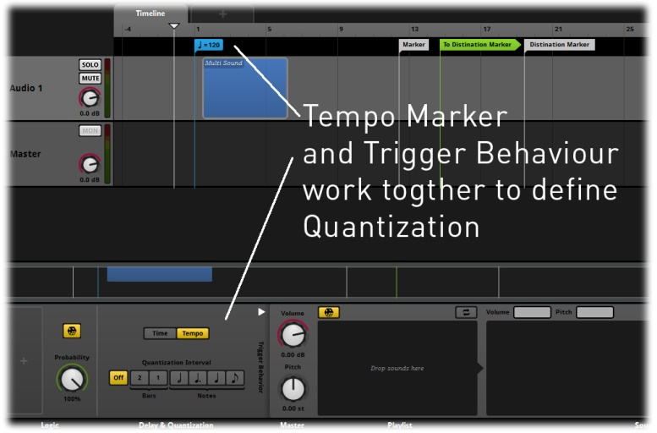
Defining Quantization

Creating Tempo Markers
Tempo Markers are created by right clicking on the Logic Track and selecting Add Tempo Marker from the context sensitive menu. A new Tempo Marker is then created at that point. Tempo markers, like other markers, can only be created on the Timeline and not on other Parameters.
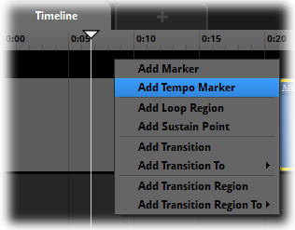
Adding a Tempo Marker
When you create a Tempo Marker in an Event, the Timeline changes to display Bars and Beats. The distribution of the Bar and Beat measures depends on the tempo defined in the Tempo Marker.

Defining Tempo
By default a Tempo Marker is created displaying 120 BPM. This value can be altered by double clicking on the Tempo Marker head and inputting the desired tempo value. Altering the Tempo value will result in the Bar and Beat measures on the Timeline being repositioned accordingly.

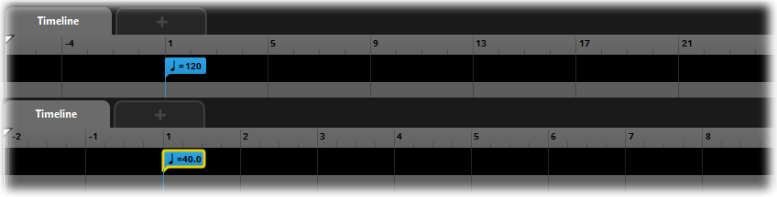
Default Tempo Markers

Working with Tempo Markers
Tempo Markers can be moved by simply dragging them back and forth or up and down on the Logic Track. To delete a Tempo Marker, either click on it to make it active and press the Delete key or right click on the head of the Marker and select Delete from the context sensitive menu that appears.
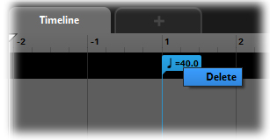
Deleting a Tempo Marker
Note
The position of a Tempo Marker indicates where the tempo of an Event is defined. Because the speed of the cursor along the Timeline usually reflects real time, the placement and positioning of the Bar and Beat measures automatically change to reflect the tempo as defined by the most recent Tempo Marker. So, while a distance on the Timeline that equals ten seconds of time still equals ten seconds of time if the tempo is changed, the number of bars and beats within those ten seconds will change to fit depending on the defined tempo.

Transitions
Transitions are a type of Marker that directly affects the flow of Event playback. A new Transition can be linked to an existing Marker or created as a blank Transition to be linked at a later time. A Transition will serve no purpose unless it is provided with appropriate information to define the transition logic. A Transition is automatically named to indicate its destination.

Transitions

Creating Transitions
To create a Transition Marker right click in the Logic Track and select Add Transition or Add Transition to.. from the context sensitive menu. If Add Transition To.. is selected a further context menu will display to allow a user to select from the available Transition targets. A new Transition will be created at the point where you clicked on the Logic Track.

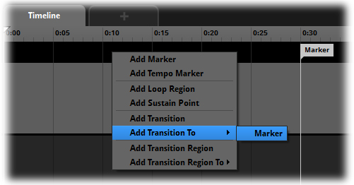
Creating a Transition

Working with Transitions
Move Transitions by dragging them back and forth or up and down on the Logic Track. To delete a Transition, either click on it to make it active and press the Delete key, or right click on the head of the Transition and select Delete from the context sensitive menu that appears.

Transition Functionality
A selected Transition displays its Logic Module in the Deck area. Transitions function by defining a Parameter as a Parameter condition.
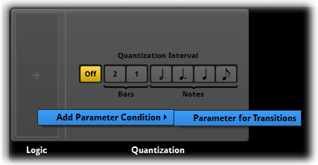
Selecting a Parameter for your Transition
Select which Parameter you wish to use to control the Transition by right clicking on the Logic Module’s ‘+’ area and selecting the desired Parameter from the context sensitive menu. This causes FMOD Studio to add the Parameter condition to the Logic Module. The Logic Module allows a user to define the value or the Parameter that will trigger the Transition behavior. Define either a single value by entering the same number into both ends of the Ribbon Slider or a range of values by defining a minimum and maximum value with the Ribbon Slider.

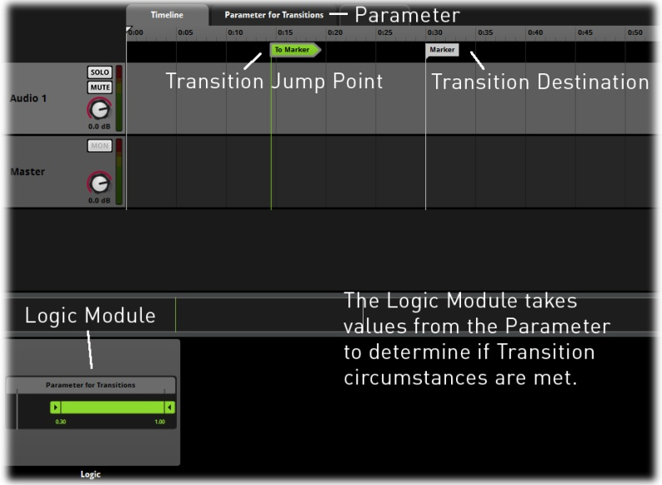
Transition Functionality
During playback FMOD Studio references the Logic Module when the Cursor makes contact with the Transition Marker. If the value of the Game Parameter is in the range defined in the Logic Module, Studio will instantly jump the cursor position to the target Marker and continue Cursor progression from that point. If the Parameter does not equal the defined values, the Cursor will continue to move along the Timeline as normal.

Transition Regions
Transition Regions are a type of Marker Region that directly affects the flow of Event playback. A Transition Region works just like a Transition Marker but can be extended over an area instead of a single point on the Timeline. When a Transition Region is created it can be defined to link to an existing Marker or it can be created as a blank transition to be linked at a later time.
A Transition Region will serve no purpose unless it is provided with appropriate information to define the transition logic.
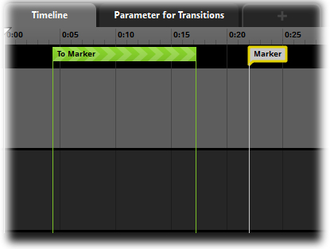
Transition Regions

Creating Transition Regions
To create a Transition Region right click in the Logic Track and Select Add Transition Region or Add Transition Region to from the context sensitive menu. If Add Transition Region To is selected, a further context menu allows you to select from the available destination markers. Whether or not you select a destination marker as a target, a new Transition is created at the point where you clicked on the Logic Track.

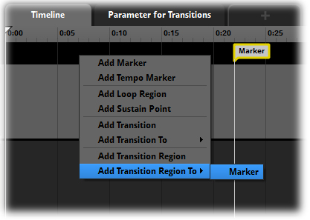
Creating a Transition Region

Working with Transition Regions
Move Transition Region end points by dragging them back and forth or up and down on the Logic Track (moving up or down will reposition the entire Region on the new vertical axis). A Transition Region is automatically named to indicate its destination. To delete a region click on it to make it active and press the Delete key, or right click on the head of the Marker and select Delete from the context sensitive menu that appears.

Transition Region Quantization
A Transition Region’s Module also includes a Quantization section displayed in the Deck area. The Quantization section allows the user to define acceptable transfer points within the region. This means that Studio will not simply perform the transition at any point in time. Instead it will wait until it reaches a suitable bar or beat as defined by the Quantization section.

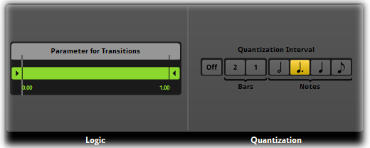
Quantization
When a particular quantization value is selected on the Quantization section, the Transition Region displays those points on the Timeline with additional marker lines. This makes it clear exactly where transitions can occur within the region.

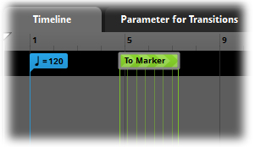
Quantization Marker Lines

Transition Timelines
Both Transition Points and Transition Regions allow for the creation of Transition Timelines. A Transition Timeline is a sub Timeline that exists only as part of its associated Transition. This function allows you to add content to a Transition Point or Transition Region that is activated when the Transition is triggered. Essentially the cursor on the main Timeline is diverted to the destination Marker via the Transition Timeline. This can be very useful in dynamic music as a way of providing actual transitional content to be played to blend the two points of transition.

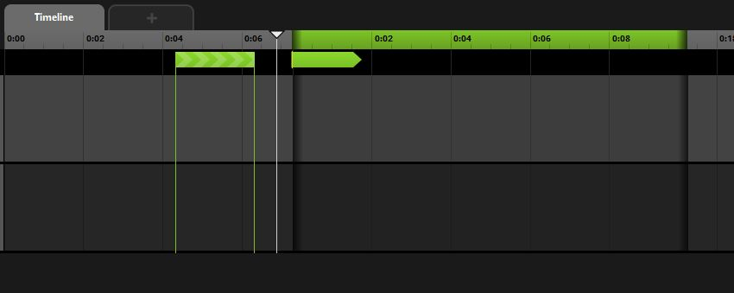
A Transition Timeline opened from its Transition Point

To create a Transition Timeline, double click on the target Transition Point or Transition Region. FMOD Studio then creates or opens the Transition Timeline as displayed in the previous image. Once created, a Transition Timeline can have content created, copied and pasted into it in the same way the main Timeline can.
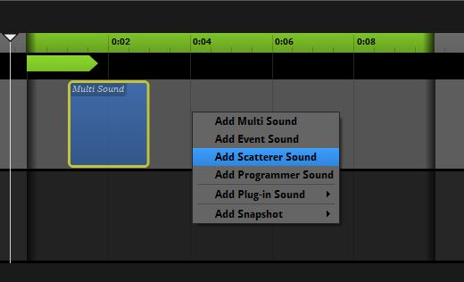
Creating Modules within a Transition Timeline
Automation can be added to objects within the Transition Timeline and Automation Tracks will continue to function through a Transition Timeline. This allows the user to automate the properties of Modules outside a Transition Timeline within a Transition Timeline.
Transition Timeline duration is displayed by the values of its green Timeline display. Adjust the duration by moving the edges of the Transition Timeline Region.
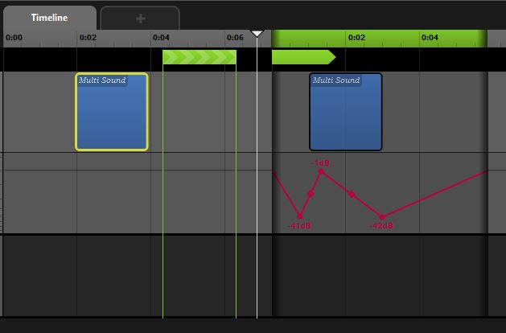
The Automation within the Transition Timeline is the for Module outside of it
A Transition Timeline cannot include Logic elements within it so the Timeline will display and measure Tempo, bar and beat measurements relative to the most recent Tempo Marker to the left of the associated Transition Marker. If no Tempo Marker has been added to the Event the Transition Timeline’s ruler displays seconds and minutes.
To close a Transition Timeline simply double click on its associated Transition Marker or Region. Double clicking again opens the Transition Timeline and displays its contents. Dragging the right edge of a transition timeline to meet its left edge automatically deletes the Transition Timeline and all its contents, so be careful when creating very small Transition Timelines. We recommend you zoom in using the Birdseye view to avoid losing any data.
It is also possible to delete a Transition Timeline from a Transition Marker or Region. First make sure the Transition Timeline is closed and then right click on its associated Marker or Region and select Remove Transition Timeline from the context menu.
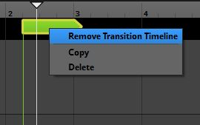
Deleting a Transition Timeline
Technically, there are no limits to the number of Transition Timelines you can create and work with, however practical considerations during design are another matter.

Loop Regions and Sustain Points
Both Loop Regions and Sustain points function in the exact same manner they do in non-musical FMOD Studio Events, and can be used in conjunction with all the other Logic Track markers. This means, for example, that a Loop Region can be combined with Transitions and Markers to create a looping section of an Event that, under the correctly defined Parameter values, jumps from the loop to another area of the Timeline.
Note
Destination Markers, Transitions and Transition Regions can be placed anywhere on the Timeline in relation to each other. This means that Transitions can jump either forward or backward along the Timeline. The head section of a Transition will point in the direction of its associated Marker as a visual aid for how the Logic of the Event will play out. Transitions cannot be moved during Playback as this can change the entire relationship of playback to time and cause playback errors and issues.

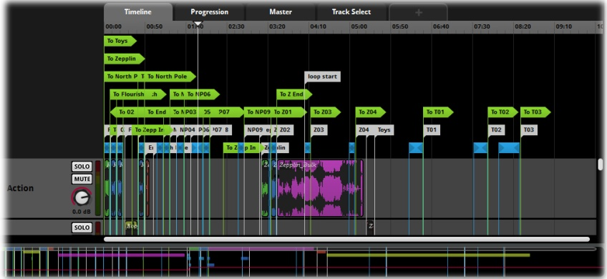
Loop Regions and Sustain Points

Trigger Behavior
All Sound Modules contain a Trigger Behavior drawer in the Deck area. This drawer is used to define Delay and Quantization behavior for a Sound Module. The Trigger Behavior drawer can be accessed by clicking on the white disclosure triangle at the left edge of the module. This extends the drawer and allows access to the Trigger Behavior Properties.
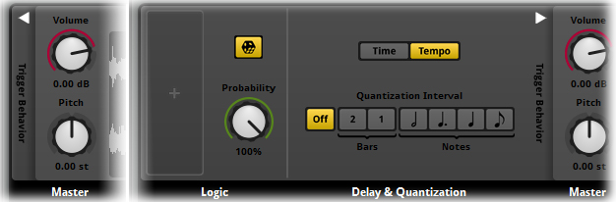
Trigger Behavior
By default the Trigger Behavior of a Sound Module is set to immediate triggering with no quantization. This means that by default, a Sound Module triggers the instant the Cursor makes contact with the Trigger Region in either the Timeline or in a Game Parameter. It also means the Sound Module will untrigger the instant the Cursor is no longer in contact with the Trigger Region.
Note
‘Untriggering’ means slightly different things depending on the placement of the Trigger Region and the type of Sound Module. A looping Sound Module stops playing as soon as the Cursor moves off its Trigger Region, while a non-looping Sound Module plays through until its end. A Timelocked Sound Module in the Timeline falls silent immediately when untriggered.

Defining Trigger Behavior
There are two methods of defining Trigger Behavior in FMOD Studio. Time allows an absolute period of time or range of time to be defined as a delay before a Trigger Region commences playback. Tempo is used to provide quantization information for triggering playback using musical measures of Bars and Beats.
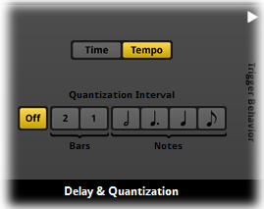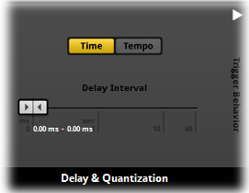
Time or Tempo

Time
The Time Property of the Trigger Behavior allows a user to define the period of time that Studio will count before a Sound Module begins to play. While a Sound Module is triggered the instant the Cursor makes contact with its associated Trigger Region, it does not actually have to start playing the sound at this point. The Time Property can define a delay in the playback.
The Time area has a Trigger Delay Property that works via a Ribbon Slider. The slider defines the minimum and maximum time values in milliseconds or second before a Sound Module will start to play its sound once activated. If both the min and max values are the same then a fixed delay will always be applied to that Sound Module every time it is activated. If the min and max values are different then they create a window in time. FMOD Studio will count at least the min time value and no more than the max time value, but between those two it will randomly select a period of delay to apply to the Sound Module.
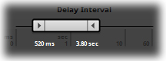
Trigger Delay Property

Define the values by either dragging the ends of the Ribbon Slider to the desired values, or double clicking on the displayed numbers to directly input exact values.

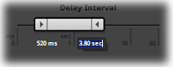
Entering Exact Values

Note
Users can define both Delay and Quantization Properties and combine the results of both. Be careful with this to avoid introducing undesirable playback behavior.

Tempo
The Tempo area defines Quantization behavior for Event using various Logic Track markers. A Tempo Marker must be included in an Event to make use of Tempo quantization.
Tempo Marker
When an Event includes a Tempo Marker, FMOD Studio applies tempo tracking as well as counting regular time. Tempo quantization allows a user to define when Sound Modules trigger in relation to the Event Tempo. This allows Sound Modules to be delayed slightly so that they trigger in time with the defined Tempo and as such sound more “musical”.
Once a Tempo Marker is added to an Event, the Timeline changes to display tempo measures in Bar and Beat format. Sound Module Trigger Regions can be moved to align with these measures, but the Quantization property will ensure they trigger in sync with the musical measures.
The Quantization Property can be set to either bar values of 1 or 2, or Beat values of minim, crotchet, dotted crotchet or quaver measures.

Parameters
Parameters are a powerful tool for controlling the play back behavior of Sounds and Events within FMOD Studio. The Timeline Parameter is included by default in all Events. There are also a number of “Built-in” Parameter types available, that are automatically updated based on data on the event’s position provided to FMOD by the game. All user-defined Parameters are referred to as Game Parameters because they take their values from data provided from the game project.
Definition of Parameters
A Parameter is a controller designed for the manipulation of arbitrary values specific to a project. FMOD Studio utilizes Parameter values to control the states and values of a variety of audio effects and signal processors.

This section will explain how to create Event Parameters and how to apply Parameter Automation Properties.
Note
By default FMOD Studio creates Events with only the Timeline displayed. Different Event Parameters can be added as required.

Step 1 Creating a Parameter
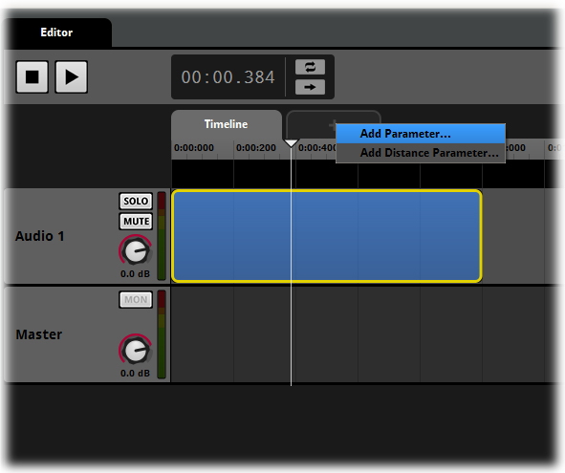
Create a Parameter
- Right click next to the Timeline tab above the ruler.
- From the context menu select the desired Parameter type.
- Enter the desired name for the new Parameter.
- (Optional) Enter the desired range for the new Parameter.
An Event can include multiple Parameters. Parameters can be used to represent controllers connected to data in a game project. RPM, speed and engine load are all common Parameter types associated with vehicle sounds. Footstep surface type, hit-points and ammunition might be relevant to an FPS style project, while time of day, weather, seasons and geographical locations could all be controlled to create the dynamic ambiances of an open world game project. There is no limit to what you can define as a Parameter to control playback behavior.
Defining Parameter types and the most appropriate measurement scale is an important part of initial planning prior to Event creation. Because of its nature and method of workflow, FMOD Studio will almost always provide a variety of different methods to achieve similar output playback. While this does mean that it sometimes requires a bit of experimentation to produce the most useful result it also means that if one particular method is not working exactly as required there will almost certainly be another approach that might offer better options.

Note
Each newly created Parameter has a tab just like the Timeline. Click on the tabs to switch between Parameters and Timeline as required.

Important
An Event is not limited to including Sound object on either the Timeline or a Parameter. A single Event could include multiple sounds across multiple Audio Tracks in the Timeline tab that are trigger as time progresses, while simultaneously including Modules on a Parameter that are triggered when appropriate Parameter values are received. This functionality allows for very complex sound creation scenarios.

Parameters represent a range of different data that can be useful for creating dynamic sounds in a game project. Certain built-in Parameters automatically calculate this data, such as distance, direction, elevation, Event orientation and Event cone angle. Game Parameters can be directly updated in game code, but an Event only changes its playback behavior due to Parameter value changes if the changing Parameters contain automation or trigger regions, or if those Parameters are used by a conditional logic module.

Parameter Properties
When a Parameter is initially created a dialog box allows you to define the name of the Parameter as well as its minimum and maximum range values. These values can be edited at any time by right clicking on the Parameter tab and selecting Edit.
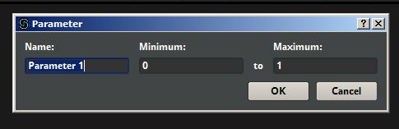
Parameter Properties

Parameters also have additional Property Modules that can be displayed in the Deck region by clicking on the Parameter Tab gray space to either side of the Parameter’s name. This displays the Value and Smoothing Module in the Deck region for the selected Parameter.

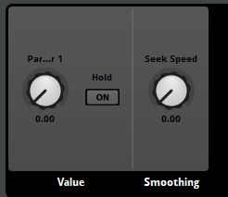
Parameter Property Module in the Deck

Parameter Value Module
The Parameter Value Module defines two Properties for the related Parameter. The dial is a replica of the Parameter dial that exists in the Transport region at the top of the Event Editor. Making changes to the value of either of these dials will result in both moving as they are essentially the same controller. This dial provides a secondary controller which may be useful if your Event contains lots of Parameters.
The Value Dial also allows users to define the value at which a Parameter will be initially set at when an Event is triggered. This can be quite useful as many sounds do not automatically sound good when triggered with a Parameter value at its lowest range. When this dial is altered the value will indicate the value on the Parameter you wish to define and the Parameter Cursor will move to match this value. To set the initial value for a Parameter right click on the dial and select ‘Set as Initial Value’ from the context menu. This will set the current displayed value for the Parameter as the default starting value.
The Value Dial will be named identically to and have the same range as its Parameter. Its default value will always be whatever the minimum defined value of the Parameter was when it was created. If the minimum defined value is changed at any time and the displayed value will alter to maintain a relative value. If the dial is double clicked, it returns to its initial value.
The Hold Radio button toggles on and off the Parameter’s Hold Property. If set to Hold, a Parameter’s value will not be updated once the Event is triggered. This means that whatever Parameter value was defined at the exact time that the Event was triggered will be locked in while the Event is playing.
Many games provide data that is used to define the playback behavior of a sound Event, but it is not always desirable to update and change that data once the Event has started playing. The data is always being provided to FMOD once the link is established. This Property provides greater control of how that data is utilized.

Parameter Smoothing Module
The Parameter Smoothing Module allows the user to define a seek speed for the selected Parameter. At the default value of zero, changes in the Parameter’s value will happen instantly and the Parameter will snap to a newly defined value with no delay. Defining a seek speed gives control over the rate of movement of the Parameter cursor when changes in Parameter values occur.
The Seek Speed property is unusual in that it does not have a fixed range of values. The values displayed are relative to the value range of their parent Parameter, but the overall effect is consistent.
The Seek Speed defines how many Parameter ruler units the Cursor will move in a second. At its maximum value the Seek Speed Property will result in the Parameter Cursor taking exactly one quarter of a second to move from the Parameter’s lowest value range to its highest value range. This is why the Seek speeds overall range is variable. When a Parameter is created with a range of 0.00-1.00 and its Seek Speed Property is 4.00, the Parameter Cursor will be able to move from the Parameter values of 0.00 to 1.00 in 250 milliseconds. If the Parameter’s overall range was redefined from 0.00-5.00, then the maximum Seek Speed would be 20.00, and if Seek Speed was set to that, the maximum movement time for the Parameter Cursor going from one end of the Parameter to the other would be 250 milliseconds.

Parameter Modulation
Random, AHDSR and Sidechain modulation can be added to a Parameter. To add modulation to a Parameter, right click on its dial in the Transport area or in the Deck and select the desired modulation type from the context menu’s ‘Add Modulation’ submenu.

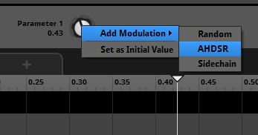
Adding Modulation to a Parameter

Distance Parameter
The Distance Built-in Parameter automatically calculates the distance in the game world between the Listener and an instance of the Event’s Emitter.

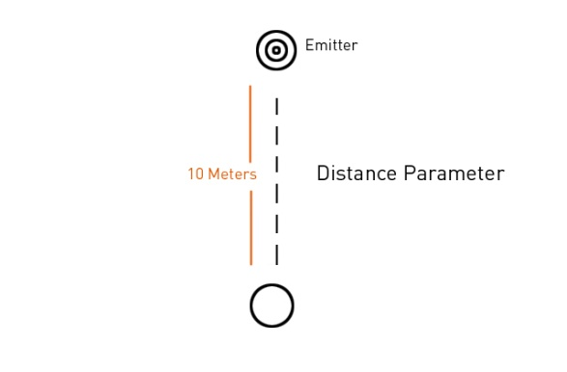
Distance is measured in game distance units

Direction Parameter
The Direction Parameter represents the angle to an Event emitter from the listener’s direction of facing in a 3D game world. This is represented in degrees from -180⁰ to 180⁰ with 0⁰ being directly in front of the listener and 180⁰ positioned directly behind.
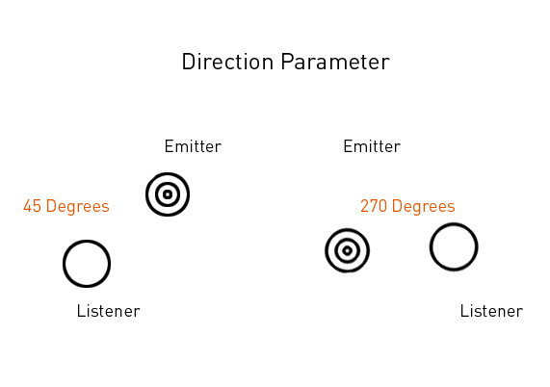
-90 Degrees
Two examples of 3D position setting Direction Parameter

Elevation Parameter
The Elevation Parameter functions in a similar manner to the Direction Parameter but instead of measuring direction on the horizontal plane it measures it on the vertical plane. Thus, an Event five distance units away from the listener and at an altitude three distance units greater than it will have an elevation of about 36.9 Degrees.

Event Cone Angle Parameter
The Event Cone Angle represents the angle between the direction towards the Listener and the Event’s facing, and is often used to define the size of the emission cone for an Event. Some sounds emit in a non-spherical manner and this Parameter can be used to define playback behavior for these conditions.

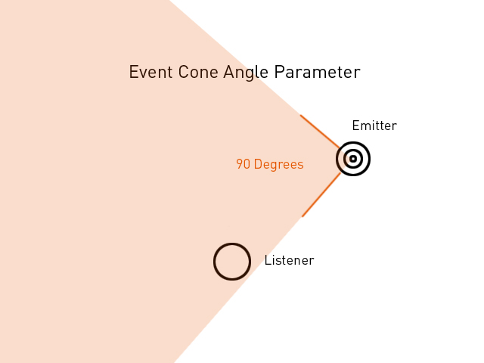
The Event Cone Angle Parameter defines how the sound projects at different angles

Event Orientation Parameter
This Parameter measures the difference between the orientation of the Listener and the orientation of the Sound Emitter for the Event. If both the Listener and Emitter are facing the same direction the difference is 0 degrees, if the Listener turns to the right by 90 degrees and the Emitter turns to the left by 90 degrees the difference would now be 180 degrees. This only takes into account orientation on the horizontal plane.
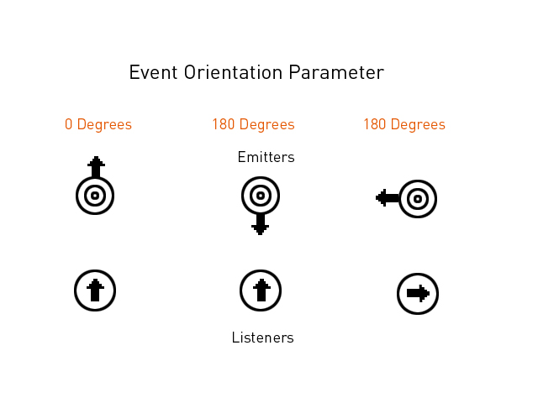
Event Orientation based on the orientation of both Emitter and Listener

The Timeline Parameter

Introduction
The Timeline Parameter is the default setup for Events created in FMOD Studio and measures time.
The Timeline functions in a very different manner to other Parameters. The most obvious characteristic of the Timeline is that it not only does it measure time with its values but it forces the cursor to advance through time as part of the play process in a way similar to many linear audio editing programs.
The Timeline incorporates the Logic Track that allows the creation of Loop Regions, and Sustain Points, and other logic markers. The nature of these markers means they need a time-based Parameter in which to work. The Timeline also includes the Time display that corresponds to the value of the cursor as it moves along the Timeline.

Aspects of Time-based Events
There are several aspects of time-based Events that need to be understood to avoid unexpected playback behavior. The non-linear nature of FMOD Studio means that even the Timeline does not always reflect the standard passing of time during playback.

Timelocked sounds
Timelocked sounds are Sound Modules that contain a single consistent and predictable sound file. The Trigger Region for a Timelocked sound actually displays the wave form of the sound file. Files that are not Timelocked cannot display the wave form for the simple reason that there is no consistent wave form to display. A Multi Sound Module is an example of a Non-Timelocked sound. The fact that a Multi Sound Module can contain any number of sound files means that it is impossible for Studio to display a single wave form.

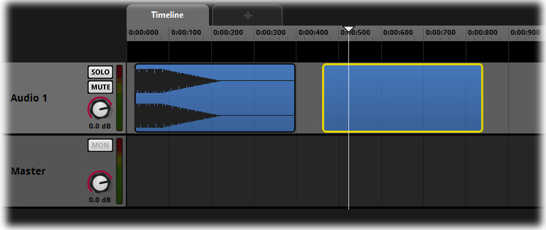
A Timelocked and Non-Timelocked Sound Module
Timelocked sounds also display different playback behavior to Non-Timelocked sounds. Because of the state of a Timelocked sound it is possible to place the cursor on the Timeline at any point within the range of the sound and trigger the sound from exactly that point. FMOD is aware of the exact nature and timing of that trigger region as it is locked and so can commence playback from the point that corresponds to the cursor position in relation to the waveform.
This is not possible with Timelocked modules. The cursor intersecting with any point of a non-locked trigger region will always trigger the sound from the beginning of the sound file, or from the point in the sound file specified by the module’s Start Offset property.
Note
Setting a Time Locked Single Sound Module to looping will stop it from being Time Locked.

Loop Regions and Time
Loop Regions by their very nature change the playback behavior of an Event and its components including how time is calculated. The Time Display on a Timeline indicates the position of the cursor on the Timeline, not the actual real time that has passed. So, if an Event is created with a Loop Region on a Timeline with values of 0.00 to 5.00 seconds the display will cycle through the values from 00:00.000-00:05.000 and then repeat as the cursor loops.
Because it is possible to have multiple Loop regions and Sustain Points in an Event the actual values shown in the Timeline Display can vary greatly.

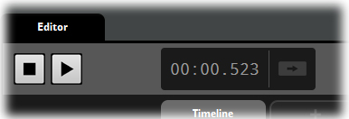
Timeline Value Display

The Distance Parameter

Introduction
The Distance Parameter is a unique and specific type of Parameter available for FMOD Studio Events. Distance Parameters allow Modules and Effects to be influenced directly by the relative distance between the sound source and the listener.
When a user creates an Event in FMOD Studio by default it will have certain behavior assigned to it. Events are 3D sound objects by default, including functions in relation to how the sound works in a 3D space depending on the relationship between the sound source and the listener. The Distance Parameter adds further functionality based on this distance information. Modules and Effects can be added to a distance Parameter and the value of distance can be used to define playback behavior.

Step 1 Creating a Distance Parameter
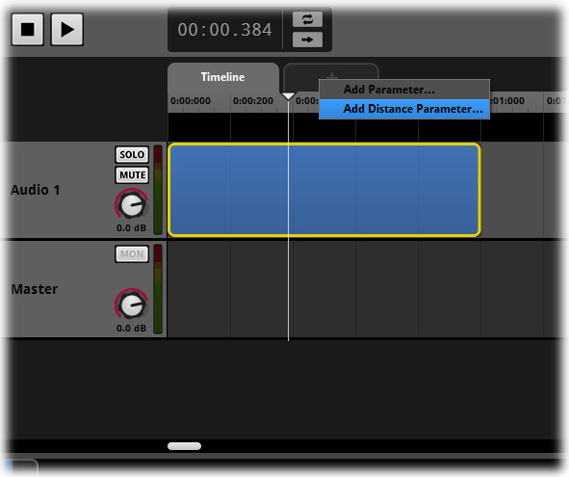
Create a Parameter
- Right click next to the Timeline tab above the Timeline ruler
- From the context menu select Add Built-in Parameter, then Distance…
- (Optional) Enter the desired range for the new Parameter
Note
An Event in FMOD Studio can only include a single Distance Parameter.

The Event Cone Angle Parameter

Introduction
The Event Cone Angle Parameter is a unique and specific type of Parameter available for FMOD Studio Events. Angle Parameters are influenced by the relative angle between the facing of the sound source and the listener.
Because Events are created as 3D sound objects by default in FMOD Studio, there are functions that define how the sound works in a 3D space depending on the relationship between the sound source and the listener. The Angle Parameter allows you to add further functionality based on this information. Modules and Effects can be added to an Event Cone Angle Parameter and the value of angle can be used to define playback behavior.

Step 1 Creating an Event Cone Angle Parameter
Create a Parameter
- Right click next to the Timeline tab above the Timeline ruler
- From the drop-down menu select Add Built-in Parameter, then Event Cone Angle Parameter…
- (Optional) Enter the desired range for the new Parameter

The Event Cone Angle Parameter describes the relative angle of the listener from the forward orientation of the sound source. An angle of 0 degrees represents a position directly in front of the sound source while 180 degrees represents directly being the sound source. This Parameter does not in itself reflect any change in the sound being produced; it provides a blank canvas with which you can create the type of audio manipulation over angle that their project requires.
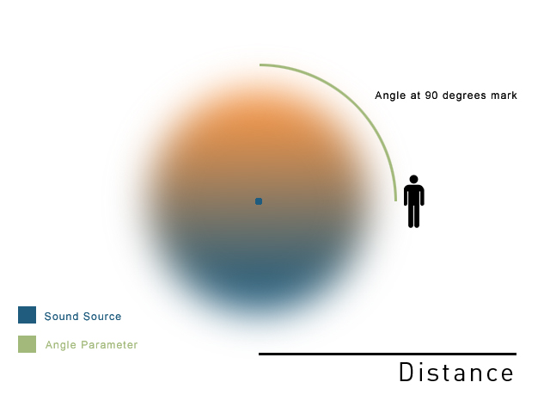
The Angle Parameter
The above diagram includes an area of transition between two colors that represents how a sound could alter as the Angle Parameter increases. These effects would be achieved by adding Automation to Event Audio Tracks that alter over the range of the Angle Parameter. The position of the figure indicates listening at a position of 90 degrees on the Angle Parameter where there is an equal blend of the front and rear positional effects.
Note
An Event in FMOD Studio can only include a single Angle Parameter.

Controlling Events External to an Event

Introduction
The ability to nest Events within Events is supported by the ability to control the Parameters of any Event from its parent Event. This allows complex interconnection of Events and Event Parameters.

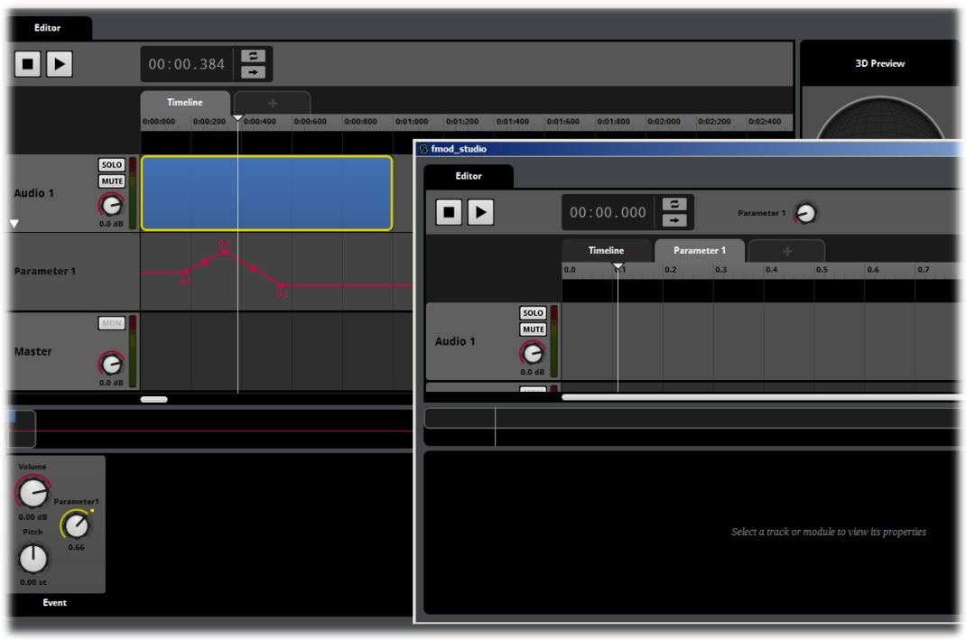
Nested Event Parameter

The above graphic illustrates controlling a nested Event’s Game Parameter. The Event in the foreground window is nested in the Timeline of the Event in the main Studio Edit region in the background. The Game Parameter Track directly below Audio 1 Track containing the red Automation line is Game Parameter 1 from the Event in the foreground window. This series of controllers lets you make changes within the parent Event to influence playback of the Event nested on that Timeline. The nested Event will also progress though its own playback process independently until it is affected by the controlling parent Event.

Creating a Higher Level Parameter Controller

Introduction
The most versatile form of external Parameter control is to assign a Parameter Automation to the direct parent of a nested Event. This increases the functionality of the sub Event beyond simple playback when triggered.

Tutorial
This tutorial will go through the steps in to create a nested Event within an Event and define an external Parameter controller.

Step 1 Create a New Event
Creating an Event
- Within the Event Browser, right click and create a new Event.
- Name the Event as required.

Step 2 Create an Event Module
Creating an Event Sound Module
- Within the Editor Region right click in an Audio Track and create an Event Sound Module.
- Double Click on the Event Sound Module’s Trigger Region to open the nested event in the event editor.

Step 3 Create a Parameter

Creating a Parameter
- Right click next to the Timeline tab and select Add Parameter… from the context menu.
- Name the new Parameter as required and click OK.
- Click on the first item in the breadcrumb trail to return to the parent event.

Step 4 Create a Parameter Automation Controller
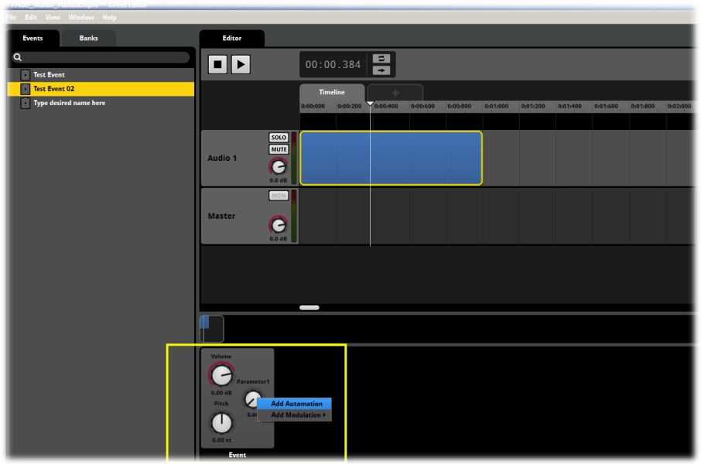
Creating an Automation Controller

- In the Original Event Click on the Event Module’s Trigger Region to make it active.
- In the Deck Region right click on the Module’s Parameter knob to open the context menu and select Add Automation.
FMOD Studio creates a new Track beneath the Audio 1 Track. This is a Parameter Automation Track and it can be used to control the Parameter of the nested Event. Click anywhere within this Track to add points and define Automation curves.

Linked Parameter Control for Nested and Reference Events
A Nested or Reference Event’s Parameter can be controlled via the parent Parameter’s values under certain circumstances. This technique can be very useful but requires some specific settings.
If an Event and its nested Event share a Parameter of the same name, the two Parameters act like they are one and the same unless told otherwise.
The nested Parameter reflects the parent’s Parameter values as closely as possible, so if both Parameters have the exact same set of values, the child Parameter will exactly reflect the values defined by the parent Parameter.
If the child Parameter values are different to the Parent Parameter values then the child’s value range will be scaled to match the parent Parameter’s range. So a position of 75% will be consistent across both Parameters regardless of the actual values being displayed.
Although this linking function only occurs from a parent Event to its direct child it can be chained to extend the process. As long as each Event in a chain has a Parameter of the same name, it is possible to create a parent Event and then multiple levels of nested Events all with the same Parameter. The top level parent Parameter will only control its direct child Event Parameter, but changing its values will result in the values of its direct child changing, and so on all the way down the nesting chain.

Breaking the Link
There are various situations where the default behavior of the linked Parameters may be undesirable so under these situations the link will be broken.
If the child Event’s Parameter is automated or modulated in the parent Event, the link will be broken. Any alteration to the Events that might break this link functionality would need to be removed for the link to re-establish its behavior.
It may in some circumstances be undesirable for the referenced Event to track the Parameter values in every instance, so for instances where it is not desirable it is possible to purposefully break the link without changing the playback behavior. Creating Automation for the nested Event’s Parameter will break the link behavior, but if no values are defined on the Automation line then the playback will not be altered. This technique can be used to specifically disrupt the linking behavior when needed.

Tags
FMOD Studio allows user to create Tags to assist in administering Events within a project. Tags provide a method of assigning extra information to Events beyond their Event name.
The Event Browser Search Bar allows for search terms to be used to filter what is displayed in the Event Browser. This is very useful for finding specific Events within large projects that may contain hundreds or thousands of Events within it. Tags allow for extra information to be defined for Event management and will also appear in Browser Searches other than the Event Browser depending on circumstances.
All Events have a Properties area where Tags can be assigned to the Event. The exact nature of the Tags is entirely up to the user and the requirements of a project. Tags such as Weapons, Vehicles, Dialogue, Player, and Environment would be common examples but anything can be used. They are words selected to provide useful information to a production team so create Tags as you see fit.
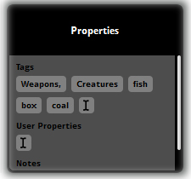
Properties Tags

Searching for Tags
Tags can be searched for in the Browser Search Bar by prefixing a search term with the # symbol. Unlike regular searches Tags will be displayed across search Bars in several areas of Studio. The following list outlines how the tags are displayed in different areas:
- Event Browser tag searches will display all the appropriate Events within a project that correspond to the defined Tag
- Mixer Browser Tag searches will display the Inputs associated with the relevant tagged Events
- VCA Browser Tag searches will only display associated Events that have been assigned to VCAs. As not all Inputs are necessarily assigned to VCA this may not be a complete list of all the relevant tags within a Project
- The Banks Browser is similar to the VCA Browser in that not every Event is assigned to a Bank so a Tag search will only display matching Tags that have been assigned to a Bank.
- Tags are not displayed within the Audio Bin Browser Search Bar.

The Tag Browser
The Tag Browser functions like any other Browser in FMOD Studio but displays a list of the Tags within a Project. This is useful for administering a Projects Tags, deleting unwanted Tags as well as checking if Events have been correctly assigned to Tags and alerting assignments if required.
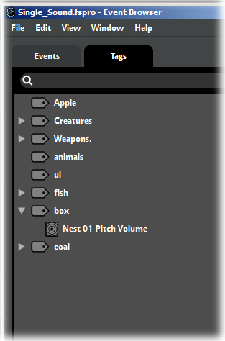
The Tag Browser
Tags can be created and deleted in the Tag Browser. Events can also be assigned to a Tag in the Event Browser via the context menu. Once assigned, an Event will be displayed in the Tag Browser under the appropriate Tags. The Sort by function in the context menu will reorder Tags alphabetically. If the Menu is accessed in the general Browser area Studio will sort all Tags alphabetically. If the context menu is accessed while a Tag is selected, Studio will sort all the assigned Events under that Tag into alphabetical order.

Creating and Assigning Tags
Tags are a useful method of assigning extra information to Events and grouping Events into categories.

Creating a new Tag
There are two methods of associating an Event with a Tag.

Method 1: Adding Tag information to an Event

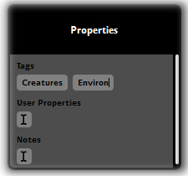
Event Properties area
- Click on an Event in the Event Browser to select it
- Within the Event Properties area Click in the Tags region
- Type in the name of the Tag you want to add to this Event
- Press Space or Enter to complete your Tag and start a new one, or
- Click elsewhere in the interface to finish adding Tags.
Note
Tags can only be single words, the space bar will finish the Tag you are typing and open a new tag box to start creating a new Tag in the same way the hitting Enter will. Tags can include numbers and other characters.

Method 2: Assigning an Event to a Tag

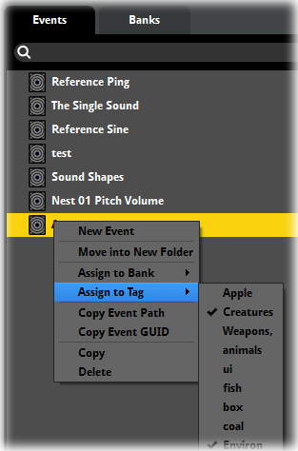
Event Context Menu
- Click on an Event in the Event Browser to select it
- Right Click/CTRL Click to access the context menu
- Select Assign to Tag from the menu
- Assign the Event to an existing Tag or select New Tag…
- Define the name of a new Tag is creating a new Tag

Creating a Tag in the Tag Browser
- Access the Event Browser via the Menu Bar/Window/Event Browser
- Select the Tag Browser via the Tags Tab
- Right Click in the general Browser area o access the context menu
- Select New Tag from the context menu
- Define the name of the new Tag
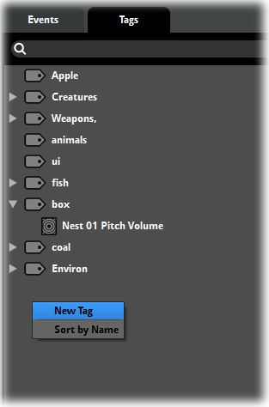
The Tags Browser
Events can be assigned to Tags or Tags can be assigned to Events, either method will result in an association between an Event and any and all tags associated with it. There is no practical limit to the number of Tags that can be created and the number of Tags that can be assigned to an Event or the number of Events that can be assigned to a Tag.
Note
Each Tag in the Tag Browser is unique; there cannot be two instances of the same Tag.

The Browser Search Bar
FMOD Studio includes a Browser Search Bar in various locations within the interface. The Browser Search Bar allows for elements within a project to be searched for a displayed.
Large projects will often contain hundreds, thousand or even tens of thousands of objects. Being able to find specific elements of a project quickly and efficiently is a critical aspect of project management and workflow.
Users can type in complete or partial words or even single letters to define a search. FMOD Studio will instantly update the items displayed in the browser that match the search terms. The items listed will be relevant only to the type associated with the active browser, so searching in the Event browser will display matching Events, searching in the Audio Bin will only display matching sound files and so on.
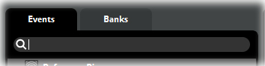
The Browser Search Bar

GUID Searches
Users can enter GUIDs into the Search bar to filter FMOD Studio’s Browser display. This results in the browser displaying only items that have a matching GUID. It is only possible to do this with complete GUIDs so the result will almost always be a single entry of the Event, Snapshot or Bus with the matching GUID.

Tag Searches
Tags can be searched for in the Browser Search Bar by prefixing the search word with the # symbol. Tags are unique in that they will be displayed across different Browser Search Bars depending on circumstances.
- All Events associated with a defined Tag search will be displayed in the Event Browser
- All Inputs associated with Tagged Events will be displayed within the Mixer Browser
- Only Inputs assigned to VCA that match a defined tag search will be displayed in the VCA Browser. As it is not compulsory for all inputs to be assigned to a VCA not all tagged Event inputs will necessarily be displayed
- The Bank Browser is similar to the VCA Browser in that not all Events must be assigned to a Bank, so a tag search in the Banks browser may also display an incomplete list of tagged Events as only those that have been assigned to Banks will be displayed
- Tagged Events will not be displayed in the Audio Bin Browser Search Bar
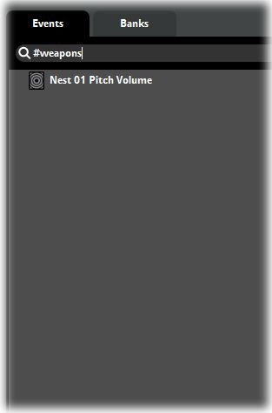
Tag Search

Note
Because of the nature of how stereo sound files work it is important to understand the consequences of panning channels throughout the signal path. A stereo sound file contains information that provides the special effect of hearing things to the left and rights and the illusion of distance. Mixing a stereo file down to mono removes this information permanently, so even if you mix a mono file back up to “stereo” or pan it from 100% either left or right, back to the middle, the stereo effect will be lost. You will end up with the same mono signal duplicated in the left and right channels, not a stereo signal.

Routing and Assigning
FMOD Studio has several Browser interface areas. They all look very similar but there is two different ways in which they can function. The Event Browser allows you to assign Events to Folders, Events to tags, and Events to Banks. The Mixer Browser allows you to Route inputs to Group Buses and to perform other Routing functions. Routing and Assigning have very different consequences and it is important that these are understood.
When you assign an object in FMOD Studio you are creating an association between that object and another object. By Assigning an Event to a Folder you are allocating the name for the Event with the Folder in which you are placing it. The Event itself does not alter in any way and the act of assigning is more administrative in its effect. Objects can be assigned and reassigned without altering their function or how they operate within a project.
In the Mixer Browser the action is called Routing because the association between objects physically alters the signal path within FMOD Studio and can have significant effects on the output of a project. Routing an Input into a Group Bus actually changes the signal path and can result in the sound altering depending on the setup of the Group Bus. Rerouting elsewhere can result in further changes.
Routing needs to be planned carefully with full realization of where the signal path will travel and what processes will be applied to it otherwise unexpected playback behavior may occur.

The Mixer
The Mixer functionality in FMOD Studio brings it in line with many common hardware and software Digital Audio Workstations. Users can create and route signal paths and create complex signal networks.
The Mixer in FMOD Studio is the only screen not displayed by default. To access the Mixer go to the main menu and under the Window menu select Mixer.

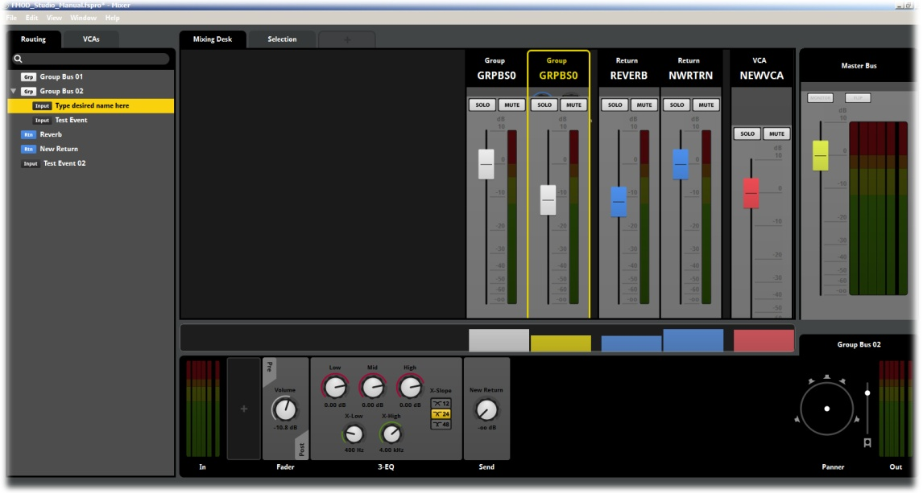
The Mixer
The Mixer can be as simple or complex as a project requires. By default Studio will rout all signals out the master channel as simple projects do not require the Mixer. For more complex projects the Mixer can control large numbers of Events assigned to Group Buses with complex routing paths, effects chains and automation. Because of the virtual nature of FMOD Studio it can create far more complex signal paths than even the largest of hardware devices.

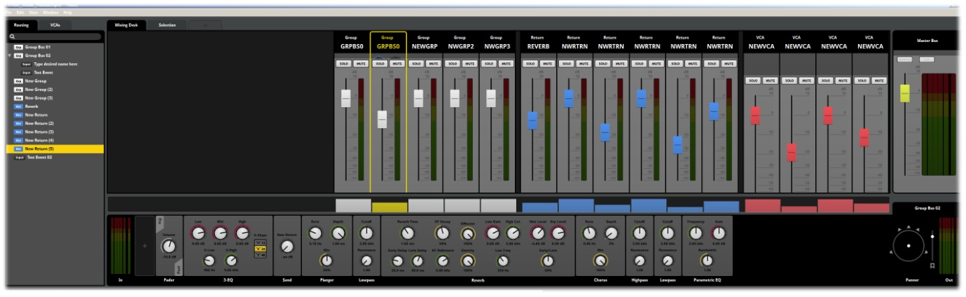
Mixer Interface

In Depth: The Mixer Functionality
The Mixer tool set in FMOD Studio has been designed to allow a broad range of level access from users. At its most basic level a user can create and implement simple sound environments with no need at all to interact with the Mixer interface. By default Studio will rout signals out of the Master bus exactly as they have been setup to play in the projects Events. In this example there is no requirement to make use of the Mixer in a project.
The other extreme is the ability to create complex audio events routed through practically limitless signal paths passing through a wide range of effects and other signal processors with complex mixing and manipulation control groups.
The level to which a user takes advantage of the Mixer functionality is entirely up to the requirements of a project and their familiarity with creating signal paths.

The Mixer Tool Set
This chapter will go into considerable depth of explaining exactly how the Mixer tool set in FMOD Studio functions and provides users with an understanding of the basic signal path flow through Studio. Tutorials will provide practical steps towards creating various types of signal paths within FMOD Studio.

Multiple Mixer view
FMOD Studio supports multiple Mixer views. This means it is possible generate more than one Mixer window and assign specific Mixer objects to the desired Mixer View. This can allow for viewing of several Mixer view Windows across multiple monitors and can be very convenient for mixing larger projects.
To assign an object to a new Mixer View, right click on the object in the Mixer Browser and select Assign to New Mixer View from the drop-down menu.

Group Solo
When editing groups of Channel Strips in the Mixer activating the Solo function will solo the selected group for playback. This can be reverted by again clicking on the solo button to switch off the solo for the group.

Basic Signal Paths
A signal path at its most basic requires an input stage and an output stage. A Sound-File added to an FMOD Studio project is the input or starting stage of a basic signal path. The sound that is played out from Studio is the output of final stage of the signal path.

Input
Output

Within FMOD Studio a sound file must be added to an Event to be audible. The sound file is added to an Audio Track within the Event (By default Audio Track 1). All Events also contain a Master Track.
When a new Event is created in the Event Browser, Studio automatically creates a corresponding input within the Mix in the Mixer Browser. By default all inputs in the Mixer browser are routed directly out of the Master Bus. As a result the most basic Signal path produced in FMOD Studio is as follows.
Event
Event 01
Audio Track (contains sound file)

Master Track
Mixer
Input (Event 01)

Master Bus

This is the path a sound takes from initial input to ultimate output.
This basic signal path is the core of every sound that can be created within FMOD Studio. Even the most complex signal routing set-ups will still have this basic path at their core. Without the chain from input to master output, no sound is produced.

Note
It is possible in FMOD Studio to have multiple instances of any single Event. This is to allow users to work with Events in a more flexible manner. You may wish to have two or three instances of the same Event open at the same time to allow for simultaneous comparison of Parameters settings or Effects.
It is important to note that there is only ever one single corresponding Input in the Mixer for each Event in a Project. This means that all instances of a single Event are all routed through the single Mixer Input and as a result will all be affected equally by any routing or signal processing that occurs in the Mixer.

How this looks in Studio
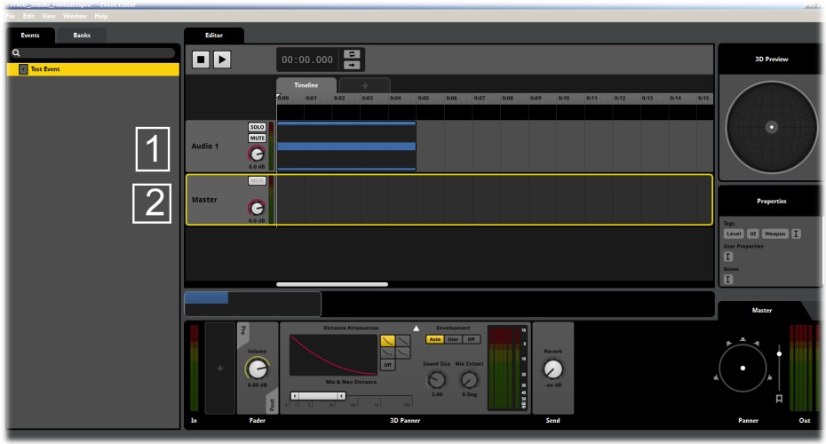
Basic Signal Path Diagram 1
At the Event level, 1. The Audio Track contains a Module containing a Sound File and 2. The Master Track is where all Audio Tracks in an Event are sent prior to routing to the Mixer.
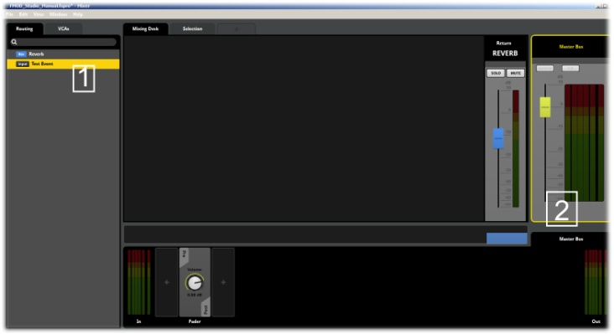
Basic Signal Path Diagram 2
At the Mixer level, 1. All Event Master Tracks rout to the Mixer as an Input object. All objects pass out of the Mixer via 2. The Master Bus.

A Word on Effects
Effects are objects inserted into the path of a signal. The extent to which they affect the signal is entirely up to the values defined for each Effect object.
Effects can be added to signal paths at many stages along the rout of the signal from input to Master bus. Effects are added to the Deck regions and can be added to an individual Audio Track, to the Master Track of an Event or to a Group Bus in the Mixer. It is possible to have the same Effect object inserted into the signal path of a single sound in all three of these stages and for each Effect to be controlled individually and uniquely.
Effects will be discussed in more detail in a later chapter, but it is important to understand their setting as one of the main reasons for creating alterations to a signal path is to insert an effect into the path to manipulate the output sound. As such they will be used as examples in explaining the Properties of the Mixer tool-set.
Important Note
As will be discussed in the Chapter it is possible in FMOD Studio to create complex signal paths and there are a great variety of functions that allow for manipulation of signals and sounds.
It is important to understand however that it is not essential to try and combine all of these features into projects. The complex possibilities that the FMOD Studio tool set provide for are more about providing a wide range of options rather than trying to overcomplicate the creative process of Sound Design.
The ability to insert Effects into multiple locations within a signal path is the perfect example. There will very seldom, if ever be a need to create a project that includes the same Effects object multiple times within a single signal path. However some Events will work better if the Effect is on an individual Audio Track, while others will work best if the Effect is on the Event Master Track and still others might need it to be a part of a Group Bus in the Mixer tool.
The functions provided within FMOD Studio may seem complex and overwhelming if you attempt to apply all of them to all of your projects all of the time. The tools exist to provide options to the Sound Designer. Do not overcomplicate things for yourself.

Group Buses
By default FMOD Studio will populate the Mixer Browser with inputs that coincide with all the Events that exist in a project. These inputs are all routed directly to the Master Bus for playback output. This means that FMOD Studio will playback all of the Events included within a project without the need to access the Mixer at all.
If a project requires a further level of control over the output behavior of the signal paths then they can be assigned to specific groups within the Mixer View; these groups are called Group Buses.
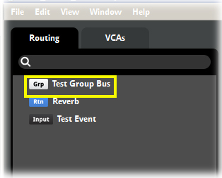
A Group Bus
A Group Bus is a way of assigning multiple inputs together so they can be controlled simultaneously and have effects and routing behavior assigned to all the signals within a group. Essentially it is like copying all the signal paths to a folder and then everything that is applied to that folder from that point onwards will affect all the objects within the folder.
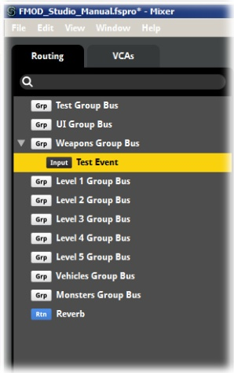
The Mixer Browser
Any Input that is not assigned a Group Bus is considered to be assigned to the Master Bus. All inputs must be assigned to either a Group Bus or the Master Bus and cannot be assigned to more than one Bus at a time. They can however be freely reassigned between Busses.

Why Group Buses?
FMOD Studio provides a wide range of options for creating, editing and optimizing both individual signals paths and the overall signal chain for a project. Effects Modules can be inserted into the signal path of a sound in various locations to control and alter the final output sound. FMOD Studio is a complex application and there are several best practice processes that will help you get the best results. One of these involves the use of Group Buses.

Keep Things Simple
Keeping your signal chain as simple as possible will help you in some key ways. The first and most important is simply for your own sanity. While it might seem straight forward to add an effect directly into an audio track or master track of an Event while you are creating it, this could lead to issues later on in development.
With any large project, it is best to have a well thought out and planned structure for the audio required. This plan should include the types of effects and processes you are likely to need to achieve the end result. Working from such a plan allows you to think forward and work efficiently. If you require a particular type of effect for several sound events then the most direct way to apply that effect is to add it in a single location in the signal chain and rout all events that are relevant through this single location. This means there is only one type of this effect to keep track of and control. Should anything need to be altered or edited you know exactly where to go rather than having to search through each input trying to find where an issue may lie.
A Group Bus provides a single routing junction where all Inputs assigned to that Group Bus can be modified together. An Effect Module added to the Group Bus will be applied to all signals routed through that Group Bus. All the Inputs will now have the relevant effect applied to their signals in the same manner.
So if you have a series of Inputs that would naturally be grouped together for signal processing then it makes sense to rout them all to the same Group Bus and add effects as required. If however you have a variety of Signals that you otherwise do not want to group together, but do need to add a common effect to, this is where Sends and Return Buses are useful.
Sends can be added to Inputs and Group Buses, so you can rout an individual Input or a group of Inputs within a Group Bus. All of these signals will be routed via the send module to the Return Bus. At this point they can all be processed by Effects Modules as required. This allows for common signal processing while still maintaining whatever grouping may have been assigned to the Inputs elsewhere.
This process is also very efficient from a resource point of view as there is only a single Effect Module requiring resources to operate rather than multiple modules applied individually to each input.

Creating a Group Bus
All Inputs in the Mixer View default to the Master Bus, Group Buses provide a further level of control over signal paths in FMOD Studio.
This tutorial will go through the steps in to create a Group Bus in the Mixer View.

Step 1 Display the Mixer View
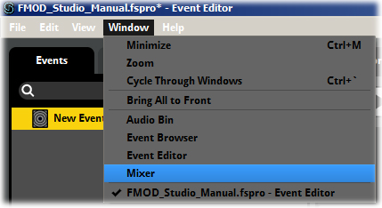
Selecting the Mixer
- Within the default FMOD Studio view go to the Main Menu – Window
- Select Mixer

Step 2 Create a Group Bus
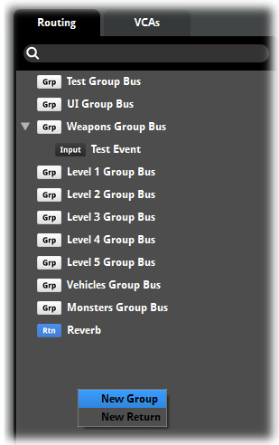
Creating a New Group Bus
- Within the Mixer Browser right click to display the drop-down menu
- Select New Master Group Bus
- Type in the desired name of the new Group Bus

FMOD Studio will now create a new Group Bus and add it to the Mixer Browser. This Group Bus can now have Input objects reassigned to it as required.

Note
Remember that any Input objects not assigned to Group Buses are considered to be automatically assigned to the Master Bus

Routing Inputs to Buses
Inputs may be freely routed and rerouted between existing Group Buses, The Master Bus or to newly created Group Buses
This tutorial will go through the steps in to route Inputs to Buses

Step 1 Open a Project with existing Events and Group Buses
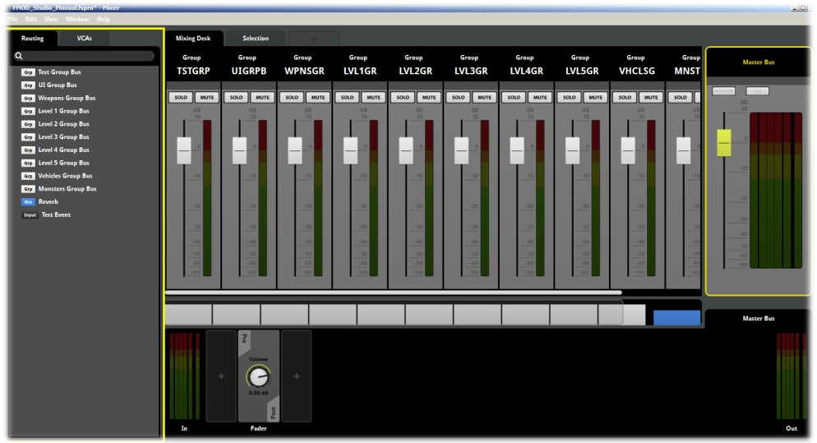
The Mixer
- Select a Project that contains both Events and Group Buses
- Select Mixer from the Main Menu – Window drop-down menu

Step 2 Route an Input to an existing Group Bus
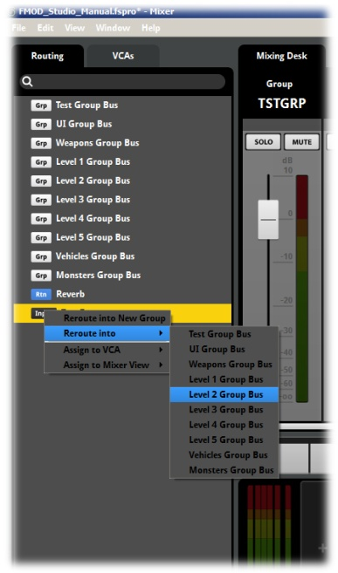
The Mixer Browser
- Within the Mixer Browser right click on an Input to display the drop-down menu
- Select Reroute into and navigate via the arrow to the list of existing Group Buses
- Select the Group Bus you wish to assign the Input to
FMOD Studio will reroute the selected input to the desired Group Bus. The input will no longer be displayed in the general Mixer Browser area which indicates it is no longer routed to the Master Bus.

Step 3 Rerouting an Input to a New Group Bus
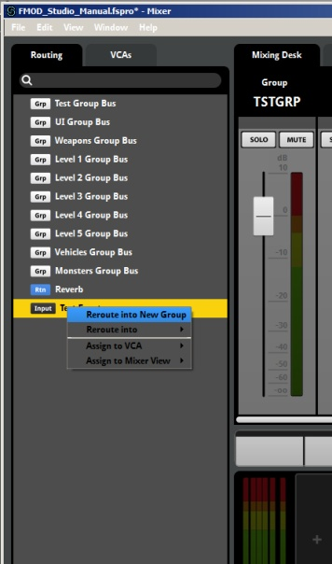
FMOD Studio Main view
- Within the Mixer Browser right click on an Input to display the drop-down menu
- Select Reroute into new Group Bus, Studio will create a new Group Bus
- Define the name for the new Group Bus
FMOD Studio will route the selected input to the newly created Group Bus and in the Mixer Browser the Input will alter its position to reflect this rerouting. If the input was in the Master Bus it will shift from the general Browser area to be assigned into the new Group Bus. If the Input was already assigned to a Group Bus, it will shift from being assigned to the old Group Bus to the new Group Bus.

Step 3 Route an Input to the Master Bus
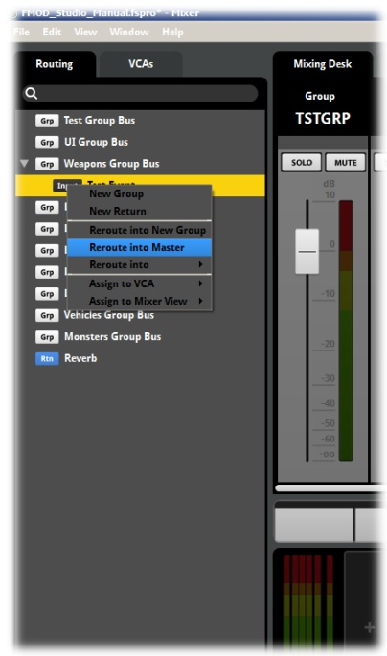
The Mixer Browser
- Within the Mixer Browser right click on an Input that is routed to a Group Bus
- Select Reroute to Master Bus
This setting can be used to return an input to the Master Bus if you no longer wish for it to be routed to a Group Bus
Note
Remember an Input can only be routed to a single bus at any one time. It can be rerouted freely but cannot be routed simultaneously through two buses.

Signal Routing
It is important to understand some of the implications of signal routing and what the process entails.
A Send Module creates a duplicate of the signal path and routs it to a Return Bus in the Mixer. For many routing situations this is the best step to apply. But it can create adverse effects if used in the wrong circumstance. For example duplicating a signal via a Send Module and then reducing the original signal by 6dB and then amplifying the Send Duplicate by 6dB will result in the two signals cancelling each other out and no noticeable effect being produced. This is a very basic example of how a duplicate signal could cause an issue. The physics of sound waves means that applying a band pass filter of any type to a Send and combining it with the original signal could have very different results when combined than either of the two signals in isolation.
Certain Effects work very well when included as part of a Send / Return signal path. Reverb, Chorus and Delay as well as some Flanger Effects work well because their functionality involves the mixing of the original signal with a subsequent versions anyway. So a Send Duplicate signal can become part of this mixing process to produce the desired result.
Other types of Effect Module such as Distortion and filters are altering the signal itself. Combining them with a duplicate will at best dilute the alteration effect or at worst alter the signal by combining the material in a manner difficult to predict or control. For this reason we recommend that Effects that alter a signal should be inserted directly into the signal chain rather than as part of a Send Return routing step.

Deck Order
The Deck area is not only part of the signal chain process, each Deck is an extension of each individual signal path. This means the order in which Modules are placed into the Deck has a significant impact.
Modules can be placed in either the Pre Fade or Post Fade position, but also a signal is processed in order from left to right as it passes through the Deck area. If a Send Module is inserted into the Deck Area between two other Modules the duplicate signal will be created at the exact point of the Send.
Planning the order and layout of Deck areas is an integral part of planning your overall signal chain.

Working with Group Buses

A new Channel Strip
Once you create a Group Bus a new Channel strip is added to the Mixer View to control the output of the Group Bus, This channel strip includes the standard controls for Mute, Solo and a fader slider for output levels. There is also a Peak meter to allow users to visually monitor the levels for the Group Bus’s output levels.
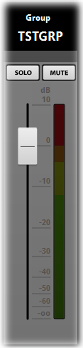
Group Bus Channel Strip

The Deck
Each Group Bus also has its own Deck region. By clicking on the Channel strip for any Group Bus you will make it the active selection. The Target Channel Strip will now be outlined in yellow to indicate it is active and the Deck region for that Bus is now active and can be populated with effects as required.
By default the Deck region will include input and output peak meters at the left and right extremes of the deck as well as a Fader control dial. The fader control dial is bookended by markers for pre and post effect placement. By right clicking on these markers you can insert effects objects, but define whether you want them to be inserted in the signal path before the Fader (pre) or after the Fader (post) in the signal path.
There are a great many reasons as to why an effect object may be needed either pre or post fader in a signal path. The exact needs of your project will often dictate the best course of action, but it is worth experimenting with your various options so you understand how each may affect the playback behavior of your sounds.

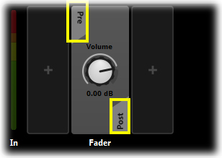
Deck Region Pre and Post Fader Positioning

Buses within Buses
As a Group Bus is essentially a way in which to group inputs together to allow for common control mechanics, there may be times when it is useful to create lower level groups internally to other groups. Studio allows for Group Buses to be created within existing Group Buses to provide sub groups. This provides an even greater level of control over a projects signal paths.

Basic Routing Setup
Input (Event01)
Input (Event02)
Input (Event03)
Input (Event04)
Isolated control of Event04

Group control of Event02
Event03
Event04
(With sub controls)
Sub Bus

Group Bus

Master control of all signals
Master Bus

Signal Routing
The above diagram illustrates a simple routing setup that includes a single Group Bus and within that Group Bus a single Sub Bus. This routing allows for specific processing of the four Events that are the input stages of the process.
Event01 follows the default direct path directly to the Master Bus. This means that it will be processed by any and all Effects objects that are applied to the Master Bus.
Event02 and Event03 are routed into the Group Bus. Any processes applied to the Group Bus will be applied to these two Inputs and then the Group Bus is routed to the Master Bus so the signals will be altered again by any processes applied by the Master Bus.
Event04 is routed first to the Sub Bus then into the Group Bus and then onto the Master Bus. The signal path for the input Event04 can therefore be manipulated by three processes at three individual stages of its signal path.
The exact nature of the signal processing or what effects may be included is not relevant to this diagram. Its purpose is to illustrate how signal paths are created and how each stage of a signals journey combines to produce the final output. Be aware that effects and processes at each stage of a signal path will stack so it is important to keep track of how you rout a signal.
This is how it looks in FMOD Studio.
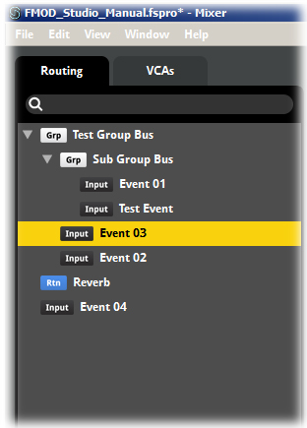
Signal routing with Group Buses

Creating Sub Group Buses
Group Buses can be created inside existing group buses to provide finer control of a single path. It is possible to create an almost endless chain of sub Group Buses.
This tutorial will go through the steps to create a sub Group Bus.

Step 1 Open a Project with existing Events and Group Buses
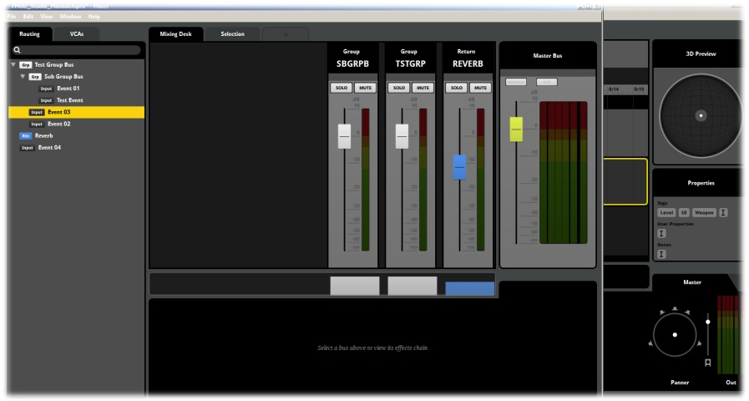
FMOD Studio Mixer view
- Select a Project that contains both Events and Group Buses
- Select Mixer from the Main Menu – Window drop-down menu

Step 2 Create a Group Bus within an existing bus
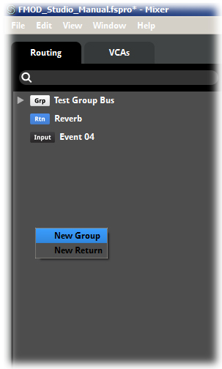
Create a New Group Bus
- Select a Group Bus from the Mixer Browser, Right Click on the Icon
- Select New Group Bus from the drop-down menu
- Type in the name for the new Group Bus

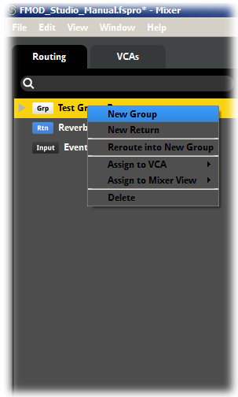
Create New Sub Group Bus
Studio will create the New Group Bus, but it will be displayed in the Mixer Browser inset and nested inside the Bus it was created in. This means that all effects, panning or levels applied to the parent bus will also be applied to the nested bus as well as any effects or Properties it may include.
Note
Because every level of nested bus within a parent bus will also adopt all of its behavior it can be easy to lose control of your signal path if you bury it too deeply within nested buses.
Nested buses can be a very powerful method of controlling playback behavior, but take careful note of what you apply to each level of the hierarchy to avoid confusion at later stages of development.

Sends
A Send is a way of duplicating a signal path at the exact point at which it is inserted in the path. Sends can be added to Audio Tracks within Events and Buses within the Mixer. A signal path can contain multiple Sends. The primary function of a Send is to allow a copy of a signal to be created so it can be processed and manipulated while the original signal continues unaltered.
Original
“Clean” signal
“Clean” signal
Effect 01 added
“Clean” signal
Duplicated
Track 01

Send 01
Effect 01
“Clean” signal
Pan processed
Panned signal
Effect 02 added
Clean Panned
Signal Duplicated
Pan
Panned Effect 02 signal arrives
Effect 01 signal arrives
Send 02
Effect 02
Clean Panned
Signal arrives
Output
Basic Signal routing including Sends

Basic Send routing in Events
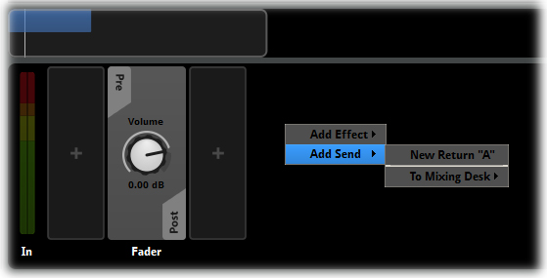
Creating a Send in an Event

Basic Send routing in Mixer
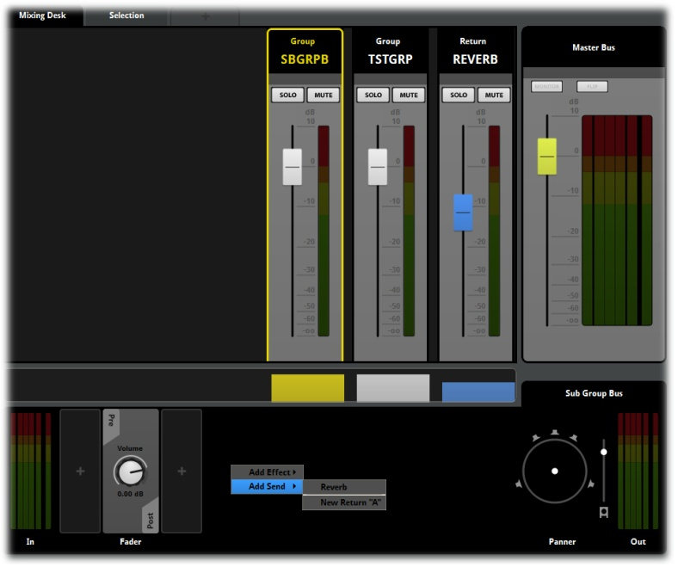
Creating a Send in the Mixer

Adding Sends to Events
Sends within Events allow for duplicate signals from Audio Tracks to be created allowing manipulation of the signal while still preserving the original track path to the Master Track
This tutorial will go through the steps to create a Send within an Event and route Audio Tracks through an Event Send

Step 1 Creating a Send
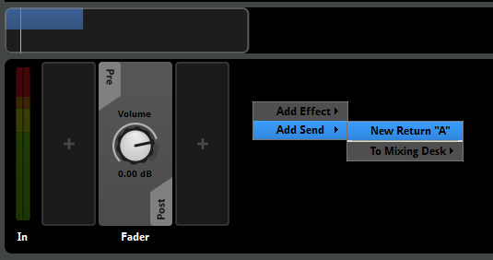
Creating a New Send
- Within an existing Event select and Audio Track by clicking on it
- Once an Audio Track is active you can access its Deck region, right click in the Deck region to display the drop-down menu.
- From the Drop down menu select Add Send
Studio will create a new type of Track within the Event; this is a Return Track. Return tracks are different from Audio Tracks, they cannot contain Modules within the track, but they have an active Deck area where Effects objects can be added. This allows for Tracks routed to the return track to have the full range of Effects applied to them, but the original Audio Track that was routed via the Send will still be preserved.
Note
Return Tracks exist in the signal chain just like any other Audio Track. By default Return Tracks are routed directly to the Event Master Track, but they can be mixed to other tracks prior to the Master. Ultimately all tracks within an Event will route to the Master Track including Return Tracks

Send/Return Functionality
A Send object creates a duplicate signal at the point in the signal chain where the Send is inserted. It has a simple setting and control set.
When a Send object is created in the Deck region of either an Event or a Mixer Channel Strip it creates an object that includes a level control. The signal sent to the associated Return Track or Return Bus is a duplicate of the original signal in all ways. The Send object does however include a volume control to be able to adjust the level of this duplicate signal as a function of input.
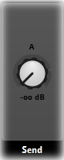
A Send object
The Send object is essentially the input source of the new duplicate signal and can have its levels controlled via the volume dial. A “sent” signal requires a destination at which it can be controlled by the FMOD Studio Properties. This is the purpose and function of Return Tracks and Return Buses.
Return objects provide a new location for the signal path where it can be processed and manipulated. It is possible to send signals from many sources to a single Return object where they can all be processed in a same manner. Any object that includes a Send object mapped to the relevant Return object will have a duplicate signal routed to that Return.
Return objects must ultimately be routed out the master channel. Either the Master Track in the case of Return Tracks in Events, or the Master Bus for Return Buses in the Mixer. Return objects can be routed to other tracks and buses instead of directly to the Master channels by using Send objects in the same manner as in regular tracks and buses.

Routing Audio Tracks to Return Tracks
Once a Return Track has been created in an Event Audio Track signals can be routed to the Return Track using Send objects. This tutorial will go through the steps to create a Send within an Event that route to an existing Return Track.

Step 1 Creating a Send
Signal Routing via a Send
- Within an existing Event select and Audio Track by clicking on it
- Once an Audio Track is active you can access its Deck region, right click in the Deck region to display the drop-down menu.
- From the Drop down menu select Add Send and via the arrow select an existing Return destination.
There is always an option within the menu Add Send setting to create a New Return, however all existing Returns will also be displayed in this menu space. This allows for users to select from the existing list of Returns or to create new Returns as required.
Note
While creating a new Send object in the Deck is part of creating the overall signal chain it is different to routing within the Event. In the drop-down menu of a Track Header you can mix an Audio Track to either the Master Track or to one of the other existing Audio Tracks.
To “Route” an Audio Track signal to a Return Track it must be done by creating a Send object in the Deck region of the Audio Track in question. This is because Event signal routing is directing the original signal of an Audio Track within and ultimately to outside of the Event. A Return Track can only receive signals from a Send object which will always be a duplicate of a tracks signal.
While this is a subtle difference that in many projects may not even be noticeable it is a very important distinction to understand when working with the signal chain.

Adding Sends in the Mixer
Sends can be inserted into any Mixer function that has a Deck region. This includes Group Buses, Sub Group Buses, the Reverb Bus and Return Buses. It is also possible to add a Send object into the Deck region of the Master Bus. Sends can also be created that rout a signal to the Reverb Bus. By doing so you create a copy of the signal rather than routing the original signal through the reverb

Adding a Send
The process for adding a Send is consistent across all Mixer functions that include Deck regions. This tutorial will go through the steps to create a Send within a Mixer Deck region.

Step 1 Creating a Send
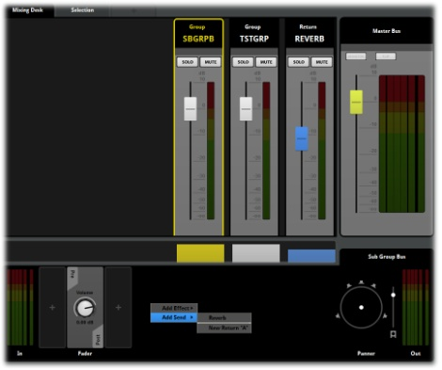
FMOD Studio Main view
- Within the Mixer click on any channel strip to select it and make it active
- Once the Channel is active and the Deck region for the channel is displayed, Right Click in the Deck region to display the drop-down menu
- From the Drop down menu select Add Send
Studio will create a new type of bus within the Mixer Browser; this is a Return Bus. Return Buses are different from Group Buses, they cannot have inputs routed to them, but they have an active Deck area where Effects objects can be added. This allows for buses duplicated to the return track to have the full range of Effects applied to them, but the original bus that was routed via the Send will still be preserved.
Note
Return Buses exist in the signal chain just like any other Bus. By default Return Buses are routed directly to the Project Master bus, but they can be sent to other Group Buses and Return Buses prior to the Master. Ultimately all buses within a Project will route to the Master Bus including Return Buses

Routing buses to existing Return Buses
Once a Return Bus has been created in a Group Bus signal can be routed to the Return Track using Send objects. This tutorial will go through the steps to create a Send within a Bus that routes to an existing Return Bus.

Step 1 Creating a Send
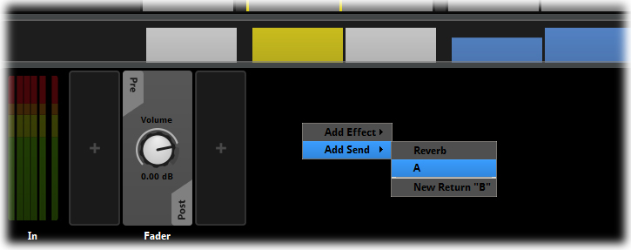
Routing to an existing Return Bus
- Within an existing Mix select a Channel Strip by clicking on it
- Once a Channel Strip is active you can access its Deck region, right click in the Deck region to display the drop-down menu.
- From the Drop down menu select Add Send and via the arrow select an existing Return destination.
There is always an option within the menu Add Send setting to create a New Return, however all existing Returns will also be displayed in this menu space. This allows for users to select from the existing list of Returns or to create new Returns as required.

Routing at the Event Level
The signal path a sound follows through FMOD Studio starts from the sound-file added to the Audio Track of an Event and ends at the Master Bus in the Mixer where it reaches the playback stage. The Mixers primary purpose is to create and control signal routing within a Project, however there are some options and Properties available within the Event editor that also provide signal routing possibilities.

Routing to tracks
The simplest Event in FMOD Studio consists of a single Audio Track and the Event Master Track. An Event can have extra Audio Tracks added as required and Audio Tracks can contain a wide range of Effects and automation controls as well as Parameter controls. By default all Audio Tracks are routed to the Event Master Track, but it is possible to route any Audio Track to pass through another Audio Track prior to it being sent to the Event Master Track. This allows for sub mixing of several tracks into a new track prior to being sent to the Event Master Track. This is similar to the functionality of the Mixer and Group Buses but at the Event level.

Routing to Audio Tracks
Audio Tracks can be routed to other Audio Tracks within an Event prior to routing to the Event Master Track. This tutorial will go through the steps to route an Audio Track to another Audio Track.

Step 1 Create an new Event
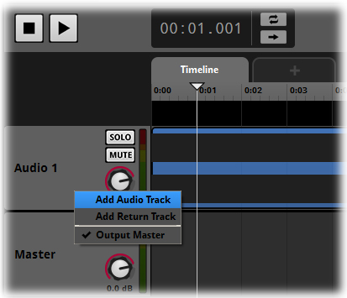
Creating a New Audio Track
- Create a new Event in the Event Browser
- Within the Event Editor right click on the Track Header region
- Select Add Audio Track from the drop-down menu
- Add a total of three new Audio Tracks to the Event
The Event should now have a total of four Audio Tracks. At this stage none of the tracks contain any sound files, but for this tutorial they are not needed. Audio Tracks 2 and 3 will now be routed into Audio Track 4.

Step 2 Assigning Audio Tracks to Audio Tracks
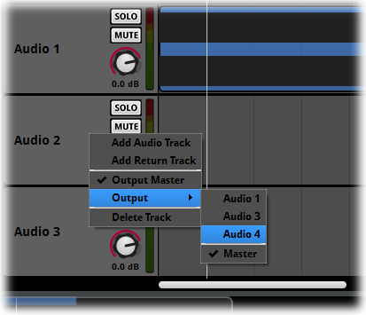
FMOD Studio Main view
- Right Click on the Track header of Audio Track 2
- Select Output and via the arrow select Audio 4
- Right Click on the Track header of Audio Track 23
- Select Output and via the arrow select Audio 4
The following routing paths have now been established internally within the new Event

Signal Routing within an Event
Audio Track 01
Audio Track 02

Audio Track 03

Group control of Audio 02
Audio 03

Audio Track 04

Master control of all signals
Master Track
Signal Routing within an Event
This diagram is very similar to the basic routing diagram within the Mixer. It demonstrates that signal path control can start from within each Event prior to the signal reaching the Mixer. The requirements of each project will need to be assessed to determine the best path layout, Event level routing simply provides more control for users.

Note
Sends introduce a delay of one audio block to the sent signal compared to the original. This is to make it possible to use signal loops without introducing painful feedback. However, it also means that the exact amount of delay introduced by a send varies by platform. While the amount of delay is generally so infinitesimal as to not cause any problems, a signal that passes through a very large number of sends (such as any signal that passes through a signal loop) may be noticeably affected.

VCAs
Voltage Control A’s (VCAs) are Mixer objects that can be applied to the signal chain within FMOD Studio projects. VCAs are an efficient way of grouping sounds for the purposes of volume control and exist in parallel with the normal signal chain.

Implementation
VCAs are created and exist in a unique Tab area within the Mixer view. Within the VCA browser there is a flat hierarchy; all VCAs exist on the same level. It is not possible to nest VCAs and VCAs do not have a deck area. VCAs are also not part of the routing chain, they exist alongside it.
VCAs provide a further level of volume control designed to allow for groups of sounds to be volume adjusted relatively across the group. The most common use situation for VCAs is as master controls within a game project main menu setup. Sound Effects, Dialogue and Music are excellent examples of typical VCA grouping in a game project.
VCAs can also be very useful for general project balancing and level mixing as they provide a quick way of grouping and adjust sound Events without affecting the signal chain in any way.
Inputs, Group Buses, Return Buses and the Reverb Bus can all be assigned to VCAs. The term Assigned is specifically relevant because signals are not routed through VCAs they are assigned as parallel controls of the main signal chain.

VCA Controls
All VCAs include a standard channel strip controller, volume fader, solo and mute controls.
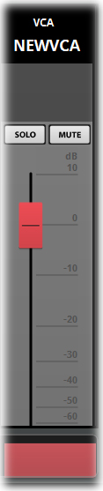
VCA Channel Strip
Note
Because VCAs exist outside of the signal chain they allow for objects to be grouped together in any way. Within a VCA there is no relationship other than the VCA group so objects from different Group Buses, Returns and Inputs can all be grouped and controlled without fear of interfering with their routing pathways.

Creating VCAs
VCAs are created within the VCA Browser in the Mixer view and can have Inputs, Group Buses, Return Buses and the Reverb Buses assigned to them. This tutorial will go through the steps to create a VCA.

Step 1 Create a new VCA
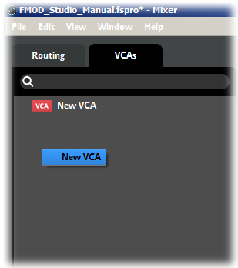
Creating a new VCA
- Navigate to the Mixer view
- Within the Mixer View hit the VCA tab in the Browser region to display the VCA Browser
- Within the VCA Browser Right Click to display the drop-down menu
- Select Add VCA from the drop-down menu
- Type in the desired name for the new VCA, hit Enter or click away from the VCA to confirm
The new VCA with the defined name will now be displayed in the VCA Browser and a new corresponding Channel Strip will be created in the Mixer region. Inputs, Group Buses, Returns and the Reverb Bus can all be assigned to VCAs.

Assigning to VCAs
Mixer objects can be assigned to VCAs from the Routing Browser. Objects can also be assigned to a new VCA which will create a NEW VCA as part of the process
This tutorial will go through the steps to assign Mixer objects to a VCA

Step 1 Assigning to VCAs
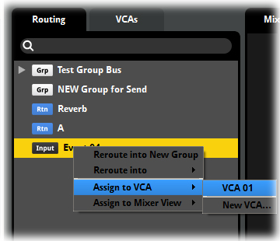
Assigning to an existing VCA
- Navigate to a Mixer view that contains Inputs or Group Buses
- Within The Router Browser Right Click on an object to access the drop-down menu
- Select Assign to VCA and navigate through the arrow to the selection menu
- Select an existing VCA or Add VCA from the selection menu
- If a new VCA is selected, type in the desired name of the new VCA
Any Mixer object assigned to a VCA will appear in the VCA Browser under the appropriate VCA Adjusting the levels of a VCA will adjust relatively the volume levels of all objects assigned to that VCA.

Multiple Mixer Views
FMOD Studio allows for the creation of multiple mixer views that will all setting live simultaneously. Multiple Mixer views is a useful tool for balancing a project by section, level, sound types or any other desirable grouping that can assist in improving the efficiency of production.

Concept
A Mixer view is simple a visual representation of a selection of Mixer Channels. The choice and inclusion of a Channel in a view does not alter how a project works, it is simply a way to view specific Channel strips while obscuring others. A user can assign any Mixer Object to a Mixer view. In this way you could have one mixer view that contains all the character sounds, one of adversary sounds and a third for environmental sounds. A fourth view could then include all of the above.
With multiple monitors it is possible to view and work with multiple views simultaneously. Obviously adjusting any single specific channel strip will result in all versions of that Channel that exist in the various views to be altered in the same way.

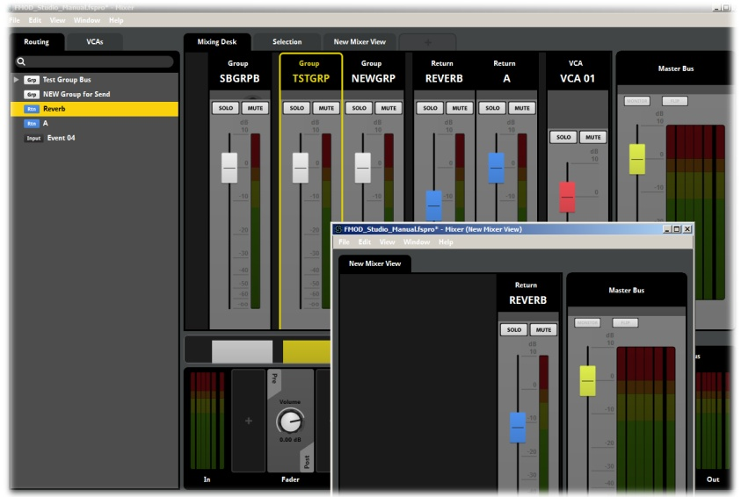
Multiple Mixer Views
Note
Mixer views are not instances. They are simply a different view of the same information. Each view of a specific channel and its information will be identical and adjustment to any values will be reflected across all views of the same channel.

Administering Mixer Views
The Mixer Region includes a Tabs area that displays all Mixer views included in a project. Users can switch between Mixer views by selecting the relevant tabs. Right clicking in the tabs region provides options for:
- Creating new Mixer Views
- Renaming Mixer Views
- Opening Mixer Views in a new window
- Deleting Mixer views

Bus Naming
The Mixer in FMOD Studio allows you to rename Buses in multiple ways. A Bus can be renamed in the Mixer Browser simply by double clicking on the Bus name within the Browser, or by selecting it and pressing the ‘F2’ key. This activates the text edit mode for the name and the new name can be directly typed in. Once the name is complete hitting enter commits the change.
Another way to rename a Bus is by double clicking on the Bus name on a Channel Strip. This opens a text field for that Strip and the new name can be directly typed in. Hitting Enter commits the new name.

Assigning to Mixer Views
All Mixer objects including VCAs, Group Buses, Inputs, Return Buses and the Reverb Bus can all be assigned to Mixer views to assist in production workflow. This tutorial will go through the steps to assign Mixer objects to Mixer views.

Step 1 Assigning to Mixer views
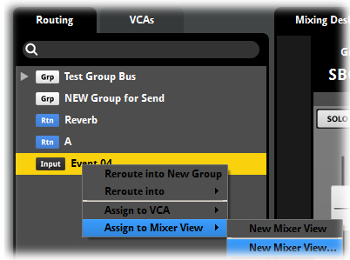
Assigning to a Mixer View
- Navigate to a Mixer view that contains Inputs, Group Buses or VCAs
- Within The Router Browser Right Click on an object to access the drop-down menu
- Select Assign to Mixer View and navigate through the arrow to the selection menu
- Select an existing Mixer View or Add Mixer View from the selection menu
- If a new Mixer View is selected a type in the desire name for the new Mixer view
Mixer Objects will be assigned as defined to the selected Mixer View. All Mixer Views will be listed in Tab form in the Mixer region and can be switched between by selecting the relevant Tab.

Snapshots
Snapshots are a method of automating Module and Bus Properties in the FMOD Studio’s Mixer. Specifically a Snapshot stores specific values for any applicable properties you specify, and can override their natural values when and as required. A user can create transitions between various snapshots to alter the values of Mixer Properties.

Mixer Snapshots
Unlike Event Properties, Mixer Properties do not normally have the facility to add automation to control them. The solution to this problem is to use Mixer Snapshots. A Mixer Snapshot is not, as the name suggests, a capture of all the Property values within the Mixer at the time when the Snapshot is created. Instead, it is a collection of values for a specific list of ‘scoped-in’ properties that you specify. New properties can be scoped in and out of an existing snapshot at any time, and their property values can likewise be adjusted.
A Snapshot can be used individually or in combination with other snapshots. When used individually FMOD Studio sets the values of all the properties scoped into the snapshot to the values specified in that snapshot, and properties not scoped into the snapshot are completely unaffected. When two or more snapshots are active at once, Studio simply applies them both – and if a property scoped into one snapshot is also scoped into the second snapshot, Studio will determine which property value takes precedence based on the order in which the snapshots appear in the Snapshots Browser, with snapshots listed higher up having a higher priority.
The Intensity Property (visible in the deck when selecting a snapshot trigger region in the event editor) allows you to specify a “mix” between the property values specified in a snapshot and those that would be in place were the snapshot not active As the Intensity Property is increased, the closer the properties’ values are shifted to those of the snapshot. So an Intensity value of 0% will result in none of the Snapshot being applied, where as a value of 50% would be an equal mix of both the current values and the Snapshot values.
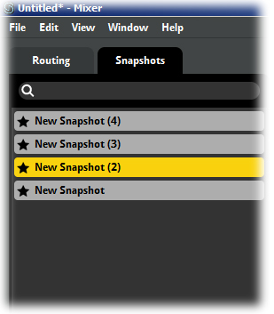
Snapshots
Note
A Snapshot can be as simple or complex as a project requires. A Snapshot can change just one single Property value by the smallest measurable difference or it can be used to automate sweeping changes to a project across the entire range of Inputs, Group Buses and their Property values.

Creating a Snapshot
The first stage in working with snapshots is to create the snapshot.
- Go to the Mixer.
- Go to the Snapshots Tab.
- Right click on the Snapshots Browser and select New Snapshot or New Blank Snapshot.
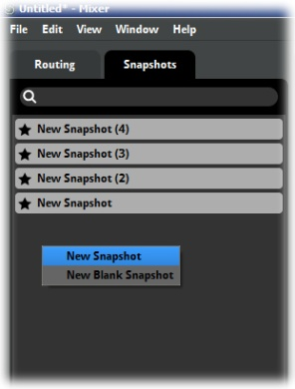
Create a new Snapshot
Once a snapshot has been created you can select which Properties you wish it to have control over. While a snapshot is selected, the context menu for bus and bus effect module properties includes a Scope In command. All Properties that have been Scoped In are included in the Snapshot, and can be assigned values to be applied when the snapshot is active. If a Property is not scoped in (is ‘scoped out’), the user interface will change to reflect this, so at a glance it is very easy to see which Properties are scoped in to the selected snapshot.
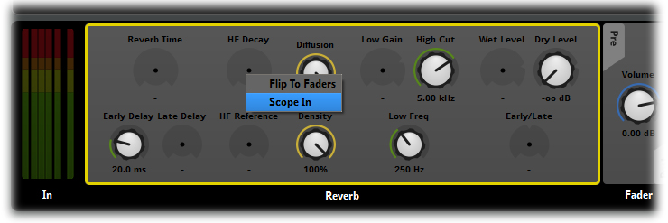
Scoping In a Property
Once a Snapshot has been created and defined in the Mixer it can be activated and controlled from within an Event. To do this a special Trigger Region object is created in an Audio Track or the Master Track of an Event. There are two methods of creating a Snapshot Trigger Region.

Method 1
Open both the Mixer and the Event Editor and drag the desired Snapshot from the Snapshot area onto an Audio Track or the Master Track of the Target Event. This causes FMOD Studio to create a new Trigger Region that can be resized, repositioned, renamed and have its color set in the same manner as any other Trigger Region. When a Snapshot’s trigger region is selected, the associated Snapshot Module appears in the deck, where the Intensity Property and Parameters appear as controls. These properties can be automated and modulated within an Event.
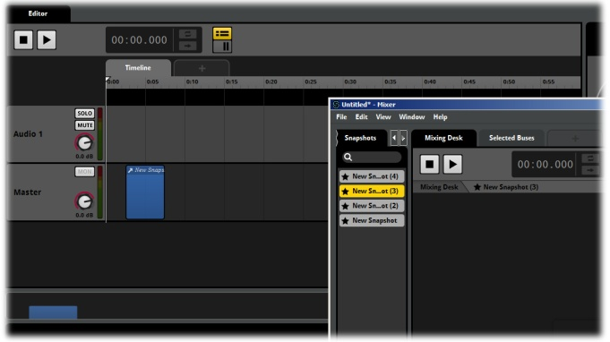
Creating a Snapshot Trigger Region

Method 2
Right click within an Event Master Track and select Add Snapshot from the context sensitive menu. You can either create a new Snapshot for the trigger region or create a Trigger Region for an existing Snapshot. Adding a new Snapshot creates a new trigger region on the Master Track, and associated Snapshot Module, and a corresponding new Snapshot in the Snapshot Browser in the Mixer. Creating a Trigger Region for an existing Snapshot only creates the Trigger Region and Module.
Note
A Triggered Snapshot Module is an instance. This means there can be multiple Trigger Regions for the same Snapshot across various Events, or even to have multiple instances of a Snapshot triggered by multiple instances of a single Event. It is also possible to rename and adjust the properties of Snapshot Modules independently of each other and of the Snapshot. Because of this we recommend you name your Snapshots and associated Trigger Regions very carefully to avoid confusion.
When multiple instances of a snapshot are simultaneously active, their intensities are averaged to determine the intensity with which the snapshot is applied to the mix.

Working with Snapshots
A Snapshot is “controlled” via the Intensity Property in the related Snapshot Trigger Region within an Event. There are various ways in which a Snapshot can be controlled within an Event.
A Snapshot Trigger Region functions just like any other Trigger Region. It will be activated when the cursor in an Event makes contact with the Trigger Region. On either the Timeline or a Parameter once the Cursor touches the Trigger Region it will activate. If there is no automation or modulation this behaves in a very basic ON/Off method just like switching on a light.
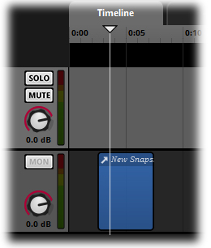
Triggering a Snapshot

Modulation
Like all Property Dials in the Deck area users can add Modulators to the Intensity Property of a Snapshot Trigger Region. This allows a user to create a “fade-in” and “fade-out” behavior for the Snapshot Trigger.
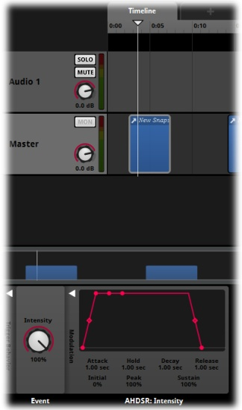
Snapshot Modulation

Automation
Automation can also be added to the Snapshot Intensity Property. This allows for precise control of the Snapshot intensity over the course of time on the Timeline or other values via a Parameter. Automation for Snapshots is created in the same method as other Property Automation by creating and adjusting nodes and curves.
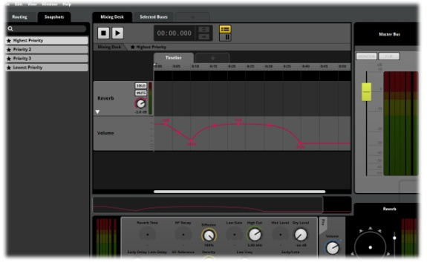
Snapshot Automation

Copying Snapshots
Snapshots and Snapshot Trigger Regions can be copied and pasted. Copying and pasting a Snapshot Trigger Region produces a copy of that Snapshot Trigger Region and Module. This means both the original and the copy will reference the same Snapshot. Copying and pasting a Snapshot in the Snapshot Browser creates a new Snapshot with the same settings as the old Snapshot. In such a case, existing Snapshot Trigger Regions continue to trigger the original Snapshot.
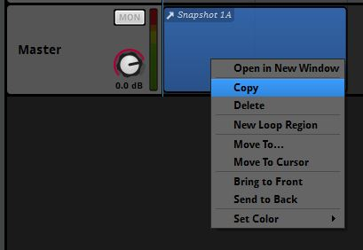
Copying a Snapshot Trigger Region

Blank Snapshots
The context menu provides an option to create blank Snapshots. This menu option creates a Snapshot that does not have any Properties Scoped In. In contrast, the New Snapshot menu option automatically Scopes In all the Group and Return buses in the Project. Aside from their initial scope, there is no difference between these two kinds of snapshots, and either allows you to Scope In and Scope Out properties as desired.

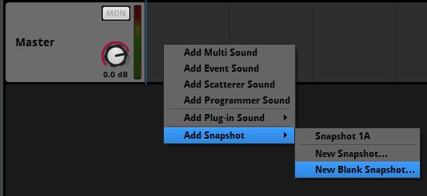
Creating a Blank Snapshot

Snapshots and Stacking
Because it is possible to have multiple instances of a snapshot controlled across several Events with multiple Trigger Regions it is possible to stack the effects of the Snapshot Intensity Property. For example, the way a gunshot that has a Snapshot created to reduce the volume by 80% sounds will depend on both the level of intensity and the number of instances being triggered of the Snapshot.
Obviously a single instance set to 100% Intensity will apply 100% of the change and so alter the output by 80%, so the sound will drop considerably. A single instance set to 50% will apply 50% of the Snapshot value so would reduce the sound by 40%.
If however there were two instances of the snapshot being controlled by two Events to trigger at the same time they would both trigger and their values would combine. So if they were both set to 20% Intensity they would stack to apply 40% of the effect, which in this case would reduce the volume by 40%.

The Snapshot Priority List
The area in the Mixer where Snapshots are created and listed is more than a simple browser window. It provides functionality for how Snapshots are processed. When multiple Snapshots are triggered simultaneously Studio will respond differently depending on the nature of the Snapshots being triggered.
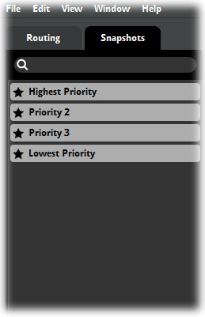
Snapshot Priority List

Multiple Instances of the same Snapshot
Triggering multiple versions of the same Snapshot will cause the values of the Intensity Property to be stacked and provide the final intensity value to be applied.

Multiple Snapshots with no shared Properties
If there are multiple Snapshots triggered and none of them share any Properties then they can all freely be applied at the same time and Studio will adjust all the relevant Properties to influence the output signal.

Multiple Snapshots with Shared Properties
If multiple Snapshots with shared Properties are triggered then FMOD Studio must apply them in order of the priority they have been assigned. The order in which Snapshots appear in the Snapshot Priority List defines this behavior; See Priorities.

Priorities
The Priority list works from the bottom up. This means that the further up the list the higher a priority a Snapshot has. From a processing point of view when Studio detects Snapshot conflicts, it will work its way up from the bottom of the list, each level higher is a higher priority and will take precedence over lower priority entries.
Note
FMOD Studio only overrides Snapshots values when absolutely necessary and does so only to the Properties it needs to and only by as much as it needs to. This allows the Snapshot system to work effectively while allowing the creative requirements of a game to be met.

Snapshot Automation
FMOD Studio includes an Interface display that is designed to support Snapshot Automation from within The Mixer. The Mixer Display buttons toggle between the regular Mixer view and a horizontal Track view of Mixer elements. This provides an interface to add automation to Properties within a Snapshot.
The Snapshot Track interface looks very like the Event Editor. It includes a Timeline, can also have Game Parameters added and supports the creation of Automation Tracks and their relevant functionality.

Snapshot Timeline and Parameters
Snapshots have the option to include a Timeline and Parameters. Neither is required but they can both extend the functionality of a Snapshot significantly.
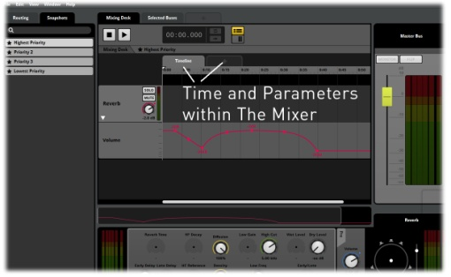
Snapshot Timeline and Parameters
Each time a Snapshot is triggered, the Timeline position will start again from zero on the Timeline. A Parameter will start from whatever value it is set to in the snapshot module’s properties.
Automation for Mixer Properties can be added within the Timeline or Parameter views. Only Properties that have been Scoped In for the Snapshot in question can have Automation applied. Properties can of course be Scoped In at any time, but this needs to be done before Automation can be created for a specific Property.

Mixer Routing Window
The Mixer Routing Window can be accessed via the Menu Bar Window/Mixer Routing. FMOD Studio will display a pop-up Window similar in appearance to the Event Browser. The Mixer Router defines Signal Paths within the Mixer; it is not just an administrative display. This replicates the Routing functions of the Mixer Routing area within the general Mixer view.
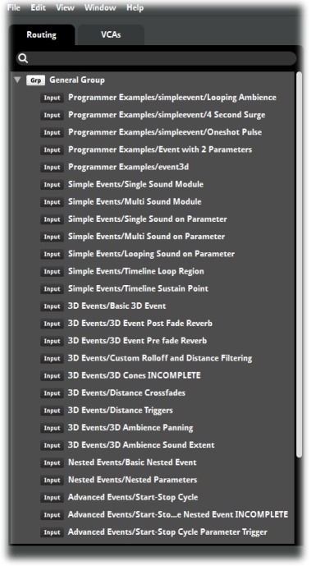
Mixer Routing Window
The Mixer Routing Window also includes the Voltage Control Amplifier (VCA) Tab and this is the only way to access the VCA area. Within the VCA Tab, VCA’s can be created and organized and Mixer Buses can be dragged from the Mixer Router onto VCAs within the area to assign them to a VCA.

Assigning Mixer Buses to VCAs
- Open the Mixer Router Window and select the VCA Tab
- Drag the desired Bus onto the target VCA from the main Mixer Router area or from a second pop-up Mixer Router. The object will be assigned to that VCA.
Any number of Mixer Router Windows can be open at a given time, which can make it easier to assign objects to VCAs as well as to set up your projects Routing system by dragging objects from one window to another.
Note
Remember that objects dragged into the VCA area are simply assigned to a VCA whereas objects dragged within the Mixer Router are positioned within the Signal Chain. Consider these actions carefully before progressing.

Add Sends: To Mixing Desk
This is a sub menu of the Add Sends context sensitive menu within the Deck area. This command provides routing access to Return Buses within the Mixer to allow for the Signal from an Event to be routed directly to a Mixer Return Bus rather than just to a Return Track within the Event. It also allows direct routing access to the Reverb Return Bus.

Channels and Panning
FMOD Studio provides a range of different Panning controls for both Event objects and Mixer objects. The Deck region displays the input levels, output levels and Panner control appropriate for the channel setup selected.
There are three channel setups available for objects within FMOD Studio
- Mono
- Stereo
- Surround
The input and output levels as well as the Panner Controls will automatically update to reflect which channel setup has been selected. By default Studio will assign Surround channel setup to all objects except Return Buses which default to mono.

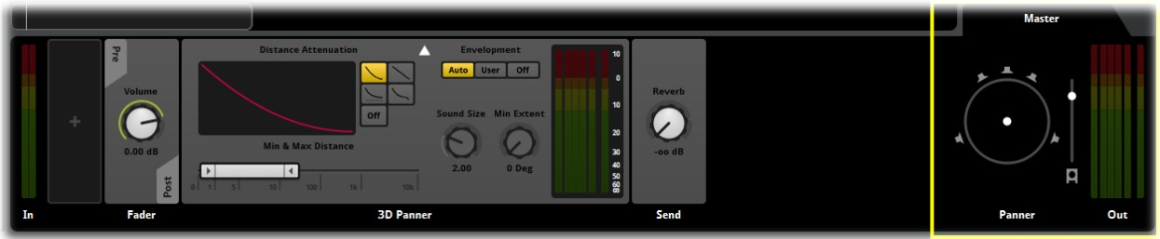
Pan and Channel Controls
FMOD Studio also has an automatic system of channel setup by default. If an Event has its channel setup switched to Mono, Studio will automatically switch all channel inputs and outputs along the signal path to match this switch. If the automatic setting is overridden somewhere along the signal path however the channel will be set at whatever setup is defined by the user at each stage of the signal path and will stay in that mode.

Setting Channel modes
All Channel and Pan Controls Properties are consistent across both the Event View and the Mixer View in FMOD Studio. Channel controls default to automatic but can be altered by users at any time. This tutorial will go through the steps to switch between channel modes.

Step 1 Switching channel output modes
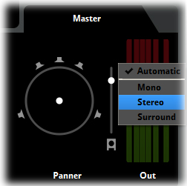
Deck region with channel setup
- Navigate to any object that contains a Deck Region
- Within the Deck region right click on the output peak meters
- From the drop-down menu select the desired Channel output mode
The display will alter the Channel output mode to the appropriate number of meters to correspond with the selection. 1 for mono, 2 for stereo and 6 for surround. The Panner control will also update to provide the appropriate controller for the channel setup. There is no Panner control for channels defined as Mono as by its very definition Mono sends a single signal of equal strength to all outputs.
Note
It is only possible to define the output channel setup for an object in FMOD Studio. The input is by necessity defined by the previous stage in the signal path. An Event that has a its channel output set to stereo will always generate a corresponding Mixer Input with its input set to stereo to match.

Using the Panner Controls
The Panner controls are used to define the strength of a signal through each of the available output channels. A Panner works by dividing the signal among the available channels.

Concept
A Panner is not the same as applying volume to channels as the overall 100% signal is divided among the available channels. A Stereo Channel setup when evenly balanced sends 50% of the signal to each channel evenly. To adjust the Panning weight to increase the signal to one channel must result in a corresponding and relative reduction in signal to the other channel. So setting the right channel to 65% must result in the left channel being set to 35%. The two values will always combine to make up the 100% signal output.
Surround Panning has one exception to this rule. The sub frequency channel is isolated from the surround channels and can be defined without influencing the surround channels. The values of the surround channels however will all combine to create the 100% signal output.

Stereo Panner
The stereo Panner has a control display that allows for the values to be adjusted from 100% left to 100% right and all values in between. By default the Stereo Panner is set to the center position of 50^ left/50% right. Clicking on the Stereo Panner and dragging the mouse up and down will alter the balance between left and right. The control will visually display the weighting between the two channels

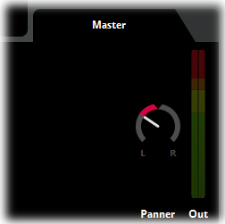
Stereo Panner Controls

Surround Panner
The Surround Panner incorporates two controllers: the sub channel level slider and surround Panner speaker controller.
The sub channel level is an independent controller that can be used to define the signal strength sent to the sub frequency channel. Dragging the mouse up and down will move the controller through its range of values from 0-100%
The surround Panner speaker controller lets the user move the signal strength around within the surround output region. By default the Panner is set to the center of the display region, meaning that the track outputs a signal equally to all channels. Dragging the mouse around the surround region alters the weighting of the output signal between the available channels. The display updates with a green highlight to indicate the weighting strength of the output signal.
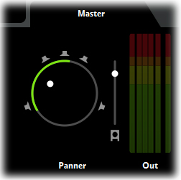
Surround Panner Controls
Regardless of the method of channel output setting selected or the type of Panner that is being controlled, the output of the sound signal should reflect the changes being controlled by the users. If you are unable to hear changes to your audio output that correspond to the changes you are defining then there may be an issue with your computer sound setup or your hardware setup, or an error somewhere further down the signal path. Consult your system setup manual as well as any hardware setup manuals to ensure your system is functioning as expected.

Pan Automation
The Pan Property can have Automation added. The available options depend on the currently selected Pan mode.
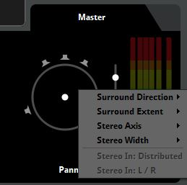
Pan Context Menu

Mono
No Panning options available.

Stereo
Automation

Surround
Surround Direction
Automation
Surround Extent
Automation
Stereo Axis
Automation
Stereo Width
Automation
Automation Properties function in the same manner as for all other FMOD Studio Properties.

Surround Direction
The Sound Direction Property defines where within the Surround Pan area the sound is located. Automation of modulation of this Property allows for the sound source to be repositioned within the Panning plane to achieve pan ‘movement’

Surround Extent
Surround Extent defines the degree to which a sound appears to be ‘around’ the listener. At its smallest value a sound will appear to occupy a single point in space. As this Property is increased in value it will expand across the available speakers and wrap around the listener position.
Note
Surround Extent and Surround Direction are linked in their functionality. A sound set to fully envelop the listener will not have a discreet directional location, so the lower the value of Surround Extent the more important the values defined by Surround Direction become.

Stereo Axis
Stereo Axis defines the central line of the pan space and how it is oriented.

Stereo Width
Stereo Width defines the ‘broadness’ of a sound. Increasing this Property will make the sound appear wider and more open, conversely reducing the Property will make the sound seem closer to the listener.

Switching Speakers On and Off
When set to Surround Panning it is possible to switch speaker channels on and off as required. Clicking on a channel’s Speaker icon will gray it out to indicate that speaker output is now switched off. No signal is routed to a speaker channel while it is switched off.
When a speaker channel is switched off it is not just muted, its signal is routed to the remaining speaker channels appropriately. For instance if an Audio Track has been panned to the center speaker in the Surround Panner and then the center speaker is switched off the signal is rerouted to the front left and right speakers with a 3dB attenuation applied.

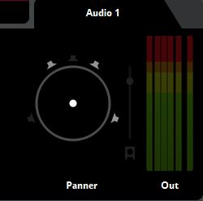

Surround Panner with Speaker Channels switched off Mixer Strip Source Control Lock
FMOD Studio is designed to directly integrate with the Perforce and Team Foundation Server source control systems. These systems are ideal for audio teams to use to ensure the security of project data and allow multiple users to work on a single project while mitigating many of the risks of altering other team members’ work.
One of the features of the source control integration is to allow individual Mixer Channel Strips to be locked in the source control setup to prevent unwanted alterations. To lock a Mixer Channel Strip, right click on the Channel Strip to access the context menu and from the revision control submenu and select Lock.
Once a Mixer Strip has been locked it is clearly indicated as locked to all other users of the project to ensure all team members are aware of its status. If the user that locked the Channel Strip manually unlocks the Strip or checks in any changes to that Channel Strip the Channel Strip will then be unlocked.
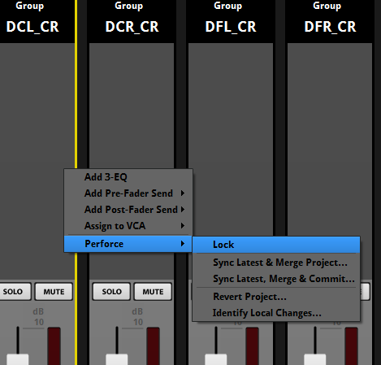
The Perforce Lock command
The Perforce Lock function only exists for Mixer Chanel Strips. A similar function can be applied to Events to lock an entire Event. A revision control sub menu also exists in the Event context menu accessed by right clicking on an Event in the Event Browser.
All functionality related to source control and revision control specific actions are only accessible if a revision control integration has been specified in the project’s Preferences window (Menu Bar/Edit/Preferences...).

Note
The use of source control locks should only be considered during the final stages of a project and when a team of multiple audio members is working on the same project. In general this system is designed to provide stability of project data, but it can also limit workflow as once an element is locked by an individual it cannot be accessed by other team members until it is unlocked. If a team member is away sick or unavailable this can cause workflow issues. Consider carefully how you establish your workflow practices before utilizing this feature.

FMOD Music System
FMOD Studio includes a series of tools and functions that have been designed to assist in the creation and implementation of musical works for games. All functions within FMOD Studio are designed to be flexible and the distinction between music and sound design in games is often blurred. For this reason “Music” tools are just as suitable for sound design purposes and vice versa. These tools are classified as musical tools as they deal with many aspects of production often related to music.
The integration of all tools into a unified tool and a single editing space allows for total integration of sound and music aspects within a project. It allows for any tool to be utilized for either sound design, music design or dialogue. Within the confines of more traditional musical creation concepts some tools deal more with musical terminology and workflow. These tools will be described in this section.

The Logic Track
The Logic Track includes a variety of functions that help control the playback behavior of Tracks within an Event. Some of these functions work well for music composition and implementation. The Logic Track can have items created and positioned along it horizontally to reference points along the Timeline. The Logic Track can also be expanded vertically to allow multiple levels of placement on a vertical axis. Placement vertically applies a priority to the various objects within the Logic Track. An object placed higher on the Logic Track will be prioritized more highly than objects positioned lower on the Logic Track.

Markers
Markers can be used in a variety of ways in Event creation. The simplest use is to indicate a section or significant area by placing a Marker and naming it appropriately. In this case, Markers are being used much like a street sign. They mark an area with a word or message that can provide useful information to the users or team of users while developing a project. This function can also be very useful for educational purposes as you can clearly indicate various aspects of a project with markers.

Markers
Markers also have a purpose within the Logic function of Event creation. Using the Logic function, Markers can be established as Transition destinations. In this case they quite literally work as street signs as Studio can be instructed to jump to a Marker location when the Logic function circumstances are met.

Markers and Logic Function

Creating Markers
Markers are created by Right Clicking in the Logic Track and selecting Add Marker from the context sensitive menu. A new Marker will be created at the point where you clicked on the Logic Track.
Add a Marker

Working with Markers
Markers can be moved by simply dragging them back and forth or up and down on the Logic Track. A Marker can be renamed by double clicking on the head of the Marker. To delete a Marker either click on it to make it active and press the Delete key or right click on the head of the Marker and select Delete from the context sensitive menu that appears.
Move a Marker

Tempo Markers
Tempo Markers look similar to Markers and share most of the basic workflow functionality but a Tempo marker defines the Musical Tempo applied to the Event Timeline from the position the Tempo Marker is placed onwards. Multiple Tempo Markers will result in the Tempo being recalculated as the cursor reaches each Tempo Marker in turn.
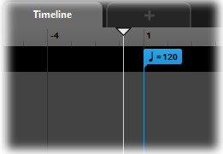
Tempo Marker
The Tempo of an Event does not affect the rate at which the Cursor progresses along the Timeline; this is always mapped exactly to measuring regular time. A Tempo Marker applies Tempo measurement to the Timeline for the purposes of Quantization for Trigger Region activation. So a Tempo Marker is used in conjunction with the Trigger Behavior Module that is part of all Sound Modules.
Defining Quantization

Creating Tempo Markers
Tempo Markers are created by Right Clicking in the Logic Track and Selecting Add Tempo Marker from the context sensitive menu. A new Tempo Marker will be created at the point where you clicked on the Logic Track.
Add a Tempo Marker
When you create a Tempo Marker in an Event, the Timeline will change to display Bars and Beats. The distribution of the Bar and Beat measures is dependent on the tempo defined in the Tempo Marker.

Defining Tempo
By default a Tempo Marker is created displaying 120 BPM. This value can be altered by double clicking on the Tempo Marker head and inputting the desired tempo value. Altering the Tempo value will result in the Bar and Beat measures on the Timeline being repositioned accordingly.

Default Tempo Markers

Working with Tempo Markers
Tempo Markers can be moved by simply dragging them back and forth or up and down on the Logic Track. To Delete a Marker, either click on it to make it active and press the Delete key or right click on the head of the Marker and select Delete from the context sensitive menu that appears.
Deleting a Marker
Note
The position of a Tempo Marker indicates where the tempo of an Event is defined. Because the speed of the cursor along the Timeline will always reflect real time, the placement and positioning of the Bar and Beat measures will alter to reflect the defined tempo in relation to the Tempo Marker. So a distance on the Timeline that would equal ten seconds of time will always equal ten seconds of time. The number of bars and beats within those ten seconds will alter to fit depending on the tempo that has been defined by a Tempo Marker.

Transitions
Transitions are a type of Marker that links directly to the Logic function of Event playback. When a Transition is created it can be defined to link to an existing Marker or it can be created as a blank Transition to be linked at a later time. A Transition will serve no purpose unless it is provided with appropriate information to define the transition logic.
Transitions

Creating Transitions
Transitions are created by Right Clicking in the Logic Track and Selecting Add Transition or Add Transition to.. from the context sensitive menu. If Add Transition To.. is selected a further context menu will display to allow a user to select from the available Transition targets. A new Transition will be created at the point where you clicked on the Logic Track.
Create a Transition

Working with Transitions
Transitions can be moved by simply dragging them back and forth or up and down on the Logic Track. A Transition will be named to indicate its destination. To delete a Transition, either click on it to make it active and press the Delete key or right click on the head of the Transition and select Delete from the context sensitive menu that appears.

Transition Functionality
A selected Transition will display its Logic Module in the Deck area. Transitions function by defining a Parameter as its controlling function. A Transition Logic Module cannot work unless there is a Game Parameter present in its parent Event. There can be multiple Parameters within the Event but there must be at least one for the Logic Module to refer to.

Transition Functionality
Select which Parameter you wish to use to control the Transition by Right Clicking on the Logic Module and selecting the desired Parameter from the context sensitive menu. FMOD Studio will then display the Properties for the Logic Module. The Logic Module allows a user to define the value or the Parameter that will trigger the Transition behavior. The Ribbon Slider can define a single value by inputting the same number into both ends of the Ribbon Slider, or it can define a range of values by defining a minimum and maximum value with the Ribbon Slider.
During playback FMOD Studio will reference the Logic Module when the Cursor makes contact with the Transition Marker. If the value of the Game Parameter equals the value defined in the Logic Module, Studio will instantly jump the cursor position to the target Marker and continue Cursor progression from that point. If the Parameter does not equal the defined values, the Cursor will continue to move along the Timeline as normal.

Transition Regions
Transition Regions are a type of Marker Region that links directly to the Logic function of Event playback. A Transition Region works just like a Transition Marker but can be extended over an area instead of a single point on the Timeline. When a Transition Region is created it can be defined to link to an existing Marker or it can be created as a blank transition to be linked at a later time. A Transition Region will serve no purpose unless it is provided with appropriate information to define the transition logic.
Transition Regions

Creating Transition Regions
Transition Regions are created by Right Clicking in the Logic Track and Selecting Add Transition Region or Add Transition Region to.. from the context sensitive menu. If Add Transition Region To is selected a further context menu will display to allow a user to select from the available transition targets. A new Transition will be created at the point where you clicked on the Logic Track.
Create a Transition Region

Working with Transition Regions
Transition Region end points can be moved by simply dragging them back and forth or up and down on the Logic Track (Moving up or down will reposition the entire Region on the new vertical axis). A Transition Region will be named to indicate its destination. To delete a region either click on it to make it active and press the Delete key or right click on the head of the Marker and select Delete from the context sensitive menu that appears.

Transition Functionality
When a Transition is selected it will display its Logic Module in the Deck area. Transition Regions function by defining a Parameter as its controlling function. A Transition Region Logic Module cannot work unless there is a Game Parameter present in its parent Event. There can be multiple Parameters within the Event but there must be at least one for the Logic Module to refer to.
Selecting a Parameter for your Transition
Select which Parameter you wish to use to control the Transition Region by Right Clicking on the Logic Module and selecting the desired Parameter from the context sensitive menu. FMOD Studio will then display the Properties for the Logic Module. The Logic Module allows a user to define the value or the Parameter that will trigger the Transition Region behavior. The Ribbon Slider can define a single value by inputting the same number into both ends of the Slider, or it can define a range of values by defining a minimum and maximum value with the Ribbon Slider.
During playback FMOD Studio will reference the Logic Module when the Cursor makes contact with the Transition Region. If the value of the Game Parameter equals the value defined in the Logic Module, Studio will instantly jump the cursor position to the target Marker and continue Cursor progression from that point. If the Parameter does not equal the defined values the Cursor will continue to move along the Timeline as normal.

Transition Region Quantization
A Transition Region also includes a Quantization Module displayed in the Deck area. The Quantization Module allows the user to define acceptable transfer points within the region. This means that Studio will not simply perform the transfer jump at any point in time, it will instead wait until it reaches a suitable bar or beat as defined by the Quantization Module.
Quantization
When a particular quantization value is selected on the Quantization Module, the Transition Region will display those points on the Timeline with additional marker lines. This makes it clear to the user exactly where transitions can occur within the region.

Quantization Marker Lines

Loop Regions and Sustain Points
Both Loop Regions and Sustain points function in the exact same manner they do in non-musical FMOD Studio Events, but because they make up part of the Logic Track, both Loop Regions and Sustain points will integrate with all the other Logic Track objects. This means a Loop Region can be combined with Transitions and Marks to create a looping section of an Event that under the correctly defined Parameter values will jump from the loop to another area of the Timeline; this could even be into another loop.
Note
Markers, Transitions and Transition Regions can be placed anywhere on the Timeline in relation to each other. This means that Transitions can jump either forward or backward along the Timeline. The head section of a Transition will point in the direction of its associated Marker as a visual aid for how the Logic of the Event will play out.
Loop Regions and Sustain Points

Trigger Behavior
All Sound Modules have a Trigger Behavior Drawer in the Deck area. This Drawer is used to define Delay and Quantization behavior for a Sound Module, as well as Seek, Polyphony and Probability Properties. The Trigger Behavior drawer can be accessed by clicking on the white disclosure triangle; this extends the drawer and allows access to the Trigger Behavior Properties.
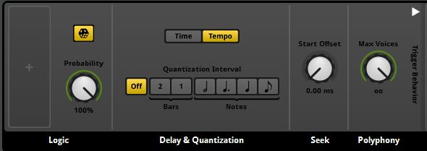
Trigger Behavior
The Trigger Behavior Properties function somewhat like a Logic Signal Path, in that FMOD Studio will process each step from left to right to determine if and how a Sound Module will trigger. The Logic Properties will define whether the Sound Module triggers at all. The Delay and Quantization then apply any time or tempo conditions that affect precisely when the sound starts to play. Next the Seek Property is queried to see if an offset has been defined and finally the Polyphony Property is checked to see if there are sufficient voices for that sound to be played.
All of these Property conditions influence the ultimate playback behavior of a sound, so it is important to ensure they are set correctly as they could otherwise result in unpredictable or undesirable playback.
By default the Trigger Behavior for a Sound Module is set to immediate triggering with no quantization. This means a Sound Module will trigger the instant the Cursor makes contact with the Trigger Region in either the Timeline or in a Game Parameter. It also means the Sound Module will untrigger the instant the Cursor is no longer in contact with the Trigger Region.
Note
Untriggering means slightly different things depending on the placement of the Trigger Region and the type of Sound Module. A Looping Sound Module stops playing as soon as the Cursor moves off its Trigger Region. A Non-looping Non-Timelocked Sound Module continues to play through to the end of the sound file, whereas a Timelocked Sound Module will stop playing as soon as the Cursor moves off its Trigger Region.

Logic
The Logic section provides additional conditional Properties to define whether a Sound Module triggers when its trigger region is intersected by a Parameter or timeline cursor. The box with the plus symbol allows you to associate a Parameter with this Sound Module to provide a conditional switch for triggering.
The Toggle Button will toggle the Probability Property on and off. In its off state Probability will be set to 100%, which means the sound will always trigger. The Probability Property dial has a range from 0-100% and represents the probability that the Sound Module will play whenever all the other trigger conditions are met.
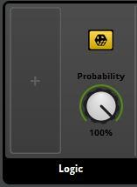
The Logic Module
Note
A variety of conditions must be met for a Sound Module to play.
- The cursor on the relevant Timeline or Parameter must intersect with the Trigger Region.
- Any associated Parameter conditions must be met.
- The Probability value must equal or exceed a random number between 1 and 100 that’s generated whenever all the other conditions are met.
- There must be an available voice as defined by the Polyphony Property.
If even one of these conditions is not met then the Sound Module will not play.

Defining Delay and Quantization
There are two methods of defining the Delay and Quantization of a Sound Module. Time allows an absolute period of time or range of time to be defined as a delay before a Trigger Region will commence playback. Tempo is used to provide quantization information for triggering playback using musical measures of Bars and Beats.
Time or Tempo

Time
The Time Property of Trigger Behavior allows a user to define the period of time that Studio counts before a Sound Module begins to play. While a Sound Module is triggered the instant the Cursor makes contact with its associated Trigger Region, it does not actually have to start playing the sound at this point.
The Time area has a Trigger Delay Property that works via a Ribbon Slider. The slider defines the minimum and maximum time values in milliseconds or second before a Sound Module starts to play its sound once triggered. If both the min and max values are the same then a fixed delay will always be applied to that Sound Module every time it is triggered. If the min and max values are different then they create a window in time. FMOD Studio will count at least the min time value and no more than the max time value, but between those two it will randomly select a period of delay to apply to the Sound Module. The precise amount of delay is randomized within this range every time the module is triggered.
Trigger Delay Property

Values can be defined by either dragging the ends of the Ribbon Slider to the desired values, or double clicking on the displayed numbers to directly input exact values.
Enter Exact Values

Note
It is possible to define both Delay and Quantization Properties and combine the results of both. This should be done carefully so as not to introduce undesirable playback behavior.

Tempo
The Tempo area defines Quantization behavior for Event using various Logic Track objects. A Tempo Marker needs to be included in an Event to make use of the Tempo functions.
Tempo Marker
When an Event includes a Tempo Marker, FMOD Studio applies tempo tracking as well as counting regular time. The Tempo Quantization allows a user to define when Sound Modules trigger in relation to the Event Tempo. This allows for Sound Modules to be delayed slightly so they trigger in time with the defined Tempo and as such sound more ‘musical’.
Once a Tempo Marker is added to an Event, the Timeline will change to display tempo measures in Bar and Beat format. Sound Module Trigger Regions can be moved to align with these measures, but the Quantization property will ensure they trigger in sync with the musical measures.
The Quantization Property can be set to either bar values of 1 or 2, or beat values of minum, crotchet, dotted crotchet or quaver measures.

Seek
The Seek Property allows users to define an offset for each Sound Module. This means you can define where within a Sound Module it actually starts to play. So a Seek value of 5 seconds means that when the cursor triggers the Sound Module, FMOD Studio commences playing from 5 seconds into the sound file.
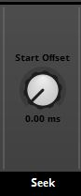
The Seek Property
The Seek Property has a range from 0-10 seconds with a default value of 0. Note that this Property can be defined in either milliseconds (ms) or seconds (sec). Like all dial-based Properties, Start Offset can be automated to add further control to this Module.

Note
The Start Offset value is applied to any sound file within the Playlist of the target Sound Module. Because of this it is important to be aware of the length of all the sound files within a Multi Sound or Scatter Sound Module as applying a Start Offset value to a sound file that is greater than the length of the sound file may cause undesirable playback behavior.

Polyphony
The Polyphony Property defines the number of instances of a particular Sound Module that can be voiced simultaneously. So if set to a value of 1 the target Sound Module will only ever have a single instance of it played at the same time. The Polyphony Property has a range from 1-64/Infinity with a default value of infinity.
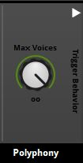
The Polyphony Property

Note
Once the maximum defined Polyphony value is reached, any requests for further instances of the Module to play will simply fail until a voice channel is available. FMOD Studio will not cue requests; if a voice channel is not available the request will fail and be discarded. Once a currently playing voice channel is available any future requests for that Sound Module will be free to play.

The 3D Panner
The 3D Panner defines the behavior of a sound Event within a 3D world space. By default all Sound Events in FMOD Studio are created as 3D sounds. The 3D Panner directly influences how sounds relate to the Listener in 3D audio.
Many games are created in a 3D world space and utilize 3D audio. 3D audio has far more complex playback behavior than traditional 2D audio and as such there are a range of settings to define the exact behavior required of a sound played in a 3D space. The Master Track of every Sound Event created in FMOD Studio will contain a 3D Panner in the Deck region. The default setting values of the 3D Panner will allow for a general standard form of playback behavior from all sounds.

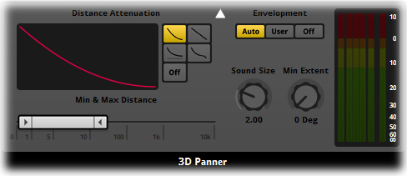
3D Panner Controls

Min and Max Distance
There are two primary settings that define how a sound is heard in a 3D space. Min and Max Distances refer to the Minimum Distance a sound will travel within the 3D space before attenuation begins. The Maximum Distance is the point at which attenuation stops. Understanding these two functions is an essential part of working with 3D audio.
The Min and Max distance values can be used to influence a sound within a 3D space by defining how far that sound will travel before drop-off occurs (min Distance) and then defining a point where drop off ceases (Max Distance). The Distance Attenuation settings display the type of curve applied to the drop-off and provides four different curve types and the ability to switch off drop-off completely.

3D Sound Properties
Understanding the relationship between the 3D Min and 3D Max distances is essential for creating 3D audio environments. These two properties define a major aspect of how audio functions in 3D spaces. There are other properties that also influence sound behavior but they are usually closely related to the 3D Min / Max properties.

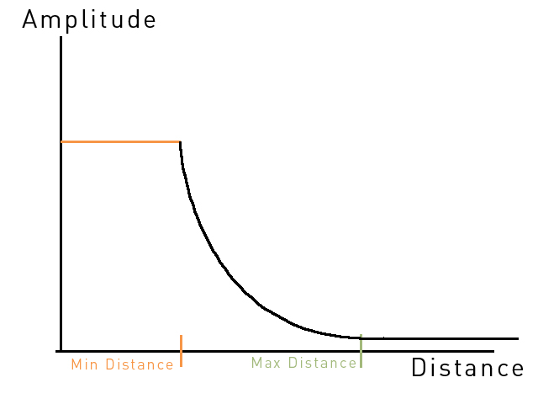
3D Min and Max Distance Behavior
When presented on a graph the relationship between 3D Min and Max properties can be examined. The vertical axis indicates the amplitude of the example sound. The exact amplitude is not important for this example, what is important is that the amplitude remains constant at its defined value from its point of origin out to the Min distance amount. This means that wherever the listener is in the area between the point of origin and the Min distance the sound will be heard at its defined volume.
Once the Min distance is reached the amplitude will drop of and the sound will start to fade. The exact way in which the sound fades is determined by the attenuation curve. The amplitude of the sound will continue to reduce (following the curve characteristics) until the Max distance is reached. At this point the amplitude will no longer reduce and the sound level will be constant from the Max distance point to infinity. Note that if the Max distance is set sufficiently far away from the Min distance the attenuation curve will likely result in the sound signal dropping to zero.
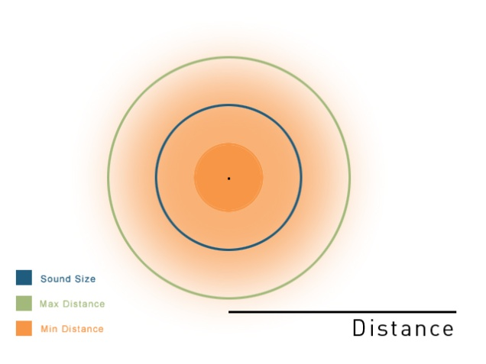
3D Min and Max distance behavior (top-down view)
If we examine this same information from above we can extend our understanding of the process. The sound emanates outwards from the point of origin in a spherical manner just as sound does in the real world. The 3D Min Distance value defines how far it will travel before it starts to attenuate. In this example this is represented by the solid orange circle. This Min Distance region essentially has a volumetric quality in that even though the sound is generated from a single point (which all sounds are) the sound is maintained at its defined volume within the entire region. Once outside of the min distance the sound starts to attenuate towards the 3D Max Distance point.

Sound Size
This diagram also includes an indication of the Sound Size property. This is separate and independently defined to the 3D Min and Max distances but its behavior is related. The Sound Size defines how big an area the sound will occupy and while you are within that area you will perceive that the sound is all around you, encompassing you. Once you move outside of the sound area it will now occupy a specific location in 3D space and you will perceive its direction and distance from the listener’s point of view.
To explain this example in real-world terms, think about how a car engine sounds if you have the bonnet open and your ear close to the engine. The engine is producing lots of different sounds that combine to create the overall sound of the car running. Listening so close, you will be surrounded by the sound of the engine as if you are in among the many components. As you step back and walk away from the car the sound is no longer all around you and it now occupies a specific point in space, as you walk further away you perceive that the sound of the car becomes smaller in space and all the sound is focused into that small area.
By defining the Sound Size as larger than the 3D Min distance you extend the volumetric area of the sound beyond where it starts to attenuate, so while you are still “inside” the sound, you will start to hear it reduce in volume as you move away from the Min Distance point. Once you move outside the Sound Size point you will then notice the sound has a noticeable location in the 3D world space, and once you move past the 3D Max distance the sound will no longer reduce in volume and if it is still audible it will remain so indefinitely.

Min Extent
The Min Extent property allows users to expand the speaker spread of a 3D sound. The default value of zero will result in a 3D sound occupying a single point in the 3D world. This is represented by speaker playback of a discreet signal panned to a single location that corresponds to the location of the sound relatively in the 3D world. By increasing the value of this property the sound will expand across a greater area of the speaker pan range. This can make a sound seem bigger as it will encompass a larger “area” of the speaker output. Large dynamic events such as explosions may benefit from considered use of this property.
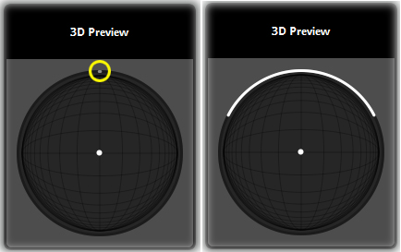
Min Extent values displayed in the 3D preview

Note
All Events are created by default with a 3D Panner module in the Master Track. If your sound is designed to function in a 2D manner it is best to remove the 3D Panner from the Event. This will optimize performance of your project.

Pan Override
The Pan Override property allows a user to define specific speaker output for a Sound Event. This override output can be mixed with the 3D Panner’s output to produce different effects, from all 3D Panner signal and no override signal, to all override signal and no 3D Panner signal.

3D Preview
The 3D Preview is a graphical display that provides information for various properties controlled from the 3D Panner. The white arrow icon represents the point of origin of the emitter, and the center of the circle is the location of the listener. The circle itself represents a top-down view of a spherical 3D space, where the upper half of the diagram represents locations in front of the listener, and the lower half of the diagram represents locations behind it. The emitter icon can be dragged to different positions in order to preview the panning behavior of the active event. The Sound Size is represented by a grey zone it expands outward from the emitter point and moves in direct relation to it.
The circumference of the 3D Preview is where the envelopment value is displayed. The grey line that appears there indicates how sound is being panned to the speakers as the event is moved around 3D space. By altering the Min Extent value you can override this value by defining its minimum effect.

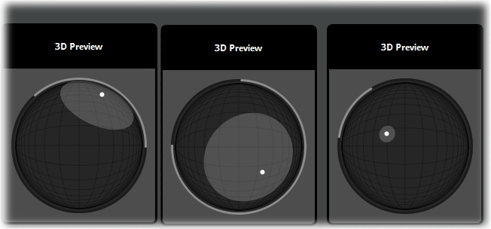
Various 3D Preview views
Holding down the Ctrl key while dragging the emitter in the 3D Preview allows you to alter the vertical height of the Emitter, such that dragging away from the Listener increases the Emitter’s altitude and dragging closer to the Listener decreases it. This allows further auditioning of 3D cone volume as well as auditioning of the ‘Elevation’ built-in property.
The maximum distance the Emitter can be from the Listener is still fixed by the maximum value of the ‘Distance’ built-in property, so the movement of the Emitter is constrained to within a sphere rather than to within a cylinder. This may occasionally lead to the Emitter changing distance or height when the other property is being changed.
The facing of the emitter is indicated by the direction the emitter icon’s arrow faces. This facing can be changed by spinning the mouse wheel while the cursor is over the 3D Preview. The facing of the listener is always straight ‘up’ (forward).

Distance Attenuation
The Distance Attenuation display and selectors allow the user to define the most suitable drop off curve for their sound in a 3D space. The display will update to indicate the selected drop-off curve. The Distance Attenuation can also be switched to Off which will result in the sound having no drop-off curve. The various attenuation curves will alter the behavior of how the sound diminishes over distance.
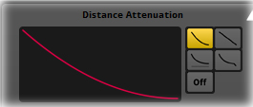
Distance Attenuation Controls and Display

Note
The 3D Panner will automatically upgrade the Panning of the Signal Path it is included in to surround output. This can be manually overridden but doing so may affect the accurate representation of the sound event in a 3D space.

Event Macros
There are a series of Properties for each Event that define its overall playback behavior. These Properties are all located under the Event Macros Tab in the Master Track Deck region.

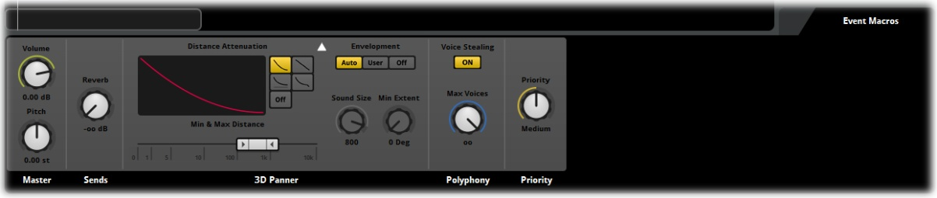
Event Macros

An essential part of getting sounds into a game project is the implementation stage. This is where all the carefully created audio content must be integrated into the game and tuned to function as expected. The Event Macro Properties are an important part of ensuring that Sound Events behave in the way you need them to once they are part of the game. An Event’s Macro Properties display in the deck by default so long as no other elements of the Event that could be displayed in the deck are displayed there.

Master
The Master Controls for an Event are included in the Event Macro region. These Properties include a Volume setting as well as the only overall Pitch setting for the Event. Both of these Properties will function as overall master controls for the Event, but their effects will stack with all other Volume and Pitch Properties within the Event.

Note
The Pitch Property within the Master controls for an Event will affect the playback behavior of Timeline based Events.
Pitch alteration within FMOD Studio is a simulation of an analogue process. What this means is that FMOD Studio replicates how pitch alteration would be achieved with a reel to reel tape deck or record turntable. Increasing the pitch results in shortening the duration of a sound, while lowering the pitch will lengthen it.
This process means that altering the Master Pitch value of an Event will result in playback of a Timeline to be slowed or sped up accordingly. This will scale the entire Event Timeline. The duration of individual Trigger Regions as well as the spacing between them will all alter relative to the overall change in the Pitch value.

Sends
The Sends setting functions to control the level of signal sent to the Reverb Bus in The Mixer. Like all other Macro Properties this is a master control for the entire Event.

3D Panner
The 3D Panner has been explained previously, but it is important to note that this set of controls is an exact mirror of the 3D Panner found in the Effect Deck region of the Event. Changes made to either set of controls will be mirrored across both objects.

Polyphony
The Polyphony setting defines how many instances of this Event can be played simultaneously. There may be circumstances in a project where multiple versions of an Event are triggered simultaneously. If this setting does not have a range greater than one, then FMOD will not allow more than one instance of the Event to play at a time.
Voice stealing will allow FMOD to override any currently playing instance of the Event to trigger a new version of the Event. This can be useful if you have limited access to voice channels so the new instance will always play at the cost of the existing instance.

Priority
FMOD Studio has an automatic system of prioritization that attempts to administer the playback behavior of all sounds intelligently. It will prioritize louder sounds over softer sounds and will only steal a channel if it reaches the limit of available channels. The priority setting allows for sounds to be allocated a level of importance to ensure they are triggered when needed.

Note
Under most circumstances it should not be necessary to set the priority for Events. Studio’s automatic system should provide a working solution for prioritization. The default values for the Priority setting can be altered as required but this is likely to require careful mapping of all Events and their relative priorities to avoid unexpected playback behavior.

Flip Control
You can assign any of the Properties in the Macro region to the fader controls by right clicking on the setting controller and selecting Flip to Fader. This will assign control of that particular setting to the Channel Strip Faders for easy editing control. Remember that Fader control can be set to fine tune by holding CTRL which operating the fader. To return fader functionality to Volume Right Click on the setting control currently set to the Faders and select Clear Flip to Faders

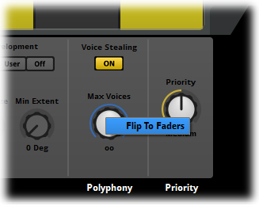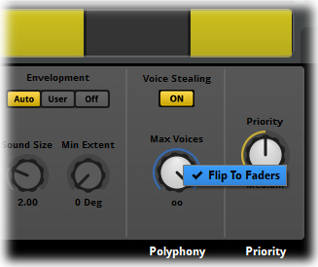
Flipping and Un-flipping between Dials and Fader
Faders will adjust setting values relative to the values that existed prior to the group select. To override this relative adjustment, hold the Shift key while adjusting the values. FMOD Studio will set all Fader values to the same number.

Note
For Properties that have set “Modes” group editing will set all selected Inputs to the same mode as a group. Relative adjustment of Settings while group editing will only occur for settings with numerical value ranges such as Volume or Pitch.

Effects
FMOD Studio has a broad range of Effects units that can be inserted into the signal path of Events within projects. Effects will alter the playback behavior of a signal in a variety of ways depending on the specific Effect used and the properties defined.
Effects units are added to the Deck region in FMOD Studio and can be added to the Deck in Event Audio Tracks, Event Master Tracks, Mixer Group Buses and the Mixer Master Bus. Effects contain a range of controls specific to the Properties of the individual effect. Dial Controllers are the primary input method for most Effects units.
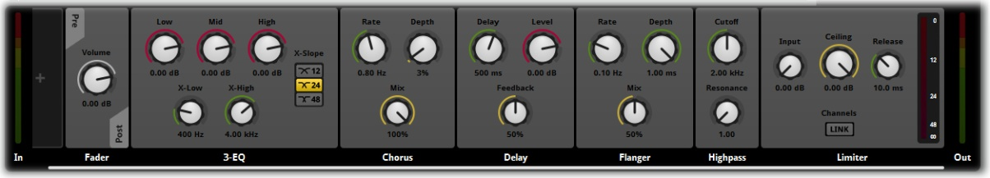
FMOD Studio Effects units

Inserting Effects
Effects units can be added to the Deck region of Audio Tracks, Master Tracks, Group Buses and The Master Bus.

Inserting and Effect unit
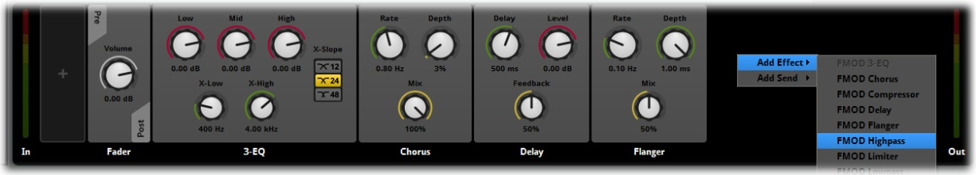
Adding a new Effect
- Navigate to any object that contains a Deck Region
- Within the Deck region right click to access the drop-down menu
- Select Add Effect and via the arrow access the Effect drop-down menu list
- Select the desired Effect unit to add to the Deck
The Deck will have a new object added to it. The Effect unit will contain a selection of controls that allow its setting Properties to be controlled. Once an Effect unit is added to a signal path it will alter the output of that signal path relative to the values set in the Effect unit.
Effects units can be deleted by Right Clicking on the Effect unit to access the drop-down menu and selecting Delete. FMOD Studio will ask you to confirm you choice to delete the unit.
Effects units can be switched on and off via the Right Click drop-down menu. An Effect unit that is switched off will darken to indicate it is not active and its controls will not accept input. The Drop down menu will only provide the relevant menu option. When the Effect unit is on the menu will list the Switch Off option, when the unit is off the menu will list the Switch On option
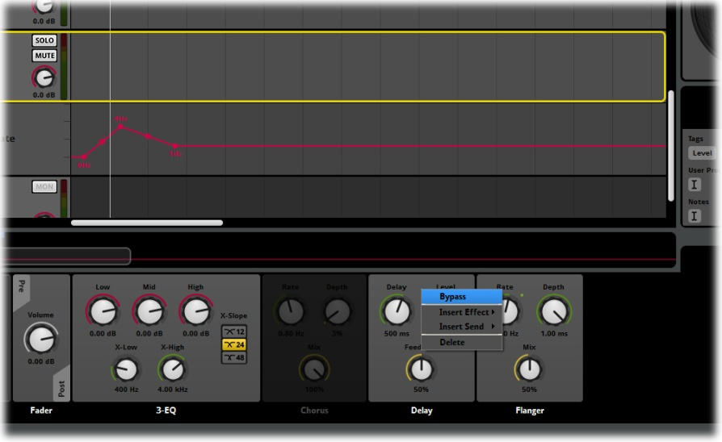
Bypassing an Effect

Note
Effects inserted in the signal path will stack with other Effects, so a signal can be altered in different ways along the entire signal path. For this reason it is important to keep track of where all effects have been inserted and what settings are being used, otherwise unpredictable playback behavior can occur.

3rd Party and User Created Plugins
FMOD Studio supports 3rd party and user-created Plugins. Because of this the various context menus that apply to adding Effects Modules to the Deck region may vary in the content they display, so the menus described or pictured in this manual may differ slightly from those that appear in the version you are using.

Effects Automation
Effects Units added to Event Audio tracks and Event Master Tracks can have automation controls added to their functionality.
Automation controls provide users with a way to define Effect Properties that can alter throughout the course of Event playback. Once an Automation control has been applied to a specific Effect unit a relevant Automation Track will be added to the associated Audio or Master Track and can be edited as required.
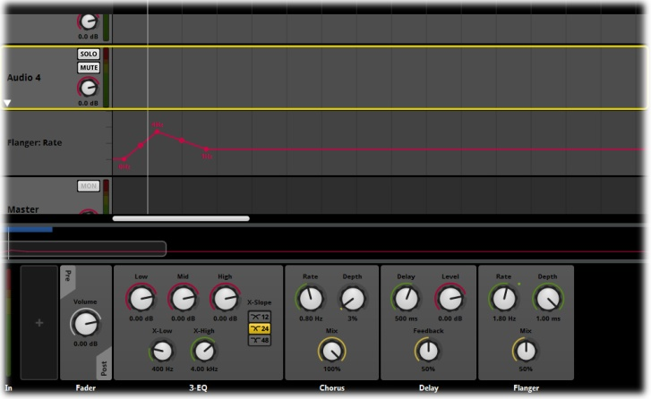
Automation Track for an Effect Setting
Automation Tracks provide a graphic interface for users to plot out the values of the various Effects Properties over either time in the Timeline tab or relative to Parameter values in Parameter tabs. The Automation lines can have control nodes added to them and through manipulation of these node envelope shapes can be created to achieve a wide range of dynamic effects.

Inserting Effects Automation
Effects units can be added to the Deck region of Audio Tracks, Master Tracks, Group Buses and The Master Bus.

Inserting and Effect Unit

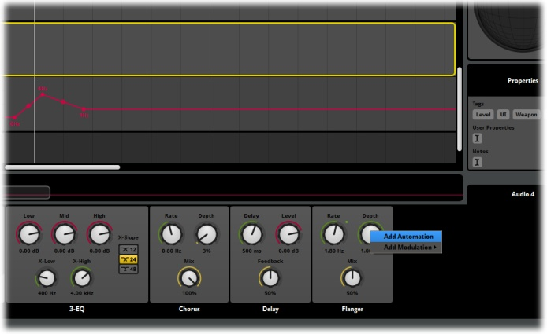
Creating an Effect Automation Track
- Navigate to any object that contains a Deck Region with an Effect unit
- Within the Deck region right click on any setting controller on an Effect unit
- From the drop down menu select Add Automation

3-EQ
The 3EQ Effect is provides a simple method of balancing the major frequency groups of a signal path.
Low, mid and high frequency regions can be easily attenuated to apply a broad range of audio effects to a signal’s output sound.
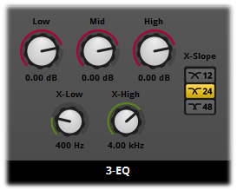
3-EQ Effect

3 EQ Properties and Default Values
- Low 0.00 dB
- Mid 0.00 dB
- High 0.00 dB
- X-Low 400 Hz
- X-High 4.00 kHz
- X-Slope 24
The 3 EQ can drastically alter the output of any type of sound. Short pulses as well as sustained signals can be significantly altered in character. The 3EQ is a quick method for simulating “radio talk” type effects as well as simulating low fidelity playback. The X-Low and X-High functions allow for the cross over points between Low, Mid and High to be defined, so “Low” can be whatever frequencies you define as low.

Properties

Low, Mid and High
Each of the Low, Mid and High Properties controls the attenuation of the frequencies assigned to that particular group. Because the X-Low and X-High setting define the exact range all of these setting essentially have the same functionality but will be applied to the defined frequency range. The Low, Mid and High Properties have values from -80 dB(-∞ dB) – +10 dB.

X-Low
The X-Low setting defines the crossover point between the Low and Mid setting values. This function defines the point where the Low frequencies finish and the Mid frequencies begin. The terms Low, Mid and High are relative as this crossover point can be defined anywhere within the available frequency spectrum. The X-Low Setting has a value from 10Hz-22 kHz

X-High
The X-High setting defines the crossover point between the Mid and High setting values. This function defines the point where the Mid frequencies finish and the High frequencies begin. The terms Low, Mid and High are relative as this crossover point can be defined anywhere within the available frequency spectrum. The X-High Setting has a value from 10Hz-22 kHz

X-Slope
The Slope setting allows for three values to be applied defining the gradient of the crossover curves between the Low, Mid and High ranges. The three Properties refer to the following values
- 12 dB per octave
- 24 dB per octave
- 48 dB per octave
12 dB defines the shallowest curve for the crossover while 48 dB defines the steepest curve.
The cross over curves will significantly influence the playback behavior of a sound depending on its frequency makeup and the values defined for Low, Mid and High Properties.

Note
Slope selection will have a direct impact on CPRU usage. The greater the resolution of the slope value the more CPU is required. A 24 slope will use twice the CPU of a 12 slope while a 48 slope requires 4 times the CPU power.

12 dB per Octave
24 dB per Octave
48 dB per Octave

Compressor
The Compressor Module narrows a signals dynamic range by reducing the loudest parts of the sound. This is a common process applied to media to ensure that softer passages are not lost in the mix and so users do not need to constantly alter the playback volume.
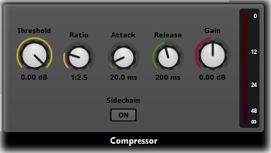
Compressor Effect

Compressor Properties and Default Values
- Threshold 0.00 dB
- Ratio 1:2.5
- Attack 20 ms
- Release 200 ms
- Gain 0.00 dB
- Sidechain Off
The Compressor default settings are a good starting point to work with, but each signal will need to be specifically tuned to get the best results out of the Compressor Effect. Dynamic Range Compression is a very complex aspect of audio production and entire books have been written on the subject. For more information look for the tutorial video on FMODTV on YouTube that covers compression for FMOD Studio.

Properties

Threshold
Threshold is the level at the compression effect will be activated. The default value of 0.00dB is nominally the loudest a signal can be (above 0.00dB it risks distortion). Reducing the value of the Threshold Property will lower the level at which the compressor will activate and as a result the overall dynamic range will be more greatly compressed. Threshold has a range from -80 dB(-∞ dB) – 0.00 dB.

Ratio
Ratio sets how much compression will be applied to the signal. Only signals that exceed the threshold will be compressed. The default value of 1:2.5 means that every signal that is 2.5dB above the threshold will be compressed to 1dB above the threshold. The greater the ratio, the greater the compression. The Ratio Property has a value from 1:1.0-1:50.0.

Attack
Attack defines how rapidly the compression effect will be applied. This Property is an important part of working with signal compression successfully as it tweaks how your sound “sounds” when passing through the Compressor. Too rapid an Attack time will make the output sound very harsh, while too long an Attack time can be just as bad. The Attack Setting has a range from 10ms-500ms.

Release
Release also effects how the eventual playback of your sound will be affected and needs to be carefully considered alongside the Attack Property. The default values for both Attack and Release are good values to start with when working with Compression. The Release Property has a range from 10ms-500ms.

Gain
The process of compressing the dynamic range of a signal will by its very nature reduce the overall volume of the sound as it compresses the loudest elements downwards. The Gain property provides the ability to increase or decrease the output volume of the newly compressed sound. The Gain Property has a range from -30dB -30dB.

Sidechain
The Sidechain button will toggle between the on and off function for Sidechaining. Check out the Sidechain section of the manual for more information on Sidechains.

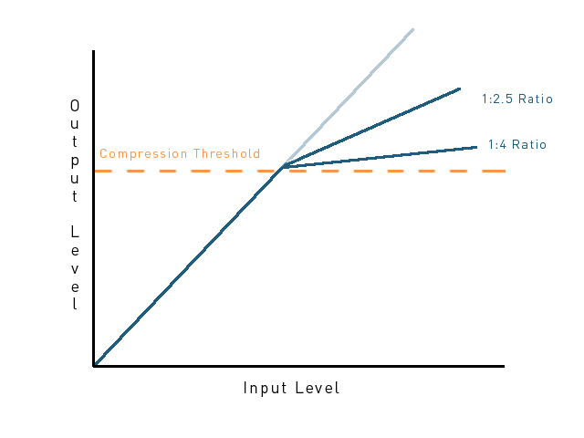
Dynamic Range Compression
Note
Compression is an important aspect of many audio mixes. A thorough understanding of the process will improve the quality of your audio processes. Attempting to use compression with insufficient knowledge may lead to disappointing results so we recommend you invest some time in learning good techniques.

Sidechaining
Sidechaining is a process where a channel has a compressor introduced to the Signal Chain but the control of this compressor is defined by a secondary channel. This is very useful for creating channel ducking behavior.

Channel Ducking
Channel Ducking, is when a project requires that the sound levels from one channel are reduced to allow the output from another channel to be clearly audible. The most basic example of this is many games duck non-dialogue channels when the dialogue channel is active to ensure that players can hear the dialogue clearly.
A Sidechain is a method of creating a compressor in a Signal Path that can be controlled from a different Signal Path. In the above example a Compressor would be created in the combined Signal Path of all non-dialogue channels, and the control channel would be the dialogue channel. This would allow a user to tune the Compression behavior to ensure that dialogue playback was clearly audible above all other sounds.

Creating a Sidechain
Sidechains can be created in the Deck areas of both the Event Editor and the Mixer. They function slightly differently in both locations, but the creation process is the same in both areas.

Creating a new Compressor
The first step in creating a Sidechain is to add a Compressor to the channels you wish to duck.

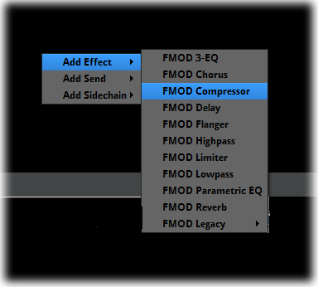
Creating a Compressor
- Select and Event in the Event Editor or an Input or Bus in the Mixer
- Right click in the Deck area to access the context menu
- Select FMOD Compressor through the Add Effect menu
FMOD Studio will create a new Compressor Effect Module in the Deck area of the target Event or Bus. This Compressor will currently function as a regular Compressor Effect until the Sidechain is created.
Note
Sidechains can be created in either the Event Editor or the Mixer. A control channel within the Event Editor will control a Sidechained Event channel and a control channel within the Mixer will control a Sidechained Mixer channel. It is not possible to set up a Sidechain relationship from the Event Editor to the Mixer.

Creating the Sidechain

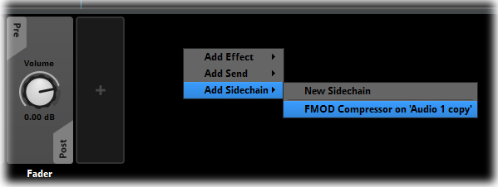
Creating a Sidechain
- Select the Event or Bus you wish to use as the control channel for the Sidechain
- Right click in the Deck area to access the context menu
- Within the context menu, via Add Sidechain select the Target channel to be controlled
FMOD Studio will create a Sidechain meter within the Deck area of the control Channel.
The Sidechain process is a very simple function. It works exactly as a Compressor Effect Module would work in any other circumstance with the one exception that where a Compressor uses the input signal from its own channel to define the level of compression a Sidechain compressor will use the signal from the control channel to define the level of Compression.

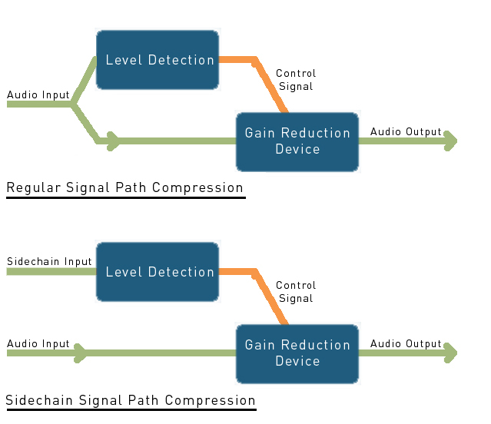
Compression and Sidechain Compression
Note
A Sidechain compressor needs to be tweaked and tuned in exactly the same manner as a regular Signal Path compressor Effect; it simply has the function controlled from a different source. All the tip and techniques for successful compression should be equally applied to the use of Sidechain compression.

Chorus
The Chorus Effect Module produces a “widening” of the sound by adding slightly altered duplicate versions of the original sound to create the illusion of multiple voices playing the same sound. The Chorus Effect works similarly to the Flange Effect except it utilizes three delay lines instead of only one.
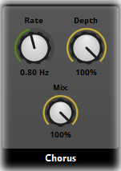
Chorus Effect

Flanger Properties and Default Values
- Rate .80 Hz
- Depth 3%
- Mix 100%
The Chorus Effect is more noticeable with sustained or looping input sounds. Single pulse notes do not produce much of an effect when chorused. A sustained note will sound like there are slightly “out of tune” duplicates being played alongside similar to three people singing the same line of a song. The lines in a Chorus Effect are out of phase with each other by 90 degrees, so the Dry signal is a 0 º , tap 1 at 90 º , tap 2 at 180 º and tap 3 at 270º.

Chorus Settings

Rate
Each delay line in the Chorus oscillates on a sine wave. The rate property defines the speed or the sine wave that each delay line follows. The Rate Property has a range from 0.00-20.0 Hz.

Depth
The Depth Setting defines the size of the sine wave that each delay line follows. 100% makes it oscillate from the dry position to the delay value, 0% would make it remain constant on the delay value. The Depth setting has a range from 0-100%.

Mix
The Mix Setting blends the power of the original and duplicate signals. Its default of 50% produces an even mix of the two signals. Altering the value up or down will change the mix to either emphasize the original signal or the duplicate signal. This can produce a broad range of results. The Mix Setting has a range from 0% Dry (only the original signal) – 100% Wet (only the duplicate signal).

Delay
The Delay Effect unit plays the input signal and then repeats it a specific number of times depending on the Properties provided. This unit includes three controllers that allow for the signal processing to be altered in a variety of ways.

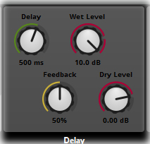
Delay Effect

Delay Properties and Default Values
- Delay 500 ms
- Wet Level 0.00 dB
- Dry Level 0.00dB
- Feedback 50%
The default Properties when applied to a single ping input sound will produce a series of repeating echoes spaced half a second apart. The first echo will playback at the same output level as the initial signal and each subsequent echo will diminish in amplitude until the sound is inaudible. The default setting will produce approximately 16 audible echoes.

Properties

Delay
The Delay Setting defines the length of time between the playback of each echo. This setting is measured in milliseconds and abbreviated to ms. The default value of 500 ms is equal to one half a second delay. The Delay Setting has a range from 10ms-5 sec.

Wet Level
The Wet Level Setting defines the output level of the first echo. The default value of 0.00 means the first echo will be equal to the output level of the initial source signal. Each subsequent echo is reduced in amplitude from the one before it; the Wet Level setting defines the initial amplitude of the echo drop-off curve. The Level Setting has a range from -80 dB-10 dB.

Dry Level
The Dry Level Setting defines the output level of the original signal without the Delay Effect applied. The default value of 0.00 means the original signal will be played at the same level at which it entered the Delay Module. Reducing the Dry level will result in the effected signal being easier to hear. A blend of the Wet Level and the Dry Level can be used to achieve the desired output balance. The Dry Level Setting has a range from -80 dB-10 dB.

Feedback
The Feedback Setting defines the number of echoes that will follow the initial signal. The echoes will always diminish with each subsequent repeat, the less echo steps defined the more extreme the attenuation will be between each echo step. Feedback has a range from 0.00-100%.

Flanger
The Flanger Effect produces a duplicate of the original signal that is played at the same time as the original signal but with a minute delay in its starting time. The delay value of this second signal also changes over time in a sinusoidal manner. The combination of these two processes creates a sweeping effect as the two signals blend. Their phase relationship with each other ebbs and flows creating the sweeping effect.

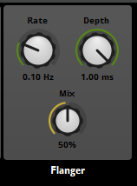
Flanger Effect

Flanger Properties and Default Values
- Rate .10 Hz
- Depth 1.00 ms
- Mix 50%
The Flanger Effect is more noticeable with sustained or looping input sounds. Single pulse notes do not produce much of an effect when flanged. A Sustained note will sound like there is a slightly “out of tune” duplicate being played alongside. The relationship between the two sounds will alter over time as they shift more and less out of phase with each other.

Properties

Rate
The Rate setting creates a pattern at the designated frequency. This pattern is what determines the rate of delay of the Flange Effect. The duplicate signal will be delayed initially by the amount set in the Delay Setting value, but it will alter over time by the amount defined in the Rate setting. The rate setting has a range from 0.00-20.0 Hz.

Depth
The Depth Setting defines the length of the initial delay between the original signal and the duplicate signal. At its minimum value of 0.01 there is such a small delay it may not be noticeable. The delay value may not seem very large but when the value is multiplied by the Rate setting it can cause quite extreme changes to the overall signal. The Depth setting has a range from 0.01 -1.00 ms.

Mix
The Mix Setting blends the power of the original and duplicate signals. Its default of 50% produces an even mix of the two signals. Altering the value up or down will change the mix to either emphasize the original signal or the duplicate signal. This can produce a broad range of results. The Mix Setting has a range from 0% Dry (only the original signal) – 100% Wet (only the duplicate signal).

High Pass
High Pass is a type of filter that allows signal material of a defined frequency range and above to be audible while filtering out frequency material below the defined range. This can produce a variety of results very much dependent on the frequency makeup of the input signal and the Properties defined within the Effects unit.

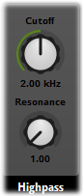

Hi Pass Effect

High Pass Properties and Default Values
- Cuttoff 2.00 KHz
- Resonance 1.00
The High Pass effect will be noticeable for both sustained and single pulse or repeated pulse types of sounds. Because of the nature of this Effect unit if the original signal is entirely made up of frequency material above the Cuttoff frequency defined then there will be minimal effect to the output signal from that setting, but the value of the Resonance setting may still produce an audible effect.

Properties

Cuttoff
The Cuttoff setting defines the frequency value at which the filter will activate. Any material of a frequency value below the Cuttoff frequency will be filtered out of the signal. The extent to which this will affect the input sound is entirely dependent on the frequency makeup of the original sound. If the entire sound consists of frequencies below the Cuttoff value then the entire sound will be filtered out essentially leaving silence. The Cuttoff Setting has a range from 10.0 Hz – 22.0 KHz

Resonance
The Resonance Setting acts as signal boost for frequency material that matches the Cutoff frequency. The nature of how frequency signal processing occurs means that this boost is not isolated to the exact frequency value defined in the Cuttoff setting but that it lifts the power of the cut-off frequency and generates a curve in values that drops off to either side.

Gain
Resonance
can influence the entire placement of the curve

Cuttoff
defines the positioning of
the curve

Frequency

Note
Because of the nature of the resonance curve and how harmonics function, the Resonance Function can produce a wide range of effects. It is possible to set a cut-off frequency at a particular value and use the resonance function to affect the sound of frequency material far outside the range of the cut-off frequency.

Limiter
The Limiter Effect allows for control of signal peaks while also increasing the overall levels. By limiting the maximum level and boosting the lower levels the limiter can be used to produce a punchier overall output signal

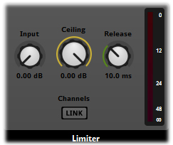
Limiter Effect

Limiter Properties and Default Values
- Input 0 dB
- Ceiling 0.00 dB
- Release 10.0 ms
- Channels Link deactivated
The Limiter Effect is particularly good in adding punch to short pulse sounds, but is also very useful for tightening up longer loop sounds.

Properties

Input
The Input defines the amount of gain prior to limiting. This setting works like an input gain control.
The input setting has a range from 0 dB-12 dB

Ceiling
Ceiling controls the maximum output signal that leaves the Limiter effect. The output amount will not exceed this value. Louder input peaks will be mostly limited, while lower signal levels will be increased.
The Ceiling setting has a range from -12 dB (-∞ dB)- 0.00 dB

Release
The Release setting defines how quickly the Limiter recovers from signal peak reduction. The faster the release, the louder the limiter output level.
The Release setting has a range from 1.00 ms- 1.00 sec

Channels
Link will apply absolute peak levels for all channels the same, this will maintain relative values between channels while limiting. Without Link a flat volume will be applied across all channels.
Note
The Limiter is a basic effects unit. It is fairly low quality but is very cheap on resource use.
The Limiter Effect has no Attack time and so will instantly clip signals at ceiling level and then allow a slow release.

Low Pass
Low Pass is a type of filter that allows signal material of a defined frequency range and below to be audible while filtering out frequency material above the defined range. This can produce a variety of results very much dependent on the frequency makeup of the input signal and the Properties defined within the Effects unit.

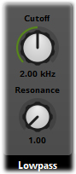
Low Pass Effect

Low Pass Properties and Default Values
- Cuttoff 2.00 KHz
- Resonance 1.00
The Low Pass effect will be noticeable for both sustained and single pulse or repeated pulse types of sounds. Because of the nature of this Effect unit if the original signal is entirely made up of frequency material below the Cuttoff frequency defined then there will be minimal effect to the output signal from that setting, but the value of the Resonance setting may still produce an audible effect.

Properties

Cuttoff
The Cuttoff setting defines the frequency value at which the filter will activate. Any material of a frequency value above the Cuttoff frequency will be filtered out of the signal. The extent to which this will affect the input sound is entirely dependent on the frequency makeup of the original sound. If the entire sound consists of frequencies above the Cuttoff value then the entire sound will be filtered out essentially leaving silence. The Cuttoff Setting has a range from 10.0 Hz – 22.0 KHz

Resonance
The Resonance Setting acts as signal boost for frequency material that matches the Cutoff frequency. The nature of how frequency signal processing occurs means that this boost is not isolated to the exact frequency value defined in the Cuttoff setting but that it lifts the power of the cut-off frequency and generates a curve in values that drops off to either side.

Gain
Resonance
can influence the entire placement of the curve

Cuttoff
defines the positioning of
the curve

Frequency

Note
Because of the nature of the resonance curve and how harmonics function, the Resonance Function can produce a wide range of effects. It is possible to set a cut-off frequency at a particular value and use the resonance function to affect the sound of frequency material far outside the range of the cut-off frequency.

Parametric EQ
The Parametric EQ effect allows for boosting of ranges of frequency material within a signal path. The Properties allow for specific frequency ranges to be targeted and the gain on that frequency material to be increased or decreased as required.

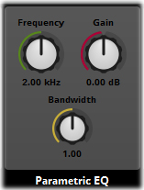
Parametric EQ Effect

Parametric EQ Properties and Default Values
- Frequency 2.00 KHz
- Gain 0.00 dB
- Bandwidth 1.00
The High Pass effect will be noticeable for both sustained and single pulse or repeated pulse types of sounds. Because of the nature of this Effect unit if the original signal is entirely made up of frequency material above the Cuttoff frequency defined then there will be minimal effect to the output signal from that setting, but the value of the Resonance setting may still produce an audible effect.

Properties

Frequency
The Frequency setting defines the target frequency that will be affected by the EQ Effect. Because of the nature of manipulating frequency material this setting will always define the center frequency of an overall range that will be affected. The Frequency setting has a range from 20 Hz – 22 KHz

Gain
The Gain Setting allows for the attenuation of the target frequency range. The frequencies can be boosted or reduced as required over the range of this setting. The Gain Setting has a range from -30 dB (-∞) – 30dB

Bandwidth
Bandwidth defines the width of the range of frequencies around the target frequency defined in the Frequency Setting. The smaller the value of the Bandwidth setting, the fewer frequencies on either side of the target frequency are affected. The Bandwidth Setting has a range from 0.20-5.00

Gain
Bandwidth
defines the width of
the peak

Gain
defines the height of
the peak

Frequency
Frequency defines the positioning of the peak

Reverb
Reverb is the effect of a sound being sustained beyond its initial source as a result of the environmental effects in the location where the sound is produced. This is most commonly caused by sound waves reflecting of surface material and generating subtle echoes. Reverb is a common effect used in many forms of media to reproduce the environmental behavior of different environments such as caves, large rooms, sport arenas or room with particular surface material.

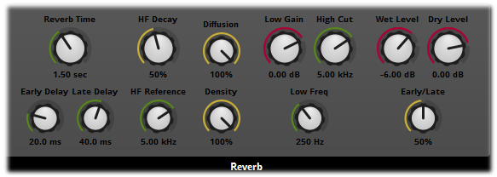
Reverb Effect

Reverb Properties and Default Values
- Delay Time 1.50 sec
- Early 20.0 ms
- Late 40 ms
- HF Decay 50%
- HF 5.00 kHz
- Diffusion 100%
- Density 100%
- Low Gain 0.00 dB
- High Cut 5.00 kHz
- Low Freq 250 Hz
- Wet Level -6.00 dB
- Dry Level 0.00 dB
- Early/Late 50%
The Reverb Effect unit has a large number of Properties that allow for a huge variety of reverb environmental effects to be produced. Reverberation is most noticeable on pulse type sounds where the reverb echoes continue after the primary sound has finished playing. With continual or looping sounds Reverb can produce muddy or feedback type results.

Properties

Reverb Time
The Reverb Time setting defines the length of the Reverb tail. This essentially controls how long a sound will be once processed by the Reverb effect. Reverb Time has a range from 100 ms – 20.0 sec

Early Delay
Early Delay defines the amount of time before the early reflections. This is essentially defining the size of the space. A longer Early Delay time indicates the initial sound source must travel further before it is reflected. This is indicative of a larger space in which the sound is being heard. The Early Delay setting has a value from 0.00 ms – 300 ms

Late Delay
Late delay is the period of time between the early reflection and the reverb tail. This is also a function related to the size of the room space. The Late Delay setting has a value from 0.00 ms – 100 ms

HF Decay
HF Decay defines the amount of time that High Frequency material takes to decay. The behavior of high frequency sounds indicates the material makeup of a room. Low levels of HF decay will dampen the room making it sound like it has absorbent materials. High levels of HF Decay will indicate lots of hard surfaces from which high frequency sounds will reflect. The HF Decay values are a percentage of overall reverb time. HF Decay has a range from 10%-100%

HF Reference
HF Reference defines the exact frequency that is used to measure the HF Decay setting. This setting can considerably alter the color of the sound that outputs from the Reverb effect. HF Reference has a range from 20 Hz – 22.0 kHz

Diffusion
Diffusion defines irregularities in a room space that break up standing waves. Low values will result in a resonant space with lots of parallel surfaces; a high Diffusion value will stop resonance so there will be less ringing tones by scattering the reflections. Diffusion has a range from 0.00- 100%

Density
Density controls the number of extra reflections in a room space representing extra surfaces that bounce the sound wave. The higher the Density value the more complex a room space with more reflective surfaces. Density has a range from 0.00 - 100%

Low Gain
This setting controls the signal boost for the EQ controls of the Reverb Effect. The EQ is essentially a shelf filter so the Low Gain setting will boost all frequency material below the defined value of the Low Freq setting. The Low Gain setting has a range from -36 dB (-∞) -12 dB

Hi Cut
Hi Cut is a low pass filter that will cut all frequencies material above its defined value. This combines with the Low Gain and Low Freq to generate the overall EQ of the Reverb Effect. The High Cut setting has a range from 20 Hz – 22.0 kHz

Low Freq
The Low Freq setting defines the upper frequency of the Low Frequency range. All frequency material below this value will be affected by the Low Gain setting value. The Low Freq setting has a range from 20 Hz – 22.0 kHz

Wet Level
Wet Level sets the overall output level of the Reverb affected signal. Wet Level contains only signal material that has been passed through the Reverb unit. A Combination of Wet Level and Dry Level determines the overall output signal from the Reverb effect. The Wet Level setting has a range from -80 dB (-∞ dB) -12.00 dB.

Dry Level
Dry Level sets the overall output level of the original clean signal, unaffected by the Reverb effect. A Combination of Wet Level and Dry Level determines the overall output signal from the Reverb effect. The Dry Level setting has a range from -80 dB (-∞ dB) -12.00 dB.

Early/Late
The Early/Late setting defines the balance between the Early Delay and Late Delay Properties. Its default 50% value defines an equal balance between the two delay Properties and it can be altered to weight the value towards either setting. The Early/Late setting has a range from 100% Early – 100% Late.

Legacy Effect Modules
FMOD Studio includes a series of Effect Modules that represent effects included in FMOD Designer 2010. These Modules were designed to provide solutions to very particular use cases, so while their functionality is typically limited, they usually very resource efficient for projects. New Effect Modules created for FMOD Studio have a broader range of applications, so these older Effects have been classed as Legacy Effects to indicate their narrower focus.

Distortion
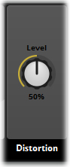
Distortion adds harmonics and texture to an existing signal by boosting the signal's Sound File until clipping occurs. Whilst distortion reduces the fidelity of a sound, at times the increased harmonics and reduced dynamic range can add an appealing effect.

Highpass Simple
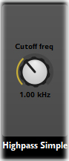
This Effect is a second-order filter that leaves high frequencies unaffected but attenuates (or reduces) frequencies below a cutoff frequency point. This Effect is used to reduce the amount of bass frequency in a signal. This property represents the frequency at which the filter will stop attenuating. The cutoff frequency range is 10 to 22000Hz.

Lowpass Simple
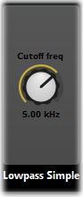
This Effect is a first-order filter that leaves low frequencies unaffected but attenuates (or reduces) frequencies above a cutoff frequency point. This Effect is used to reduce the amount of treble in a signal.
FMOD’s Lowpass Simple Effect was specifically designed to provide full bandwidth response (up to 22 kHz) at the cheapest CPU costs. It does not provide any resonance control.
This property represents the frequency at which the filter will start attenuating. The cutoff frequency range is 10 to 22000 Hz.

Pitch Shifter
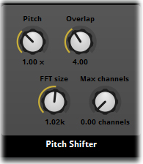
This Effect allows a sound to be raised or lowered in pitch without changing its time duration.
This plug-in is very CPU intensive. However, using mono files, selecting a smaller FFT size and reducing the sampling rate of the source file can reduce the CPU load, albeit at the expense of sound quality.
Pitch: This property represents the change to the original pitch ranging from 0.5 (one octave down) to 2.0 (one octave up). A value of 1.0 represents the original pitch.
FFT Size: The property specifies the spectral resolution used in the FFT process. A higher number reduces the number of unwanted artefacts in the sound (but requires more CPU time). The FFT size ranges from 256 to 4096.
Max Channels: This property makes it is possible to set the number of channels (and memory allocation) to be used by the Pitch Shifter plug-in. This property can be set from 0 (default) to 16. The value 0 represents FMOD's default polyphony, 1 = mono, 2 = stereo, etc.

Tremolo
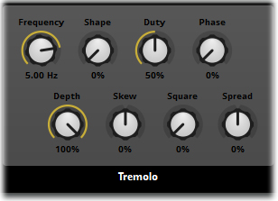
This Effect produces a periodic variation in the amplitude of the signal.

Frequency: Specifies the speed at which the variation in amplitude occurs. Frequency ranges from 0.01 to 20Hz. The default is 5Hz.

Depth: Specifies the amount of variation in amplitude. Depth ranges from 0 (no change) to 1 (full signal). The default is 1.

Shape: Specifies the LFO shape, morphing between triangle and sine. Shape ranges from 0 (triangle) to 1 (sine). The default is 0.

Skew: Specifies time-skewing of LFO cycle. It ranges from -1 to 1. The default is 0.

Duty: Specifies the LFO 'on-time', ranging from 0 (always off) to 1 (always on). The default is 0.5.

Phase: Specifies an offset to the phase of the LFO. Ranges from 0 (LFO starts at its low point) to 1. Setting the 'Phase' to 0.5 means the LFO is at its high point, allowing the start of the signal to be heard. The default is 0.

Square: Specifies the flatness of the LFO shape, ranging from 0 to 1. The default is 0.

Spread: Creates rotation / auto-pan effects in multichannel audio files by spreading the LFO phrase evenly between channels (In 5.1 the LFE channel is synced to the center channel). Spread ranges from -1 to 1, with the default being 0.

Settings for creating basic LFO shapes:
Triangle: shape = 0, skew = 0, square = 0
Sine: shape = 1, skew = 0, square = 0
Rising saw: shape = 0, skew = 1, square = 0
Falling saw: shape = 0, skew = -1, square = 0
Square: skew = 0, square = 1

When using a pure square or saw tooth saw LFO shape, the presence of clicks should be expected as a natural by-product of instantaneous volume change. Clicks can be avoided by setting 'skew' and 'square' values within their extremes (not 1). This provides some time to ramp the volume, and avoid clicks.

Plugin Modules
FMOD Studio supports Plugin Modules and allows for both user created and third party created plugins to be used in projects. Plugins are different to built-in Effect Modules as they are not automatically supported when FMOD Studio is used in a project.
Plugins need to be set up for each platform your project will run on and be compiled into the build for that target platform. The Plugin then needs to be loaded within the FMOD Studio API. This aspect of production will obviously need to be undertaken by your programming team.

Gain Effect Module
The Gain Plugin Module provides two basic functions. The first of these is a Gain property that can be used to boost or reduce the signal that passes through it. The Gain property has a range from -80dB (negative infinity) to +10dB.
The Gain Module also has an Invert toggle button that inverts the wave form of the signal passing through it.
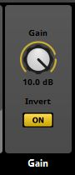
The Gain Plugin Module

Distance Filter Effect Module
The Distance Filter Plugin Module provides a series of Properties that can be useful in simulating the behavior of physical sound characteristics in a 3D world. The nature of this plugin is such that it needs to be used in combination with other Property settings in a specific manner to utilize the module effectively.
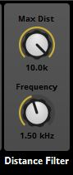
The Distance Filter Plugin Module
The Max Distance Property has a range of values from 0-10,000 (10K). This property defines the value at which the effects of this module will be applied. Note the information below on how this value is influenced by other functions within FMOD Studio.

The Frequency Property defines the target frequency for a band-pass filter. This property has a range of values from 10Hz-22KHz. As the distance value of the Event moves closer to the Max Distance Property value the filter will affect all frequencies both above and below the defined Frequency value reducing all frequency content around the defined frequency. This essentially creates a high-pass and low-pass filter with converging cutoffs towards the Frequency value.

Note
The Distance Filter Plugin Module is dependent on various other FMOD Studio features. By definition it is designed to function with 3D sounds, however if a 3D Panner is included in the Event you will need to switch off its Distance Attenuation or extend its Max Distance to be greater than that of the Distance Filter, as otherwise the sound will fade out as a consequence of Distance Attenuation before the effect of the Distance Filter is audible.
There are a variety of different FMOD Studio Modules and Properties that can influence how a sound plays within a 3D space. Ensure all these Properties are set to complement and not conflict with each other.

Building and Implementing Projects

Introduction
The final stage in producing any audio project is getting that content into an actual project. Whether it is a game, a dynamic surround sound artwork or a piece of functional infrastructure for a simulator or professional system, all the material developed in FMOD Studio needs to be exported correctly and then implemented into the relevant project to be usable.
There are several aspects to correctly exporting an FMOD Studio project that can impact its performance efficiency and overall functionality. Depending on the size and scope of your project some of these aspects may need to be planned for early in development, and others can be applied when the time comes to implement your created content into your project.

Banks

Introduction
Banks are collections of the assets, events and other content used in your project, to be built and used in your game. How you allocate Events and set up your Banks can significantly affect the performance and efficiency of your project. There is no limit to the number of Banks your project can include.

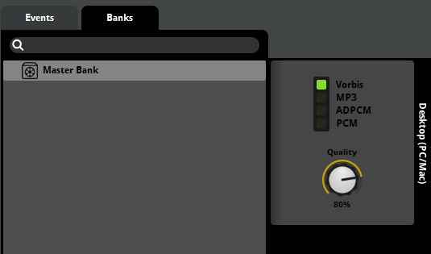
The Banks Browser with the default Master Bank
By Default all projects are created with a single Master Bank in the Banks Browser. FMOD Studio does not automatically assign any Events to Banks (not even to the Master Bank) so if you run the build process without first assigning the Project Events to a Bank, then your exported files will contain no Events.
For a small project it may not be necessary to create additional Banks. It might work with all events assigned to the Master Bank. The number of banks that’s best for your project depends on the requirements of your project.

Assigning Events to a Bank
This section describes how to assign Events to a specified Bank.

Accessing the Events within a Project
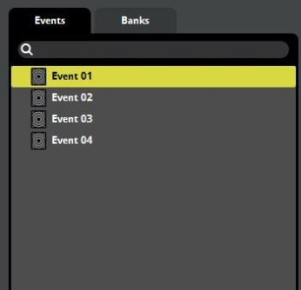
Accessing a Project’s Events

- Right click on the target Event to access its context menu

Assigning to a Bank
- Select Assign to Bank from the context menu
- From the sub menu select either one of the existing Banks or create a new Bank
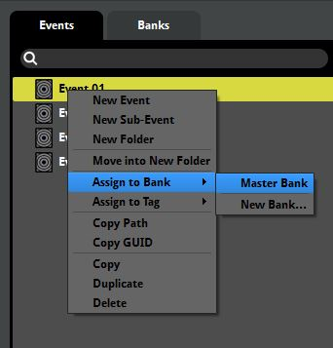
Assigning an Event to a Bank
If you choose to create a new Bank a dialogue box allows you to define the name of the new Bank. Once defined, a new Bank will be created in the Banks Browser and the targeted Event will be assigned to that Bank.
The exact same process can be used to assign an Event to an additional Bank. Follow steps 1-3 and at step 4 simply select a different Bank from the list. Once an Event has been assigned to a Bank a tick will appear next to that Bank in the sub menu to indicate the association. A single Event can be assigned to an unlimited number of Banks. When Events are assigned to Banks, the Banks Browser updates to display which Events are assigned to which Banks.

Note
When you assign an Event that is already in a Bank to another Bank it will be added to the new Bank in addition to its association with the old Bank. If you do not wish the Event to be assigned to both Banks you will need to remove it from one via the context menu.

Assigning Events within the Banks Browser
This section describes how to assign Events to specified Banks within the Banks Browser.

Assigning Events within the Banks Browser
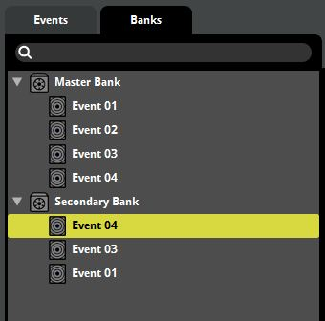
Accessing a Projects Events
- Click on an Event to select it.
- Drag the target Event onto a Bank to assign it to that Bank.
Events do not appear in the Banks Browser unless they have been assigned to at least one Bank. Once an Event is visible within the Banks Browser it can be dragged within the Browser freely to assign it to other Banks.

Removing Events from Banks
There are two ways in which an Event may be removed from a Bank.

Method 1
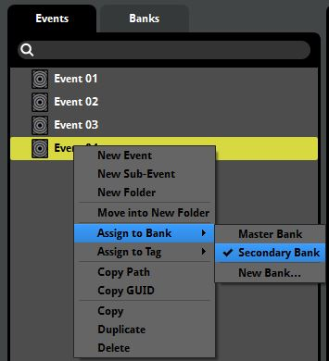
Removing an Event in the Events Browser
- From the Events Browser select the Event you wish to remove from a Bank.
- Right click on the event to access the context menu and select Assign to Bank.
- From the submenu select the Bank you want to remove the Event from (it should have a checkmark marking it)

Method 2
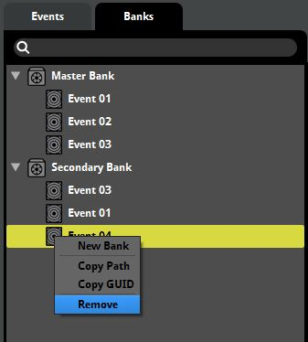
Remove an Event from the Banks Browser
- Within the Bank Browser select the Event you wish to remove from a Bank
- Right click to access the context menu and select Remove
Remember that if an Event is not assigned to any Banks then that Event will not be included within the build process for export.

Creating New Banks
This section describes how to create a new Bank within the Banks Browser.

Creating a New Bank
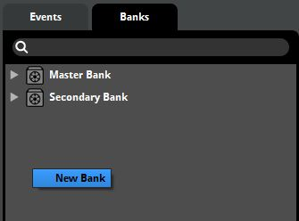
Creating a new Bank
- Right click within the Banks Browser and select New Bank from the context menu.
- Type the name of the Bank you are creating.
Once a Bank has been created it can have Events assigned to it either via the Events Browser or within the Banks Browser.

Bank Properties
Banks within FMOD Studio have a series of Properties that define how the audio assets for a Project will be packaged and formatted when built.

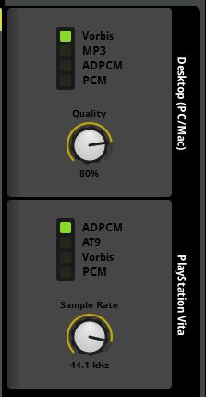
Platform Property Modules
In the above diagram you can see two Bank Platform Property Modules within the Banks Browser. These two modules refer to the same Bank, but define the Properties for different target platforms. A new set of Platform Properties can be added to a Bank by simply right clicking in the Platform Property area and selecting from the available list.
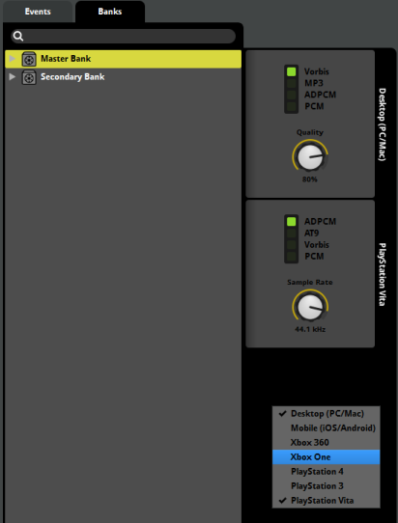
Adding a new Platform Property Module
The exact list of Property values displayed depends on the related platforms’ specifications and also which compression types have been selected. PCM and ADPCM will both display a Sample Rate Property dial, while MP3, Vorbis, AT9, XMA and WXMA will all display a Quality Property dial. With both Properties, higher values can result in larger file sizes so in general these Properties provide a tradeoff between file compression and audio quality.
Creating a new Platform Property Module instructs FMOD Studio to add that platform to the list of formats to be exported during the build process. Running the build process with multiple platforms defined will result in the build process exporting version of assets in the correct format for each platform. All of the built assets will be created in platform-specific subfolders within the FMOD Studio project’s folder structure to make it easy to identify each set of assets.

Note
While the Sample Rate Property can provide a quick and simple way to reduce the memory footprint of your project’s audio, be aware that there are very real consequences to adjusting this Property. Reducing the Sample Rate on audio material that contains frequencies in the higher range bands can significantly change how sounds play back, so it is very important to be aware of the makeup of the assets in your project before you apply changes to the Sample Rate, and if possible, spend time listening to how your content sounds in-game before releasing it publically.

Bank Browser Specific Event Properties
There is a single Event Property that is not accessible via the Event Browser or standard Event display. The Streaming property is an Audio Track Property that can be set in the Event Editor only while in the Banks Browser Tab. FMOD Studio will monitor the Streaming assets and stream them as they are required.

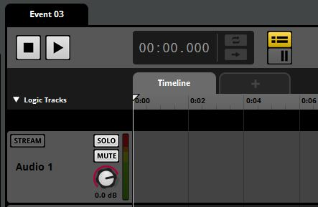
The Event Stream Property
Located on the head of each Audio Track, the Stream Property determines whether a specific Audio Track within an Event Streams its content from the Bank it is associated with or is loaded into memory. This Property can be toggled on and off to set an Audio Track and its content to Streaming mode. This is most useful for dealing with music, ambience or other long sound files that would take up too much of the available memory if they were loaded entirely into memory when used in-game.
Because each Audio Track can be individually set to Stream, a single Event can have a selection of both memory resident and streaming assets.
Note
Once an Audio Track within an Event is set to Stream that Audio Track and its content will be flagged as Streaming in all the banks where it is present. This avoids unwanted conflicts and inefficient memory usage.

The Build Process
Once all the Events have been assigned to the relevant Banks and all Bank Properties have been defined as needed, the Build process can be run to export all the files. This is a single step process that can be started by selecting Build from the File menu.

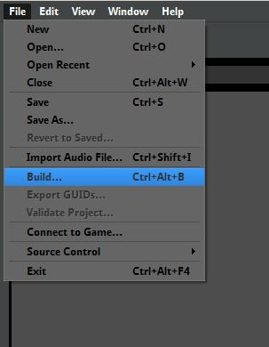
Building a Project
The time a project takes to build is dependent on the size of the project, how many sound files there are, how big those sound files are, what formats it needs to be built for, what formats the banks are in, and how many Banks are included. Smaller projects may only take a few seconds, while a very large project may take hours.
When the Build process is run, FMOD Studio packs up all the assets and relevant project files into a series of new files. Every Bank and formal combination within an FMOD Studio project results in a ‘.bank’ file, and there will also be a ’.strings.bank’ file that contains both the name of each Event and its relevant GUID, which allows an audio programmer to work with the project elements using either the name or the GUID depending on what works best for the project.
If multiple platforms have been selected under the Banks Browser then the Build process will create multiple folders within the project folder and produce a set of banks formatted correctly for the selected platforms.

Note
While FMOD Studio allows Banks to be created for all of the supported delivery platforms, it is important to know that the build process will not complete successfully for certain platforms unless the appropriate SDK is installed. This limitation is to fulfil the requirements of the various platform manufacturers’ licence agreements.

Setting up Control Surfaces

Configuring the Device
FMOD Studio supports the Mackie MIDI control surface protocol. The following section provides instructions for how to enable the Mackie protocol on some common devices.

MCU Pro
To run the MCU Pro in Mackie mode, hold down the first two SELECT buttons when booting the device. Select the Mackie option using the dials when prompted via the LCD interface.

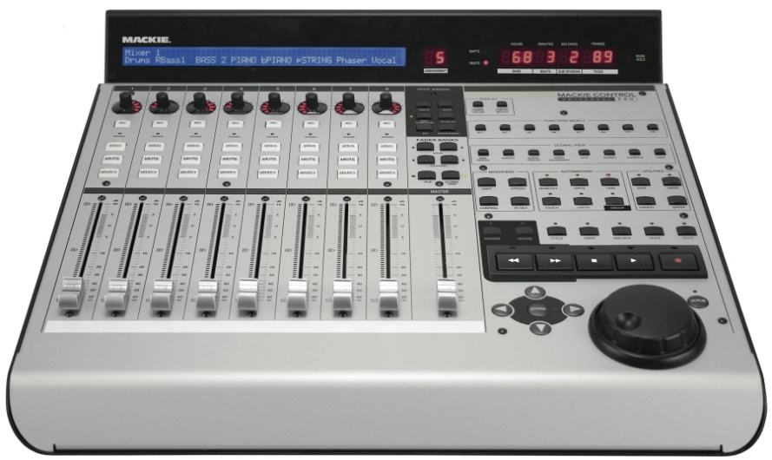
Mackie MCU Pro

Adding the Device
To configure a new control surface, go to the Preferences dialog using the [Edit>Preferences] menu. In the Control Surfaces tab, select a control surface type from the drop-down menu. Select the MIDI port(s) required for the surface. FMOD Studio will connect to the device as soon as the MIDI ports have been selected.
Ensure that both input and output ports are set to the same value. Thoroughly read the setup information for your control surface to ensure you have setup drivers and software support correctly prior to attempting connection to FMOD Studio.

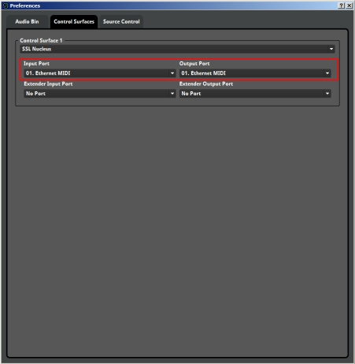
Studio Preferences Pop-up Window

Note
Once the control surface is set up correctly and the FMOD Studio preferences are also set up correctly the controller should display a message that says FMOD Studio. If it does not display this message then there is likely something that has not been set up correctly. Review the steps provided in this section to help you correctly set up the connection between the Nucleus and FMOD Studio.

SSL Nucleus
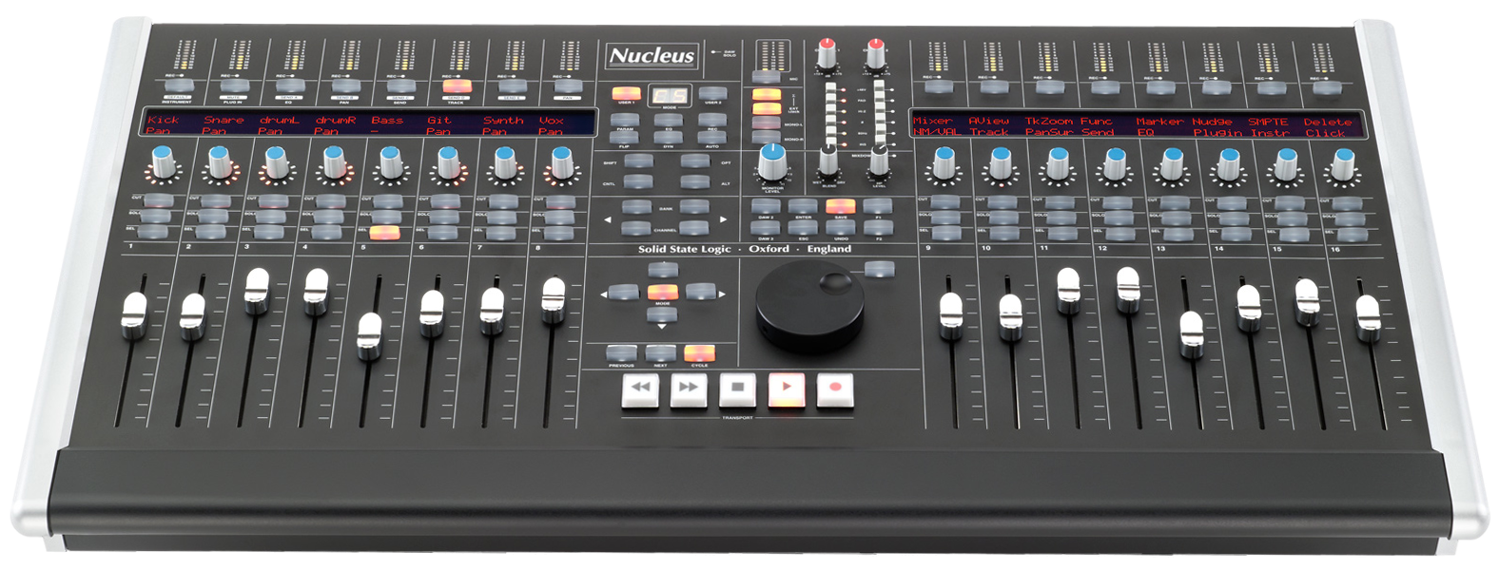
FMOD Studio integrates directly with the SSL Nucleus control desk

Software Set-up
Ensure that all setup programs that are provided on the install disk for the Nucleus are installed on your computer. There are several steps involved in getting the Nucleus to connect properly with FMOD Studio.

ipMIDI
The first step involves adjusting the setting for the ipMIDI utility before starting the Nucleus setup process. By default ipMIDI is set to 2 channels. This needs to be adjusted to 6 channels for optimal performance.

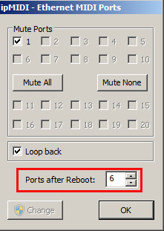

Optimal ipMIDI setup
Note
By default the Loop Back box is ticked. We recommend you un-tick this option.

Adding the FMOD Studio Profile to the Nucleus
First ensure that the SSL Nucleus is connected to your computer via the Ethernet port. The USB connection is to use the Nucleus as a sound card, the Ethernet connection is used for Digital Audio Workstation (DAW) functionality.
Open the Nucleus Remote software and connect to the device.

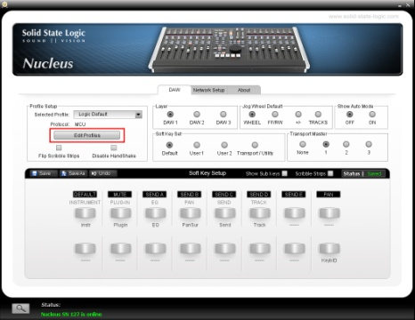
Edit Profiles setting

Select the Edit Profiles button and select the Restore option.

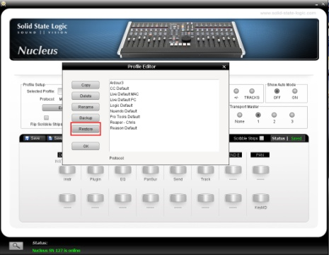
Edit Profiles pop-up window

In the Edit Profiles pop-up window select the Restore button, a standard file browser window will open. Navigate to the FMOD Studio folder on your computer. The FMOD Studio SSL Nucleus Profile.zip file can be found in the root of the FMOD Studio folder. You do not need to unzip this file, just select it directly through the Nucleus set-up program. The program will import and set-up these files as the next step.

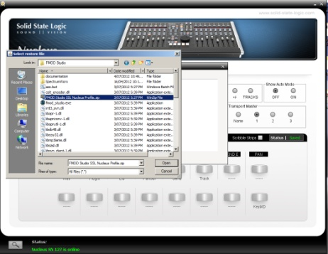
Nucleus profile zip file

The FMOD Studio profile will now be displayed in the profile editor and can be selected

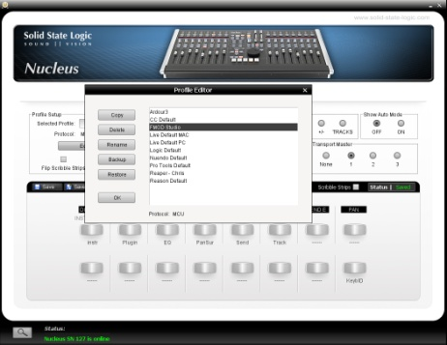
The FMOD Studio profile

Select OK and return to the main Nucleus Remote window. Select the FMOD Studio profile from the Selected Profile dropdown and reboot the Nucleus if prompted.

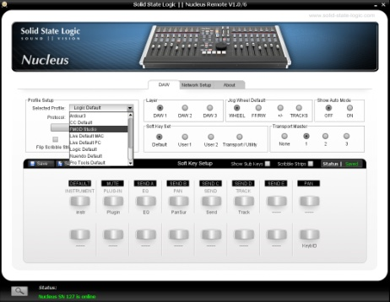
Select the profile from the drop-down menu

Nucleus Control with Studio
While the SSL Nucleus is fully programmable there is a basic default setup in regards to FMOD Studio function. By default the Nucleus will link its channels directly to the Audio Tracks within Studio Events as well as some standard global.

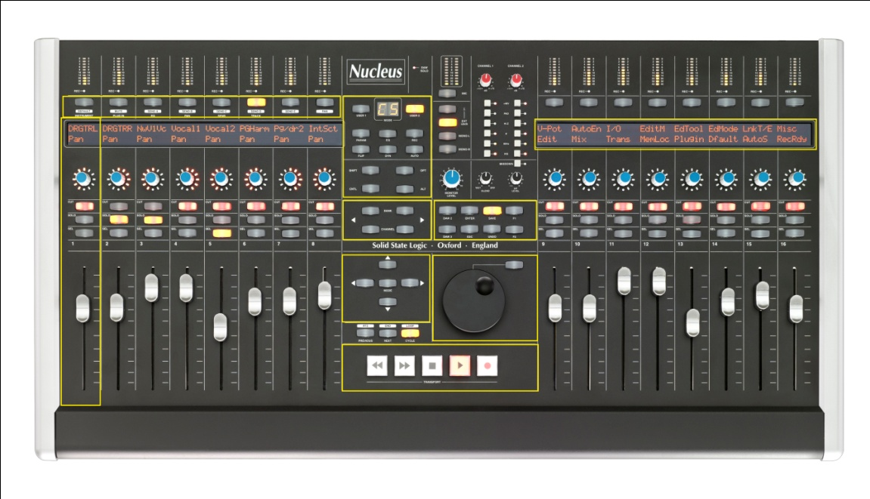
Selection Buttons
Info Display

Arrow Keys
Global Controls
Channel/Bank
Shuttle

Channel Strip
Transport Controls

Nucleus control layout

Nucleus Profiles
The information for profiles and user set-ups are saved globally on each relevant computer and the Nucleus itself has an SD memory card that saves Profiles that are imported to the hardware.

Common Controls
The Nucleus includes control strips for 16 tracks. The left hand side set of 8 are routed through midi channel 1 the right hand side 8 are routed via midi channel 2. If an FMOD Studio Event is created with more than 16 tracks the Nucleus will default to controlling the first 16 tracks created. You can change which tracks are controlled if required.

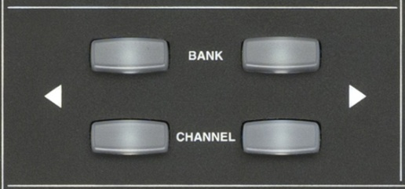
Bank/Channel Selector

The Bank / Channel selector buttons allow for the Nucleus to change which audio tracks are assigned to the available channel strips. The channel buttons will move the selection up or down by a single track. The Bank button will shift the selection by an entire group of 16 Tracks.

Transport Controls
The Nucleus control surface has the standard transport controls used on any DAW. The only exceptions are the Forward and Rewind functions, as FMOD Studio does not have traditional linear functionality at its core. These options are currently not linked to any settings.

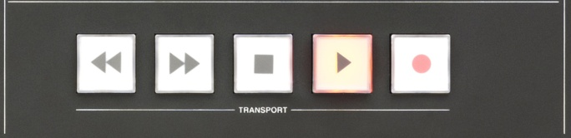
Transport Controls
- Reverse Button: No Setting currently
- Forward Button: No Setting currently
- Stop Button: This will stop playback when pressed once, but will not reset the cursor
position. When pressed twice this will return the cursor to the beginning of
the timeline
- Play Button: The play button will always play the Event from the beginning of the timeline

Selection buttons
The Nucleus has a range of selection buttons along the top of the unit. These buttons have specific settings when working with FMOD Studio. Activating the different buttons alters which settings are mapped out to the Channel Strip controls and the information in the display screen. The Value Dials can be used to manipulate displayed values, but pressing the value dial as a button can also access extra settings.

Nucleus Selection Buttons

Instrument
This button accesses the values of Parameters. Holding down the Instrument button will allow the user to select between all available Parameters using the Dial controller. Once a Parameter has been selected and the Instrument button is released the Dial controller is used to alter the Parameter values. Events with only the timeline view are not affected.

Plug In
The Plug In button displays a list of all plug-ins added to the Deck for the active Event Audio track.
By default an audio track contains only a Fader control. As more plug-ins are added to the Deck the Nucleus display will alter to indicate all Plug-Ins present. In this view any of the Dial controls associated with a Plug In can be pushed to gain access to that Plug-In. The Nucleus display will alter to indicate all the relevant controls for that Plug In and its values can now be accessed through either the control Dial or the Fader.
To return to the plug-in selection display, simply press the Plug In button again.

Note
The range of controllers and they type of display and values is entirely dependent on the Plug-In being controlled. The selection of Plug-Ins provided with FMOD Studio covers a wide range of effects and controllers and each one has a unique set of controllers. There is a logical link between the active controllers on the Nucleus and the visual display of each Plug-In in Studio.

EQ
EQ will directly link to the EQ plug-in for the active audio track. It will display the relevant property values and allow direct control of those properties via the control dials.

Pan
The Pan button will access a range of pan controls for the active audio track. FMOD Studio has a range of panning options and this setting can access all of them.
For Surround Pan Events, the pan control, when first activated, will provide control Properties to alter the listening position within the circular field of the 3D pan environment. The 3D Pan Preview in FMOD Studio will display the relevant graphical representation of the pan position as values are altered on the Nucleus.
Pressing the Pan button a second time for a 3D sound will open the Extent setting. This represents the range from center to the outer boundary of the 3D Pan Preview. Altering this value will move the signal from center point where the signal is strongest to the outer edge where it is weakest.
For audio tracks set to stereo the pan control will allow for value adjustment from center to either 100% left or 100% right hand side channel assignment.
Audio tracks set to mono default to equal left and right channel values and cannot be changed.

Send
The Send button will display all Sends created within the Deck for the active audio track. It will allow for individual control of the values of each Send displayed. Audio tracks that do not include Sends will display nothing when the button is pressed.

Track
Activating the Track button will display all the included tracks within an Event including the Master Track. Each Track is assigned to a control strip and the Nucleus display will indicate the volume levels of all audio tracks. The Faders can be used to directly control the Volume values of each audio track. This setting can be used to readjust the tracks that are being displayed by the Nucleus for control by using the Channel/Bank controls in the center of the Nucleus surface.
While in Track mode the arrow keys can be used to scroll the display in FMOD Studio up and down within the Event as well as to the left and the right. If the entire Event is can display in the default screen view these Properties will have no effect.
Flashing display lights on the Nucleus Surface indicate which track has been selected as active.

Send E
This button when pressed will automatically override all Mute and Solo Properties active in the Event. This allows a user to instantly monitor the Event with all tracks present and active. Releasing this button will return the Event to its actual state with any active Solo or Mute Properties reactivating.

Pan
The Pan selection button above track 8 currently has no function.

Track 9 Selection Button
This button is a shortcut to display the Events view in FMOD Studio. Pressing this button multiple times will cycle through all existing Event windows within the project in order.

Track 10 Selection Button
This button is a shortcut to display the Mixer View in FMOD Studio. Pressing this button multiple times will cycle through all existing Event windows within the project in order.

Tracks 11-16 Selection Buttons
These buttons currently have no function.

The Shuttle Wheel

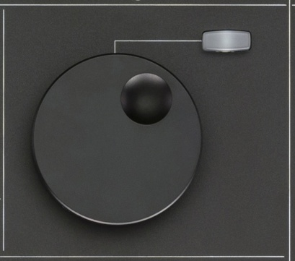
The Shuttle Wheel
The Shuttle Wheel control on the Nucleus directly controls the cursor in FMOD Studio. As its name suggests, it will shuttle the cursor backwards and forwards in directly relation to how it is turned.
Holding the toggle button with Shuttle control will alter its function to a visual display zoom within FMOD Studio. This will allow quick horizontal zooming in and out of the audio tracks in an Event.

Global Controls
There are a series of global control buttons on the Nucleus with a range of functions.

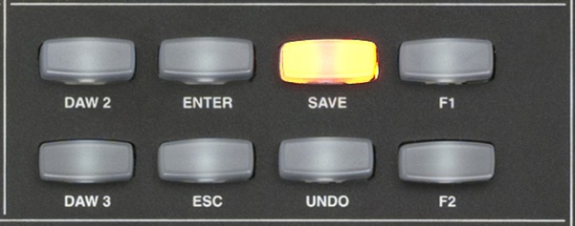
Global control buttons

DAW 2 and DAW 3
The SSL Nucleus is capable of controlling up to three Digital Audio Workstation setups and swapping between them.
The DAW2 and DAW 3 buttons will change the control surface to control secondary and tertiary applications. This allows Sound Designers to quickly jump between different aspects of a project across multiple applications and even multiple computers as long as all the relevant setup Parameters have defined correctly.

Note
You can control projects over multiple computers. The SSL Nucleus set-up programs need to be present and set-up correctly on all machines. ipMidi will also need to be setup.
For a second computer use midi port 3 and 4 and a third, use 5 and 6.

Enter
This button simply allows selection to be confirmed from the control surface. Any setting that would require the Enter key to be used can be triggered with this button.

Save
This button will save the current FMOD Studio project directly from the control surface.

ESC
This button will replicate any of the keyboard ESC functions in FMOD Studio.

Undo
Undo allows for the undo or keyboard shortcut CTRL+Z to function directly from the control surface.

F2
The F2 button maps to the Open Mixer Window command.

Miscellaneous Controls
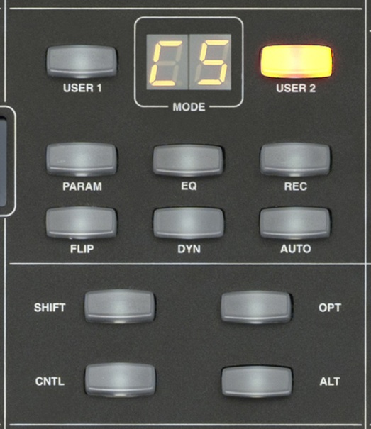
Miscellaneous controls

Flip
The Flip button will swap the Properties assigned to the Dial controller and the Fader controller. This allows for the default volume control of the fader to be swapped for Parameter control, effects value controls and all other controls usually assigned to the control Dial. This can be convenient for easy manipulation of multiple Parameter controls for auditioning and is very useful for teaching and other presentation purposes.

User 1 & User 2
The SSL Nucleus is a fully programmable control surface and can support up to additional 2 user defined profiles for each loaded profile setup. These buttons switch between the default profile and User Profile 1 and User Profile 2.

Channel Strips

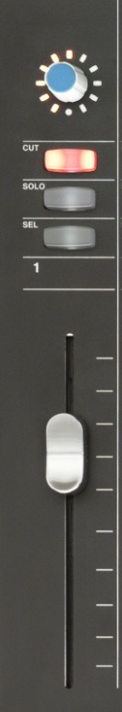
SSL Nucleus Channel Strip

Default Channel Strip Behavior
The Default behavior of the Channel Strips on the Nucleus are as one would expect of any standard DAW control surface.
- Display: IDs the assigned Audio Track in Studio and displays the volume level
- Value Dial: Controls the Volume level of the assigned Audio Track in Studio
- Cut: Mutes the assigned Audio Track in Studio
- Solo: Solos the assigned Audio Track in Studio
- Select: Selects the assigned Audio Track in Studio and makes it the active track
- Fader: Controls the Volume level of the assigned Audio Track in Studio
The Fader controls are motorized and will respond to automation value changes in FMOD Studio Events.

Profiler
FMOD Studio includes a Profiler tool that allows users to assess the performance of their projects. The Profiler can be used to check performance of Events and Projects directly in FMOD Studio, and can also work when a project is linked to a game running on a computer or console development kit to assess performance at runtime.

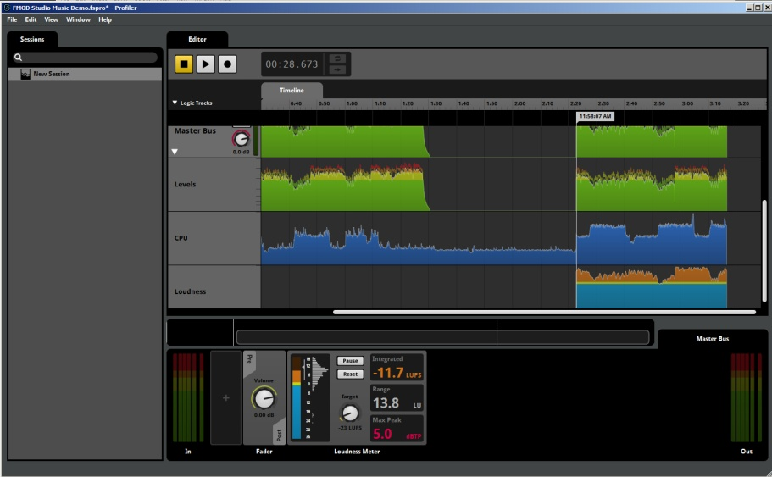
The FMOD Studio Profiler

The Profilers has many of the same interface areas as other FMOD Studio windows.

The Session Browser
The Session Browser allows the user to create and administer Sessions. Its context menu contains the following items:
- New Session: Creates a new session with all Buses scoped in, except for Input
Buses.
- New Blank Session: Creates a new session with nothing scoped in.
- New Folder: Creates an empty Folder for session grouping and administration.

Right Clicking on an object in the Session Browser will provide additional context menu items:

- Delete: Deletes the object from the project.
- Move to: Allocates the current context to the targeted Folder.
- Move into New Folder: Creates a new folder and allocates the context to the targeted
Folder.

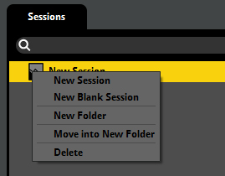
Session Browser context menu
Buses can be scoped into a Session simply by dragging them from the Mixer Routing Window onto the Editor area. Any type of Bus, including Input Buses, can be added to a Session.

Adding a Bus to a Session
1. Activate a Session by clicking on it in the Session Browser area.
2. Display the Mixer Router window.
3. Drag the desired Bus from the Mixer Router Window into the Session Editor to create a new Track.

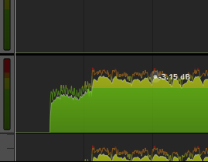
Close up of a Session Track

Using the Profiler
Once your Session includes all the Buses you wish to examine, press the Record button to activate the Profiler. Then you can audition any and all Events within your Project to capture data on performance. The Profiler will record several pieces of data as it is recording.

Master Bus
The Master Bus Track captures Peak and RMS output data. These indicate the output levels of all signals playing through the Master Bus in FMOD Studio.
The Disclosure Triangle on the Master bus expands the tracks to indicate both the output levels and the CPU usage for the Events being played. Hovering the cursor over the output curve displays the exact value for the point at which the cursor is positioned.

Note
The data displayed in the Profiler is vertically scaled to maximize space and visibility, so the maximum peak of a data stream will be at the top of the display area, but this peak may only represent one or two percent of capacity. A subsequent greater peak will result in the entire data display to be scaled appropriately. For this reason it is important to use mouse hover to gather accurate data values.
Each Track displays the relevant data for its associated Bus. In this way it is easy to scan though Track data looking for anomalies and performance issues. Session data is useful for debugging and optimization purposes.

Loudness Meter
A Loudness Meter Module can be added to the Master Bus Deck to measure the Integrated Loudness, Loudness Range and True Peak of the game’s output. The Module can also be added to any bus or track to measure loudness at any point in the signal chain. Momentary and Short-term Loudness are logged in the Profiler window. Refer to the Loudness Meter description for a full explanation of how this Module functions.

Loudness Meter Module
FMOD Studio provides a Loudness Meter Module that can be added to the Deck region of Events Tracks, Mixer Buses and profiled track. The Loudness Meter will track output levels and display a range of data to assist in balancing your project.
Standards of Loudness are a complex aspect of audio production for media and the games industry has many people involved with attempts to provide useful information to developers to produce contact that is consistent with other forms of media.
The Loudness Meter included in FMOD Studio provides data that is consistent with the EBU recommendation R128. http://tech.ebu.ch/loudness and the ITU’s BS. 1770-3 recommendation http://www.itu.int/rec/R-REC-BS.1770-3-201208-I. This is a series of standards agreed upon within Europe and the US to guide broadcasters in the production of media.
The general concept is that measurement of sound pressure levels and values defined by decibels does not provide sufficient information for developers to be able to accurate balance the audio for a project. The way humans perceive sound is more of a psychoacoustic phenomenon that something that can be perfectly mathematically measured. There are many reasons for this, but the following describes a simple issue with audio measures.
Humans perceive the range of frequencies differently. A very low frequency sound at 60dB will sound softer than a high frequency sound. For this reason a flat measurement of dB output is very limited in its usefulness. Loudness Units or LU are a measurement standard that provides a useful way of measuring the overall perceived loudness of a signal.
This article provides further information on this method of measuring audio output
http://auphonic.com/blog/2012/08/02/loudness-measurement-and-normalization-ebu-r128-calm-act/
The FMOD Studio Loudness Meter provides a range of tools to the user to measure Loudness and assist in the balancing your projects output levels.
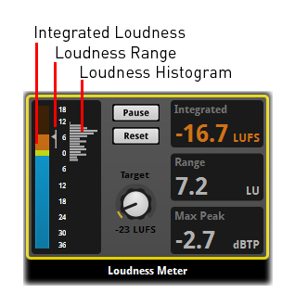
The Loudness Meter
The Loudness meter is useful for capturing an overview of a projects output. While it does update its measured values constantly it is designed less for moment by moment monitoring and more to provide a summary of the overall output performance of a project.

Integrated Loudness
The Integrated display provides an overall summary of the output measured in Loudness Units with reference to Full Scale (LUFS). This will show a running total of the measured loudness since playback was started.
Note
A user could essentially leave the Loudness meter to track an entire piece and return afterwards to examine the data. If the Integrated display values are displayed in blue it means the overall levels are under the defined Target level, a display in Yellow indicates the levels are within +/-1LU of the Target level and a value displayed in Orange indicates the levels exceed the Target loudness. When used as part of the Profiler the profiled output would indicate exactly where these levels fell below, matched or exceeded the defined target levels.

Loudness Range
The Range display indicates the overall dynamic range in LU that the project has produced while being tracked by the Loudness meter. This information can be useful for a variety of reasons. Mobile platforms may need a smaller dynamic range to avoid signals being obscured on smaller playback devices while projects developed for high end system may wish to maximize their use of dynamic range.

Max Peak
Audio software applications have a level to indicate where digital audio signals will Peak and potentially distort the audio signal. This usually occurs at 0dB and signals that are close to 0dB are considered undesirable. An issue with digital audio signals is that generally it measures signals by plotting the position of each sample location. While this is generally accurate it is possible for a signal to exceed 0dB between samples. The unit dBTP measures Decibels True Peak and so more accurately estimates the peak level when the signal is converted to analogue during playback. A headroom of 1dB is prescribed in loudness standards so this meter will go red when the signal exceeds -1dBTP.

Target
This property allows the user to define the desirable overall loudness. This can be set to any level between -24 LUFS and -12 LUFS and defines what information the Integrated Display and bar meters will show. Double Clicking on the Dial sets the Property to a default value of -23 LUFS. All levels in the bar meters and Profiler are shown relative to the target value.

Pause
When Paused the Loudness Meter ignores output level data and does not record it for inclusion in its summary.
Because the Loudness Meter tracks data over time and provides a summary of the output it may not always be desirable to include all data. Pausing allows the user to temporarily cease recording, alter aspects of their project that may me causing extreme output values, and then resume recording to resume collecting the data.

Reset
The reset button clears the Loudness Meter of all data to allow it to start fresh with a new set of data.

Bar Meters
The Bar Meters will track and measure the output of the Project. By default the Meter will measure Momentary information and display a range of -36 to +18 LU. All values shown are relative to the set Target loudness.
Information on EBU +9 and +18 meter ranges:
http://tech.ebu.ch/docs/tech/tech3341.pdf
The Context menu for the Meter allows the Meter to switch from Momentary to Short term signal tracking. Momentary is a 400ms response while Short Term is a 3 second response. The Context menu can also allow the meter to display a range from -36 to +18 LU or -18 to +9 LU. This context menu also switches what is displayed in the Profiler.
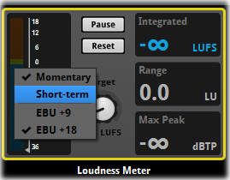
Bar Meters Context menu

Meter Signal Peak and Range Indicator
The Output Meter includes an integrated loudness indicator as well as a range indicator line. The Arrow will show the integrated loudness relative to the Target loudness while a line will extend from the arrow both up and down that tracks the overall loudness range.

Loudness Histogram
As part of the Output Meter there is a graphic display that provides a quick reference for the spread of loudness during playback. Each bar indicates a range of 1LU and the overall display is scaled to show the playback duration of each loudness range relative to each other.

Project Progression
This section provides a series of tutorials covering many aspects of Studio Functionality.

Introduction
This chapter will link a series of tutorials together with supporting information and proceed through the steps to create a complex sound Event within FMOD Studio. The source sound files are provided to allow users to download the raw assets, examine them individually and then implement them at each stage of the project to achieve the final outcome. Users are of course free to use their own assets or a mix of the provided assets and their own material.

A Generative Audio Explosion
This project will work through the steps to create an explosion sound effect that utilizes generative audio. The end result will be a sound effect that is unique each time it is triggered and utilizes control Parameters to vary the output sound depending on the desired material content of the explosive event.

Concepts
Before we even approach the production steps it is important to understand what we are trying to achieve. The sound of an Explosion is a common and dynamic element in many forms of media but even the best recording of an explosion is still a static sound effect. This project will aim at creating dynamic explosion effects from smaller sound components. By using the generative audio method of production we not only create sounds that are unique on triggering, but we can use Game Parameters to control the exact makeup of our sound. In this way we can use a single event, but manipulate it as required to define its makeup. Explosion with all elements, and explosion with just metal and glass, and explosion of wood and stonework can all be generated from a single event and adjusted as required.

Analysis of an explosion
An explosion is a violent release of a form of energy. In its smallest form this can be represented by a firework detonating or the internal working of a bullet cartridge in a gun. The initial release of energy is only a small part of the overall audio event though. It is how the released energy reacts with the world around it that produces most of the audio elements of the overall explosion sound.
Sound is transmitted via movement of airwaves. Most explosions include a rapid expansion of gases and elements this outward expanding impulse directly influences airwaves and thus most explosions generate considerable sound. The term High Explosive refers to any material that upon detonation generates a supersonic shockwave. The expanding shockwave creates the initial pop or bang of an explosion, but this is only a single component of most explosive sounds.
A car or similar vehicle exploding will also include the initial release of energy, but as the shockwave travels outwards it will tear the car apart from the inside. This process will produce the sound of plastic and metal being bent, ripped or broken apart. Any glass surfaces in the car are likely to smash and the smaller components will continue to interact as they move against and bounce off each other. The final stage is the eventual coming to rest of all the various components as they fall to earth and settle after the shockwave passes.
From this description we can see that an explosion is not a simple single sound effect, but a complex combination of audio events that combine to produce the final sound we hear. The exact makeup of an explosion sound effect is dependent on the materials present in the explosive event. A house exploding may have the sounds of wood splintering and breaking, bricks and concrete collapsing and colliding, glass smashing and metal tearing. Such a sound would not work appropriately to represent a car exploding as the wood and masonry would provide an inappropriate element to the overall sound.

Sound Components
To produce this complex Event we will require a series of smaller sound components to us as building blocks. All the following sounds are provided as raw sound-files to use in the creation of this Event.
- A Shotgun discharging (single sound-file)
- Glass smashing (multiple sound-files)
- Glass shards (multiple sound-files)
- An impact thump (Single sound-file)
- Metal Impacts (multiple sound-files)
- Metal Debris (multiple sound-files)
- Wood Breaking (multiple sound-files)
- Wood Debris (multiple sound-files)
- Stone Impacts (multiple sound-files)
- Stone Debris (multiple sound-files)
- Energy Release (multiple sound-files)
We recommend you download these files and listen to them individually to familiarize yourself with the raw source files. Understanding each of the components will help you better understand the process of change they may go through as part of creating and implementing this Event.

Tutorial 1: Creating the project

Introduction
This tutorial replicates the steps in the very first tutorial of this manual except in this case we are creating a project with a known outcome and purpose. This tutorial will introduce Project files and structure for The Explosion.

FMOD Studio Project folder on PC

Step 1 Save the new Project
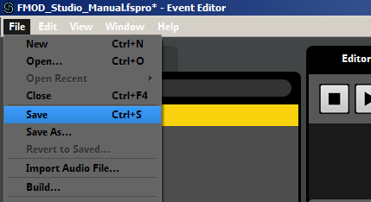
Saving a Project

- From the File Menu, select Save and either Left-Click or hit Enter.

Step 2 Define Project location and Project name
Name the Project

- Target you Desktop as the location for this project and name it The Explosion
- Click Save or hit Enter to save.

Summary
The project file is the starting point for any work created in FMOD Studio. We have defined the location for our project and all material will be contained within this project structure.

Tutorial 2: Creating an Event Folder

Introduction
Upper Level Folders are simply a method of sorting your Events for ease of use and workflow. Events can be assigned and reassigned to Upper Level Folders as required. Events can also be cut, copied and pasted between upper level folders. This tutorial will introduce Upper Level Folders by creating an empty Upper Level Folder.
Step 1 Creating a new Upper Level Folder
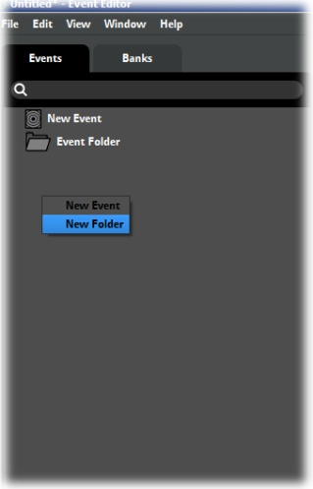
Creating a new Event Folder
- Right click anywhere in the Event Browser.
- Select Upper Level Folder from the drop-down menu.

Step 2 Naming the new Upper Level Folder
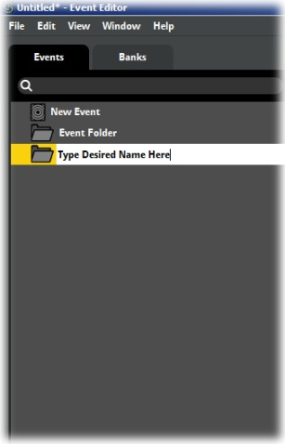
Naming Event Folder

- The Upper Level Folder will be created with the default name New Folder.
- Type in the name The Explosion for the new folder.
- Press Enter or left-click away from the Event title to confirm the Folder name.

Summary
Creating Upper Level Folders in the Browser provides a new empty object to which Events can be directly added. This will help us to sort the various Events we will use in this project

Tutorial 3: Creating the first Event

Introduction
This project is going to use a wide range of Module objects across multiple Events. The functionality of the Modules will vary. We will start with the simplest functionality. This tutorial will create an empty Event to start the project.
Step 1 Creating a new Event
Creating a new Event
- Right click on the folder called The Explosion in the Event Browser.
- Select New Event from the drop-down menu.

Step 2 Naming the new Event
Naming an Event
- The New Event will be created with the default name New Event.
- Type in the name Shotgun
- Press Enter or left-click away from the Event title to confirm the Event name.
- Click on the Event name in the Event Browser to make this Event the active.

Summary
We have now created an empty Event within our Event folder. This Event can now have a sound-file added to it.

Tutorial 4: Adding Sounds to the First Event

Introduction
This first Event will contain only a single sound-file. There are two ways of adding a sound-file to an Event, this tutorial will demonstrate both methods. This tutorial will add a single sound file to an empty Event. The Shotgun sound-file provided is the file we wish to use.
Now that there is an Event it is possible to add sound files directly into the Editor region. There are a variety of ways in which to add sounds to Studio but the simplest is to drag and drop.

Step 1 Adding the target sound file First Method
- Ensure the Event Shotgun is active by clicking on it in the Event Browser
- Open the folder on your computer that contains the downloaded project files
- Drag the sound file Shotgun from the folder into the Editor Region of FMOD Studio.
- Drop the Sound File onto the Track Audio 1
FMOD Studio will create a Module object in the Event timeline. The object will occupy an area of the timeline relative to the sound files length and can be adjusted to take more or less time by click-dragging the edges of the object. The Module will display a silhouette of the wave in both the Timeline box and in the Deck below the Event. The Deck is also where the properties for any selected Module are displayed. In this case the Volume and Pitch properties are displayed to allow for those properties to be altered for this Module.
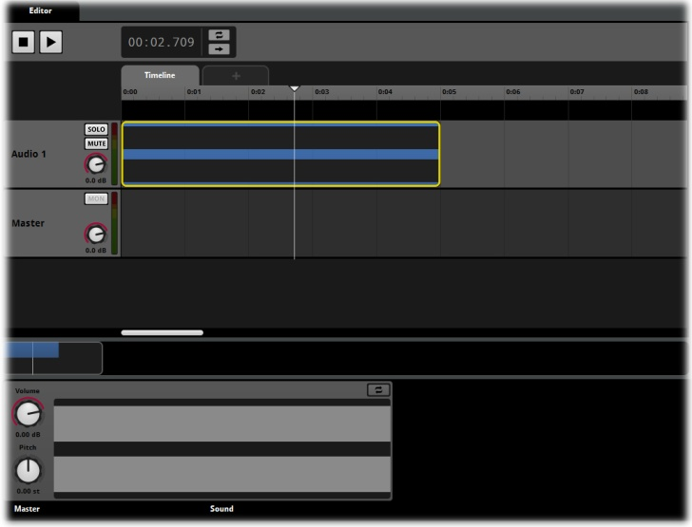
A Single Module object

Note
A Sound File must be dragged and dropped onto an Audio Track in the Editor Region of FMOD Studio. If you drag a sound file across automation tracks, the master track or any non-valid area an icon will indicate this is not a valid target for placement of the sound file.

Step 1 Adding the target sound file Second Method
- Ensure the Event Shotgun is active by clicking on it in the Event Browser
- In the Editor Region of the Event Shotgun, right click on Audio Track 1
- A pop-up window will open displaying a folder browser. Navigate to the folder containing the downloaded project files and select Shotgun
- Press Enter or click on Open to select the sound-file
FMOD Studio will create a Module object in the Event timeline in the exact manner as when a sound-file is dragged onto the Audio Track. The display should be identical to the drag method of adding a sound-file. The Module will display a silhouette of the wave in both the Timeline box and in the Deck below the Event.

Summary
The easiest and most direct method to add a sound file to FMOD Studio is to drag and drop it directly from your computer but a file can also be added through the right click menu process. Studio will automatically create a single Module that contains the selected sound file.

Analysis of FMOD Studio Projects
To assist in understanding some of the capabilities of FMOD Studio there are some example files included with the Pre-Beta download Demo. Analysis of these projects can help to further understand many of the available Properties of Studio.

Single vs. Multi Sound Module

Introduction
The Single Sound Module and Multi Sound Module objects are probably the two most commonly used Module objects within FMOD Studio. Between them they provide a range of Properties that suit many applications and they are also efficient in their use of resources. This example will demonstrate the why using a Multi Sound Module can result in better sounding audio for your project.

The Basics
Essential both the Single Sound Module and Multi Sound Module objects are an easy method of referencing sound files for playback within FMOD Studio. Both types of Module objects include Volume and Pitch controls the main difference is that a Multi Sound Module can contain more than one sound file. Different options are available when using multiple sound files within a module object, but the simplest and most direct is the reduction or removal of repetition of audio within a game project.

The Example
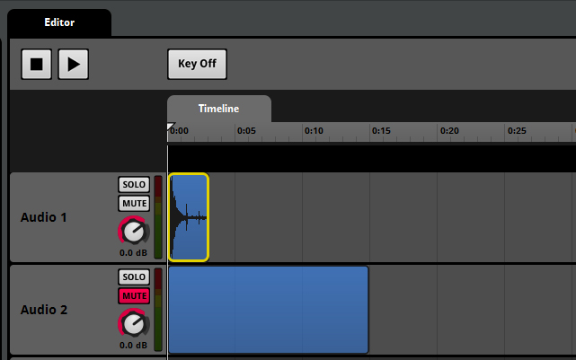
Event with Audio Track 2 Muted

Look at the example Event within FMOD Studio called Single vs. Multi by clicking on the Event name to make it active. The Event contains two Audio Tracks to allow for a comparison between the two types of Module. Audio Track 1 contains a Single Module object and Audio Track 2 contains a Multi Sound Module object. To start with Mute Track 2 so that only Track 1 is heard for Playback
If you press the Play control under the default setup, Studio will trigger the Single Module in Audio Track 1. This is the sound of a double barrel shotgun being fired. There is a single sound file with no alteration being applied to the sound in any way. Essentially FMOD Studio will simply play this sound over and over each time it is triggered. Play the Event now a few times and listen to the sound of the shotgun.
As you would expect you hear the exact same sound each time you press play. This is how a Single Module object works. Now, switch the active state of the two Audio Tracks by un-muting Audio Track 2 and Muting Audio Track 1. This will make Audio Track 2 live.

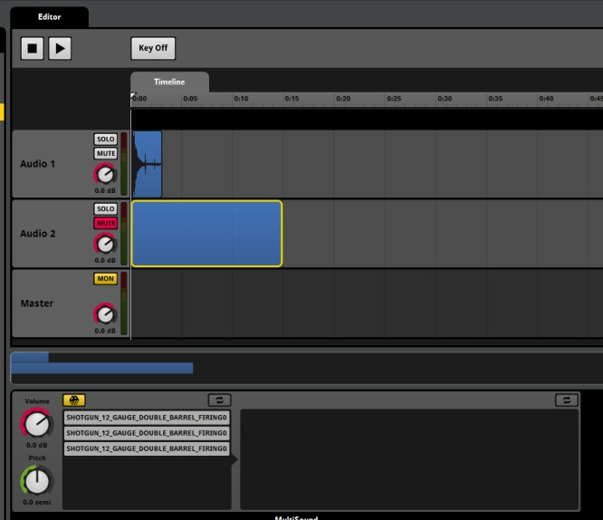
The Multi Sound Module object contains 3 sound files
Audio Track 2 contains a Multi Sound Module object that references three sound files. All three sound files are also of a Shotgun being discharged, but each sound is very slightly different. When the Event is triggered with the Multi Sound Module object active there is a subtle difference each time it plays, but even a subtle difference is enough for the human ear to register that it is not hearing the exact same sound. Obviously the more sound files that are included in a Multi Sound Module the greater the variation at playback.

Taking Things Further
Variation of a sounds playback is a powerful way to avoid repetitive sounds. Varying Pitch and Volume each time a sound is triggered can further add to the effect of having more than a single sound file. Certain Properties within FMOD Studio allow for variable Pitch and Volume to be applied to a sound on Playback. The range of values applied to the sound can subtly or drastically alter the sound at playback; experimentation with Property values is the best way to establish how far a sound can be manipulated while maintaining an appropriate effect.

Note
Do not underestimate the importance of subtle changes. When a sound is created to represent a particular object or action it needs to be relatively consistent with the event it represents. Subtle differences in playback avoid the feeling of repetition but more extreme changes in playback can make the audio sound like it belongs to a different object or event. In the case of the shotgun, slight alterations of Pitch can reinforce the subtle differences and add even more variation, but if the pitch alterations are too extreme either up or down in frequency then the sound of the shotgun may end up sounding like an explosion or a smaller handgun.

A Variable Duration Cycle

Introduction
A common requirement in game projects is to create a sound for an event that has a definable start and finish point but that can have variable duration. This is very common for machinery sounds and can often create tricky implementation issues. FMOD provides a simple solution to this problem, and with the advanced functionality within FMOD Studio the process can be developed into complex audio events.

The Event
Examine the Event named Variable Duration Cycle. It includes a single audio track and three Single Module objects. The Modules have been positioned to create a smooth cross fade between them and this could easily be recreated in any audio editing software to create the sound of a car starting up, idling briefly and then being shut down. This Event however includes a Sustain Point aligned with the middle Module that represents the idling sound and this allows the sound to be played for as long as required.
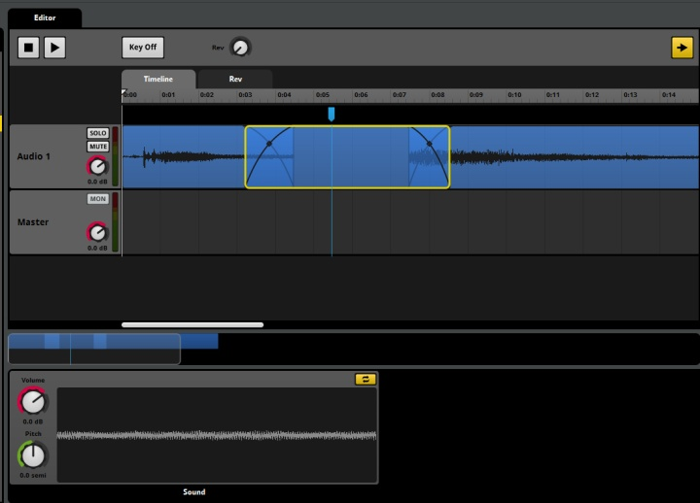
A Timeline with Sustain Point

The Mechanics
With regular playback an Event created on a Timeline will proceed through time from zero until the last sound triggered has finished. FMOD Sustain Points instruct FMOD to pause in the advancement of the cursor along the Timeline. This means FMOD will effectively continue to play that point in time until it is instructed to advance again.
In this example the Sustain Point coincides with the idle sound of the car. The Single Module object of the idle sound has been set to Loop (note the small yellow square in the Property display in the Deck). This means that while the cursor is touching the Module it will continue to play endlessly. Once Keyoff is triggered in the Event, the cursor will continue to move along the Timeline and ultimately trigger the engine shutdown sound and the Event will finish playing.

Going Further
FMOD Studio can add extra layers of complexity to a cycle Event. The dial in the Play Region to the right of the Key off button adds some extra functionality to this Event. Play the Event again, and when the sound reaches the loop point, turn the dial and listen to what happens.
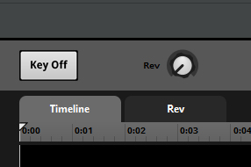
Parameter controller dial
The dial is a controller for a Parameter that has been added to this Event. The Parameter has been called Rev, but it be called anything appropriate. By clicking on the Parameter tab called Rev you can change to the Parameter view and observe what is occurring. Explore this Event to understand some of its possibilities.

Pitch Shifting Magic

Introduction
There is a previous mention in this document of the usefulness of using a single sound file for a variety of purposes. The fact the FMOD Studio only references a sound files and never alters them makes this function extremely powerful. The Event named Pitch Shifting Magic has been created to more fully demonstrate this potential.

The Event
Pitch Shifting Magic consists of a Single Module that contains a recording of a metal box about the size of a shoe box being kicked. The sound itself is somewhat plain and uninspiring and for this reason is perfect for this demonstration. Firstly you may notice that the Event looks empty on first inspection. This is because in this Event the Timeline does not include any Module objects. If however you click on the Parameter tab FMOD will display a different view that contains the Module for this example.
The Game Parameter for this Event has a range of values and an Automation curve controlling Pitch has been added to the Event. At various values of the Game Parameter different Pitches have been defined to affect the playback sound of the event. The initial value is set to the default pitch of the sound file being used for this Event.
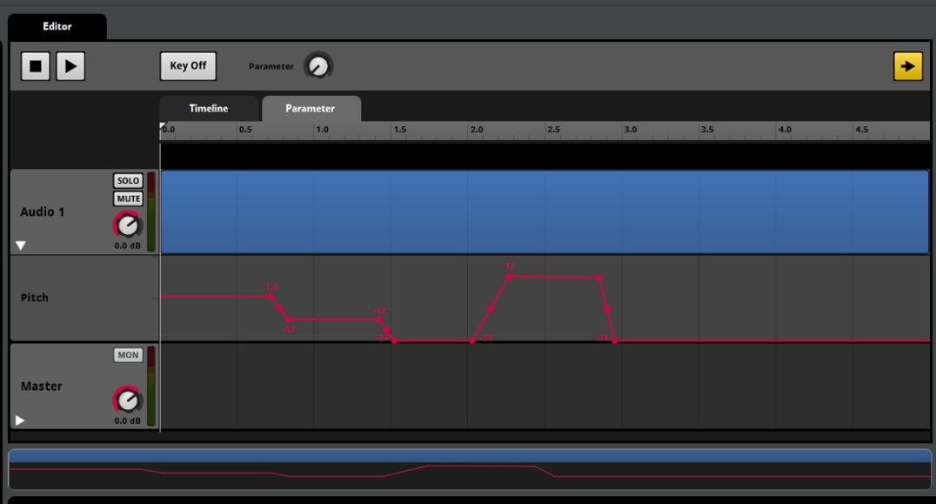
Automation of Pitch Property provides a variety of output results
When you press the Play control the Event will be triggered once and you will hear the sound of the metal box. As has been mentioned it is a fairly ordinary sound. It might perhaps be appropriate to represent a metal mailbox being struck or shut forcefully. This single sound file however can be altered in its playback behavior to provide a wider range of uses.
Click on the Parameter ruler at the value of 1.5 and the cursor will reposition to that value. The Pitch of the sound has now been altered approximately one octave below the original sound file. Pressing Play now will trigger the sound, but it now sounds like a much larger metal object, similar to a 40 gallon drum being impacted. History would suggest that games have a far greater use for the sound of a 40 gallon drum than that of a mailbox.
Clicking on the Parameter ruler again at a value of 2.5 lowers the pitch still further. This time the Event sounds more like a large metal garage or hanger door being opened. The analogue nature of the pitch shifting means that as a sound is pitched down it becomes longer than the original file length, and as it is pitched up it will become shorter.
Moving the Parameter to 3.5 will now result in the Event pitching the sound file up in pitch above the original. The sound is now higher in pitch and shorter in length; it sounds more like a tin can being kicked. A final selection of 4.5 on the Parameter ruler will pitch the Event back down to an extremely low level. The sound now takes on a far more ominous effect as it could represent the hull of a ship or spacecraft being breeched.

Going Further
All the previous effects were created using a single sound file and some pitch alteration, but remember the sound file can also be used as part of a more complex event. The low pitch effect could be combined with other sounds to simulate an impact crash of a vehicle (with the previously mentioned shotgun sound for instance), the high pitch clank could represent debris of such an event or perhaps the small component of a larger mechanical process.
This example was created simply to demonstrate how useful a single sound file can be and how powerful even simple process Properties within FMOD Studio are. Thinking outside the box of traditional sound design can produce effective results.

Appendix A

Keyboard Shortcuts
- B Hide / Reveal The Event Browser
- D Hide / Reveal the Deck Area
- P Hide / Reveal the Properties area
- CTRL + 1 Event Editor
- CTRL + 2 Mixer
- CTRL + 3 Audio Bin
- CTRL + 4 Event Editor
- CTRL + 5 Mixer Router
- Delete key (currently supported in the multi-track, hopefully everywhere in the release)
- Ctrl +N (Command+N) New
- Ctrl +O (Command+O) Open
- Ctrl +S (Command+S) Save
- Ctrl +Alt +W (Command+Alt +W) Close
- Ctrl X (Command+X) Cut
- Ctrl C (Command+C) Copy
- Ctrl V (Command+V) Paste
- Ctrl+Z (Command+Z) undo
- Ctrl+Y (Command+Shift+Z) redo
- Ctrl+` (Command+`) cycle through open windows
- Double-click on labels to edit (works for values, track names, Parameter tabs, mixer view tabs)
- Ctrl+Drag (Command+Drag) on dials/faders for fine control
- Ctrl Shift +L (Command+Shift+L) Loop Playback
- Alt+Drag on dials to set randomization
- Alt+Wheel to zoom in/out in multi-track
- Ctrl +] (Command+]) zoom in
- Ctrl +[ (Command+[) zoom out
- Ctrl +M (Command+M) minimize
- Ctrl +W (Command+W) close window
- Shift+Wheel to scroll left/right in multi-track
- Alt+Shift+B send module to back
- Alt+Shift+F bring module to front
- Alt +F4 exit the program
- Double-click on curve control points (diamonds) to change curve shape
- Shift+Drag while bulk editing in the mixer to lock all strips to the same value
- F1 Display the manual

Support

Website
www.fmod.org

Technical support
support@fmod.org

Sales / licensing enquiries
sales@fmod.org

Training and tutorials
http://www.youtube.com/user/FMODTV?ob=0&feature=results_main

Manual written and produced by
Sound Librarian
www.stephanschutze.com

